**Caver**



## 

## ****Table of Contents****

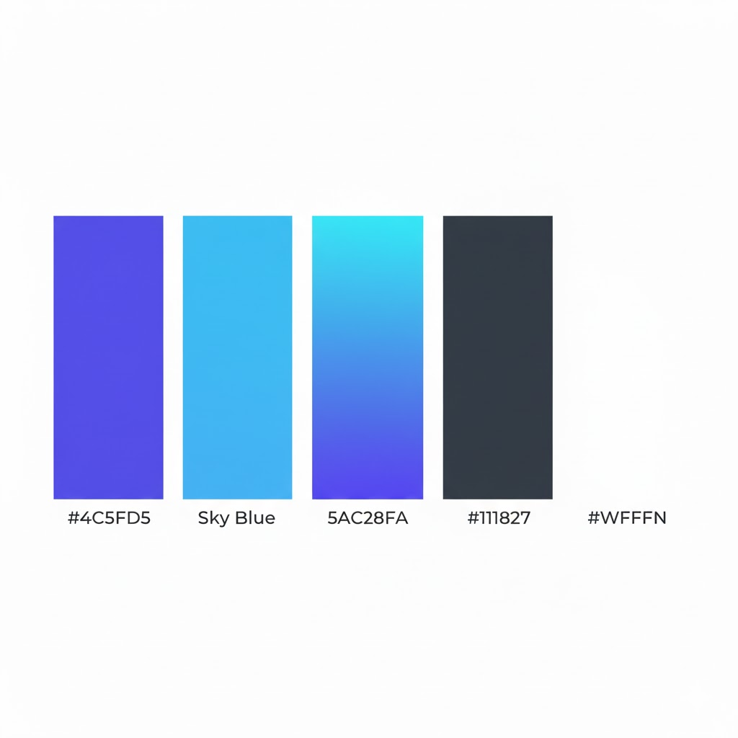

**Introduction to the Daris LMS Software Documentation**

**Welcome to the comprehensive documentation for Daris LMS, a modern, API-first Learning Management System designed to deliver scalable, secure, and accessible online learning experiences. This suite of documents outlines the complete set of Functional and Non-Functional Requirements, System Architecture, and Technical Specifications necessary to build, test, deploy, and maintain the platform.**

**Purpose of This Documentation**

**This documentation serves as the single source of truth for the Daris LMS project. It is structured to align with industry standards—specifically the IEEE 830–1998 framework—and is intended to:**

* **Define the scope, features, and constraints of the system.**
* **Guide developers, designers, testers, and stakeholders throughout the development lifecycle.**
* **Ensure clarity, consistency, and traceability across all project phases.**
* **Facilitate integration, scalability, and future enhancements through well-documented APIs and modular design.**

**Document Structure**

**The documentation is organized into three core components:**

1. **Software Requirements Specification (SRS) – Provides an overview of the system, including its purpose, scope, user classes, operating environment, and high-level features. It also includes appendices for glossary, analysis models, and a TBD list.**
2. **Functional Requirements (FR) – A detailed, categorized list of system behaviors and capabilities, organized by feature areas such as User Management, Course Management, Assessment, Search, Notifications, Analytics, and more. These requirements are derived from both the SRS and the underlying Moodle-inspired database schema.**
3. **Non-Functional Requirements (NFR) – Defines the system’s quality attributes, including Performance, Reliability, Security, Usability, Maintainability, Portability, and Compliance. Each NFR includes measurable acceptance criteria to ensure the system meets operational and user experience standards.**

**Intended Audience**

**This documentation is designed for:**

* **Developers – Backend (Laravel/PHP) and Frontend (Next.js/React) engineers implementing features and integrations.**
* **UI/UX Designers – Creating intuitive, accessible, and responsive interfaces.**
* **QA & Test Engineers – Designing test cases and validating system behavior against requirements.**
* **Project Managers & Product Owners – Tracking progress, scope, and deliverables.**
* **System Administrators & DevOps – Deploying, monitoring, and maintaining the platform.**
* **Stakeholders & Clients – Understanding system capabilities, constraints, and roadmap.**

**Technology Stack**

**Daris LMS is built using a modern, decoupled architecture:**

* **Backend: Laravel 12 (PHP 8.3+) with Laravel Sanctum for authentication, Laravel Scout with TypeSense for search, and Redis for caching.**
* **Frontend: Next.js 15 (React) with Redux Toolkit & RTK Query for state management, and Shadcn/UI for accessible components.**
* **Database: MySQL 8.0+ / MariaDB 10.4+.**
* **Deployment: Dockerized, cloud-ready, with support for AWS, Azure, or on-premise environments.**

**How to Use This Documentation**

* **For a high-level overview, start with the SRS.**
* **For detailed feature specifications, refer to the Functional Requirements.**
* **For system quality and constraints, review the Non-Functional Requirements.**
* **For technical context and future planning, see the Appendices and TBD List.**

**This documentation will evolve alongside the project. All changes will be versioned and communicated to ensure alignment across teams and stakeholders**

# ****Project Overview****

## ****2.1 What is Daris LMS?****

**Daris LMS is a modern, cloud-native Learning Management System built from the ground up with a focus on performance, scalability, and user experience. Inspired by the robust architecture of Moodle and enhanced with contemporary development practices, Daris provides a fully API-driven, modular platform designed to meet the evolving needs of educational institutions, corporate training programs, and online learning providers.**

**Unlike traditional monolithic LMS platforms, Daris adopts a decoupled architecture—featuring a Laravel-based REST API backend and a Next.js React frontend—enabling seamless integrations, mobile readiness, and a highly responsive user interface. The system supports a wide range of learning activities, from basic course delivery to advanced interactive modules, all while maintaining strict security, accessibility, and compliance standards.**

## ****2.2 Vision & Goals****

### **Vision**

**To become the preferred open-source LMS platform for organizations seeking a flexible, scalable, and developer-friendly solution that bridges the gap between traditional learning management and modern digital learning experiences.**

### **Core Goals**

* **✅ Scalability: Support thousands of concurrent users and millions of content items without performance degradation.**
* **✅ Accessibility: Ensure compliance with WCAG 2.1 AA standards, supporting learners with diverse abilities.**
* **✅ Extensibility: Provide a plugin-friendly architecture and comprehensive APIs for custom integrations.**
* **✅ User-Centric Design: Deliver an intuitive, responsive, and engaging interface for all user roles.**
* **✅ Security & Compliance: Implement robust security measures and adhere to data protection regulations such as GDPR.**
* **✅ Future-Ready: Support emerging learning standards (LTI, xAPI) and interactive content formats (H5P, SCORM).**

## ****2.3 Core Features Summary****

**Daris LMS is packed with features designed to support modern learning ecosystems:**

|  |  |
| --- | --- |
| **Feature Category** | **Key Capabilities** |
| **👥 User Management** | **Multi-role system (Admin, Instructor, Student, Support, Guest), profile management, RBAC, email verification, password reset, account suspension** |
| **📚 Course Management** | **CRUD operations, categorization, lesson/module structuring, draft/published states, public/private visibility** |
| **🎓 Enrollment & Access** | **Manual/self-enrollment, bulk CSV imports, group/cohort management, enrollment validation** |
| **📝 Assessment & Grading** | **Assignments, quizzes (MCQ, True/False, Short Answer), automated grading, manual feedback, weighted gradebooks** |
| **🖥️ Content Management** | **File uploads (PDF, video, images), version control, cloud storage (AWS S3), embedded media** |
| **🔍 Search & Discovery** | **Global search powered by TypeSense, faceted filtering, sub-500ms response time** |
| **📢 Notifications & Messaging** | **In-app alerts, email notifications, private messaging, configurable preferences** |
| **📊 Analytics & Reporting** | **Student progress dashboards, system health metrics, CSV/PDF exports** |
| **⚙️ Administration** | **Global settings, audit logs, plugin management, backup/restore** |
| **🔌 API & Integrations** | **RESTful API (/api/v1/), webhooks, LTI readiness, payment gateway support** |
| **🧩 Advanced Learning Modules** | **Forums, wikis, workshops (peer review), glossaries, SCORM/H5P support** |
| **🎯 Competency-Based Learning** | **Competency frameworks, learning plans, skill mapping, automatic achievement tracking** |
| **🏆 Gamification** | **Badges, automated issuance criteria, profile display, Open Badges compatibility** |
| **📅 Calendar & Scheduling** | **Global/user calendars, automated event creation, iCal export** |
| **🔐 Security & Compliance** | **Session management, data encryption, audit logging, GDPR tools, policy versioning** |

## ****2.4 System Architecture Overview****

**Daris LMS follows a decoupled, microservices-ready architecture that separates concerns between backend, frontend, and supporting services.**

### **Key Architectural Principles:**

* **API-First Design: All frontend interactions happen via the REST API.**
* **Stateless Backend: Uses token-based authentication (Sanctum) for scalability.**
* **Real-Time Search: TypeSense integration via Laravel Scout for fast, faceted search.**
* **Modular & Extensible: Plugin system and service-based design for easy feature additions.**
* **Container-Ready: Fully Dockerized for consistent development and deployment.**

## ****2.5 Key Technologies****

### **Backend Stack**

* **Framework: Laravel 12 (PHP 8.3+)**
* **Authentication: Laravel Sanctum**
* **Search: Laravel Scout + TypeSense**
* **Database: MySQL 8.0+ / MariaDB 10.4+**
* **Caching & Queues: Redis**
* **File Storage: Laravel Filesystem (Local, AWS S3, etc.)**
* **Task Scheduling: Laravel Scheduler + Horizon**

### **Frontend Stack**

* **Framework: Next.js 15 (App Router)**
* **Language: TypeScript (recommended)**
* **State Management: Redux Toolkit + RTK Query**
* **UI Components: Shadcn/UI + Tailwind CSS**
* **HTTP Client: Axios (via RTK Query)**
* **Form Handling: React Hook Form + Zod validation**

### **DevOps & Infrastructure**

* **Containerization: Docker + Docker Compose**
* **CI/CD: GitHub Actions / Jenkins**
* **Monitoring: Sentry, Prometheus, Grafana**
* **Hosting: AWS, Azure, DigitalOcean, or on-premise**
* **Reverse Proxy: Nginx**
* **Version Control: Git (GitHub/GitLab)**

### **Third-Party Integrations**

* **Email: SMTP, SendGrid, Mailgun**
* **Analytics: Custom dashboards, export to Metabase/Google Data Studio (future)**
* **LTI: LTI 1.3 readiness (future)**
* **Payment Gateways: Stripe, PayPal (future)**

# ****3. Software Requirements Specification (SRS)****

## ****3.1 Overall Description****

### **3.1.1 Product Perspective**

**Daris LMS is a modern, modular, web-based Learning Management System built with a service-oriented, API-first architecture. Unlike traditional monolithic LMS platforms, Daris separates the backend (Laravel REST API) from the frontend (Next.js React application), enabling greater scalability, maintainability, and integration capabilities.**

**The system is designed to be cloud-native with support for containerized deployment, horizontal scaling, and integration with modern search engines (TypeSense) and caching systems (Redis). It draws inspiration from established LMS platforms like Moodle but implements a contemporary tech stack and development practices.**

### **3.1.2 Product Functions**

**The system provides comprehensive learning management capabilities through the following core functional modules:**

1. **User Management – Registration, authentication, role-based access control, profile management**
2. **Course Management – Creation, organization, categorization, and delivery of learning content**
3. **Enrollment & Access Control – Manual and self-enrollment, group management, permission validation**
4. **Assessment & Grading – Assignments, quizzes, question banks, automated/manual grading, gradebooks**
5. **Content Management – File uploads, version control, media embedding, storage management**
6. **Search & Discovery – Full-text search with faceted filtering powered by TypeSense**
7. **Notifications & Communication – In-app alerts, email notifications, private messaging**
8. **Analytics & Reporting – Progress tracking, system health dashboards, export capabilities**
9. **Administration – Global configuration, user management, audit logs, plugin system**
10. **API & Integration Layer – RESTful API for all functionality, webhook support, future LTI compatibility**

### **3.1.3 User Characteristics**

**The system serves five primary user classes with distinct characteristics and technical proficiency levels:**

| **User Class** | **Description** | **Technical Proficiency** | **Primary Use Cases** |
| --- | --- | --- | --- |
| **Student** | **Learners who access courses, submit assignments, take quizzes, and track progress** | **Basic** | **Course navigation, content consumption, assignment submission, grade viewing** |
| **Instructor** | **Educators who create and manage courses, assess student work, provide feedback** | **Intermediate** | **Course creation, content management, grading, student monitoring** |
| **Administrator** | **System operators who manage overall platform configuration, users, and health** | **Advanced** | **User management, system configuration, backup/recovery, performance monitoring** |
| **Support Staff** | **Personnel who assist users with enrollment, technical issues, and reporting** | **Intermediate** | **User assistance, enrollment management, basic reporting** |
| **Guest** | **Users with limited access to preview public content without registration** | **Minimal** | **Course previewing, public content viewing** |

## ****3.2 User Classes & Personas****

### **3.2.1 Detailed Personas**

#### **Student Persona: "Samira"**

* **Age: 22**
* **Occupation: University Student**
* **Technical Level: Comfortable with web apps, uses mobile frequently**
* **Goals: Complete courses on time, track grades, collaborate with peers**
* **Frustrations: Slow systems, unclear navigation, delayed feedback**
* **System Needs: Easy course navigation, mobile access, clear deadlines, grade visibility**

#### **Instructor Persona: "Dr. Karim"**

* **Age: 45**
* **Occupation: University Professor**
* **Technical Level: Intermediate, not a developer**
* **Goals: Deliver engaging content, efficiently grade assignments, monitor student progress**
* **Frustrations: Complex grading workflows, poor analytics, time-consuming setup**
* **System Needs: Intuitive course builder, batch grading, progress dashboards, communication tools**

#### **Administrator Persona: "Fatima"**

* **Age: 38**
* **Occupation: IT Manager at Educational Institution**
* **Technical Level: Advanced, understands systems administration**
* **Goals: Ensure system reliability, manage user accounts, maintain security**
* **Frustrations: Lack of monitoring tools, manual processes, poor documentation**
* **System Needs: Comprehensive admin panel, audit logs, backup tools, performance metrics**

## ****3.3 Operating Environment****

### **3.3.1 Development Environment**

* **Operating Systems: Linux (Ubuntu 22.04+), macOS, Windows with WSL2**
* **Containerization: Docker 24+ with Docker Compose**
* **Development Tools: PHPStorm/VS Code, Git, Composer, Node.js/NPM**

### **3.3.2 Production Environment**

#### **Backend Requirements:**

* **PHP: 8.3+**
* **Web Server: Nginx 1.24+ or Apache 2.4+**
* **Database: MySQL 8.0+ or MariaDB 10.4+**
* **Cache/Queue: Redis 7.0+**
* **Search Engine: TypeSense 0.25+**

#### **Frontend Requirements:**

* **Node.js: 20+**
* **Web Server: Node.js server or static hosting with reverse proxy**

#### **Server Specifications:**

* **Minimum: 4 CPU cores, 8GB RAM, 100GB SSD**
* **Recommended: 8+ CPU cores, 16GB+ RAM, 250GB+ NVMe SSD**
* **Network: 1Gbps connection, TLS/SSL certificate required**

#### **Client Requirements:**

* **Browsers: Chrome 120+, Firefox 120+, Safari 16+, Edge 120+**
* **Mobile: iOS 14+, Android 10+ with modern browsers**
* **Resolution: Responsive design supporting 320px to 3840px widths**

## ****3.4 Design & Implementation Constraints****

### **3.4.1 Technical Constraints**

1. **API-First Architecture: All functionality must be accessible via REST API**
2. **Authentication: Must use Laravel Sanctum for token-based authentication**
3. **Search Integration: Must use TypeSense via Laravel Scout for all search functionality**
4. **Database: Must support MySQL/MariaDB with Laravel migrations**
5. **Frontend Compatibility: Must support major browsers and be fully responsive**
6. **Accessibility: Must comply with WCAG 2.1 AA standards**

### **3.4.2 Architectural Constraints**

1. **Stateless Backend: No server-side session storage; use tokens**
2. **JSON Communication: All API requests/responses must use JSON format**
3. **Modular Design: Features should be developed as independent modules where possible**
4. **Security: All endpoints must enforce RBAC; input validation on both client/server**

### **3.4.3 Business Constraints**

1. **Scalability: Must support up to 50,000 concurrent users**
2. **Performance: API response time ≤500ms (95th percentile)**
3. **Uptime: 99.9% availability excluding scheduled maintenance**
4. **Compliance: GDPR-ready features for data privacy**

### **3.4.4 Framework Constraints**

* **Backend must use Laravel 12+ with standard directory structure**
* **Frontend must use Next.js 15+ with App Router**
* **State management must use Redux Toolkit with RTK Query**
* **UI components must use Shadcn/UI with Tailwind CSS**

## ****3.5 System Features Summary****

### **Core System Features (Mapped to Functional Requirements)**

| **Feature ID** | **Feature Name** | **Priority** | **Description** | **Key FRs** |
| --- | --- | --- | --- | --- |
| **SF-01** | **User Management** | **Critical** | **Handles registration, authentication, profiles, and RBAC** | **FR-01.x** |
| **SF-02** | **Course Management** | **High** | **Course creation, organization, categorization, and delivery** | **FR-02.x** |
| **SF-03** | **Enrollment & Access Control** | **Critical** | **Manages user-course relationships and permissions** | **FR-03.x** |
| **SF-04** | **Assessment & Grading** | **High** | **Tools for creating and evaluating student work** | **FR-04.x** |
| **SF-05** | **Content Management** | **High** | **Upload, storage, and management of educational resources** | **FR-05.x** |
| **SF-06** | **Search & Discovery** | **Medium** | **Fast, faceted search across all system data** | **FR-06.x** |
| **SF-07** | **Notifications & Communication** | **Medium** | **Real-time alerts and messaging between users** | **FR-07.x** |
| **SF-08** | **Analytics & Reporting** | **Medium** | **Data visualization and export for progress and usage** | **FR-08.x** |
| **SF-09** | **Administration** | **Critical** | **System-wide configuration and monitoring** | **FR-09.x** |
| **SF-10** | **API & Integration Layer** | **High** | **REST API for all functionality and external integration** | **FR-10.x** |

### **Advanced Features**

| **Feature ID** | **Feature Name** | **Priority** | **Description** | **Key FRs** |
| --- | --- | --- | --- | --- |
| **SF-11** | **Advanced Learning Activities** | **Medium** | **Forums, wikis, workshops, glossaries, SCORM** | **FR-19.x** |
| **SF-12** | **Competency-Based Learning** | **Low** | **Skills frameworks and learning plans** | **FR-20.x** |
| **SF-13** | **Gamification** | **Low** | **Badges and achievement systems** | **FR-21.x** |
| **SF-14** | **Calendar & Scheduling** | **Medium** | **Event management and iCal integration** | **FR-22.x** |

## ****3.6 Appendices****

### **3.6.1 Glossary**

| **Term** | **Definition** |
| --- | --- |
| **Daris LMS** | **The name of the Learning Management System being developed** |
| **LMS** | **Learning Management System - software for delivering educational content** |
| **RBAC** | **Role-Based Access Control - permission system based on user roles** |
| **API** | **Application Programming Interface - system for software communication** |
| **REST** | **Representational State Transfer - architectural style for web services** |
| **TypeSense** | **Open-source search engine used for fast retrieval** |
| **Sanctum** | **Laravel package for API token authentication** |
| **Scout** | **Laravel package for search integration** |
| **Next.js** | **React framework for server-side rendering and static generation** |
| **Shadcn/UI** | **Component library for building accessible UIs** |
| **WCAG** | **Web Content Accessibility Guidelines - international standard** |
| **LTI** | **Learning Tools Interoperability - standard for LMS integration** |

### **3.6.2 Analysis Models**

**Entity Relationship Overview:  
The system centers around several core entities:**

* **Users with roles and permissions**
* **Courses containing lessons and resources**
* **Enrollments linking users to courses**
* **Activities (assignments, quizzes, discussions)**
* **Grades and feedback for assessments**
* **Files and media resources**
* **Logs for auditing and analytics**

### **3.6.3 To Be Determined (TBD) List**

| **ID** | **Item** | **Description** | **Status** | **Responsible** |
| --- | --- | --- | --- | --- |
| **1** | **Mobile App Integration** | **Native mobile clients (React Native/Flutter)** | **Planned** | **Development Team** |
| **2** | **LTI 1.3 Full Support** | **Complete Learning Tools Interoperability** | **Future** | **Backend Team** |
| **3** | **Real-Time Chat** | **WebSocket-based messaging system** | **Future** | **Full Stack Team** |
| **4** | **Payment Gateway Integration** | **Support for paid courses and subscriptions** | **Future** | **Product Owner** |
| **5** | **Advanced Localization** | **Full i18n with multiple language packs** | **Future** | **Frontend Team** |
| **6** | **AI-Powered Features** | **Recommendations, auto-grading, analytics** | **Research** | **Data Science Team** |
| **7** | **Advanced Reporting** | **Custom report builder, data visualization** | **Planned** | **UI/UX + Analytics** |
| **8** | **Plugin Marketplace** | **System for third-party extensions** | **Future** | **System Architect** |
| **9** | **Offline Mode** | **PWA features for limited connectivity** | **Future** | **Frontend Team** |
| **10** | **Advanced Video Processing** | **Transcoding, streaming, analytics** | **Future** | **DevOps Team** |

### **3.6.4 Team Members**

* **Gamal Sadiq – Front-end Development, UX Design**
* **Khaldoun Al-Khawlani – Front-end Development, UI Design**
* **Mubarak Ashraf – Back-end Development, Logical Design**
* **Ahmed Anwar – Back-end Development, System Design**

**Functional Requirements**

**1. User Management (FR-01)**

**Description: Handles registration, authentication, and role management.**

* **FR-01.1: The system shall allow users to register an account providing an email address, password, and full name.**
* **FR-01.2: The system shall validate email addresses via a verification link sent through an SMTP service before granting active status.**
* **FR-01.3: The system shall authenticate users via the REST API using Laravel Sanctum tokens.**
* **FR-01.4: The system shall support five distinct user roles: Administrator, Instructor, Student, Support, and Guest.**
* **FR-01.5: The system shall enforce Role-Based Access Control (RBAC) on all API endpoints.**
* **FR-01.6: Users shall be able to view and edit their profile details (Avatar, Bio, Qualifications).**
* **FR-01.7: Users shall be able to request a password reset via email.**
* **FR-01.8: Administrators shall have the ability to ban or suspend user accounts.**

**2. Course Management (FR-02)**

**Description: Allows for the creation, organization, and delivery of learning content.**

* **FR-02.1: Instructors and Administrators shall be able to Create, Read, Update, and Delete (CRUD) courses.**
* **FR-02.2: The system shall require course metadata including Title, Category, Summary, and Visibility status (Draft/Published).**
* **FR-02.3: Administrators shall be able to create and manage Course Categories (e.g., Departments, Subjects).**
* **FR-02.4: Instructors shall be able to structure courses into Sections/Topics and Lessons.**
* **FR-02.5: The system shall index course content using Laravel Scout and TypeSense immediately upon creation or update.**
* **FR-02.6: The system shall support "Private" (invite only) and "Public" (open enrollment) course visibility settings.**

**3. Enrollment and Access Control (FR-03)**

**Description: Manages the linkage between users and courses.**

* **FR-03.1: Administrators and Instructors shall be able to manually enroll users into courses.**
* **FR-03.2: The system shall allow Students to self-enroll in courses marked as "Open" or "Public."**
* **FR-03.3: The system shall validate a user's enrollment status before serving protected course content.**
* **FR-03.4: Instructors shall be able to organize enrolled students into Groups or Cohorts.**
* **FR-03.5: Administrators shall be able to bulk-enroll users via CSV import.**

**4. Assessment and Grading (FR-04)**

**Description: Tools for evaluating student performance.**

* **FR-04.1: Instructors shall be able to create Assignments with specific due dates and submission types (File Upload or Online Text).**
* **FR-04.2: Instructors shall be able to create Quizzes using a Question Bank.**
* **FR-04.3: The system shall support Multiple Choice, True/False, and Short Answer question types.**
* **FR-04.4: The system shall automatically grade objective questions (MCQ, True/False) immediately upon submission.**
* **FR-04.5: Instructors shall be able to manually grade assignments and essay questions and provide textual feedback.**
* **FR-04.6: Students shall be able to view their grades and instructor feedback via the Gradebook interface.**
* **FR-04.7: The system shall calculate course grade averages based on weighted items.**

**5. Content Management (FR-05)**

**Description: Manages files and educational resources.**

* **FR-05.1: Instructors shall be able to upload educational resources (PDFs, Images, Videos).**
* **FR-05.2: The system shall store file metadata (Size, Type, Uploader) in the database and the physical file in storage (Local or AWS S3).**
* **FR-05.3: The system shall maintain version control for uploaded resources, allowing instructors to revert to previous versions.**
* **FR-05.4: The system shall provide embed codes or streaming links for video content.**

**6. Search and Discovery (FR-06)**

**Description: Powered by TypeSense for fast retrieval of data.**

* **FR-06.1: The system shall provide a global search bar accessible from the frontend.**
* **FR-06.2: Search results shall be capable of returning Courses, Users, and Resource materials.**
* **FR-06.3: The system shall allow users to filter search results by Facets (e.g., Course Category, Instructor Name, Date Added).**
* **FR-06.4: Search queries shall return results in under 500ms (Non-functional performance requirement impacting function).**

**7. Notifications and Communication (FR-07)**

**Description: Real-time and asynchronous alerts.**

* **FR-07.1: The system shall generate internal notifications for events: New Assignment, Grade Posted, Course Enrollment.**
* **FR-07.2: The system shall send email notifications for critical events (Password Reset, Welcome Email).**
* **FR-07.3: The system shall provide a private messaging interface between Students and Instructors within a course context.**
* **FR-07.4: Users shall be able to configure their notification preferences (e.g., opt-out of non-critical emails).**

**8. Analytics and Reporting (FR-08)**

**Description: Data visualization for progress and system usage.**

* **FR-08.1: Instructors shall have access to a dashboard showing student progress (completion rates) and attendance.**
* **FR-08.2: Administrators shall have a dashboard showing system health, total user count, and active courses.**
* **FR-08.3: The system shall allow authorized users to export gradebooks and activity logs as CSV or PDF files.**

**9. Administration and Configuration (FR-09)**

**Description: System-wide control panel.**

* **FR-09.1: Administrators shall be able to configure global system settings (Site Name, Default Language, Mail Server settings).**
* **FR-09.2: Administrators shall be able to trigger manual backups of the database.**
* **FR-09.3: Administrators shall be able to view system audit logs (Who logged in, Who deleted a course).**
* **FR-09.4: Administrators shall be able to manage installed plugins or extensions.**

**10. API and Integration Layer (FR-10)**

**Description: The interface for the Frontend and external apps.**

* **FR-10.1: The Backend shall expose a RESTful API at /api/v1/ for all supported resources.**
* **FR-10.2: All API responses shall be formatted in JSON.**
* **FR-10.3: The system shall support specific webhooks to notify external systems of course completions.**
* **FR-10.4: (Future) The system shall support LTI (Learning Tools Interoperability) to connect with external tools.**

**11. Frontend Interactions (User Interface)**

**Description: Requirements specific to the Next.js/React frontend.**

* **FR-11.1: The User Interface shall be fully responsive (Desktop, Tablet, Mobile).**
* **FR-11.2: The Dashboard shall display a summary of "My Courses" and "Upcoming Deadlines" upon login.**
* **FR-11.3: The Course Player interface shall provide a sidebar for navigation between lessons and a main content area for the resource.**
* **FR-11.4: The interface shall support Dark Mode and Light Mode themes (using Shadcn/UI).**
* **FR-11.5: Forms shall implement client-side validation (e.g., required fields, email format) before submitting to the API.**

**Continuing from the previous list, here are the additional Functional Requirements for DarisLMS.**

**These requirements are derived from the Business Rules (SRS Section 5.5), Non-Functional Requirements that necessitate functional logic, and specific data structures found in the provided database schema (XML) (such as Contexts, Blocks, and Logs).**

**12. Business Logic & Workflow Rules (FR-12)**

**Description: Specific logic constraints defined in the SRS to ensure data integrity and proper workflow.**

* **FR-12.1: The system shall prevent a course from being published or visible to students unless it contains at least one published lesson or module.**
* **FR-12.2: The system shall strictly prevent Students from enrolling in courses marked as "Draft."**
* **FR-12.3: The system shall allow instructors to configure assignment "Late Submission" rules (Allow/Deny/Deduct points).**
* **FR-12.4: The system shall enforce a unique constraint on User Emails and Usernames (as seen in the user table index in XML).**
* **FR-12.5: The system shall prevent the deletion of a User if they are the sole instructor of an active course; ownership must be transferred first.**

**13. Security and Compliance Functions (FR-13)**

**Description: Features required to meet the security standards outlined in SRS Section 5.3.**

* **FR-13.1: The system shall automatically expire user sessions (Sanctum tokens) after 30 minutes of inactivity.**
* **FR-13.2: The system shall provide a "Logout All Devices" function that revokes all active Sanctum tokens for a specific user.**
* **FR-13.3: The system shall hash all passwords using Bcrypt before storage in the database.**
* **FR-13.4: The system shall provide a "Download My Data" feature for students to export their profile and grade data (GDPR compliance).**
* **FR-13.5: The system shall allow users to delete their account, triggering a soft-delete (setting the deleted flag in the user table to 1) rather than immediate permanent erasure, to preserve audit trails for 12 months.**

**14. System Logging and Auditing (FR-14)**

**Description: Based on SRS Section 5.2 and the log and logstore_standard_log tables in the XML.**

* **FR-14.1: The system shall automatically record an audit log entry for every: User Login, Grade Change, Course Deletion, and Role Assignment change.**
* **FR-14.2: Each log entry shall record: userid, courseid, ip_address, timestamp, and the specific action performed.**
* **FR-14.3: The system shall make these logs accessible to Administrators via the Admin Panel for filtering and review.**

**15. Context and Hierarchy Management (FR-15)**

**Description: Derived from the Moodle-style context table in the XML, essential for the permission system mentioned in SRS 4.3.**

* **FR-15.1: The system shall maintain a hierarchical context tree where permissions cascade (System**
* **FR-15.2: The system shall allow an Administrator to override permissions at a specific context level (e.g., granting a Student "Instructor" rights only for a specific Course Context, without changing their global role).**

**16. Block and Widget Management (FR-16)**

**Description: Based on the block and block_instances tables in the XML, allowing for a modular UI.**

* **FR-16.1: The system shall allow Administrators to position functional "Blocks" (e.g., Calendar, Recent Activity, Online Users) on the Dashboard or Course sidebars.**
* **FR-16.2: The API shall return a list of active blocks for a specific page route so the Frontend (Next.js) can render them dynamically.**

**17. Localization and Accessibility (FR-17)**

**Description: Supporting diverse user bases as per SRS Appendix C.**

* **FR-17.1: The system API shall accept a Locale header to return error messages and system strings in the user's preferred language (English or Arabic).**
* **FR-17.2: The Frontend shall support Right-to-Left (RTL) layout mirroring when the language is set to Arabic.**
* **FR-17.3: All interactive elements (buttons, inputs) shall include ARIA labels to ensure screen reader compatibility (WCAG 2.1 AA).**

**18. Future/TBD Integration Hooks (FR-18)**

**Description: Preparation for features listed in SRS Appendix C (To Be Determined).**

* **FR-18.1: The system shall expose a specific endpoint for Mobile App initialization to check the API version status.**
* **FR-18.2: The system architecture shall support LTI 1.3 standards (using tables like enrol_lti_tools in the schema) to allow future connection to external tools like Turnitin or Zoom.**
* **FR-18.3: The system shall be capable of integrating with payment gateways (using the payments and payment_accounts tables structure) for future paid course features.**

**Continuing from the previous sections, here are the remaining Functional Requirements for DarisLMS.**

**These requirements focus on specific Educational Activity Modules, Gamification, Competencies, and System Utilities found in the install.xml database schema. While the SRS provided high-level goals, the database schema reveals a much richer set of intended functionalities that the system must support to match the "Moodle-inspired" architecture.**

**19. Advanced Learning Activities (FR-19)**

**Description: Specific interactive modules beyond simple assignments and quizzes, derived from the schema tables (e.g., forum, workshop, wiki, scorm).**

* **FR-19.1 (Forums): The system shall allow Instructors to create discussion forums where users can post topics and reply to threads.**
  + ***Constraint:* The system shall support "Pinned" posts and "Subscription" modes (Forced, Optional, Auto).**
* **FR-19.2 (Wikis): The system shall provide a Wiki module allowing collaborative editing of content pages by students within a course.**
  + ***Constraint:* The system must maintain a history of page versions to allow rollbacks (as per wiki_versions table).**
* **FR-19.3 (Workshops/Peer Review): The system shall support a "Workshop" activity enabling peer assessment, where students submit work and grade other students based on an instructor-defined rubric.**
  + ***Logic:* The workflow must support distinct phases: Setup, Submission, Assessment, Grading/Evaluation, and Closed.**
* **FR-19.4 (Glossaries): The system shall allow the creation of course-specific Glossaries (dictionaries of terms) that can be auto-linked within other course content.**
* **FR-19.5 (SCORM/IMS Packages): The system shall be capable of importing, launching, and tracking standard SCORM 1.2/2004 and IMSCP learning packages.**
  + ***Data:* The system must track interaction data such as "Time Spent," "Score," and "Completion Status" (as per scorm_scoes_track logic).**

**20. Competency-Based Learning (FR-20)**

**Description: Managing learning plans and skill frameworks, based on the competency_* tables.**

* **FR-20.1: Administrators shall be able to define Competency Frameworks (hierarchies of skills or standards).**
* **FR-20.2: Instructors shall be able to map specific Course Activities (Quizzes, Assignments) to specific Competencies.**
* **FR-20.3: The system shall automatically mark a competency as "Achieved" for a student when connected activity grades meet a defined threshold.**
* **FR-20.4: The system shall support "Learning Plans" which group specific competencies required for a student to complete a program.**

**21. Gamification and Badges (FR-21)**

**Description: Motivation mechanics based on the badge_* tables.**

* **FR-21.1: The system shall allow Administrators (Site-level) and Instructors (Course-level) to create Badges.**
* **FR-21.2: The system shall support automated Badge issuance based on criteria (e.g., Course Completion, Activity Completion, or Profile Completion).**
* **FR-21.3: Users shall be able to display their earned badges on their User Profile.**
* **FR-21.4: (Future) The system shall support "Backpack" integration to export badges to external Open Badge verifiers.**

**22. Calendar and Scheduling (FR-22)**

**Description: Time management features based on the event tables.**

* **FR-22.1: The system shall generate a global Calendar for every user aggregating events from all enrolled courses.**
* **FR-22.2: The system shall automatically create Calendar Events when an Activity (Assignment/Quiz) has a "Due Date" or "Open Date."**
* **FR-22.3: Users shall be able to create personal private events on their calendar.**
* **FR-22.4: The system shall allow users to export their calendar via an iCal (.ics) feed url.**

**23. File Repositories and Storage (FR-23)**

**Description: Managing external file sources based on repository_* tables.**

* **FR-23.1: The system shall provide a unified "File Picker" interface for uploading content throughout the application.**
* **FR-23.2: The system shall support "Private Files" areas for users to store draft documents before submission.**
* **FR-23.3: The architecture shall support Repository Plugins to allow browsing and picking files directly from external services (e.g., Google Drive, OneDrive, Dropbox) without leaving the interface.**

**24. Data Privacy and Policy Management (FR-24)**

**Description: Compliance tools based on tool_policy and tool_dataprivacy tables.**

* **FR-24.1: The system shall force users to agree to the "Site Policy" and "Privacy Policy" upon their first login.**
* **FR-24.2: The system shall track versioning of policies; if a policy is updated, users must re-consent upon next login.**
* **FR-24.3: Administrators shall be able to view a list of users who have not yet agreed to the current policies.**

**25. System Health and Task Scheduling (FR-25)**

**Description: Background processing based on task_scheduled and task_adhoc tables.**

* **FR-25.1: The system shall utilize a Cron scheduler (via Laravel Scheduling) to run periodic maintenance tasks (e.g., sending queued emails, calculating analytics, cleaning up temp files).**
* **FR-25.2: The system shall support "Adhoc Tasks" for immediate background processing (e.g., grading a large quiz, backing up a course) to prevent browser timeouts for the user.**
* **FR-25.3: Administrators shall be able to view the "Task Log" to verify that background jobs are running successfully or debug failures.**

**26. Content Bank and H5P (FR-26)**

**Description: Interactive rich content management based on h5p and contentbank tables.**

* **FR-26.1: The system shall provide a "Content Bank" for instructors to store reusable interactive content.**
* **FR-26.2: The system shall support the display and tracking of H5P (HTML5 Package) interactive content (e.g., interactive videos, drag-and-drop questions).**
* **FR-26.3: The system shall allow H5P content to write grades back to the main Course Gradebook.**

**This concludes the comprehensive Functional Requirements list based on the provided DarisLMS SRS and the detailed database schema.**

**Functional Requirements Specification (FRS) Table**

**1. User Management (FR-01)**

| **FR ID** | **Requirement Name** | **Description** | **Actors** |
| --- | --- | --- | --- |
| **FR-01.1** | **User Registration** | **The system shall allow users to create an account using email, password, and full name.** | **Guest** |
| **FR-01.2** | **Email Verification** | **The system shall verify user email addresses via a confirmation link before activating accounts.** | **System** |
| **FR-01.3** | **User Authentication** | **The system shall authenticate users using secure credentials and issue access tokens.** | **User** |
| **FR-01.4** | **Role Management** | **The system shall support multiple roles (Administrator, Instructor, Student, Support, Guest).** | **Administrator** |
| **FR-01.5** | **Access Control** | **The system shall enforce role-based access control (RBAC) across all system functions.** | **System** |
| **FR-01.6** | **Profile Management** | **The system shall allow users to view and update their personal profile information.** | **User** |
| **FR-01.7** | **Password Recovery** | **The system shall allow users to reset their password via email verification.** | **User** |
| **FR-01.8** | **Account Suspension** | **The system shall allow administrators to suspend or deactivate user accounts.** | **Administrator** |

**2. Course Management (FR-02)**

| **FR ID** | **Requirement Name** | **Description** | **Actors** |
| --- | --- | --- | --- |
| **FR-02.1** | **Course CRUD** | **The system shall allow authorized users to create, update, view, and delete courses.** | **Instructor, Administrator** |
| **FR-02.2** | **Course Metadata** | **The system shall store course title, description, category, and visibility status.** | **Instructor** |
| **FR-02.3** | **Category Management** | **The system shall allow administrators to manage course categories.** | **Administrator** |
| **FR-02.4** | **Course Structure** | **The system shall allow courses to be organized into sections and lessons.** | **Instructor** |
| **FR-02.5** | **Course Visibility** | **The system shall support draft, private, and public course visibility modes.** | **Instructor** |
| **FR-02.6** | **Course Search Indexing** | **The system shall index courses for fast search and retrieval.** | **System** |

**3. Enrollment & Access Control (FR-03)**

| **FR ID** | **Requirement Name** | **Description** | **Actors** |
| --- | --- | --- | --- |
| **FR-03.1** | **Manual Enrollment** | **The system shall allow instructors or administrators to enroll users into courses.** | **Instructor, Administrator** |
| **FR-03.2** | **Self-Enrollment** | **The system shall allow students to enroll themselves in public or open courses.** | **Student** |
| **FR-03.3** | **Enrollment Validation** | **The system shall restrict access to course content based on enrollment status.** | **System** |
| **FR-03.4** | **Group Management** | **The system shall allow instructors to organize enrolled students into groups.** | **Instructor** |
| **FR-03.5** | **Bulk Enrollment** | **The system shall allow administrators to enroll users in bulk via file upload.** | **Administrator** |

**4. Assessment & Grading (FR-04)**

| **FR ID** | **Requirement Name** | **Description** | **Actors** |
| --- | --- | --- | --- |
| **FR-04.1** | **Assignment Creation** | **The system shall allow instructors to create assignments with deadlines and submission types.** | **Instructor** |
| **FR-04.2** | **Quiz Management** | **The system shall allow instructors to create quizzes using a question bank.** | **Instructor** |
| **FR-04.3** | **Question Types** | **The system shall support MCQ, True/False, and Short Answer questions.** | **System** |
| **FR-04.4** | **Automatic Grading** | **The system shall automatically grade objective questions upon submission.** | **System** |
| **FR-04.5** | **Manual Grading** | **The system shall allow instructors to manually grade subjective submissions.** | **Instructor** |
| **FR-04.6** | **Grade Viewing** | **The system shall allow students to view grades and feedback.** | **Student** |
| **FR-04.7** | **Grade Calculation** | **The system shall calculate final grades based on defined weightings.** | **System** |

**5. Content Management (FR-05)**

| **FR ID** | **Requirement Name** | **Description** | **Actors** |
| --- | --- | --- | --- |
| **FR-05.1** | **Resource Upload** | **The system shall allow instructors to upload learning resources (PDF, video, image).** | **Instructor** |
| **FR-05.2** | **File Storage** | **The system shall store files securely and maintain related metadata.** | **System** |
| **FR-05.3** | **Version Control** | **The system shall maintain versions of uploaded content and allow rollback.** | **Instructor** |
| **FR-05.4** | **Content Streaming** | **The system shall support embedded or streamed multimedia content.** | **System** |
| **FR-05.5** | **Content Access Control** | **The system shall restrict content access based on course enrollment and role.** | **System** |

**6. Search and Discovery (FR-06)**

| **FR ID** | **Requirement Name** | **Description** | **Actors** |
| --- | --- | --- | --- |
| **FR-06.1** | **Global Search** | **The system shall provide a global search function accessible from the main interface.** | **User** |
| **FR-06.2** | **Multi-Entity Search** | **The system shall allow searching across multiple entities such as courses, users, and content.** | **User** |
| **FR-06.3** | **Search Indexing** | **The system shall index searchable data to enable fast and accurate retrieval.** | **System** |
| **FR-06.4** | **Search Filtering** | **The system shall allow users to filter search results by category, type, and date.** | **User** |
| **FR-06.5** | **Search Sorting** | **The system shall allow users to sort search results by relevance, name, or date.** | **User** |
| **FR-06.6** | **Search Access Control** | **The system shall return search results based only on the user’s access permissions.** | **System** |

**7. Notifications and Communication (FR-07)**

| **FR ID** | **Requirement Name** | **Description** | **Actors** |
| --- | --- | --- | --- |
| **FR-07.1** | **System Notifications** | **The system shall generate notifications for important events (enrollment, assignments, grades).** | **System** |
| **FR-07.2** | **Email Notifications** | **The system shall send email notifications for critical system events.** | **System** |
| **FR-07.3** | **In-App Notifications** | **The system shall display notifications within the user interface.** | **User** |
| **FR-07.4** | **Messaging** | **The system shall allow users to send and receive private messages within the system.** | **User** |
| **FR-07.5** | **Notification Preferences** | **The system shall allow users to configure their notification preferences.** | **User** |

**8. Analytics and Reporting (FR-08)**

| **FR ID** | **Requirement Name** | **Description** | **Actors** |
| --- | --- | --- | --- |
| **FR-08.1** | **User Dashboard Analytics** | **The system shall provide users with dashboards showing relevant activity and progress metrics.** | **User** |
| **FR-08.2** | **Instructor Reports** | **The system shall allow instructors to view reports on student performance and engagement.** | **Instructor** |
| **FR-08.3** | **Administrative Reports** | **The system shall allow administrators to view system-wide usage and performance reports.** | **Administrator** |
| **FR-08.4** | **Data Export** | **The system shall allow authorized users to export reports in standard formats (CSV, PDF).** | **Instructor, Administrator** |
| **FR-08.5** | **Real-Time Metrics** | **The system shall update analytics data automatically based on system activity.** | **System** |

**9. Administration and Configuration (FR-09)**

| **FR ID** | **Requirement Name** | **Description** | **Actors** |
| --- | --- | --- | --- |
| **FR-09.1** | **System Settings** | **The system shall allow administrators to configure global system settings.** | **Administrator** |
| **FR-09.2** | **User Administration** | **The system shall allow administrators to manage user roles and permissions.** | **Administrator** |
| **FR-09.3** | **Audit Logs** | **The system shall record and allow viewing of system audit logs.** | **Administrator** |
| **FR-09.4** | **Backup Management** | **The system shall allow administrators to initiate and manage system backups.** | **Administrator** |
| **FR-09.5** | **Configuration Validation** | **The system shall validate configuration changes before applying them.** | **System** |

**10. API and Integration Layer (FR-10)**

| **FR ID** | **Requirement Name** | **Description** | **Actors** |
| --- | --- | --- | --- |
| **FR-10.1** | **RESTful API** | **The system shall expose system functionality through a RESTful API.** | **System** |
| **FR-10.2** | **API Authentication** | **The system shall secure API access using token-based authentication.** | **System** |
| **FR-10.3** | **Standard API Responses** | **The system shall return API responses in a standardized JSON format.** | **System** |
| **FR-10.4** | **External Integration** | **The system shall support integration with third-party systems via APIs and webhooks.** | **System** |
| **FR-10.5** | **API Versioning** | **The system shall support API versioning to maintain backward compatibility.** | **System** |

**11. Frontend Interactions (User Interface) (FR-11)**

| **FR ID** | **Requirement Name** | **Description** | **Actors** |
| --- | --- | --- | --- |
| **FR-11.1** | **Responsive UI** | **The system shall provide a responsive user interface compatible with desktop, tablet, and mobile devices.** | **User** |
| **FR-11.2** | **User Dashboard** | **The system shall display a personalized dashboard showing enrolled items and recent activity upon login.** | **User** |
| **FR-11.3** | **Navigation Structure** | **The system shall provide consistent navigation across all frontend pages.** | **User** |
| **FR-11.4** | **Form Validation** | **The system shall perform client-side validation before submitting forms to the backend.** | **System** |
| **FR-11.5** | **Theme Support** | **The system shall support light and dark UI themes.** | **User** |
| **FR-11.6** | **Localization Support** | **The system shall allow switching the interface language based on user preference.** | **User** |

**12. Business Logic and Workflow Rules (FR-12)**

| **FR ID** | **Requirement Name** | **Description** | **Actors** |
| --- | --- | --- | --- |
| **FR-12.1** | **Course Publish Validation** | **The system shall prevent publishing a course without at least one active content item.** | **System** |
| **FR-12.2** | **Enrollment Constraints** | **The system shall prevent enrollment in unpublished or draft courses.** | **System** |
| **FR-12.3** | **Late Submission Rules** | **The system shall allow instructors to configure late submission handling rules.** | **Instructor** |
| **FR-12.4** | **Data Uniqueness** | **The system shall enforce uniqueness constraints on critical fields (e.g., email, username).** | **System** |
| **FR-12.5** | **Ownership Validation** | **The system shall prevent deletion of key entities without reassignment of ownership.** | **System** |

**13. Security and Compliance Functions (FR-13)**

| **FR ID** | **Requirement Name** | **Description** | **Actors** |
| --- | --- | --- | --- |
| **FR-13.1** | **Session Management** | **The system shall automatically expire inactive user sessions.** | **System** |
| **FR-13.2** | **Token Revocation** | **The system shall allow users to invalidate all active sessions.** | **User** |
| **FR-13.3** | **Password Encryption** | **The system shall securely hash all passwords before storage.** | **System** |
| **FR-13.4** | **Data Export** | **The system shall allow users to export their personal data.** | **User** |
| **FR-13.5** | **Account Deactivation** | **The system shall support soft deletion of user accounts.** | **User, Administrator** |

**14. System Logging and Auditing (FR-14)**

| **FR ID** | **Requirement Name** | **Description** | **Actors** |
| --- | --- | --- | --- |
| **FR-14.1** | **Activity Logging** | **The system shall log critical user and system activities.** | **System** |
| **FR-14.2** | **Log Metadata** | **Each log entry shall include user ID, action, timestamp, and IP address.** | **System** |
| **FR-14.3** | **Log Access** | **The system shall allow administrators to view and filter audit logs.** | **Administrator** |
| **FR-14.4** | **Log Retention** | **The system shall retain audit logs for a configurable retention period.** | **System** |

**15. Context and Hierarchy Management (FR-15)**

| **FR ID** | **Requirement Name** | **Description** | **Actors** |
| --- | --- | --- | --- |
| **FR-15.1** | **Context Hierarchy** | **The system shall maintain a hierarchical context structure (System → Category → Course → Module).** | **System** |
| **FR-15.2** | **Permission Inheritance** | **The system shall apply permission inheritance across context levels.** | **System** |
| **FR-15.3** | **Context Overrides** | **The system shall allow administrators to override permissions at specific context levels.** | **Administrator** |
| **FR-15.4** | **Context Validation** | **The system shall validate permissions based on the active context before executing actions.** | **System** |

**16. Block and Widget Management (FR-16)**

| **FR ID** | **Requirement Name** | **Description** | **Actors** |
| --- | --- | --- | --- |
| **FR-16.1** | **Block Placement** | **The system shall allow Administrators to position functional Blocks (e.g., Calendar, Recent Activity) on dashboards and course sidebars.** | **Administrator** |
| **FR-16.2** | **Block Rendering API** | **The API shall return a list of active Blocks for a specific page route to enable dynamic frontend rendering.** | **System** |
| **FR-16.3** | **Block Visibility** | **The system shall allow Block visibility to be controlled per role, course, or context.** | **Administrator** |
| **FR-16.4** | **Block Customization** | **Administrators shall be able to configure block settings such as title, content, and refresh intervals.** | **Administrator** |

**17. Localization and Accessibility (FR-17)**

| **FR ID** | **Requirement Name** | **Description** | **Actors** |
| --- | --- | --- | --- |
| **FR-17.1** | **Multi-language API** | **The API shall accept a Locale header and return system strings in the user’s preferred language (English/Arabic).** | **System** |
| **FR-17.2** | **RTL Layout Support** | **The frontend shall support Right-to-Left (RTL) layout mirroring when Arabic is selected.** | **System** |
| **FR-17.3** | **Accessibility (ARIA)** | **All interactive elements shall include ARIA labels for screen reader compatibility (WCAG 2.1 AA).** | **System** |
| **FR-17.4** | **Language Preference** | **Users shall be able to set and persist their preferred language in their profile.** | **User** |

**18. Future / Integration Hooks (FR-18)**

| **FR ID** | **Requirement Name** | **Description** | **Actors** |
| --- | --- | --- | --- |
| **FR-18.1** | **Mobile API Check** | **The system shall expose an endpoint for Mobile App initialization and API version verification.** | **System** |
| **FR-18.2** | **LTI 1.3 Support** | **The system shall support LTI 1.3 standards for integration with external tools (e.g., Turnitin).** | **System** |
| **FR-18.3** | **Payment Gateway Readiness** | **The architecture shall support integration with payment gateways for future paid course features.** | **System** |
| **FR-18.4** | **Webhook Support** | **The system shall provide webhooks to notify external systems of key events (e.g., course completion).** | **System** |

**19. Advanced Learning Activities (FR-19)**

| **FR ID** | **Requirement Name** | **Description** | **Actors** |
| --- | --- | --- | --- |
| **FR-19.1** | **Forums** | **The system shall allow creation of discussion forums with pinned posts and subscription modes.** | **Instructor** |
| **FR-19.2** | **Wikis** | **The system shall support collaborative Wiki pages with version history and rollback capability.** | **Instructor** |
| **FR-19.3** | **Peer Review** | **The system shall enable Workshop activities with phases for submission, peer assessment, and evaluation.** | **Instructor** |
| **FR-19.4** | **Glossary** | **The system shall allow creation of course-specific Glossaries with auto-linking in content.** | **Instructor** |
| **FR-19.5** | **SCORM/IMS Support** | **The system shall import, launch, and track SCORM 1.2/2004 and IMS packages with interaction tracking.** | **System** |

**20. Competency-Based Learning (FR-20)**

| **FR ID** | **Requirement Name** | **Description** | **Actors** |
| --- | --- | --- | --- |
| **FR-20.1** | **Competency Frameworks** | **Administrators shall be able to define hierarchical Competency Frameworks (skills/standards).** | **Administrator** |
| **FR-20.2** | **Activity Mapping** | **Instructors shall be able to map course activities to specific competencies.** | **Instructor** |
| **FR-20.3** | **Automatic Achievement** | **The system shall mark a competency as “Achieved” when linked activity grades meet a threshold.** | **System** |
| **FR-20.4** | **Learning Plans** | **The system shall support Learning Plans that group competencies for program completion.** | **Instructor** |

**21. Gamification and Badges (FR-21)**

| **FR ID** | **Requirement Name** | **Description** | **Actors** |
| --- | --- | --- | --- |
| **FR-21.1** | **Badge Creation** | **Administrators and Instructors shall be able to create site-level and course-level Badges.** | **Administrator, Instructor** |
| **FR-21.2** | **Automated Issuance** | **The system shall automatically issue badges based on defined criteria (e.g., course completion).** | **System** |
| **FR-21.3** | **Badge Display** | **Users shall be able to display earned badges on their profile.** | **User** |
| **FR-21.4** | **Backpack Integration** | **(Future) The system shall support export of badges to external Open Badge verifiers.** | **System** |

**22. Calendar and Scheduling (FR-22)**

|  |  |  |  |
| --- | --- | --- | --- |
| FR ID | Requirement Name | Description | Actors |
| FR-22.1 | **Unified Calendar** | **The system shall generate a unified calendar for each user aggregating all course events.** | **System** |
| FR-22.2 | **Event Auto-creation** | **The system shall automatically create calendar events for activities with due dates or open dates.** | **System** |
| FR-22.3 | **Personal Events** | **Users shall be able to create and manage personal private calendar events.** | **User** |
| FR-22.4 | **Calendar Export** | **Users shall be able to export their calendar via an iCal (.ics) feed.** | **User** |

**23. File Repositories and Storage (FR-23)**

| **FR ID** | **Requirement Name** | **Description** | **Actors** |
| --- | --- | --- | --- |
| **FR-23.1** | **Unified File Picker** | **The system shall provide a unified File Picker interface for uploading content across the app.** | **User** |
| **FR-23.2** | **Private File Storage** | **The system shall provide a “Private Files” area for users to store draft documents.** | **User** |
| **FR-23.3** | **External Repositories** | **The system shall support Repository Plugins for browsing files from external services (e.g., Google Drive).** | **System** |

**24. Data Privacy and Policy Management (FR-24)**

| **FR ID** | **Requirement Name** | **Description** | **Actors** |
| --- | --- | --- | --- |
| **FR-24.1** | **Policy Agreement** | **The system shall require users to agree to Site and Privacy Policies upon first login.** | **System** |
| **FR-24.2** | **Policy Versioning** | **The system shall track policy versions and require re-consent when policies are updated.** | **System** |
| **FR-24.3** | **Compliance Monitoring** | **Administrators shall be able to view users who have not agreed to current policies.** | **Administrator** |

**25. System Health and Task Scheduling (FR-25)**

| **FR ID** | **Requirement Name** | **Description** | **Actors** |
| --- | --- | --- | --- |
| **FR-25.1** | **Cron Scheduler** | **The system shall use a Cron scheduler (Laravel) for periodic maintenance tasks (e.g., email, analytics).** | **System** |
| **FR-25.2** | **Adhoc Task Processing** | **The system shall support Adhoc Tasks for immediate background processing (e.g., grading large quizzes).** | **System** |
| **FR-25.3** | **Task Logging** | **Administrators shall be able to view and debug background task logs.** | **Administrator** |

**26. Content Bank and H5P (FR-26)**

| **FR ID** | **Requirement Name** | **Description** | **Actors** |
| --- | --- | --- | --- |
| **FR-26.1** | **Content Bank** | **The system shall provide a Content Bank for storing reusable interactive content.** | **Instructor** |
| **FR-26.2** | **H5P Integration** | **The system shall support display and tracking of H5P interactive content (e.g., videos, quizzes).** | **System** |
| **FR-26.3** | **Gradebook Sync** | **H5P content shall be capable of writing grades back to the main Course Gradebook.** | **System** |

**Non-Functional Requirements (NFRs) – DarisLMS**

**1. Performance & Scalability (NF-01)**

| **NFR ID** | **Requirement Name** | **Description** | **Metrics / Acceptance Criteria** |
| --- | --- | --- | --- |
| **NF-01.1** | **Response Time** | **The system shall respond to user interactions within acceptable time limits.** | **- Page load: ≤ 2 seconds (95th percentile) - API response: ≤ 500ms (95th percentile) - Search results: ≤ 500ms (as per FR-06.4)** |
| **NF-01.2** | **Concurrent Users** | **The system shall support simultaneous use by a defined number of users without degradation.** | **- Support 1,000 concurrent users - Peak usage (e.g., exam week): 5,000 concurrent users** |
| **NF-01.3** | **Scalability** | **The system shall scale horizontally to accommodate growing user and content volumes.** | **- Support up to 50,000 users - Support up to 10,000 courses - Storage scalable to TBs via AWS S3** |
| **NF-01.4** | **Throughput** | **The system shall handle a high volume of transactions per second.** | **- 100 requests per second per server instance - Batch operations (e.g., CSV import): ≤ 30 seconds for 1,000 records** |

**2. Reliability & Availability (NF-02)**

| **NFR ID** | **Requirement Name** | **Description** | **Metrics / Acceptance Criteria** |
| --- | --- | --- | --- |
| **NF-02.1** | **System Uptime** | **The system shall be available for use during defined operational hours.** | **- 99.9% uptime (excluding scheduled maintenance) - Scheduled maintenance windows: ≤ 4 hours/month, announced 72h in advance** |
| **NF-02.2** | **Fault Tolerance** | **The system shall continue operating in the event of partial failures.** | **- Database failover within 5 minutes - Graceful degradation (e.g., search fallback if TypeSense is down)** |
| **NF-02.3** | **Backup & Recovery** | **The system shall support regular backups and timely recovery.** | **- Daily automated backups retained for 30 days - Recovery Time Objective (RTO): ≤ 4 hours - Recovery Point Objective (RPO): ≤ 24 hours** |
| **NF-02.4** | **Data Integrity** | **The system shall prevent data corruption and ensure consistency.** | **- Transaction rollback on failure - Validation before commit (e.g., foreign key constraints)** |

**3. Security & Compliance (NF-03)**

| **NFR ID** | **Requirement Name** | **Description** | **Metrics / Acceptance Criteria** |
| --- | --- | --- | --- |
| **NF-03.1** | **Authentication & Authorization** | **The system shall securely authenticate users and enforce role-based access.** | **- Laravel Sanctum token-based authentication - RBAC enforced on all endpoints - Session timeout: 30 minutes inactivity (FR-13.1)** |
| **NF-03.2** | **Data Protection** | **The system shall protect sensitive data at rest and in transit.** | **- All passwords hashed with Bcrypt (FR-13.3) - TLS 1.2+ for all HTTP traffic - Encrypted database fields for PII** |
| **NF-03.3** | **Auditing & Logging** | **The system shall maintain secure and tamper-evident logs.** | **- Audit logs for all critical actions (FR-14.1) - Log retention: 12 months minimum (FR-14.4) - Immutable log storage** |
| **NF-03.4** | **Compliance** | **The system shall comply with relevant data protection regulations.** | **- GDPR compliance (FR-13.4, FR-24.x) - WCAG 2.1 AA accessibility (FR-17.3) - Policy versioning and consent tracking (FR-24.2)** |

**4. Usability & Accessibility (NF-04)**

| **NFR ID** | **Requirement Name** | **Description** | **Metrics / Acceptance Criteria** |
| --- | --- | --- | --- |
| **NF-04.1** | **User Interface** | **The system shall provide an intuitive and consistent user interface.** | **- Responsive design (FR-11.1) - Consistent navigation (FR-11.3) - Support for light/dark themes (FR-11.5)** |
| **NF-04.2** | **Accessibility** | **The system shall be usable by people with disabilities.** | **- WCAG 2.1 AA compliance (FR-17.3) - ARIA labels for all interactive elements - Keyboard navigation support** |
| **NF-04.3** | **Localization** | **The system shall support multiple languages and cultural conventions.** | **- English and Arabic support (FR-17.1) - RTL layout for Arabic (FR-17.2) - Date/time/currency formatting per locale** |
| **NF-04.4** | **Learnability** | **New users shall be able to perform basic tasks with minimal training.** | **- Average time to first course enrollment: ≤ 3 minutes - In-app guidance/tooltips for complex features** |

**5. Maintainability & Supportability (NF-05)**

| **NFR ID** | **Requirement Name** | **Description** | **Metrics / Acceptance Criteria** |
| --- | --- | --- | --- |
| **NF-05.1** | **Code Quality** | **The codebase shall be maintainable and follow best practices.** | **- Adherence to Laravel/React best practices - Code coverage ≥ 80% for critical modules - Static code analysis with zero critical issues** |
| **NF-05.2** | **Documentation** | **The system shall be accompanied by comprehensive documentation.** | **- API documentation (OpenAPI/Swagger) - Admin/user manuals - Deployment and troubleshooting guides** |
| **NF-05.3** | **Monitoring & Alerts** | **The system shall provide monitoring and alerting capabilities.** | **- Real-time dashboards for system health - Alerts for errors, performance degradation, security incidents - Integration with monitoring tools (e.g., Prometheus, Sentry)** |
| **NF-05.4** | **Extensibility** | **The system shall support plugins/extensions without core modifications.** | **- Plugin architecture (FR-09.4) - Webhook support (FR-10.3) - LTI 1.3 readiness (FR-18.2)** |

**6. Portability & Compatibility (NF-06)**

| **NFR ID** | **Requirement Name** | **Description** | **Metrics / Acceptance Criteria** |
| --- | --- | --- | --- |
| **NF-06.1** | **Browser Compatibility** | **The frontend shall work on modern browsers.** | **- Chrome, Firefox, Safari, Edge (latest 2 versions) - Mobile browsers (Chrome for Android, Safari for iOS)** |
| **NF-06.2** | **API Compatibility** | **The API shall maintain backward compatibility within major versions.** | **- Versioned API endpoints (/api/v1/) - Deprecation notices for at least 6 months before removal** |
| **NF-06.3** | **Database Portability** | **The system shall support multiple database backends.** | **- Primary: MySQL 8.0+ - Compatible with MariaDB 10.4+ - Schema migration support via Laravel migrations** |
| **NF-06.4** | **Mobile Responsiveness** | **The system shall be fully functional on mobile devices.** | **- Touch-friendly interfaces - Mobile-optimized layouts - Offline-capable features (future)** |

**7. Operational & Deployment (NF-07)**

| **NFR ID** | **Requirement Name** | **Description** | **Metrics / Acceptance Criteria** |
| --- | --- | --- | --- |
| **NF-07.1** | **Deployment** | **The system shall support automated deployment and rollback.** | **- CI/CD pipeline (GitHub Actions/Jenkins) - Zero-downtime deployments - Rollback capability within 10 minutes** |
| **NF-07.2** | **Resource Usage** | **The system shall operate within defined resource constraints.** | **- CPU usage ≤ 70% under normal load - Memory usage ≤ 80% of allocated - Disk I/O within provisioned limits** |
| **NF-07.3** | **Environmental Support** | **The system shall run in defined environments.** | **- Cloud: AWS, Azure, or GCP compatible - On-premise deployment support - Docker containerization support** |

**8. Data Management & Storage (NF-08)**

| **NFR ID** | **Requirement Name** | **Description** | **Metrics / Acceptance Criteria** |
| --- | --- | --- | --- |
| **NF-08.1** | **Storage Performance** | **File upload/download shall meet performance expectations.** | **- Upload: ≤ 30 seconds for 100MB file - Download: ≤ 10 seconds for 100MB file - Concurrent file operations: support 50 simultaneous uploads** |
| **NF-08.2** | **Storage Scalability** | **Storage shall scale with content growth.** | **- Support local storage and AWS S3 (FR-05.2) - Auto-scaling storage capacity - Support for CDN integration (future)** |
| **NF-08.3** | **Data Retention** | **Data shall be retained according to policy.** | **- User data retention: 12 months post-deletion (FR-13.5) - Log retention: 12 months minimum - Archived course data: 5 years minimum** |

**9. Integration & Interoperability (NF-09)**

| **NFR ID** | **Requirement Name** | **Description** | **Metrics / Acceptance Criteria** |
| --- | --- | --- | --- |
| **NF-09.1** | **API Standards** | **The API shall follow industry standards.** | **- RESTful design (FR-10.1) - JSON responses (FR-10.2) - Standard HTTP status codes and error formats** |
| **NF-09.2** | **External Integration** | **The system shall integrate with external services.** | **- SMTP for email (FR-01.2) - Payment gateway readiness (FR-18.3) - LTI 1.3 support (FR-18.2)** |
| **NF-09.3** | **Data Export/Import** | **The system shall support standard data formats.** | **- CSV import/export (FR-03.5, FR-08.3) - PDF export (FR-08.3) - iCal export (FR-22.4)** |

**10. Legal & Regulatory (NF-10)**

|  |  |  |  |
| --- | --- | --- | --- |
| NFR ID | Requirement Name | Description | Metrics / Acceptance Criteria |
| NF-10.1 | **Privacy Compliance** | **The system shall comply with privacy regulations.** | **- GDPR compliance (FR-13.4, FR-24.x) - Data minimization principles - Right to erasure support** |
| NF-10.2 | **Accessibility Compliance** | **The system shall meet accessibility standards.** | **- WCAG 2.1 AA compliance (FR-17.3) - Section 508 compliance (if applicable)** |
| NF-10.3 | **Licensing** | **The system shall respect third-party licenses.** | **- Open-source license compliance - Commercial license management for paid components** |

**Digrams**

**Usecases :**

**Administration & Configuration**

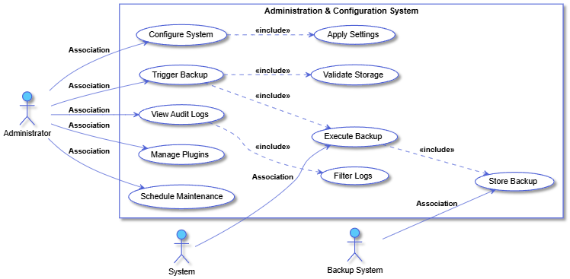

**Advanced Learning Activities**

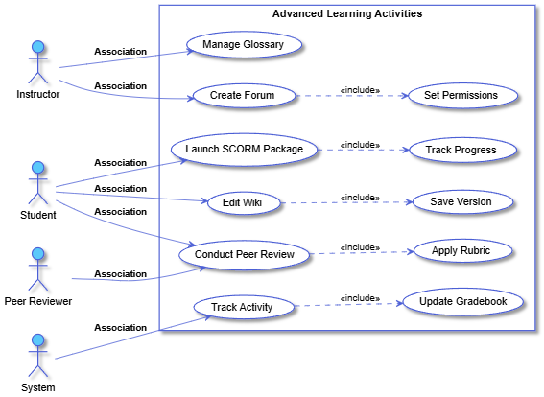

**Analytics & Reporting**

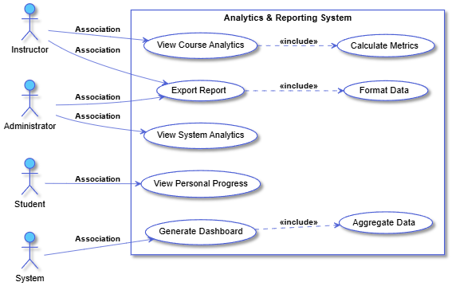

**API & Integration Layer**

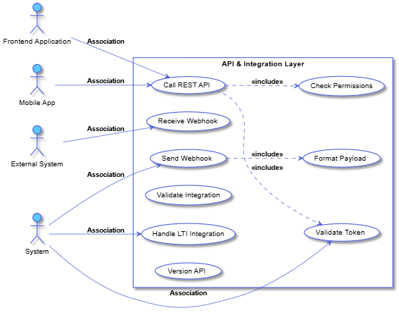

**Assessment & Grading**

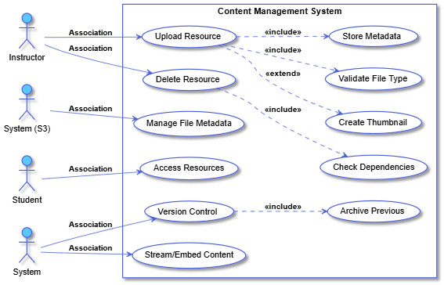

**Block & Widget Management**

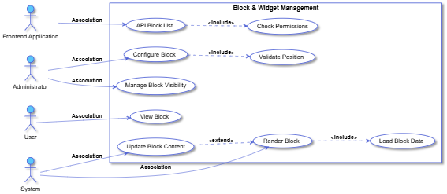

**Business Logic & Workflow Rules**

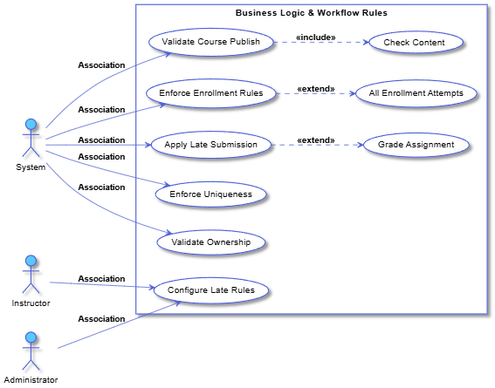

**Calendar & Scheduling**

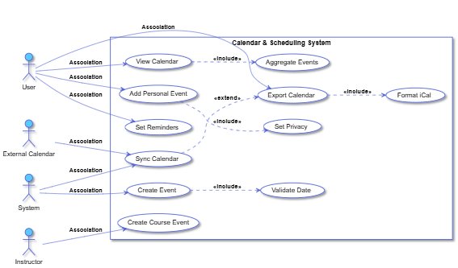

**Competency-Based Learning**

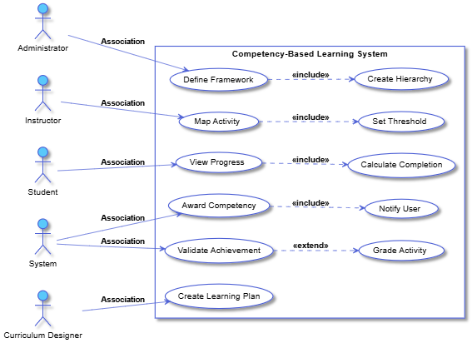

**Content Management**



**Context & Hierarchy Management**

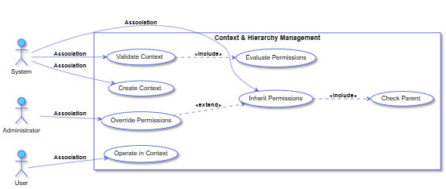

**Course Management**

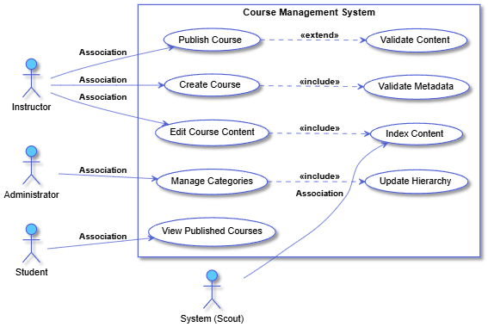

**Data Privacy & Policy Management**

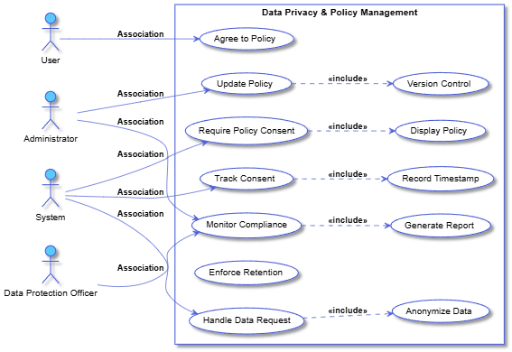

**Enrollment & Access Control**

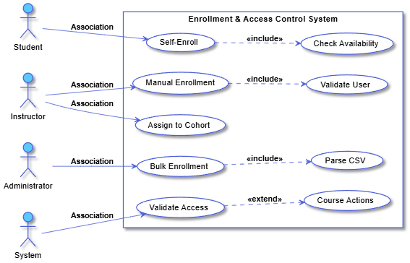

**File Repositories & Storage**

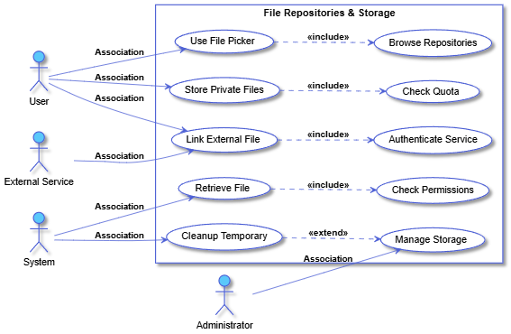

**Frontend Interactions**

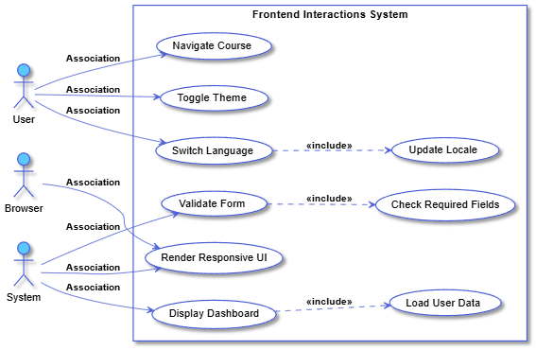

**FutureTBD Integration Hooks**

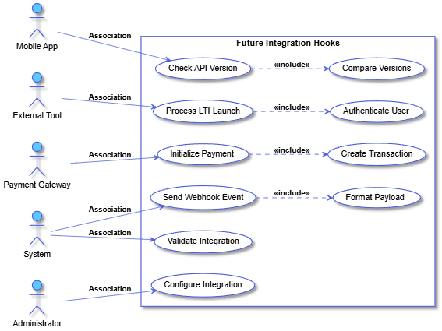

**Gamification & Badges**

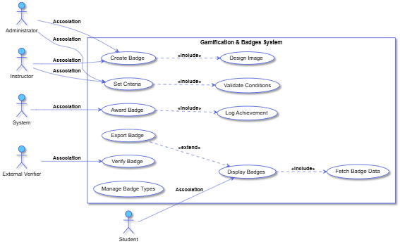**Localization & Accessibility**

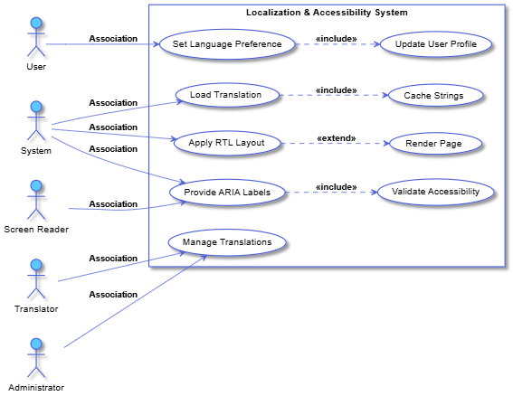

**Notifications & Communication**

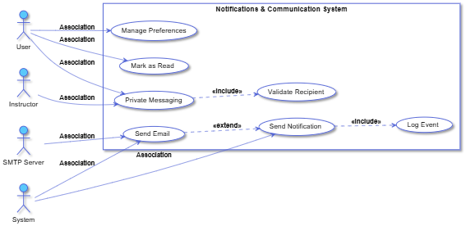

**Search & Discovery**

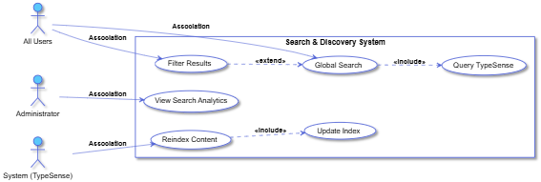

**Security & Compliance Functions**

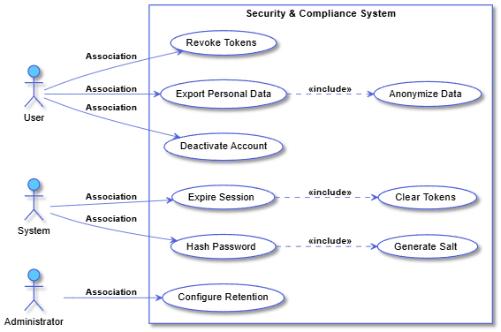

**System Health & Task Scheduling**

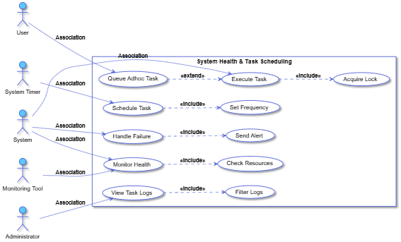

**System Logging & Auditing**

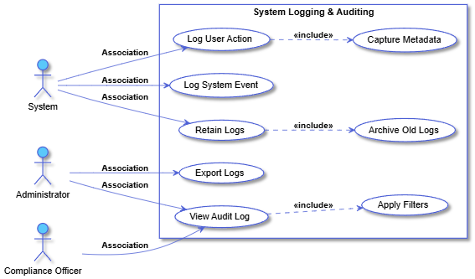

**User Management**

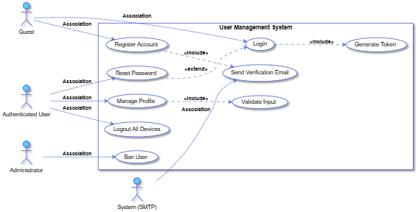

**Activetys :**

**Admin - System Backup**

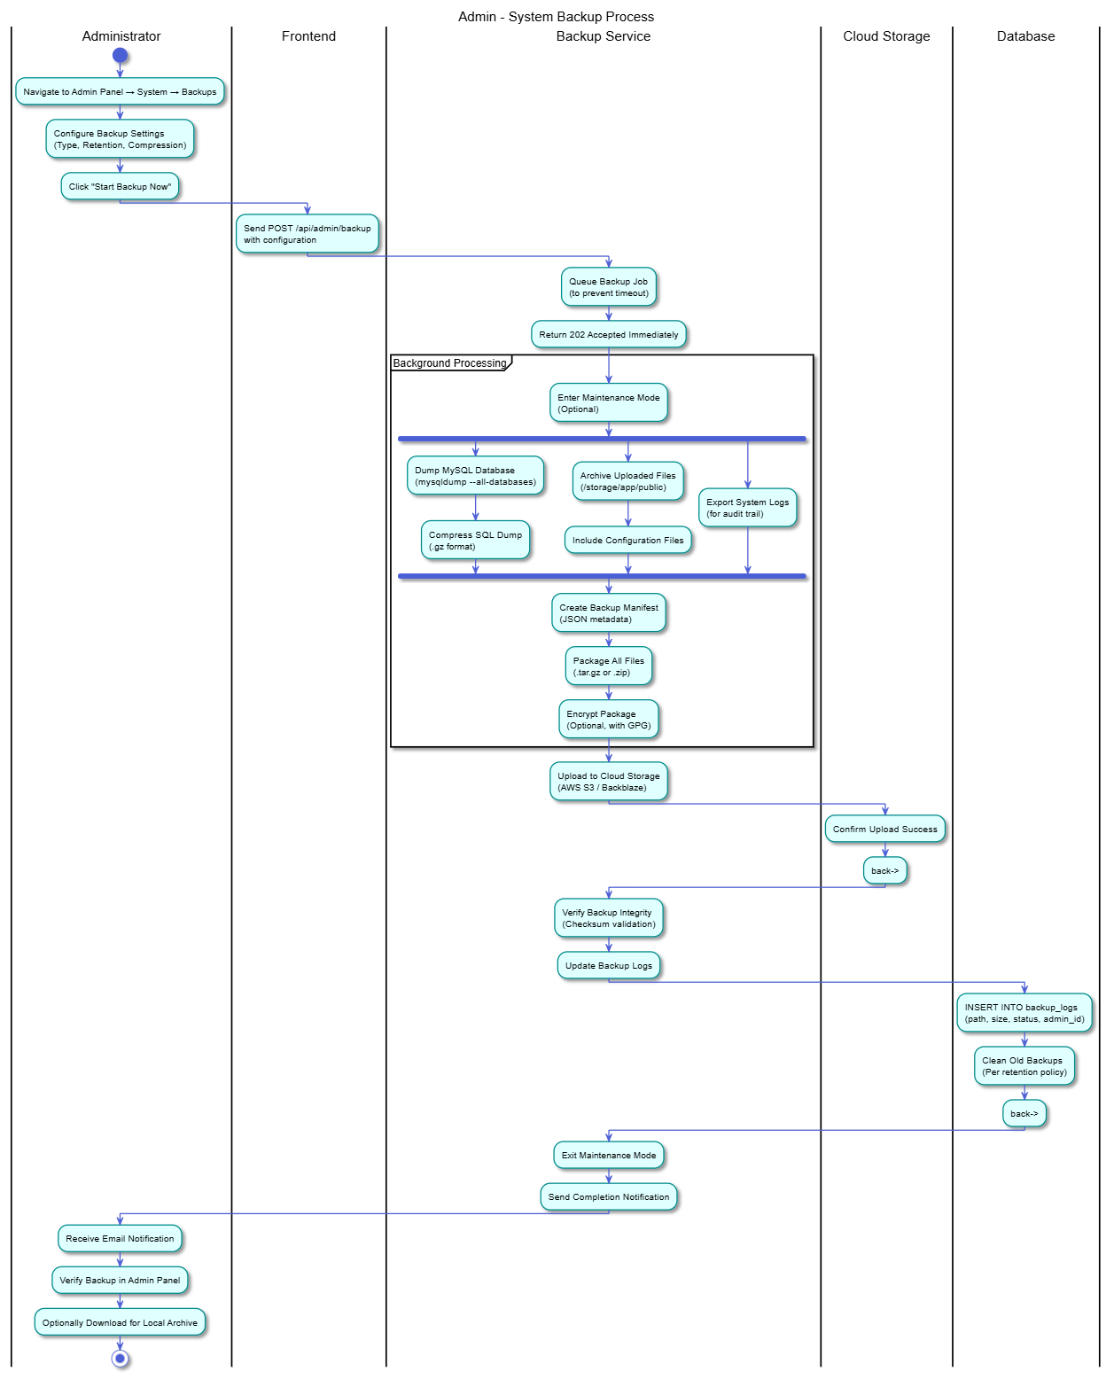

**Analytics & Report Generation**

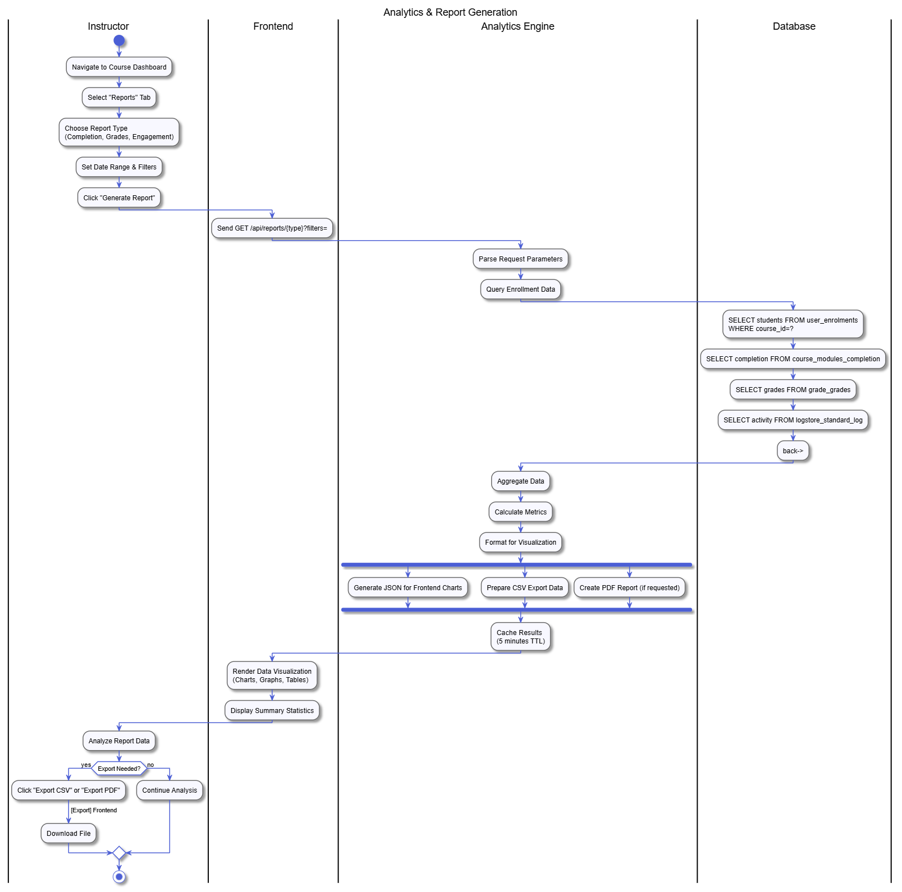**Assignment Submission & Grading Loop**

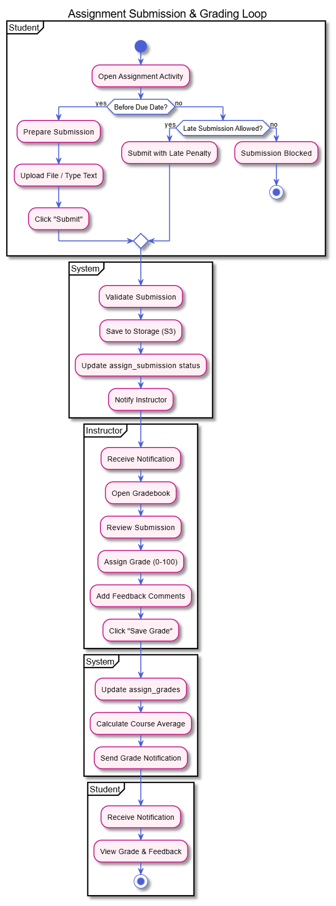

**Calendar Event Generation**

**External File Repository Linking**

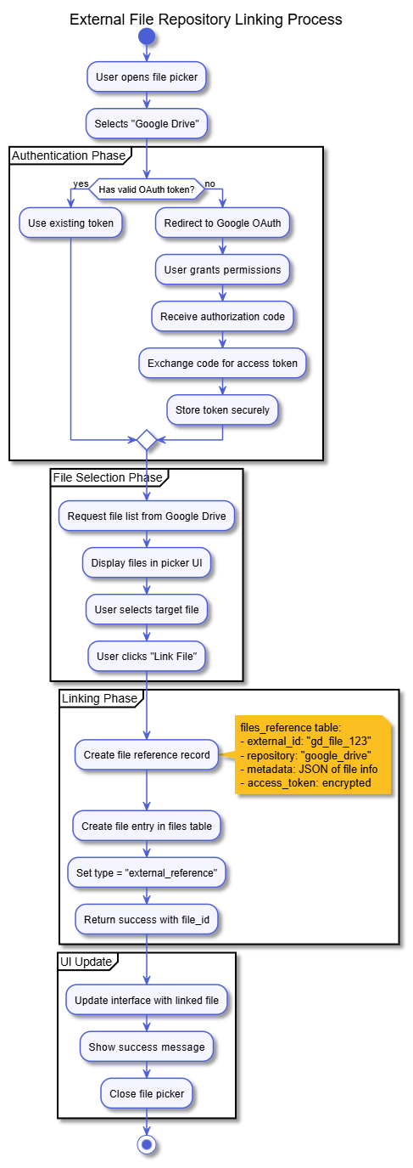

**Competency Rule Evaluation**

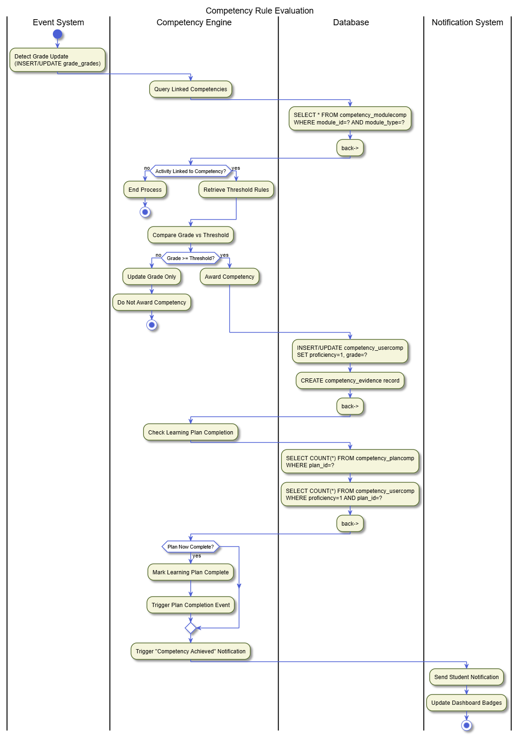

**CourseCreationPublishing**

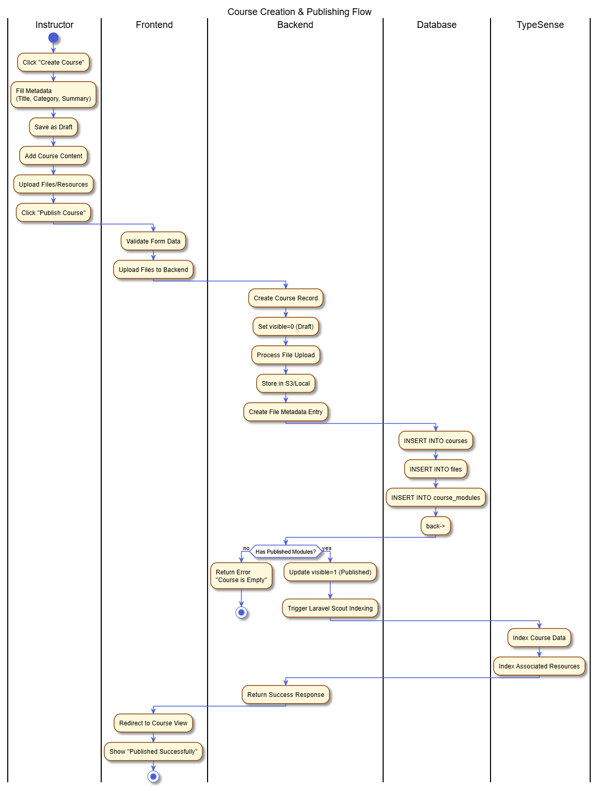

**Forum Discussion Participation**

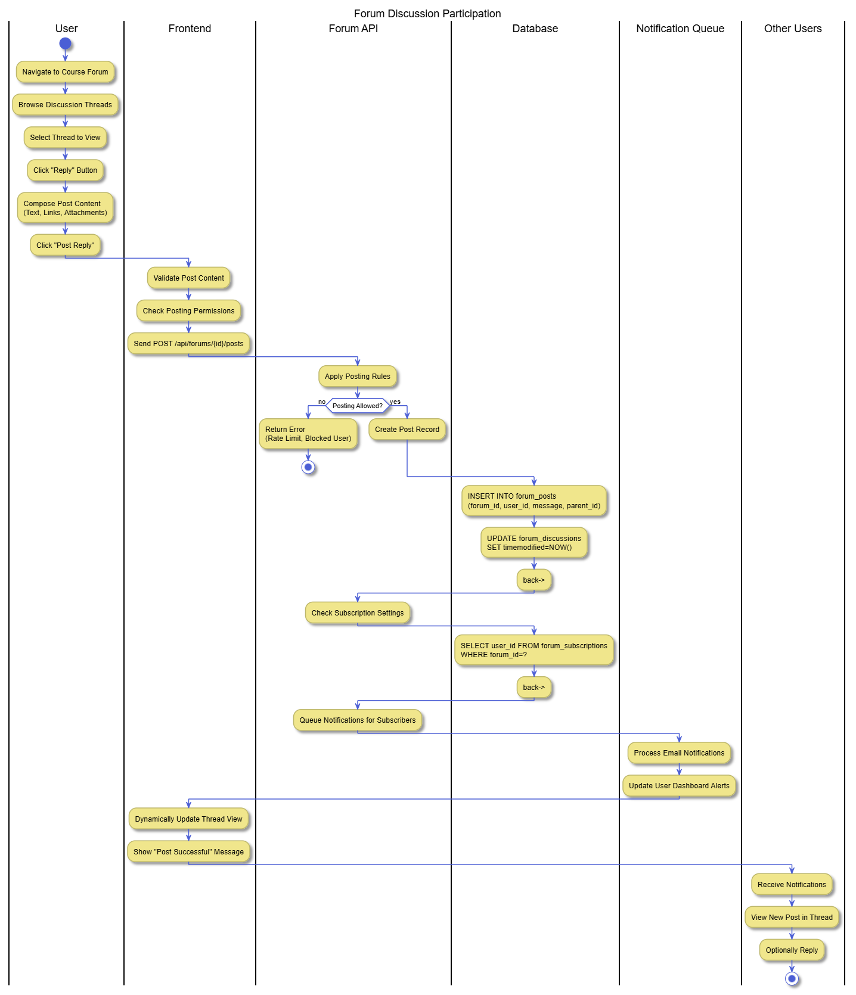

**Gamification - Badge Issuance**

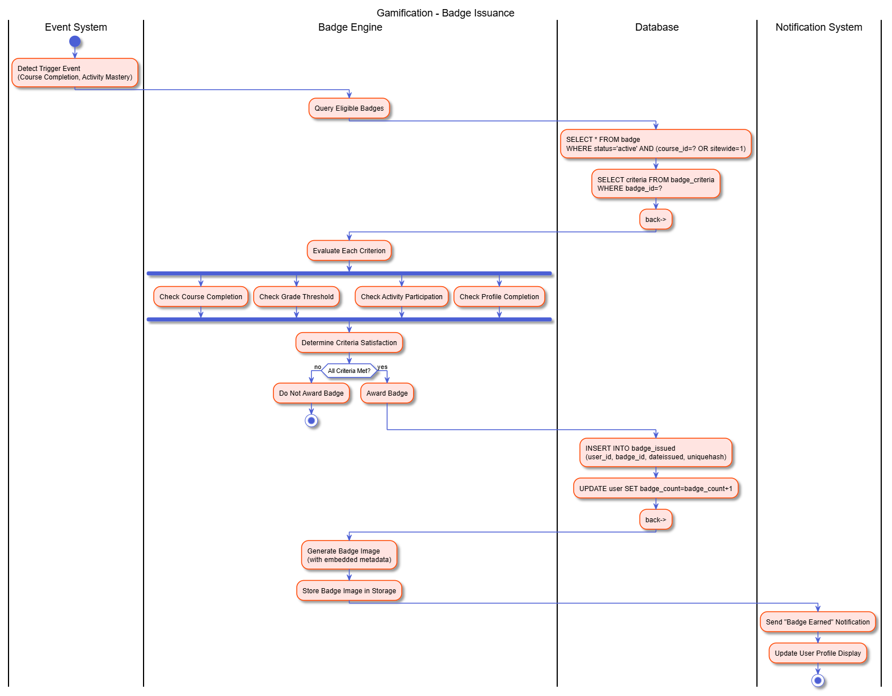

**H5P Interactive Content Tracking**

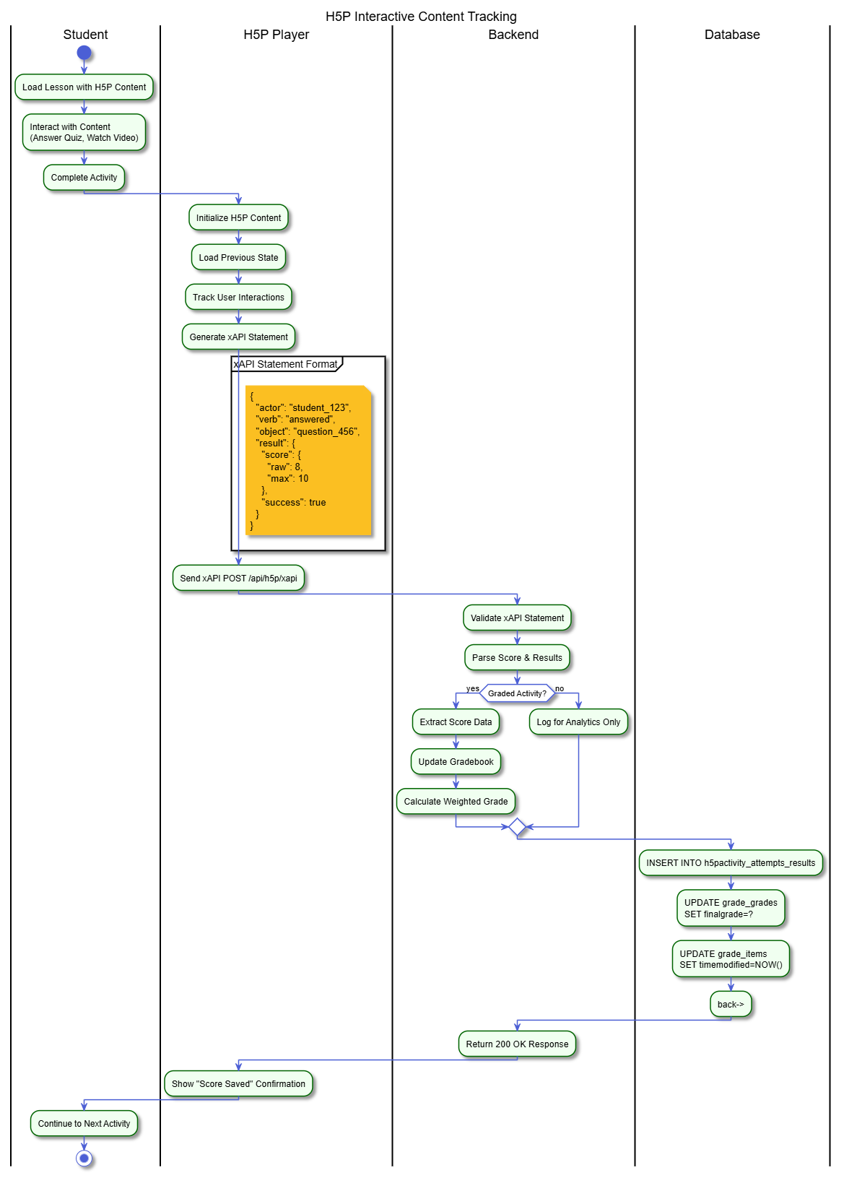**Mandatory Policy Consent**

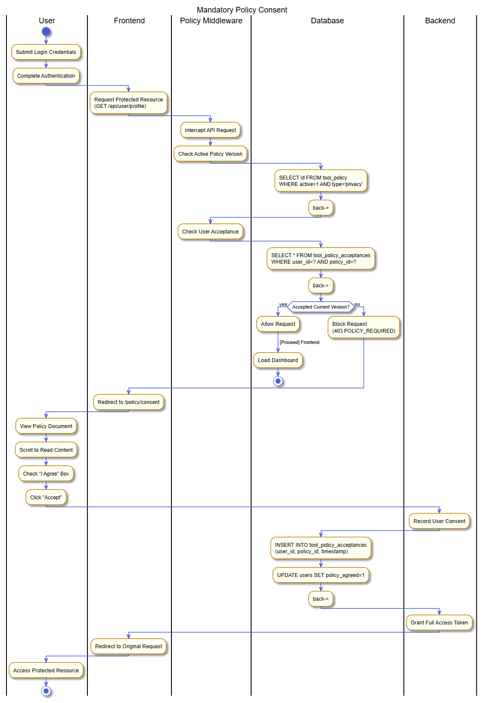**Private Messaging & Notifications**

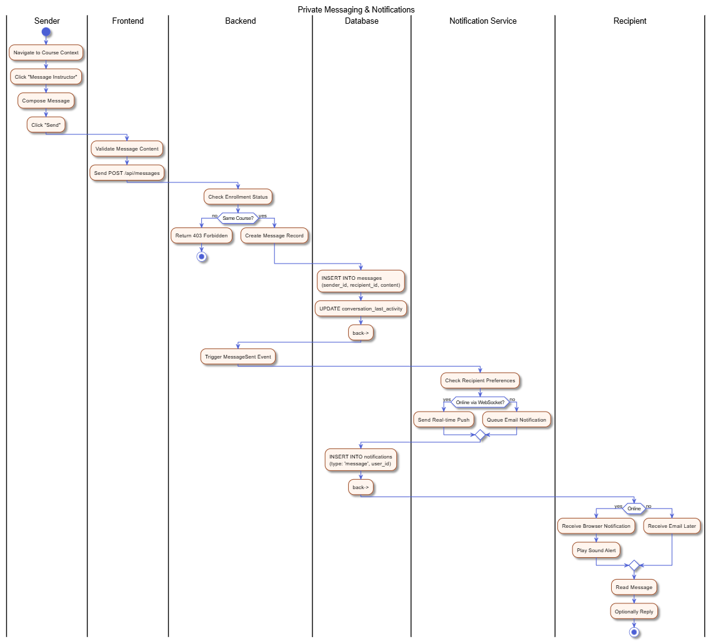

**SCORM Package Interaction**

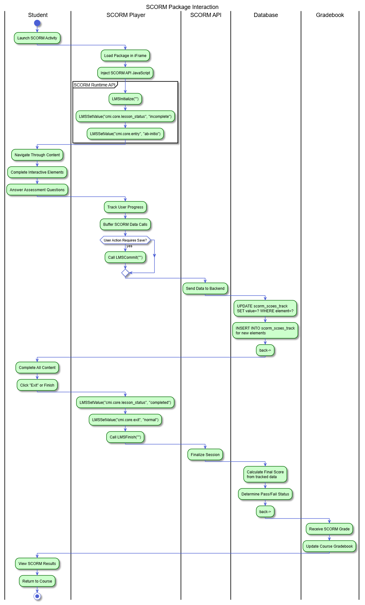**Scheduled System Maintenance**

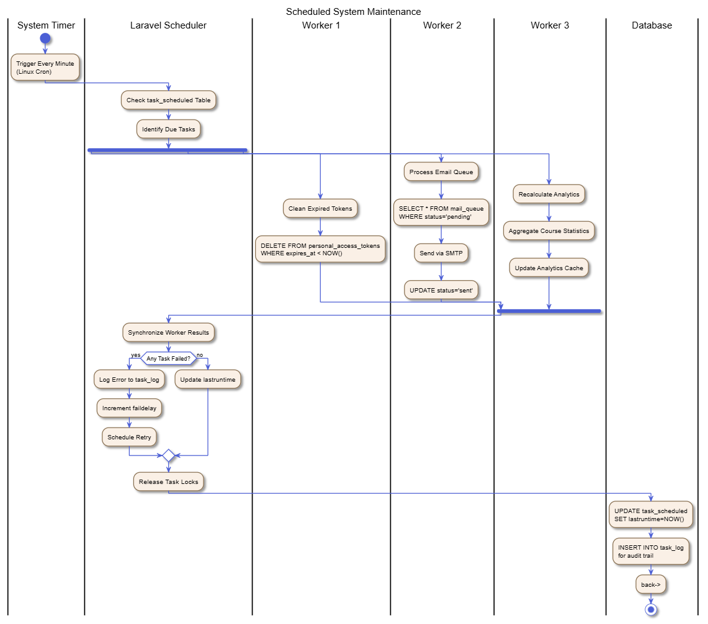

**Search & Discovery**

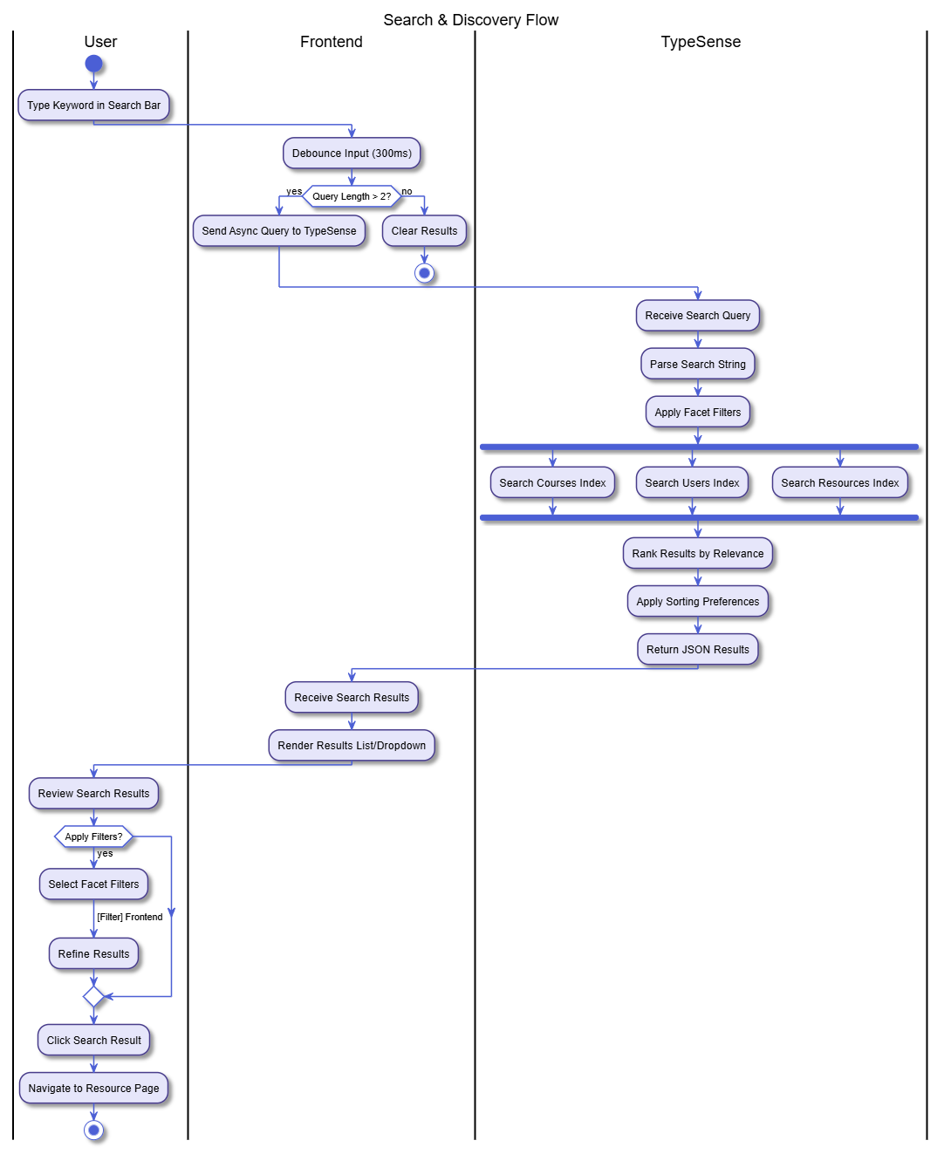

**StudentEnrollmentProcess**

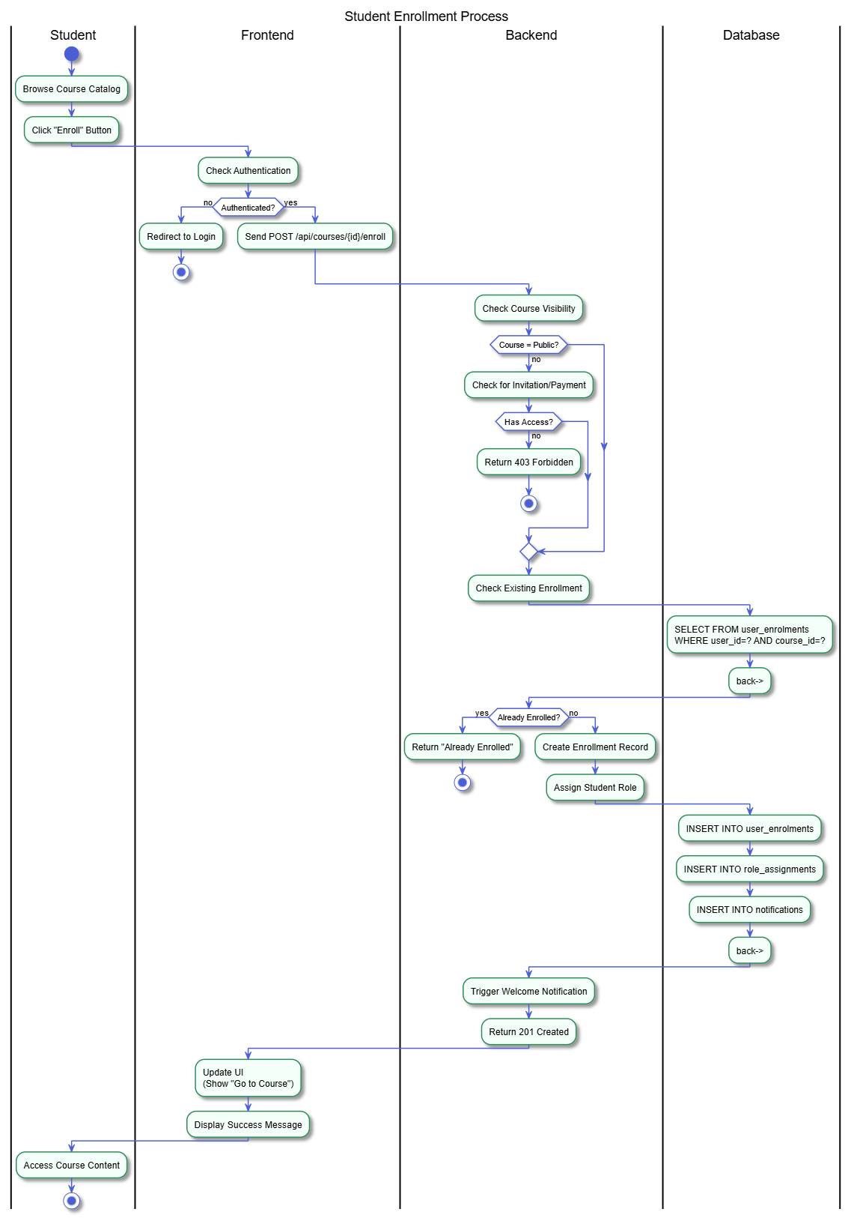

**UserAuthenticationFlow**

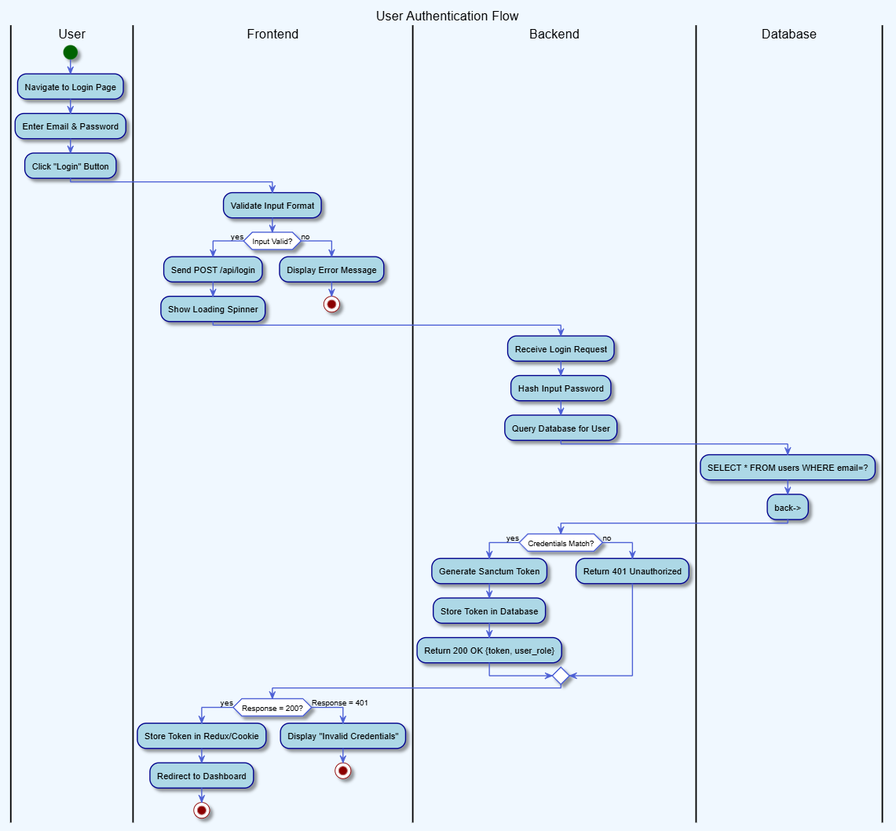

**Workshop Peer Assessment Flow**

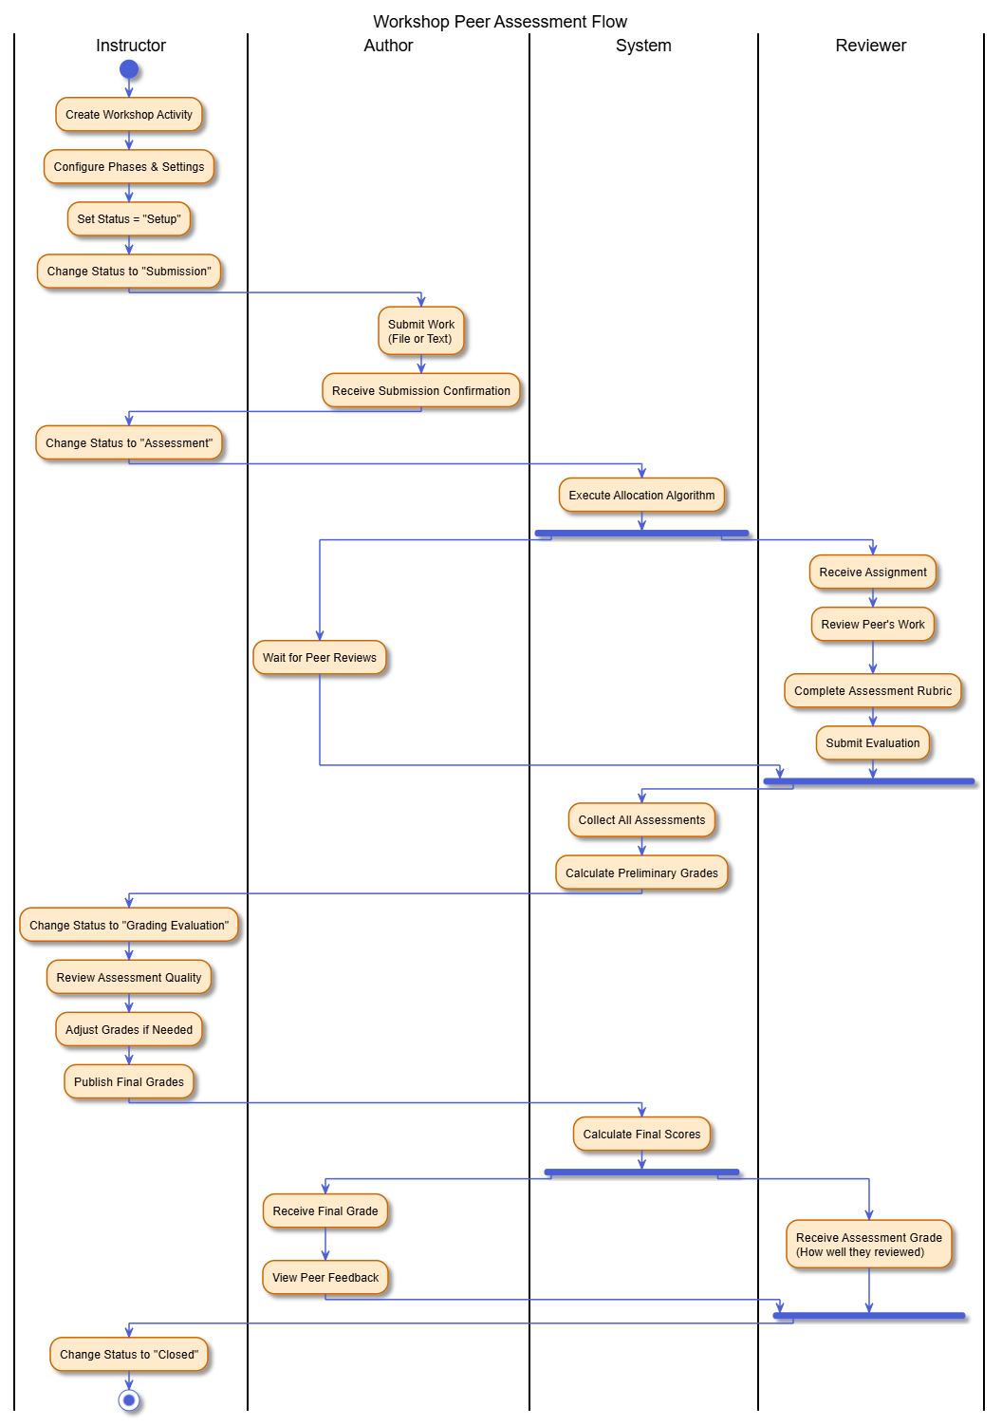

**sequenceDiagram :  
AdminAuditLogReview**

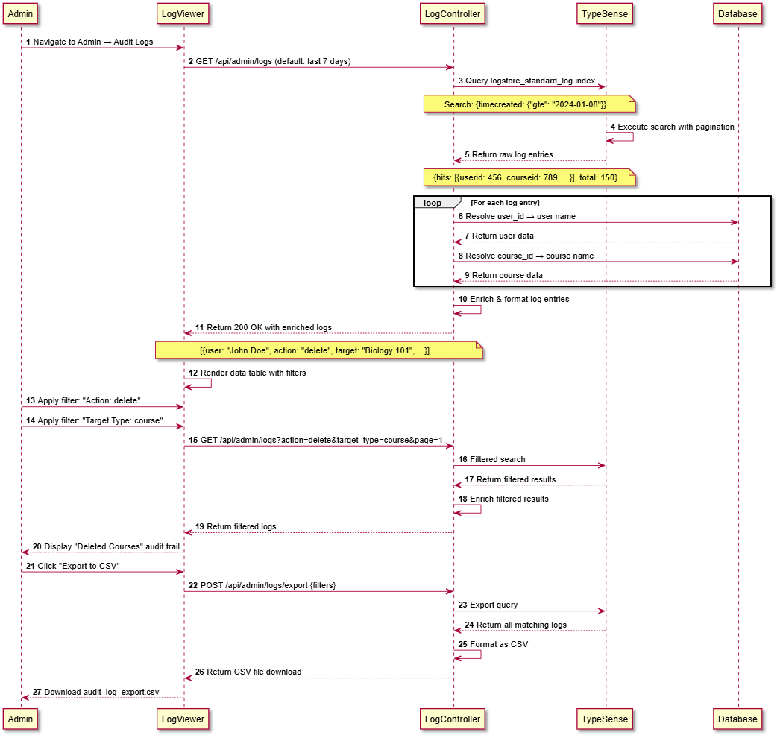**AdminUserBan**

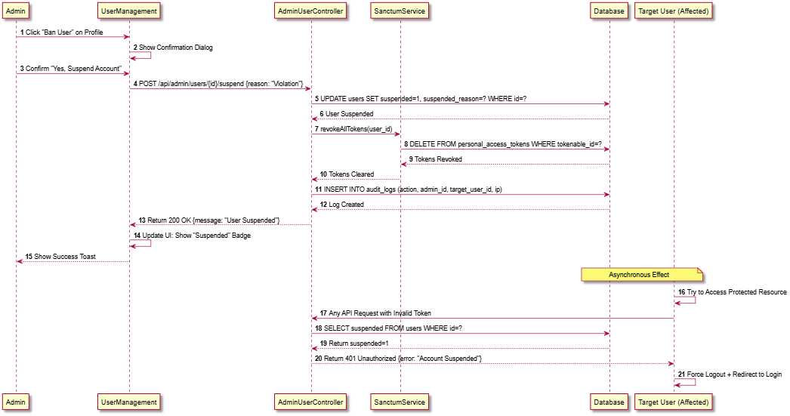

**AssignmentSubmission(FileUpload)**

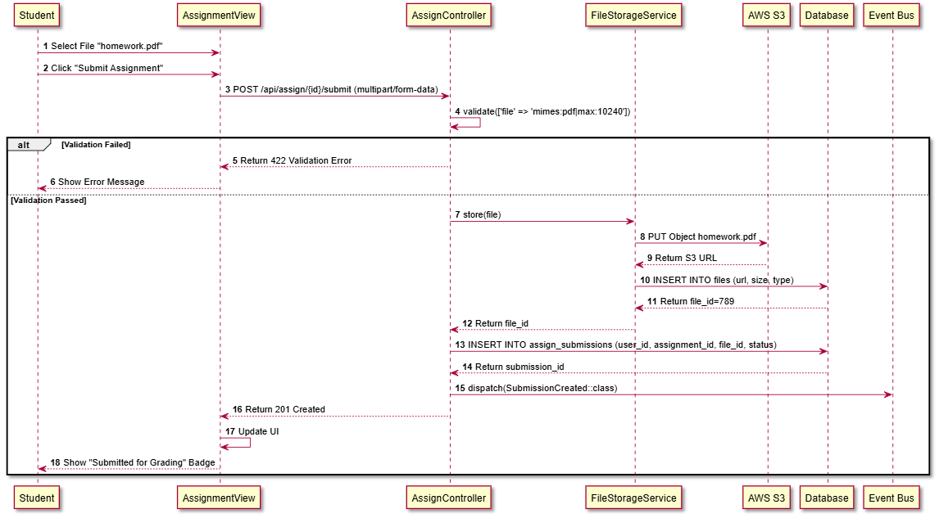

**CalendarEventRetrieval**

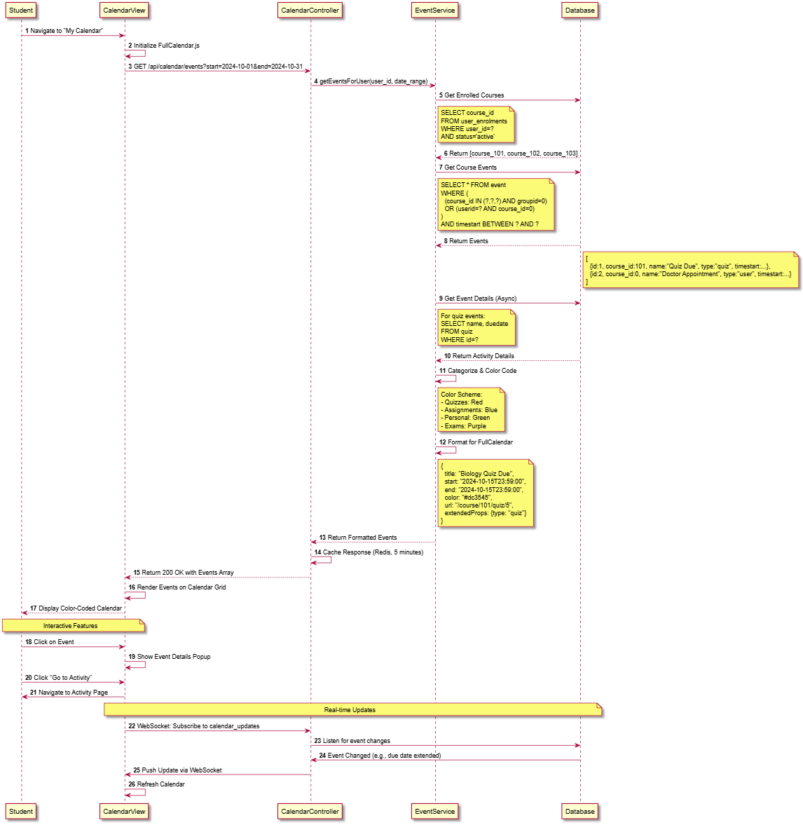

**CompetencyAwarding**

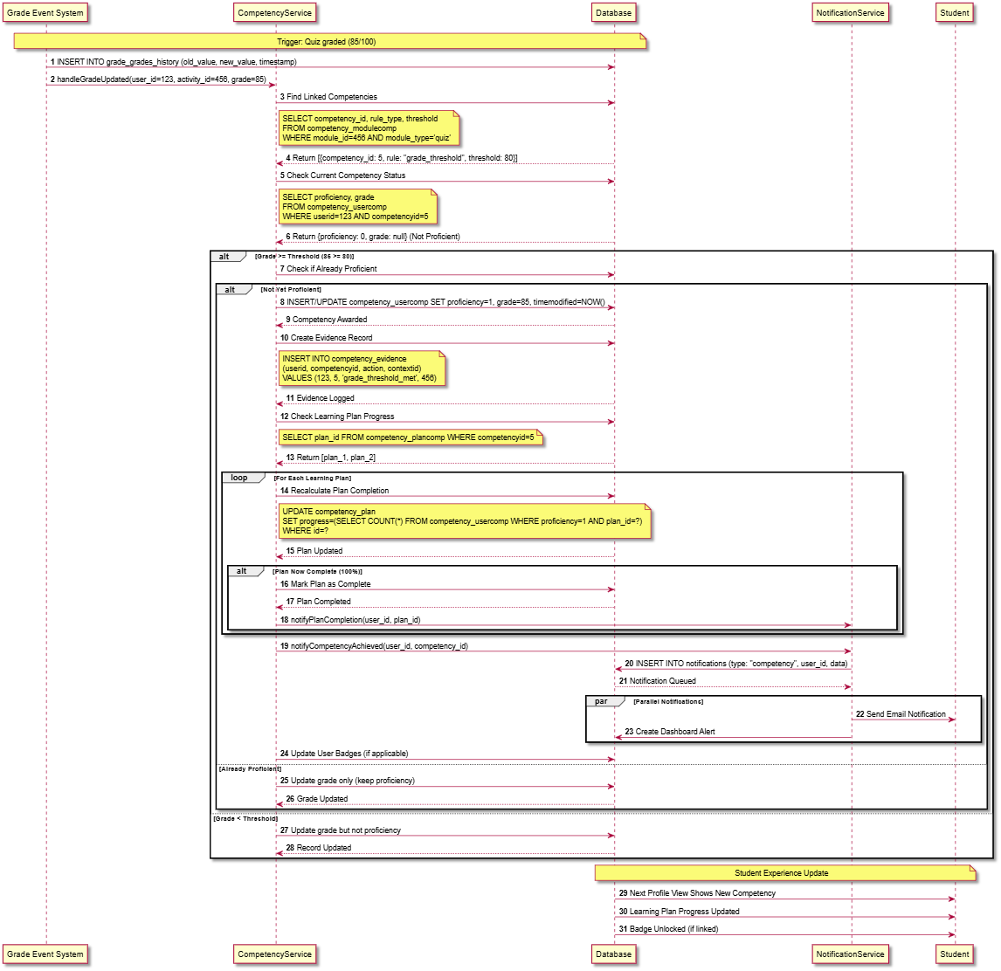

**CourseCompletion(Automated)**

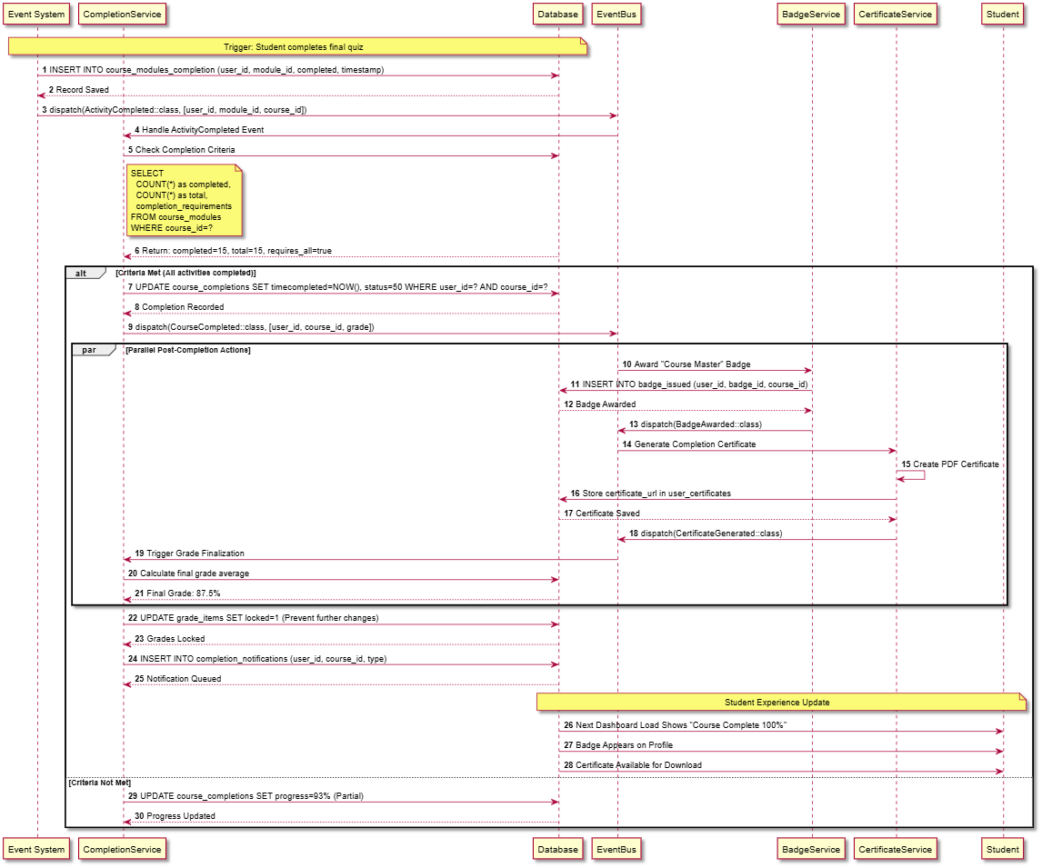**CourseEnrollment(Self-Enrollment)**

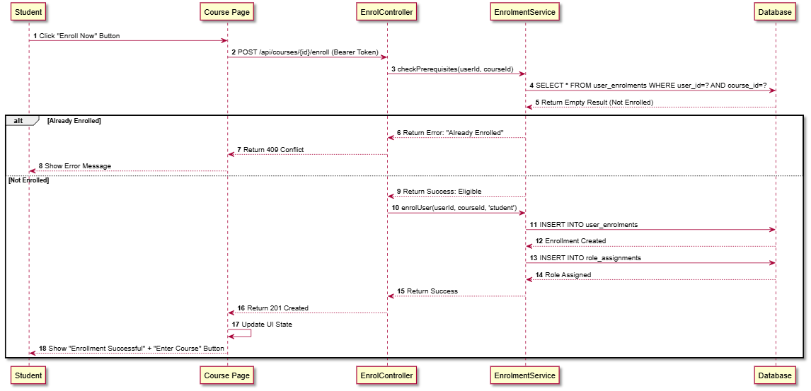

**ForumPosting**

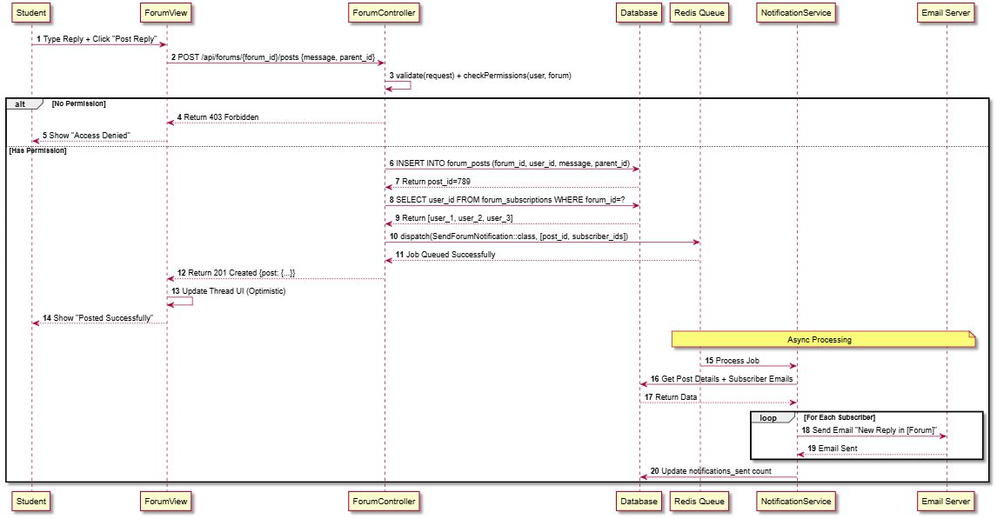

**GlobalSearch(TypeSenseIntegration)**

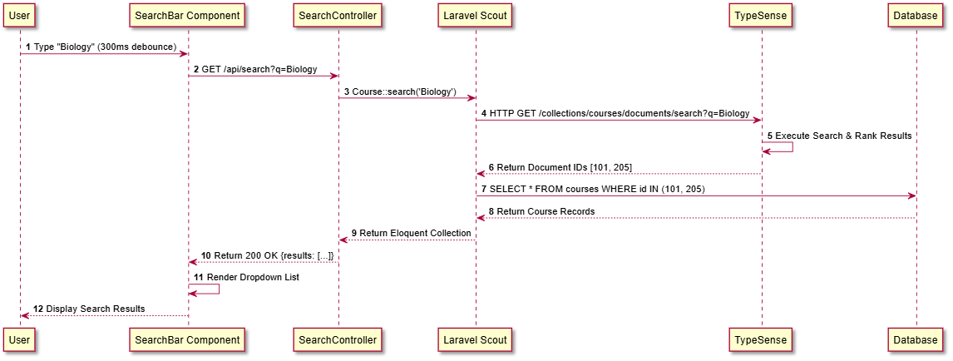

**GradingAnAssignment**

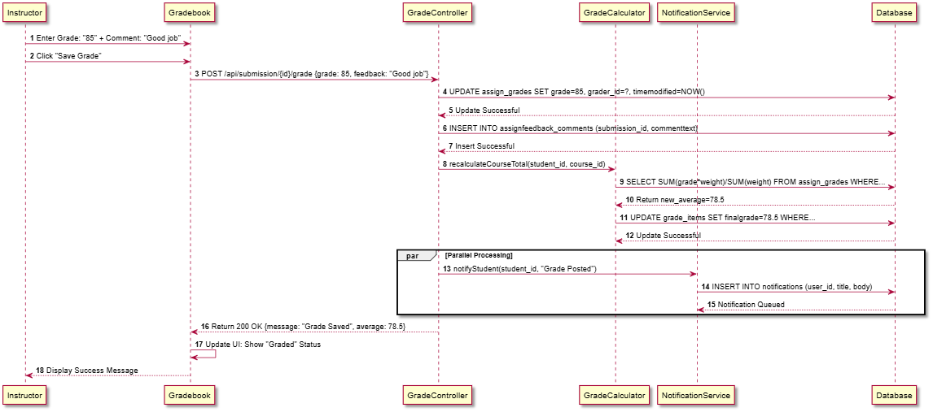**H5PInteraction(xAPI)**

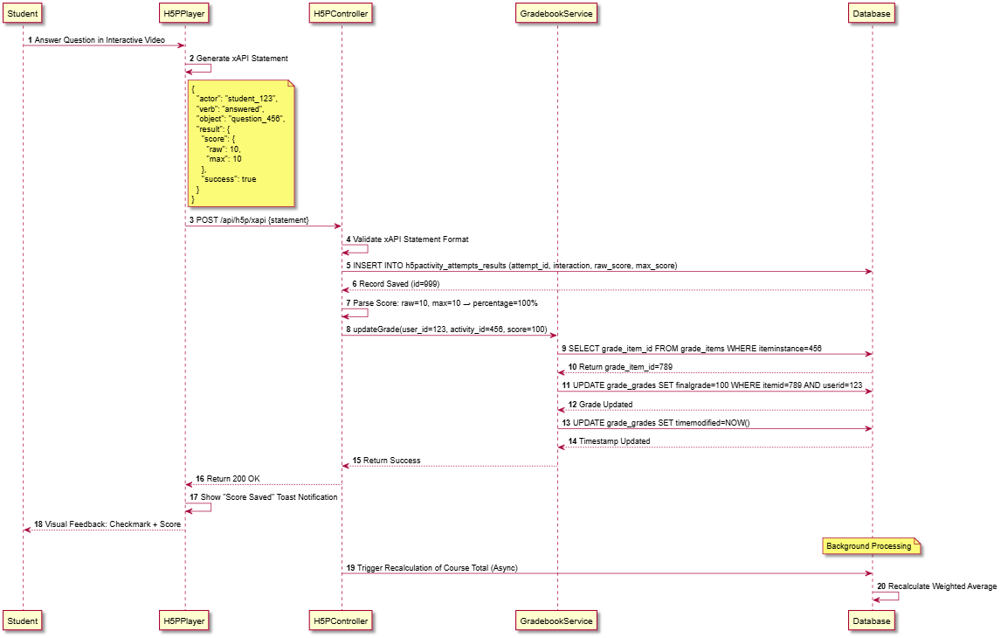**LinkingExternalFiles**

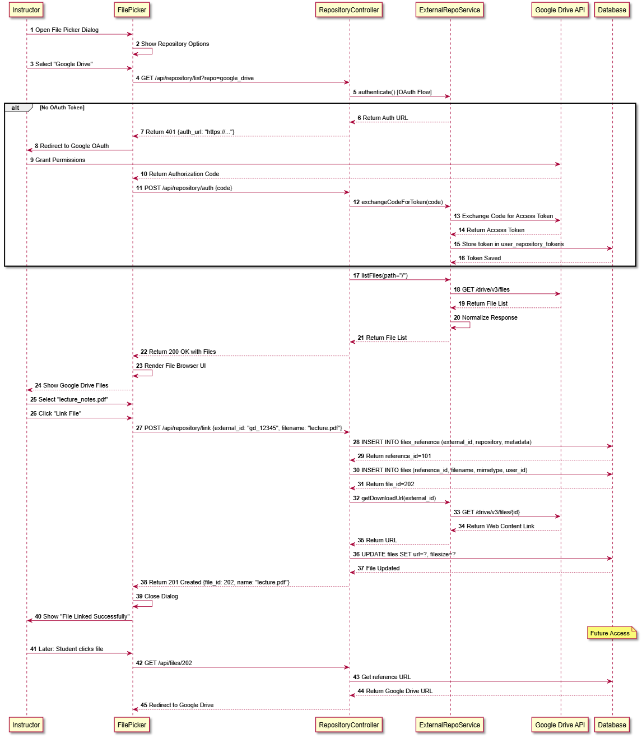

**PolicyConsent**

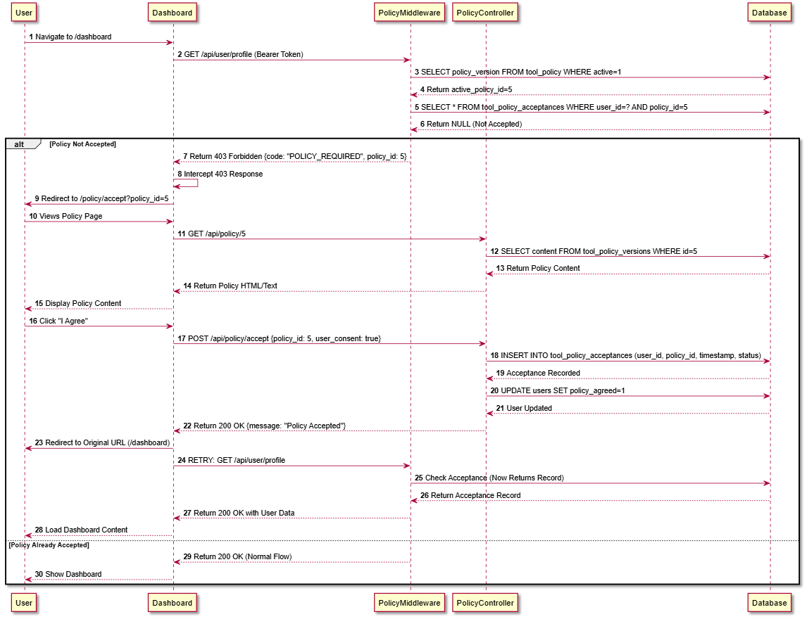

**RealTimeChat(SendingMessage)**

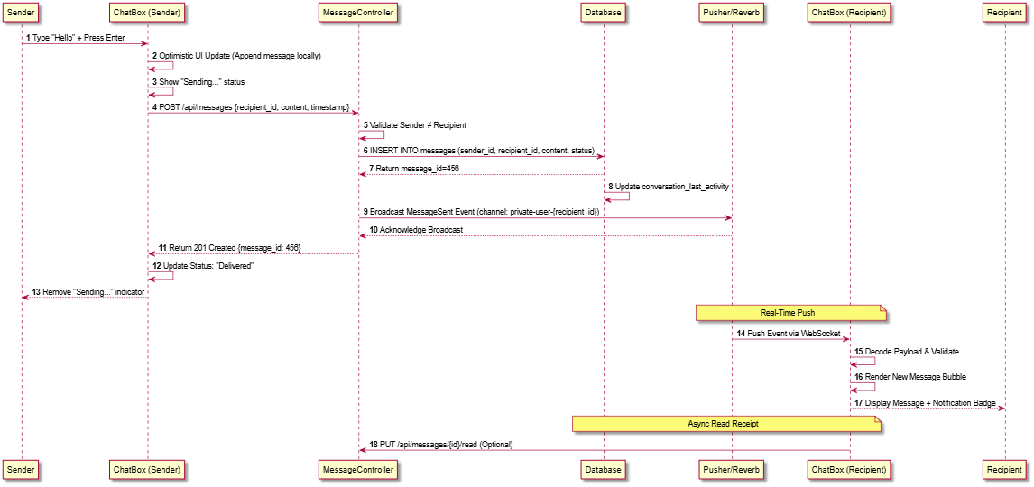

**SCORMPlayerInteraction**

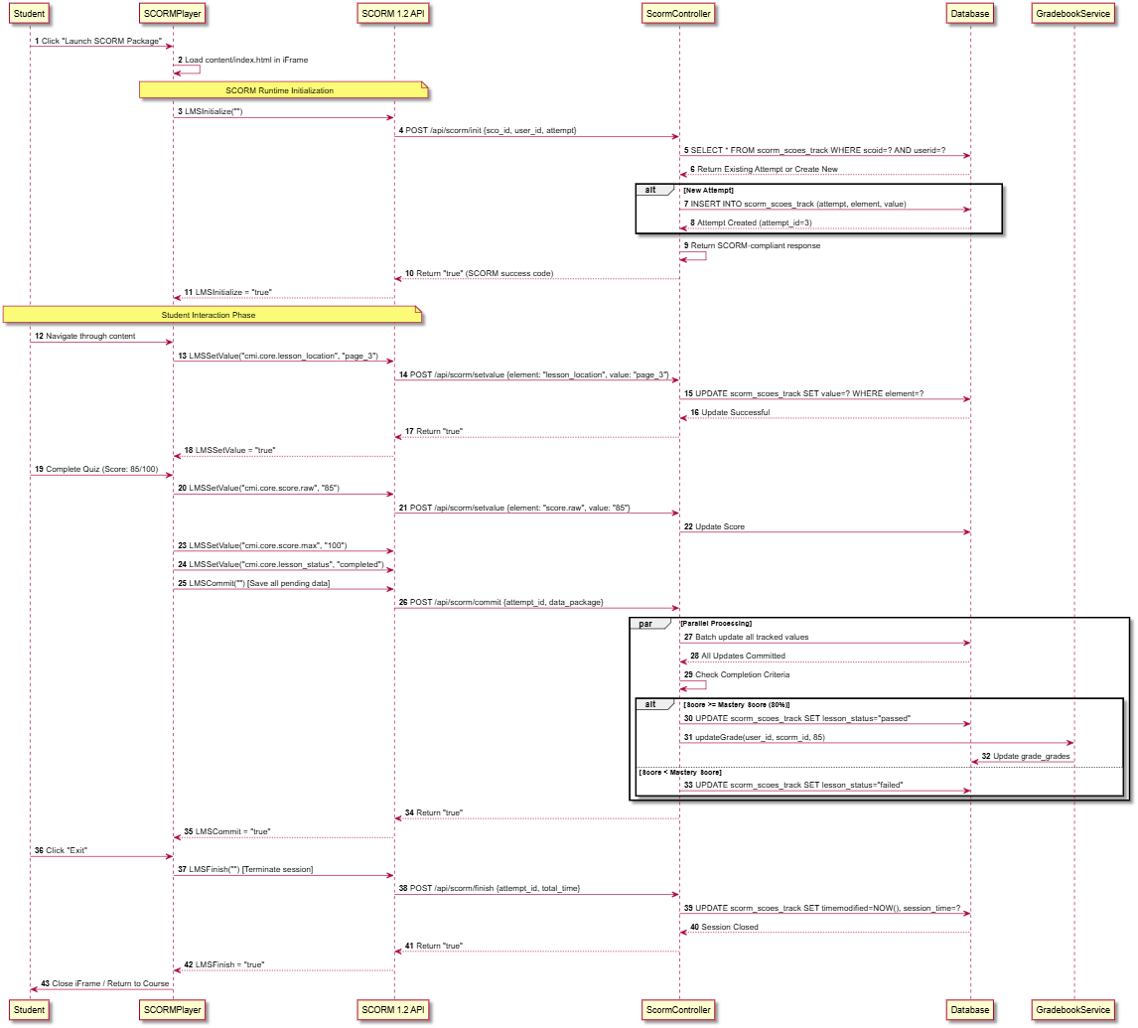**SystemBackup(Admin)**

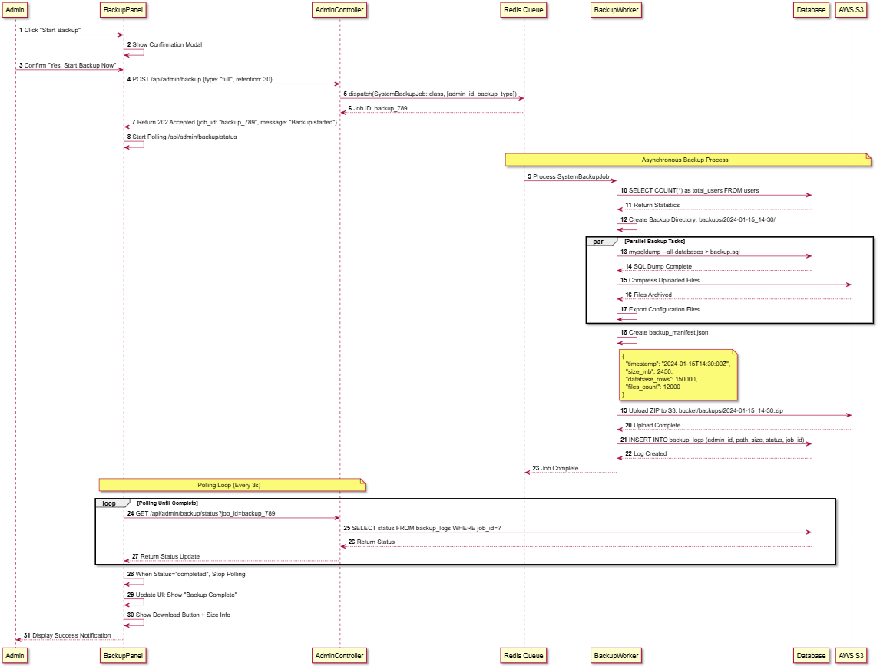**UserAuthentication(Login)**

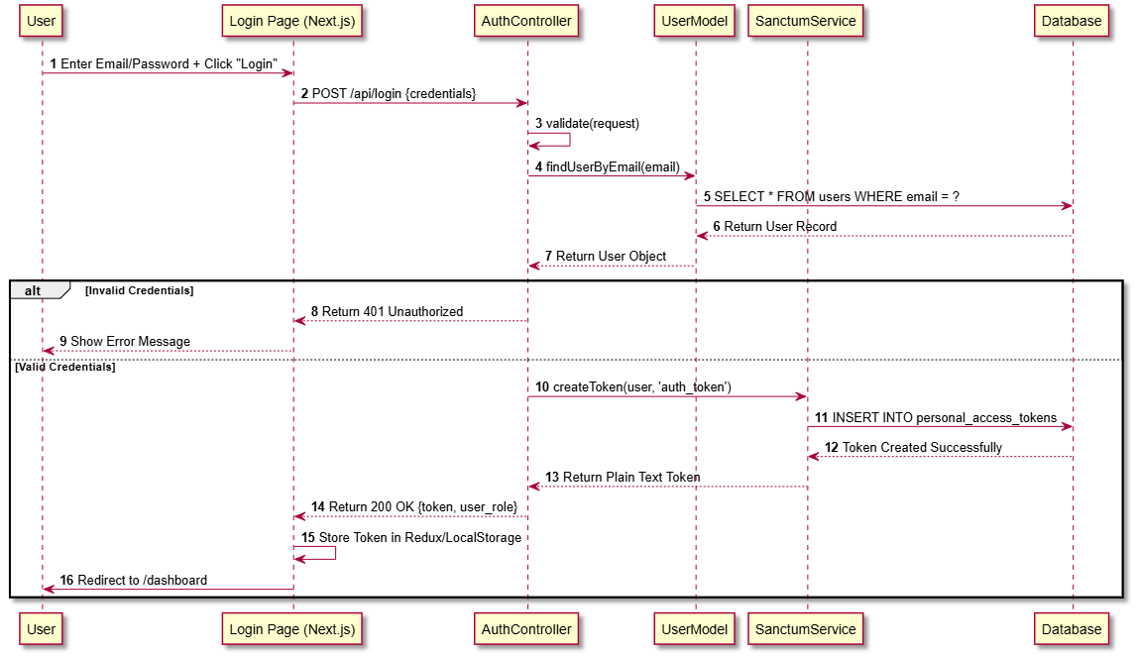

**WorkshopPeerAssessment**

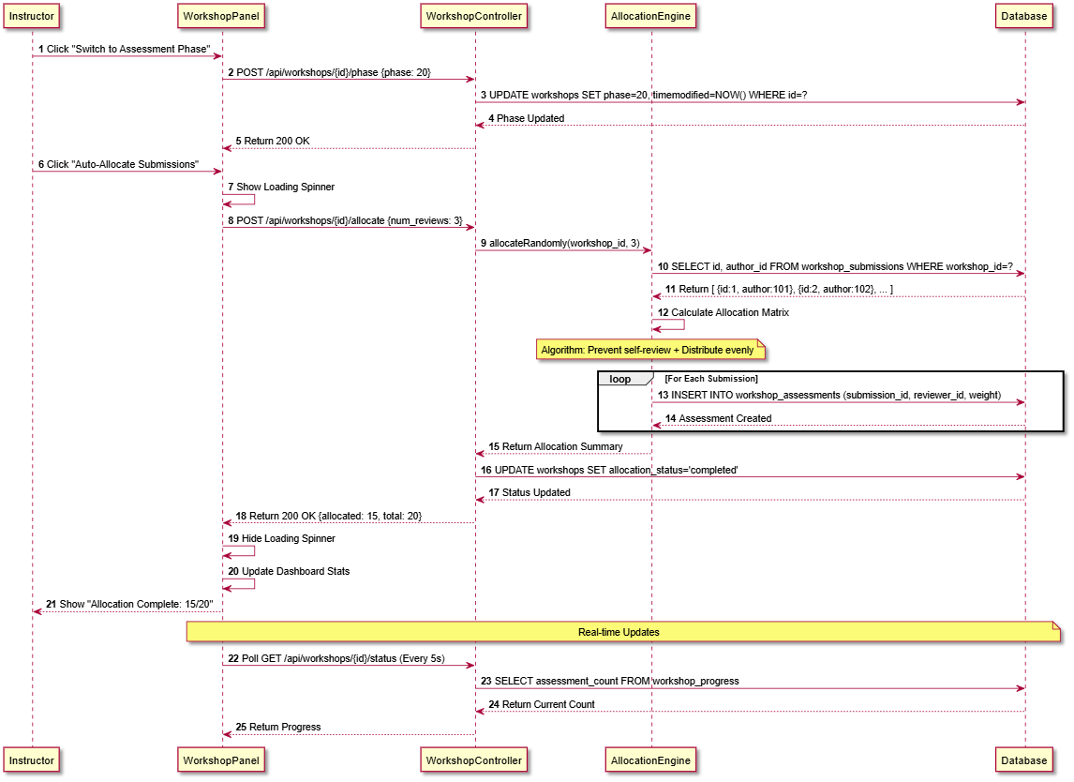

**classDiagram**

**daris_class_analytics**

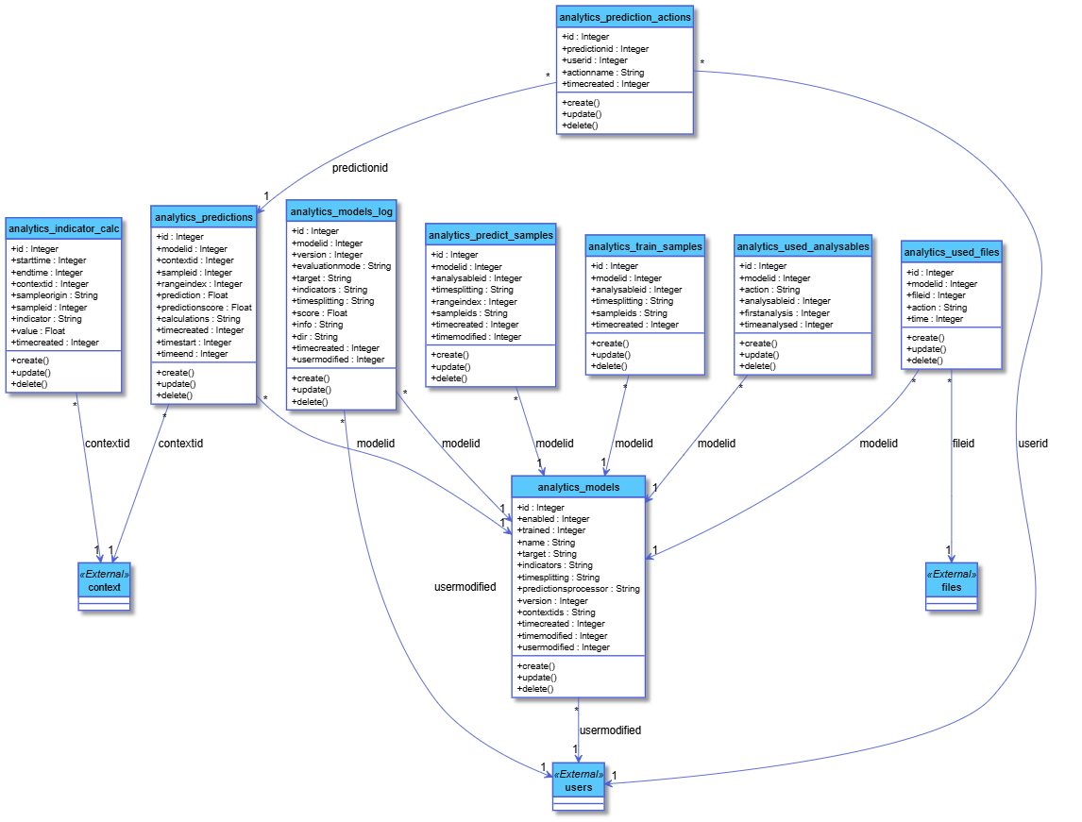

**daris_class_assignment**

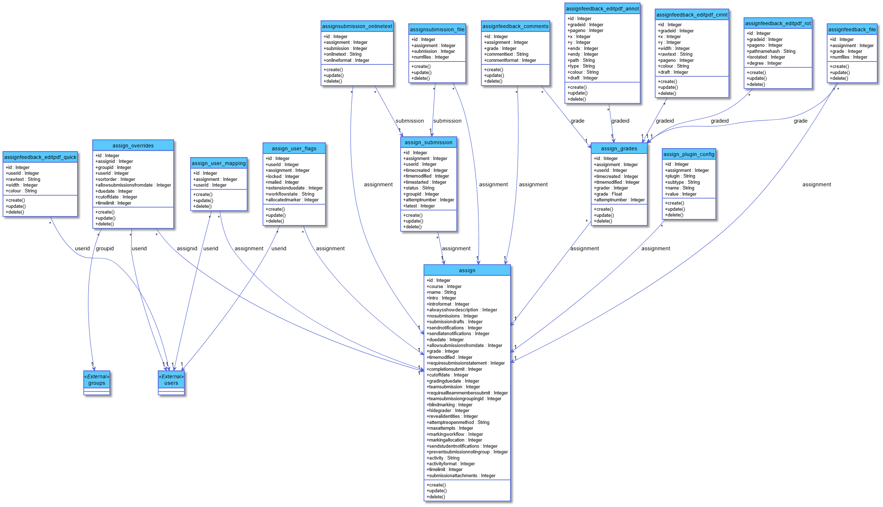

**daris_class_auth**

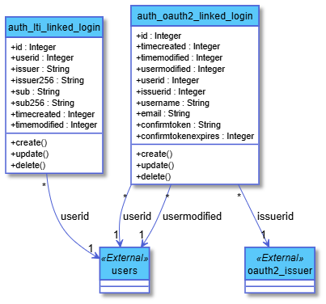

**daris_class_backup**

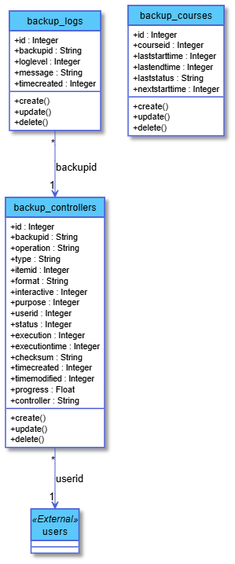

**daris_class_badge**

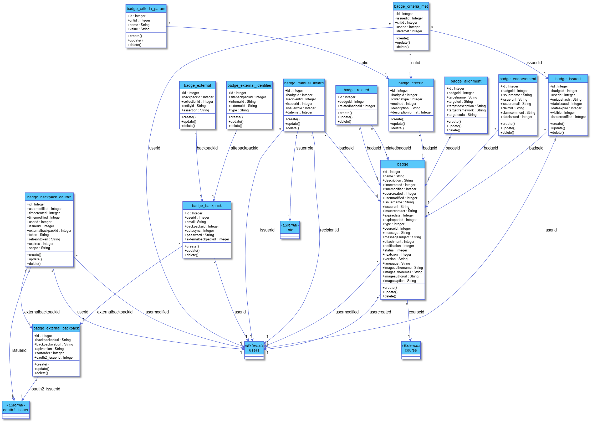

**daris_class_block**

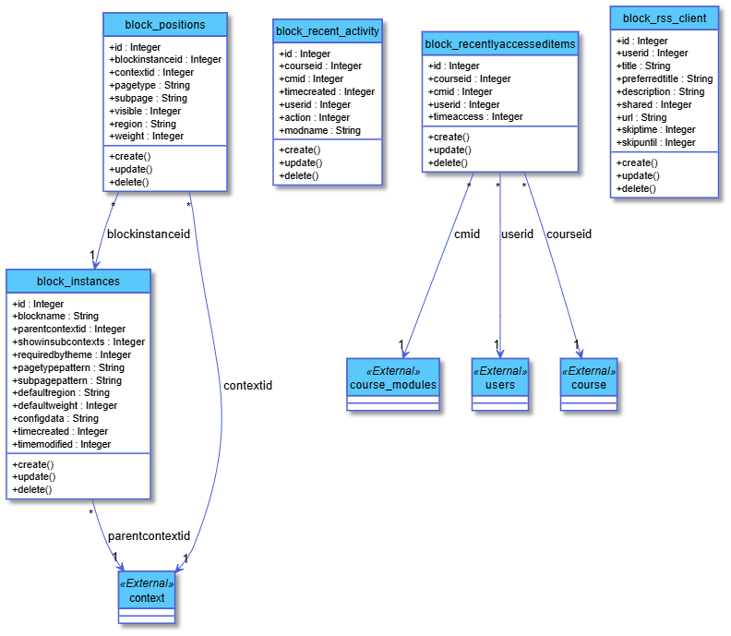**daris_class_book**

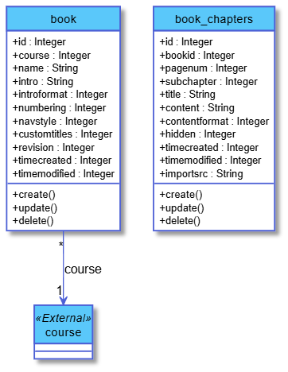

**daris_class_cache**

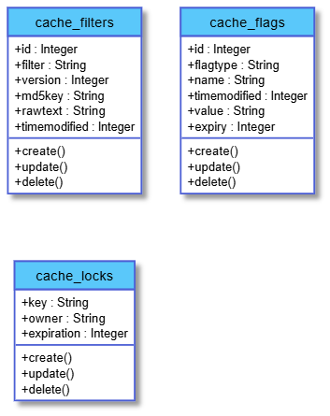

**daris_class_chat**

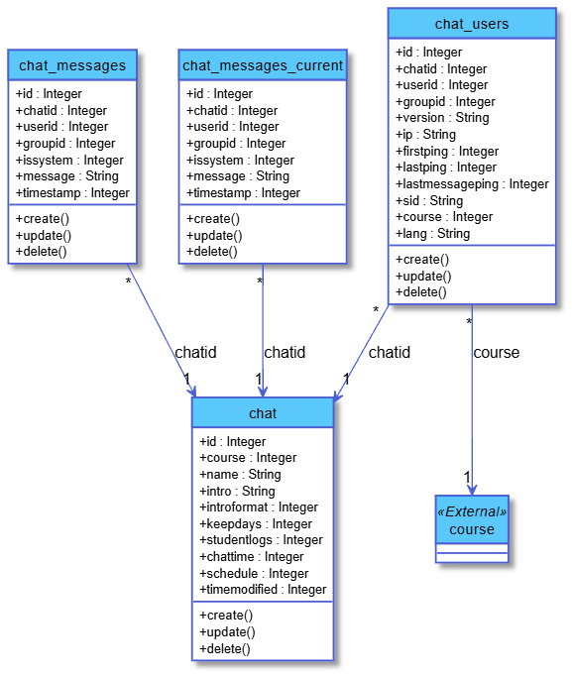**daris_class_choice**

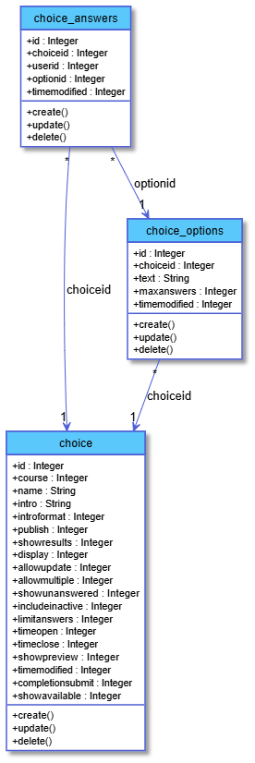

**daris_class_competency**

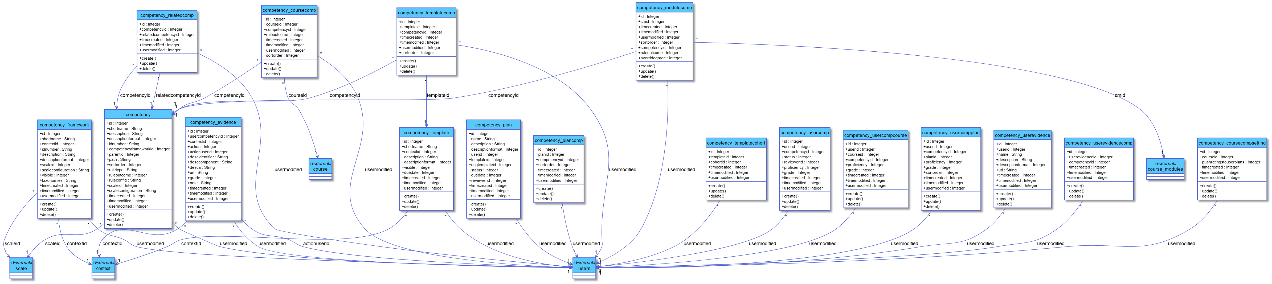

**daris_class_core**

**daris_class_enrolment**

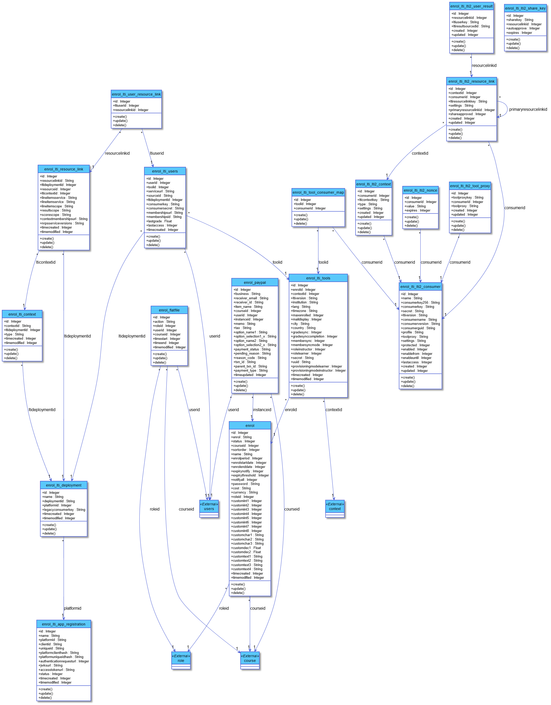

**daris_class_events**

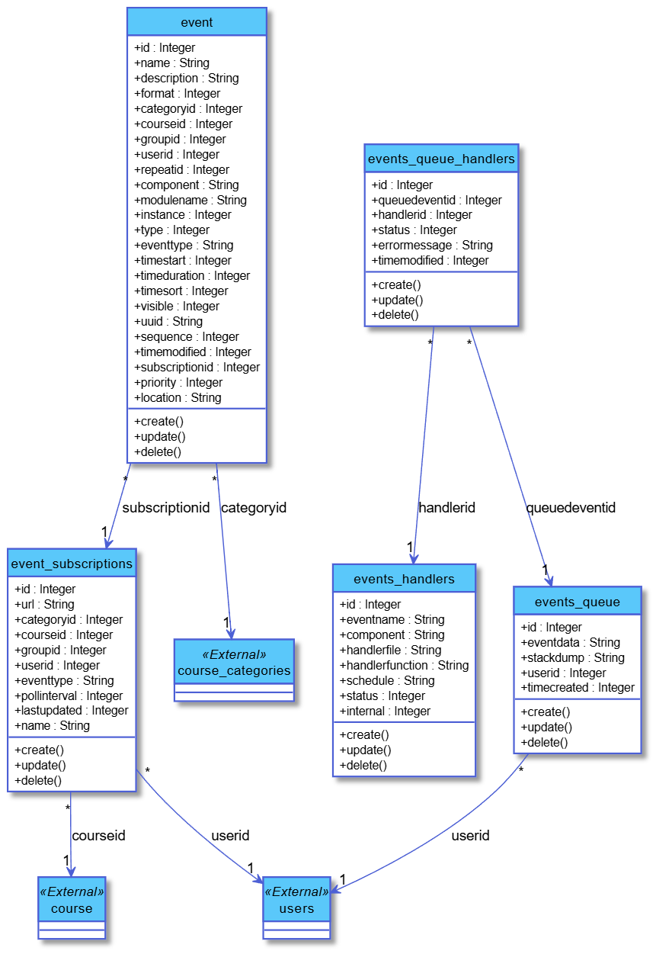

**daris_class_feedback**

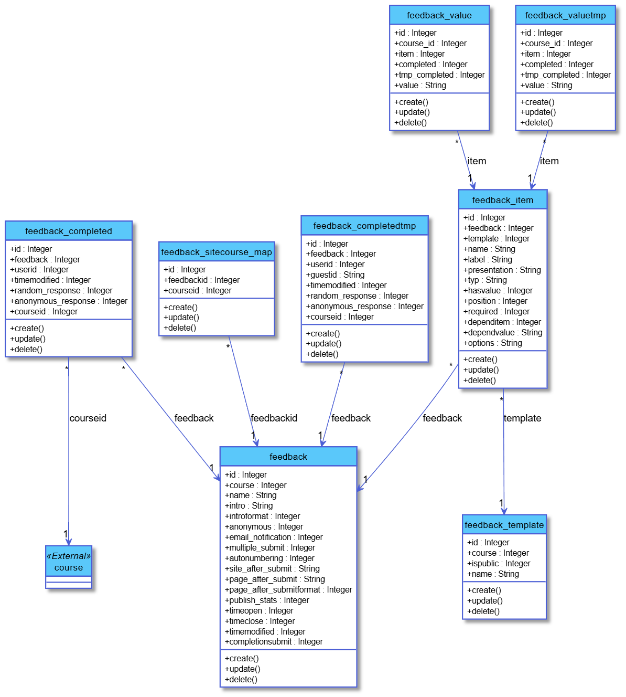

**daris_class_files**

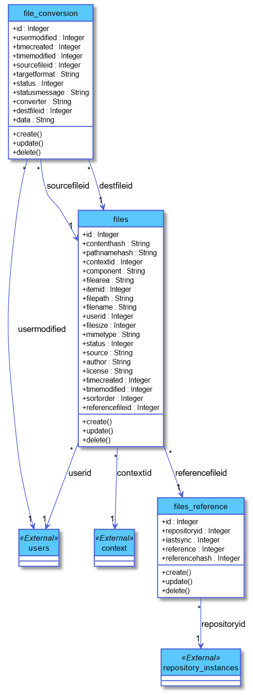

**daris_class_forum**

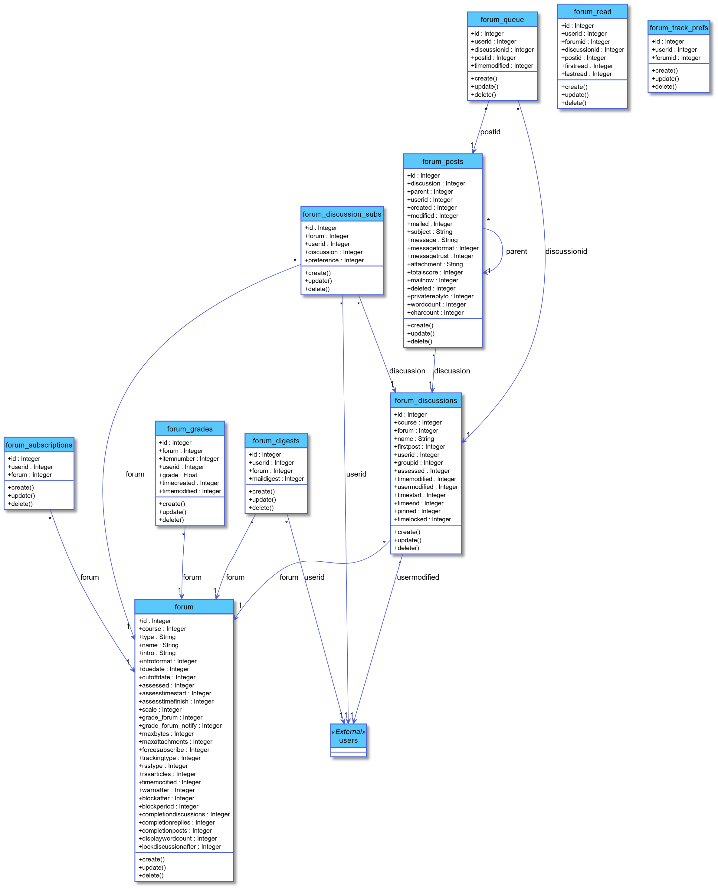**daris_class_glossary**

**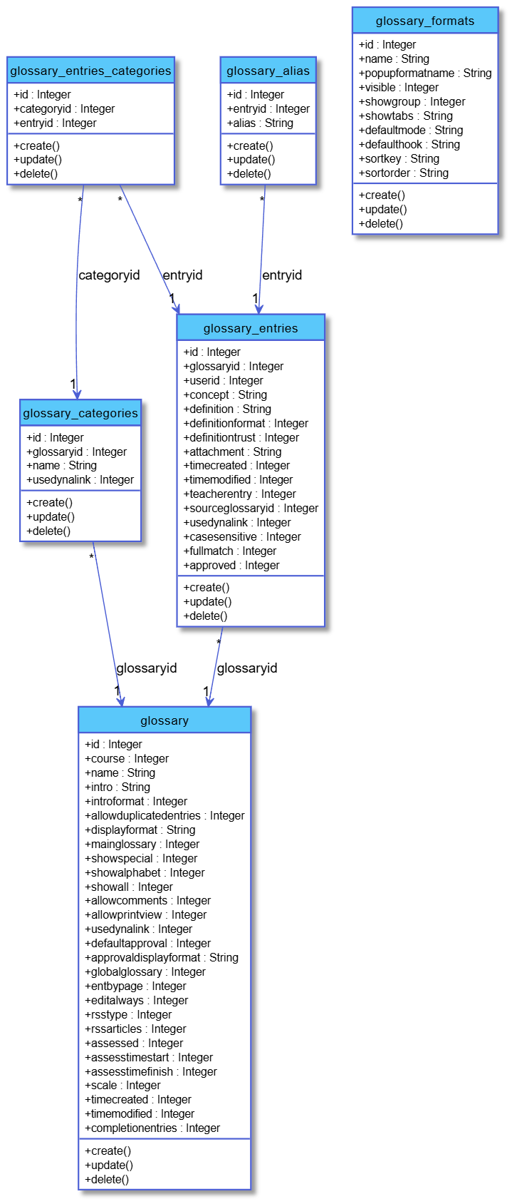  
daris_class_grades**

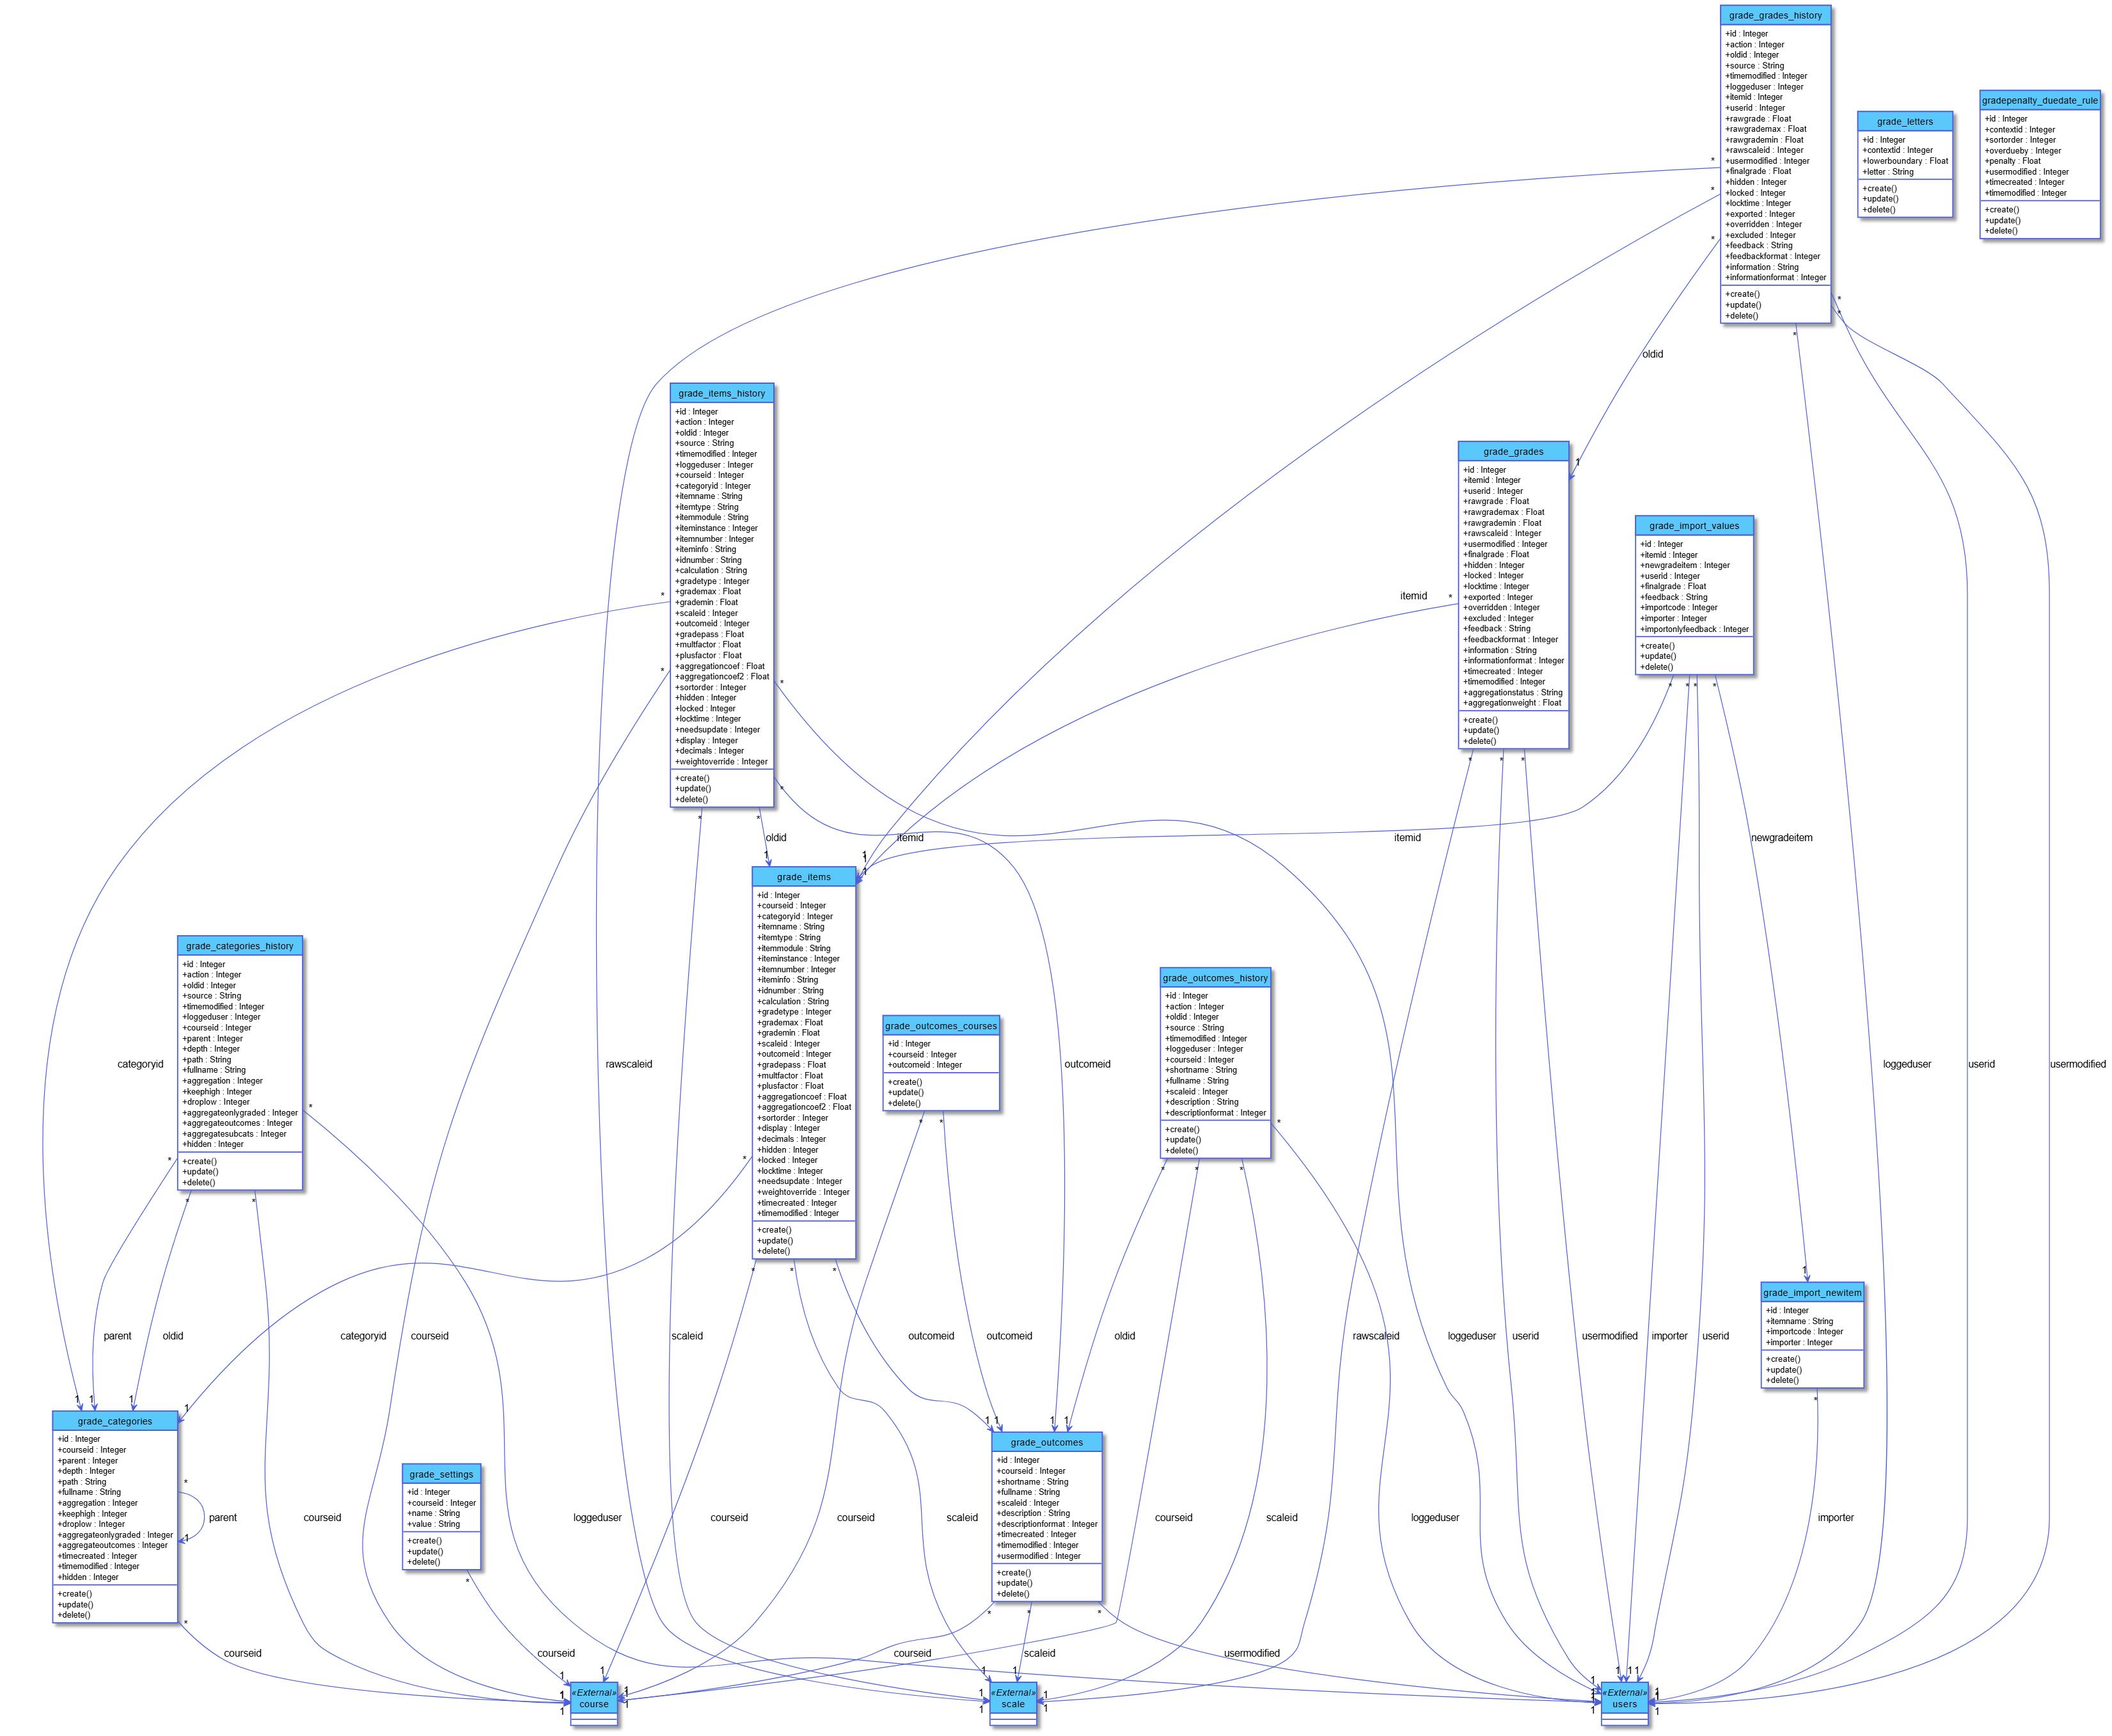**daris_class_h5p**

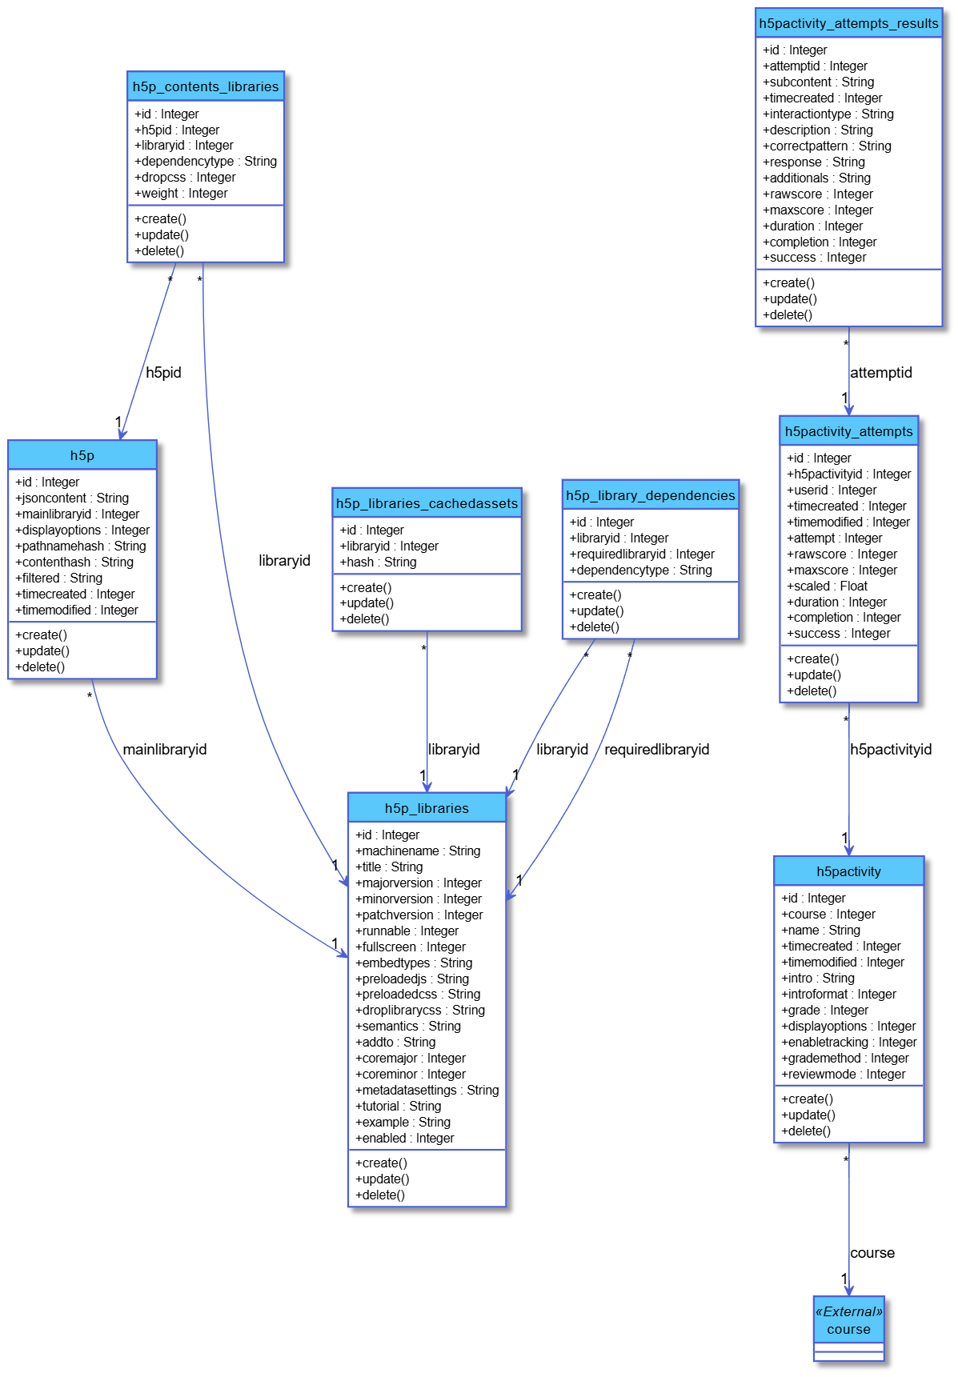

**daris_class_lesson**

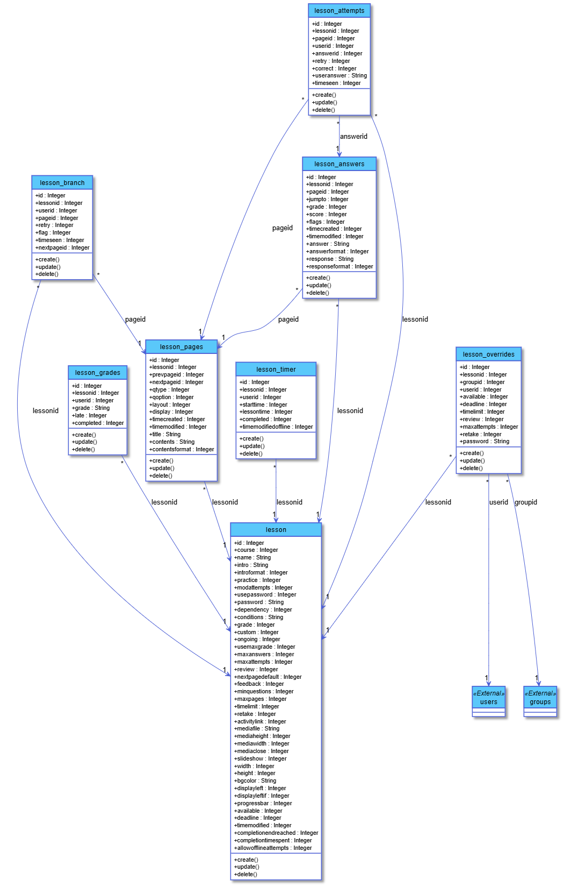**daris_class_lti**

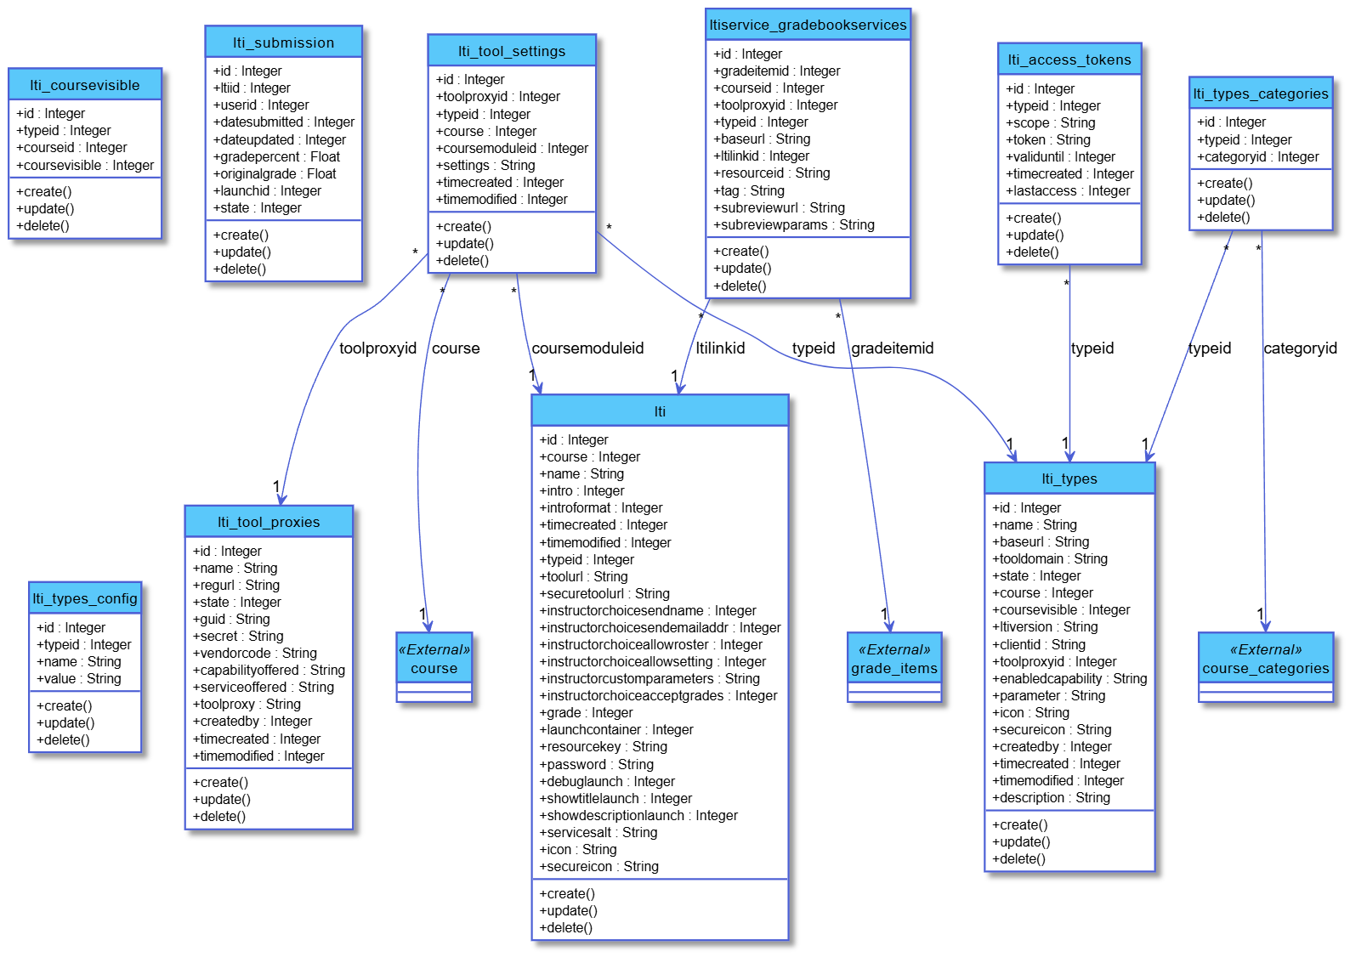**daris_class_message**

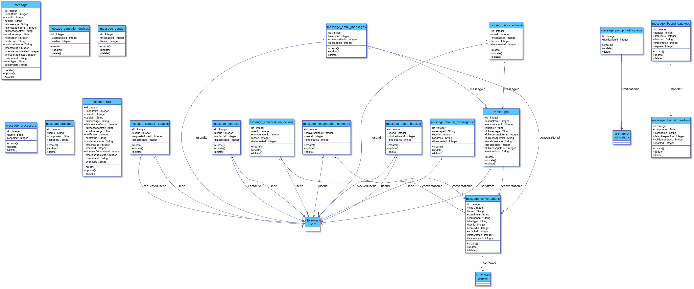**daris_class_mnet**

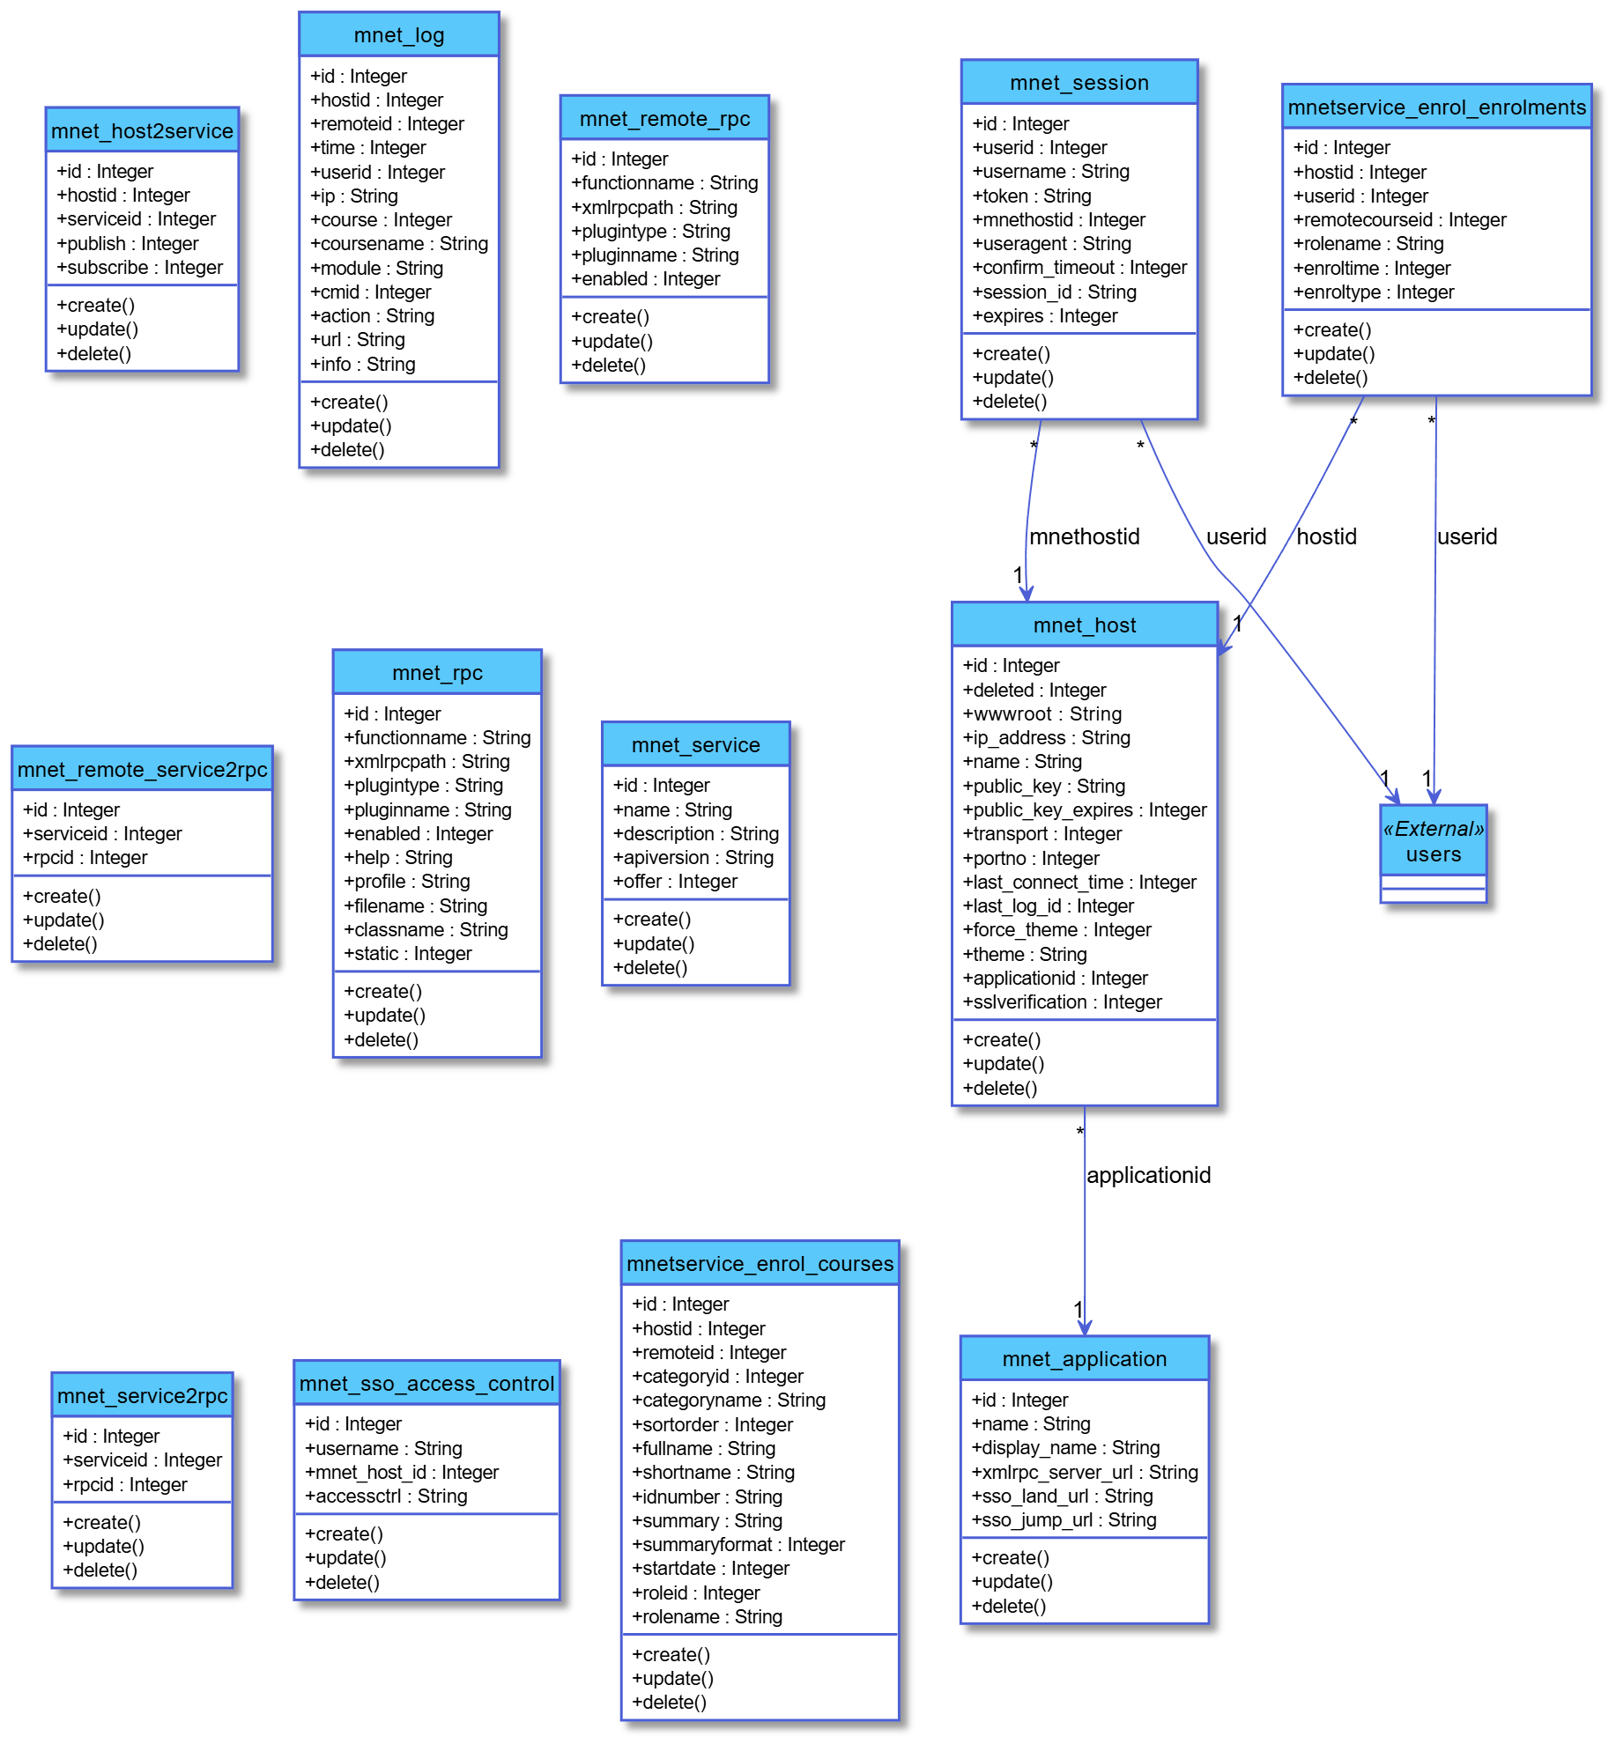

**daris_class_modules**

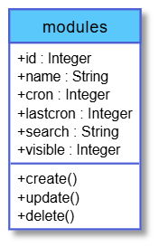

**daris_class_my_dashboard**

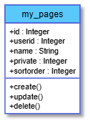

**daris_class_notification**

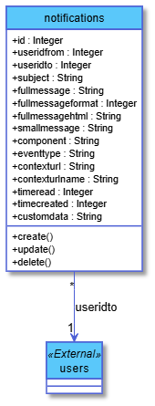

**daris_class_oauth2**

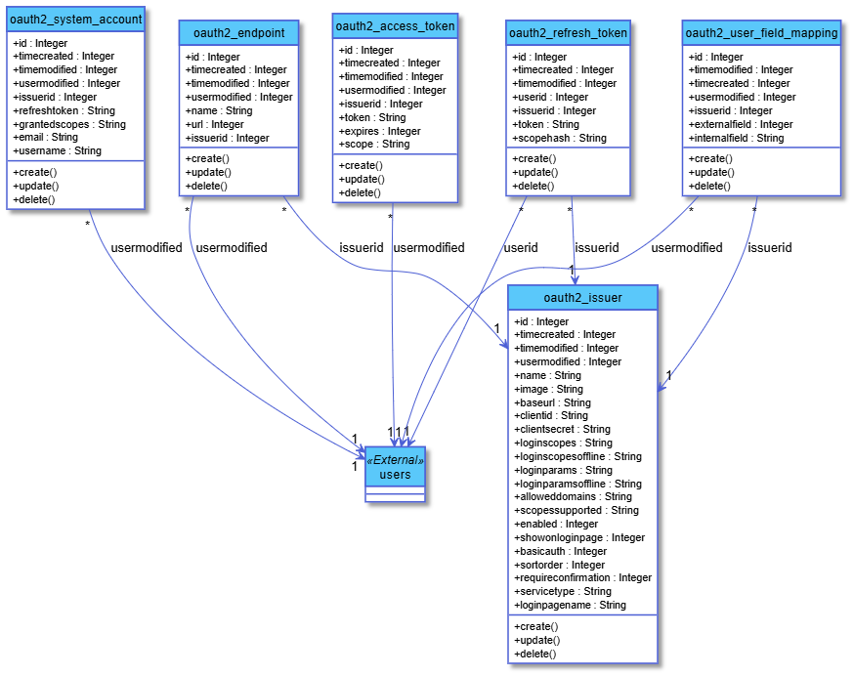

**daris_class_other**

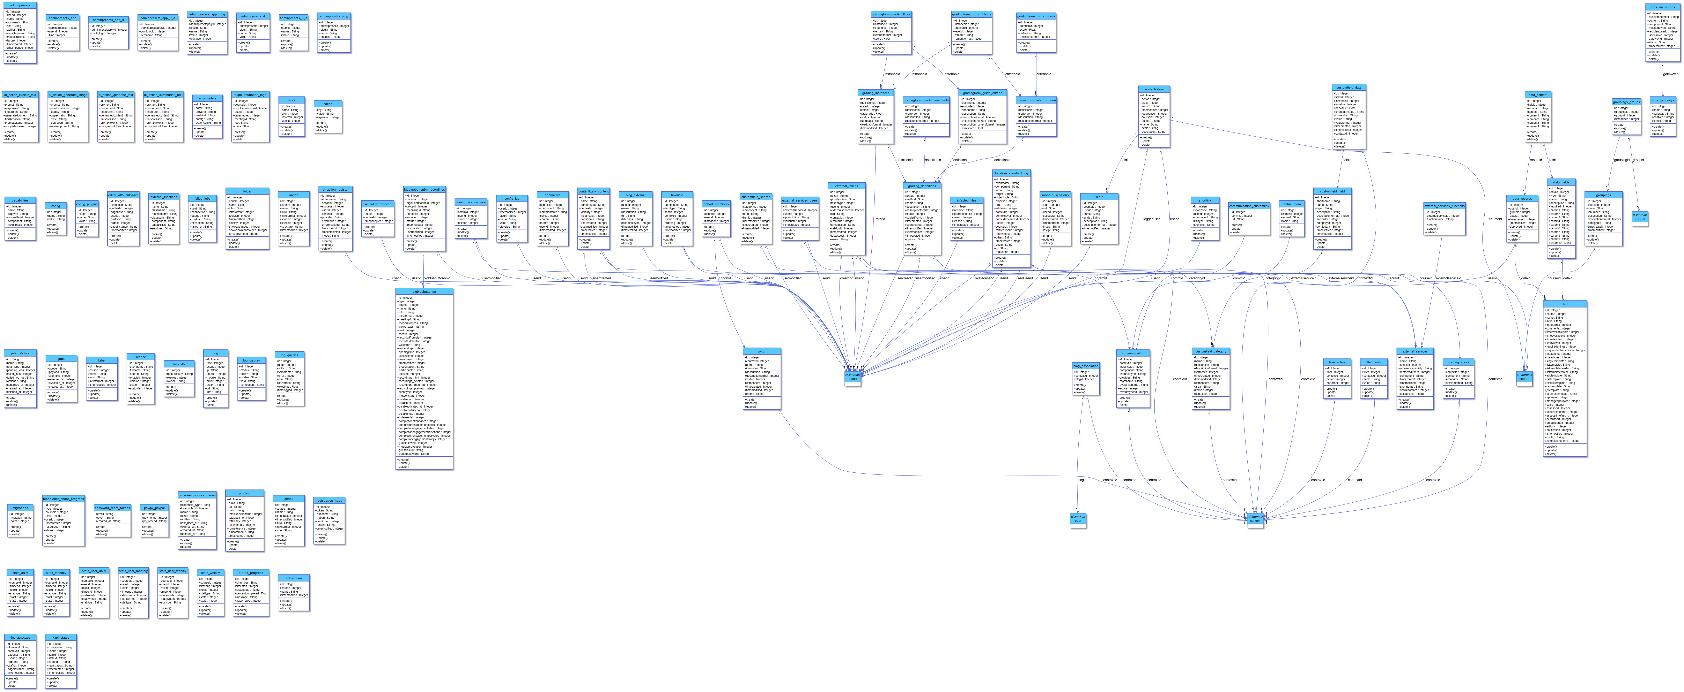**daris_class_page**

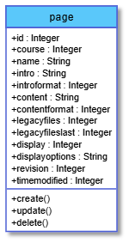

**daris_class_payment**

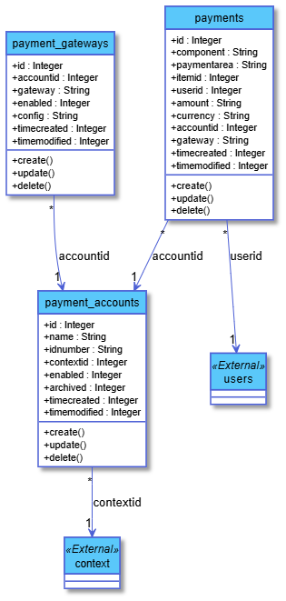

**daris_class_portfolio**

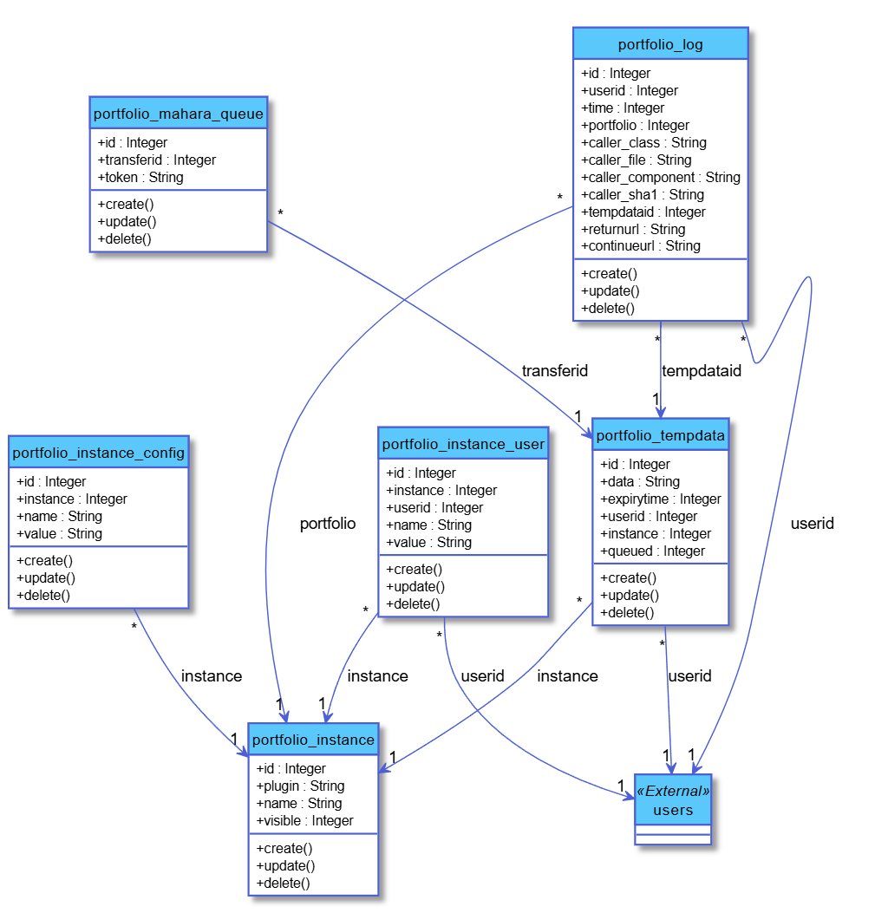**daris_class_post**

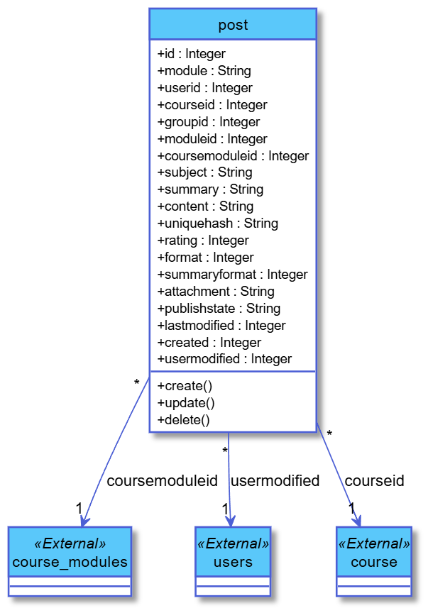

**daris_class_quiz_question**

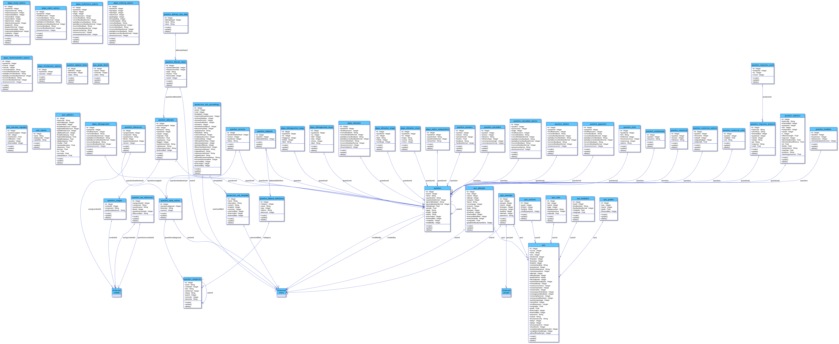**daris_class_rating**

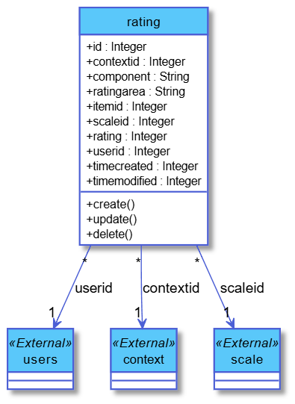

**daris_class_report**

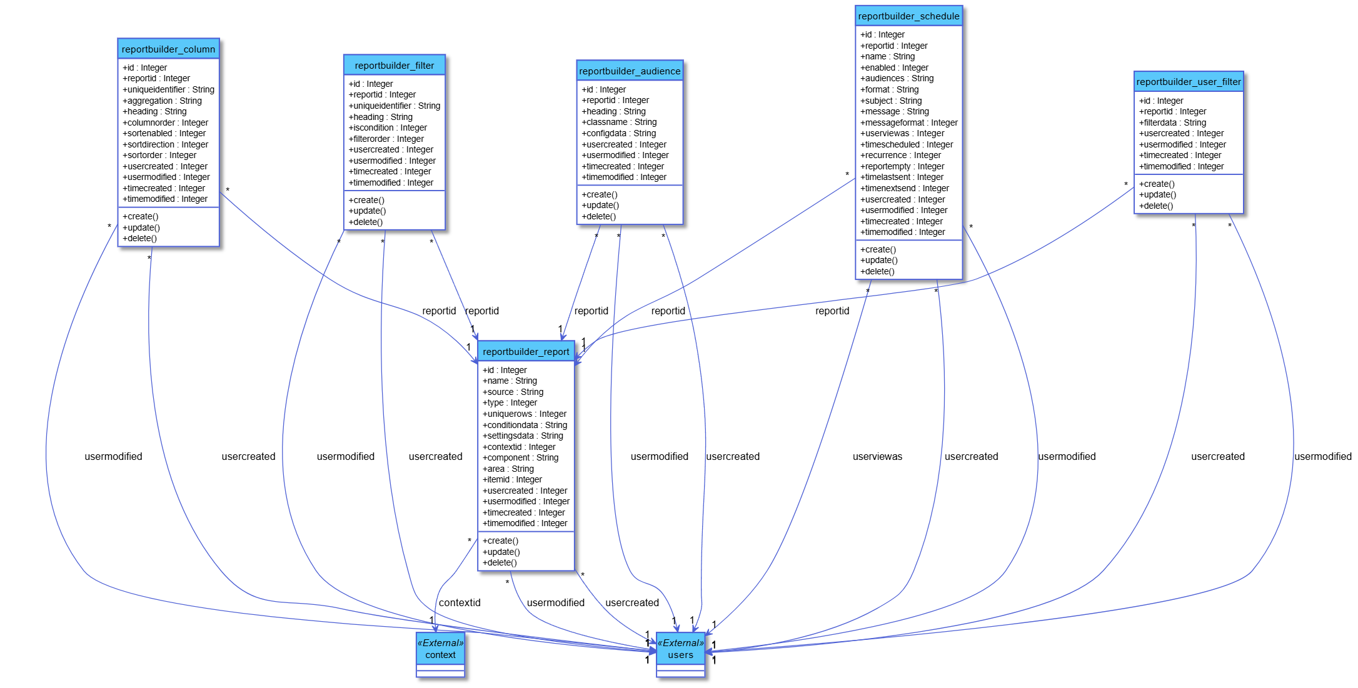

**daris_class_repository**

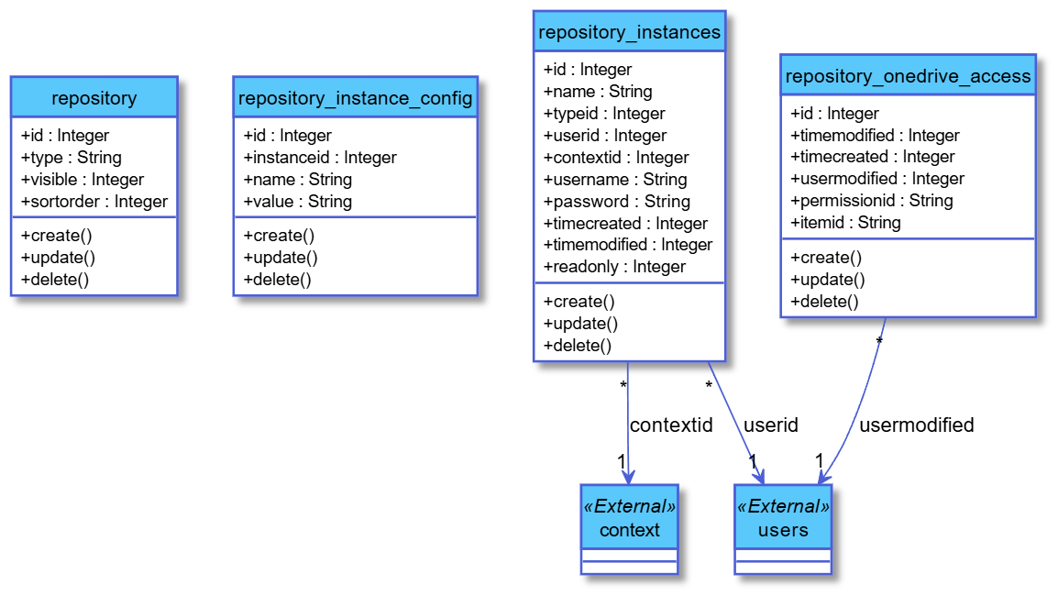

**daris_class_resource**

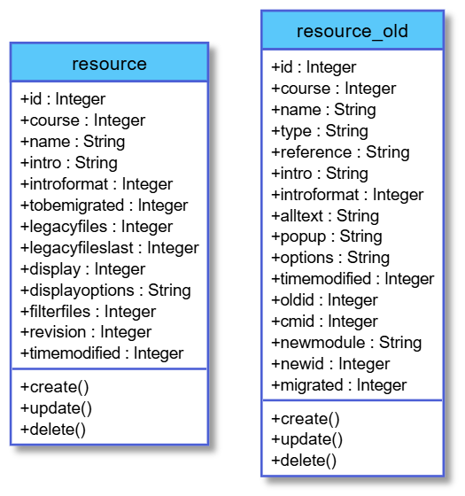

**daris_class_scorm**

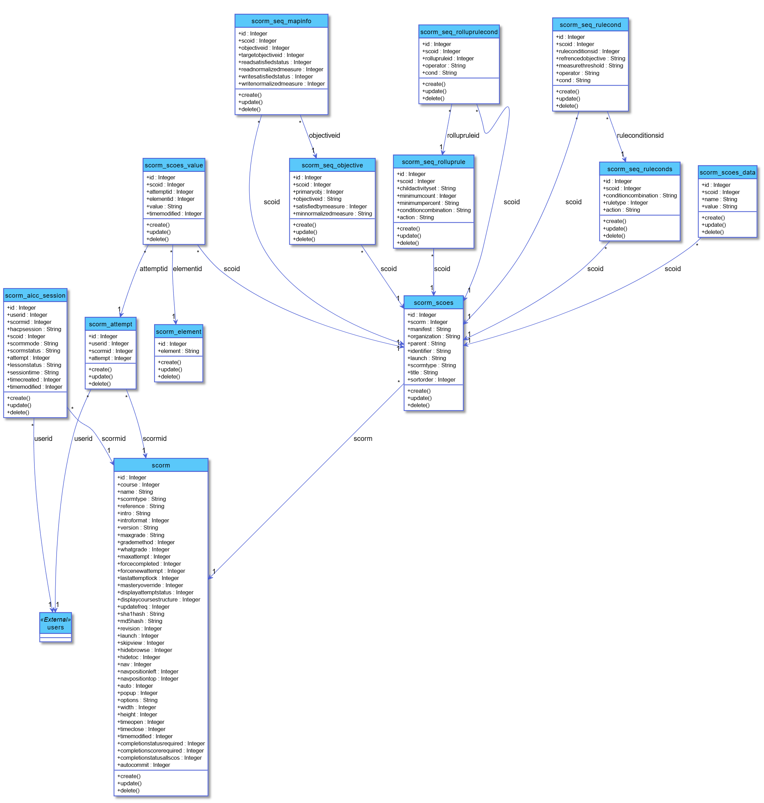

**daris_class_search**

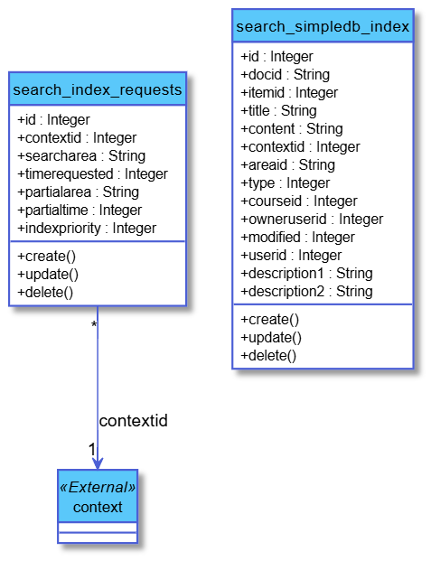

**daris_class_sessions**

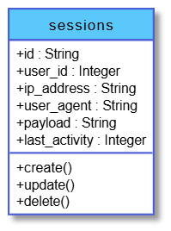

**daris_class_survey**

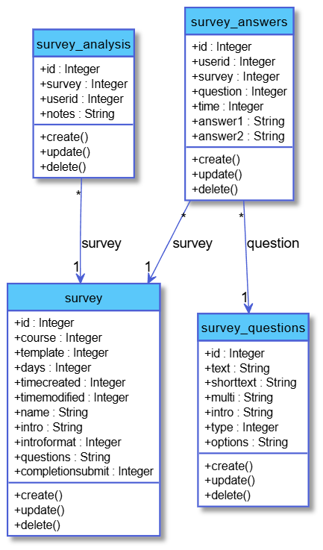

**daris_class_tags**

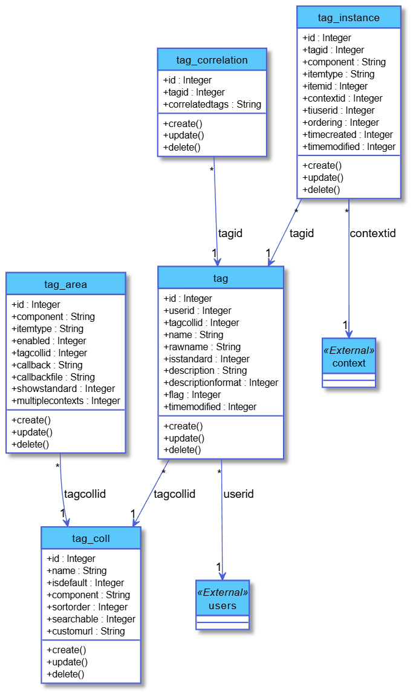**daris_class_task**

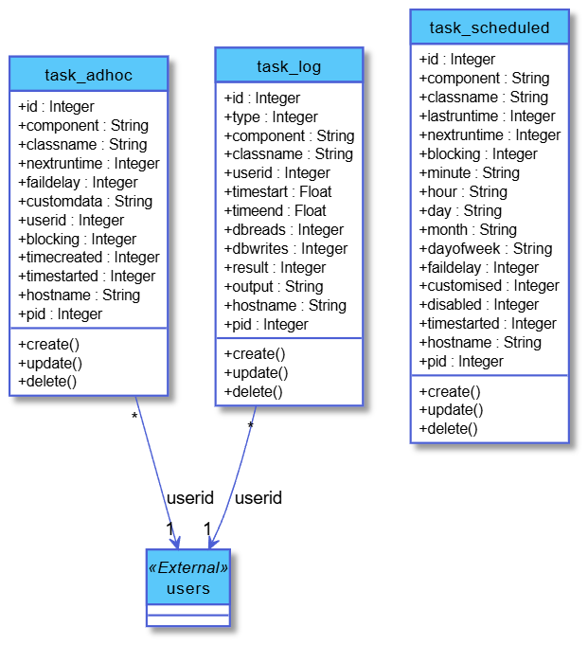**daris_class_tool**

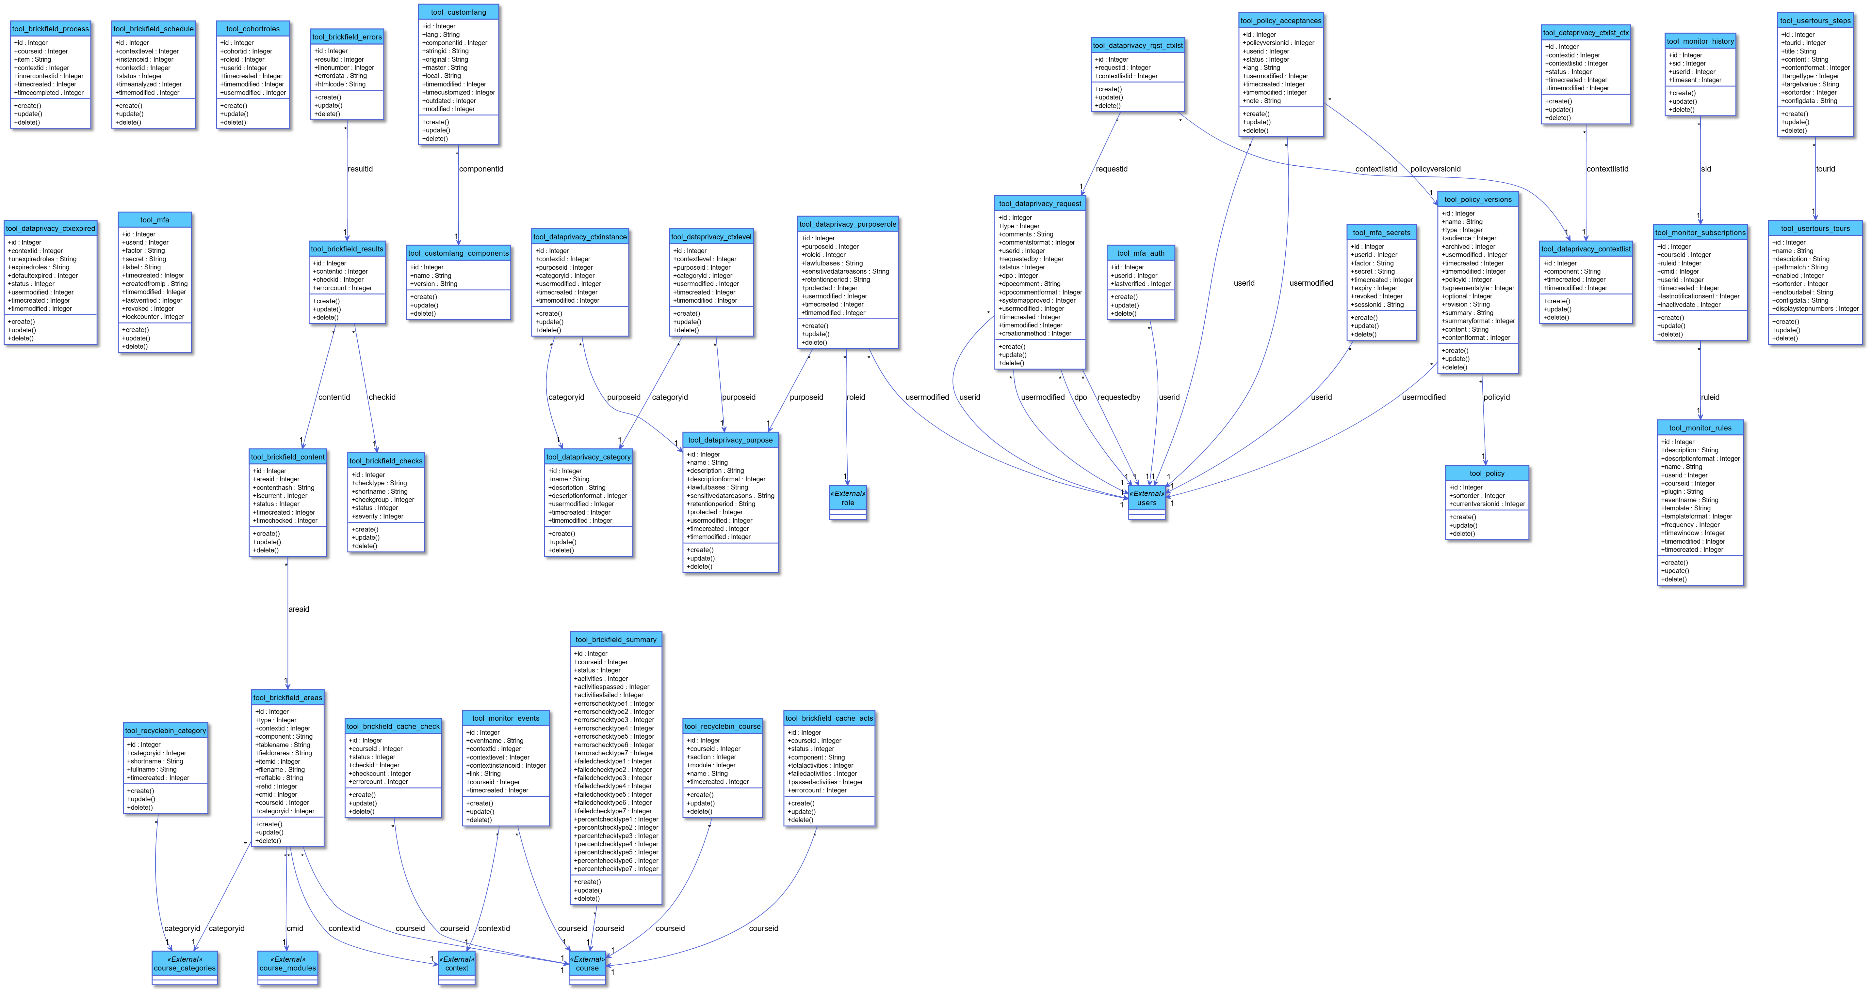**daris_class_upgrade**

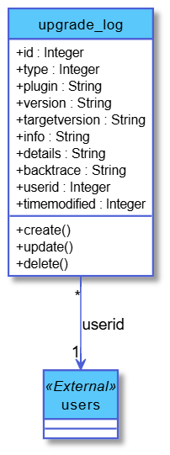

**daris_class_url**

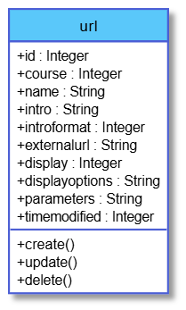

**daris_class_wiki**

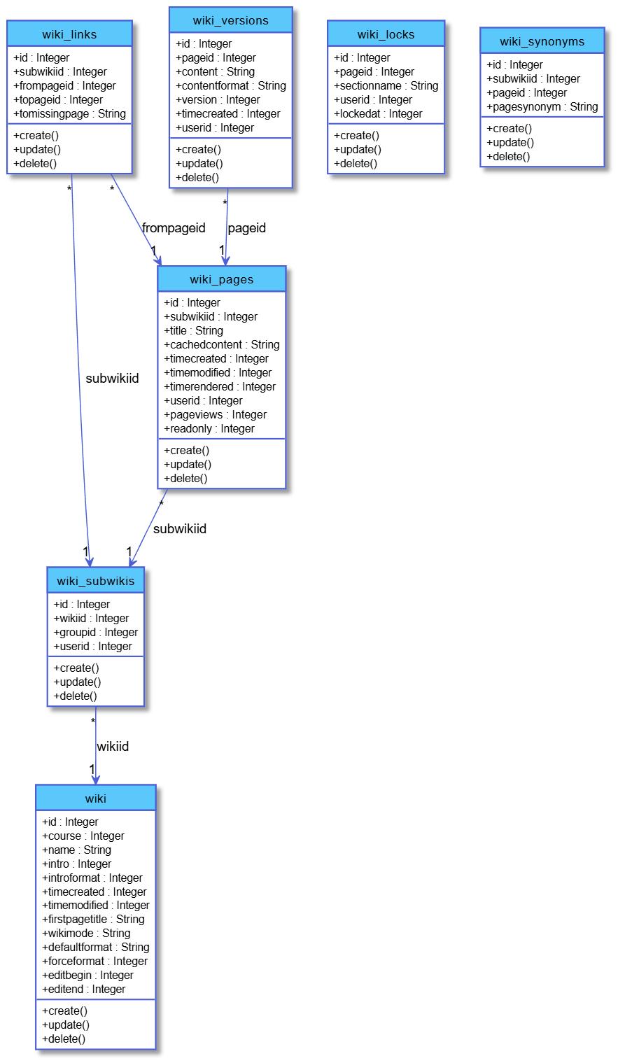**daris_class_workshop**

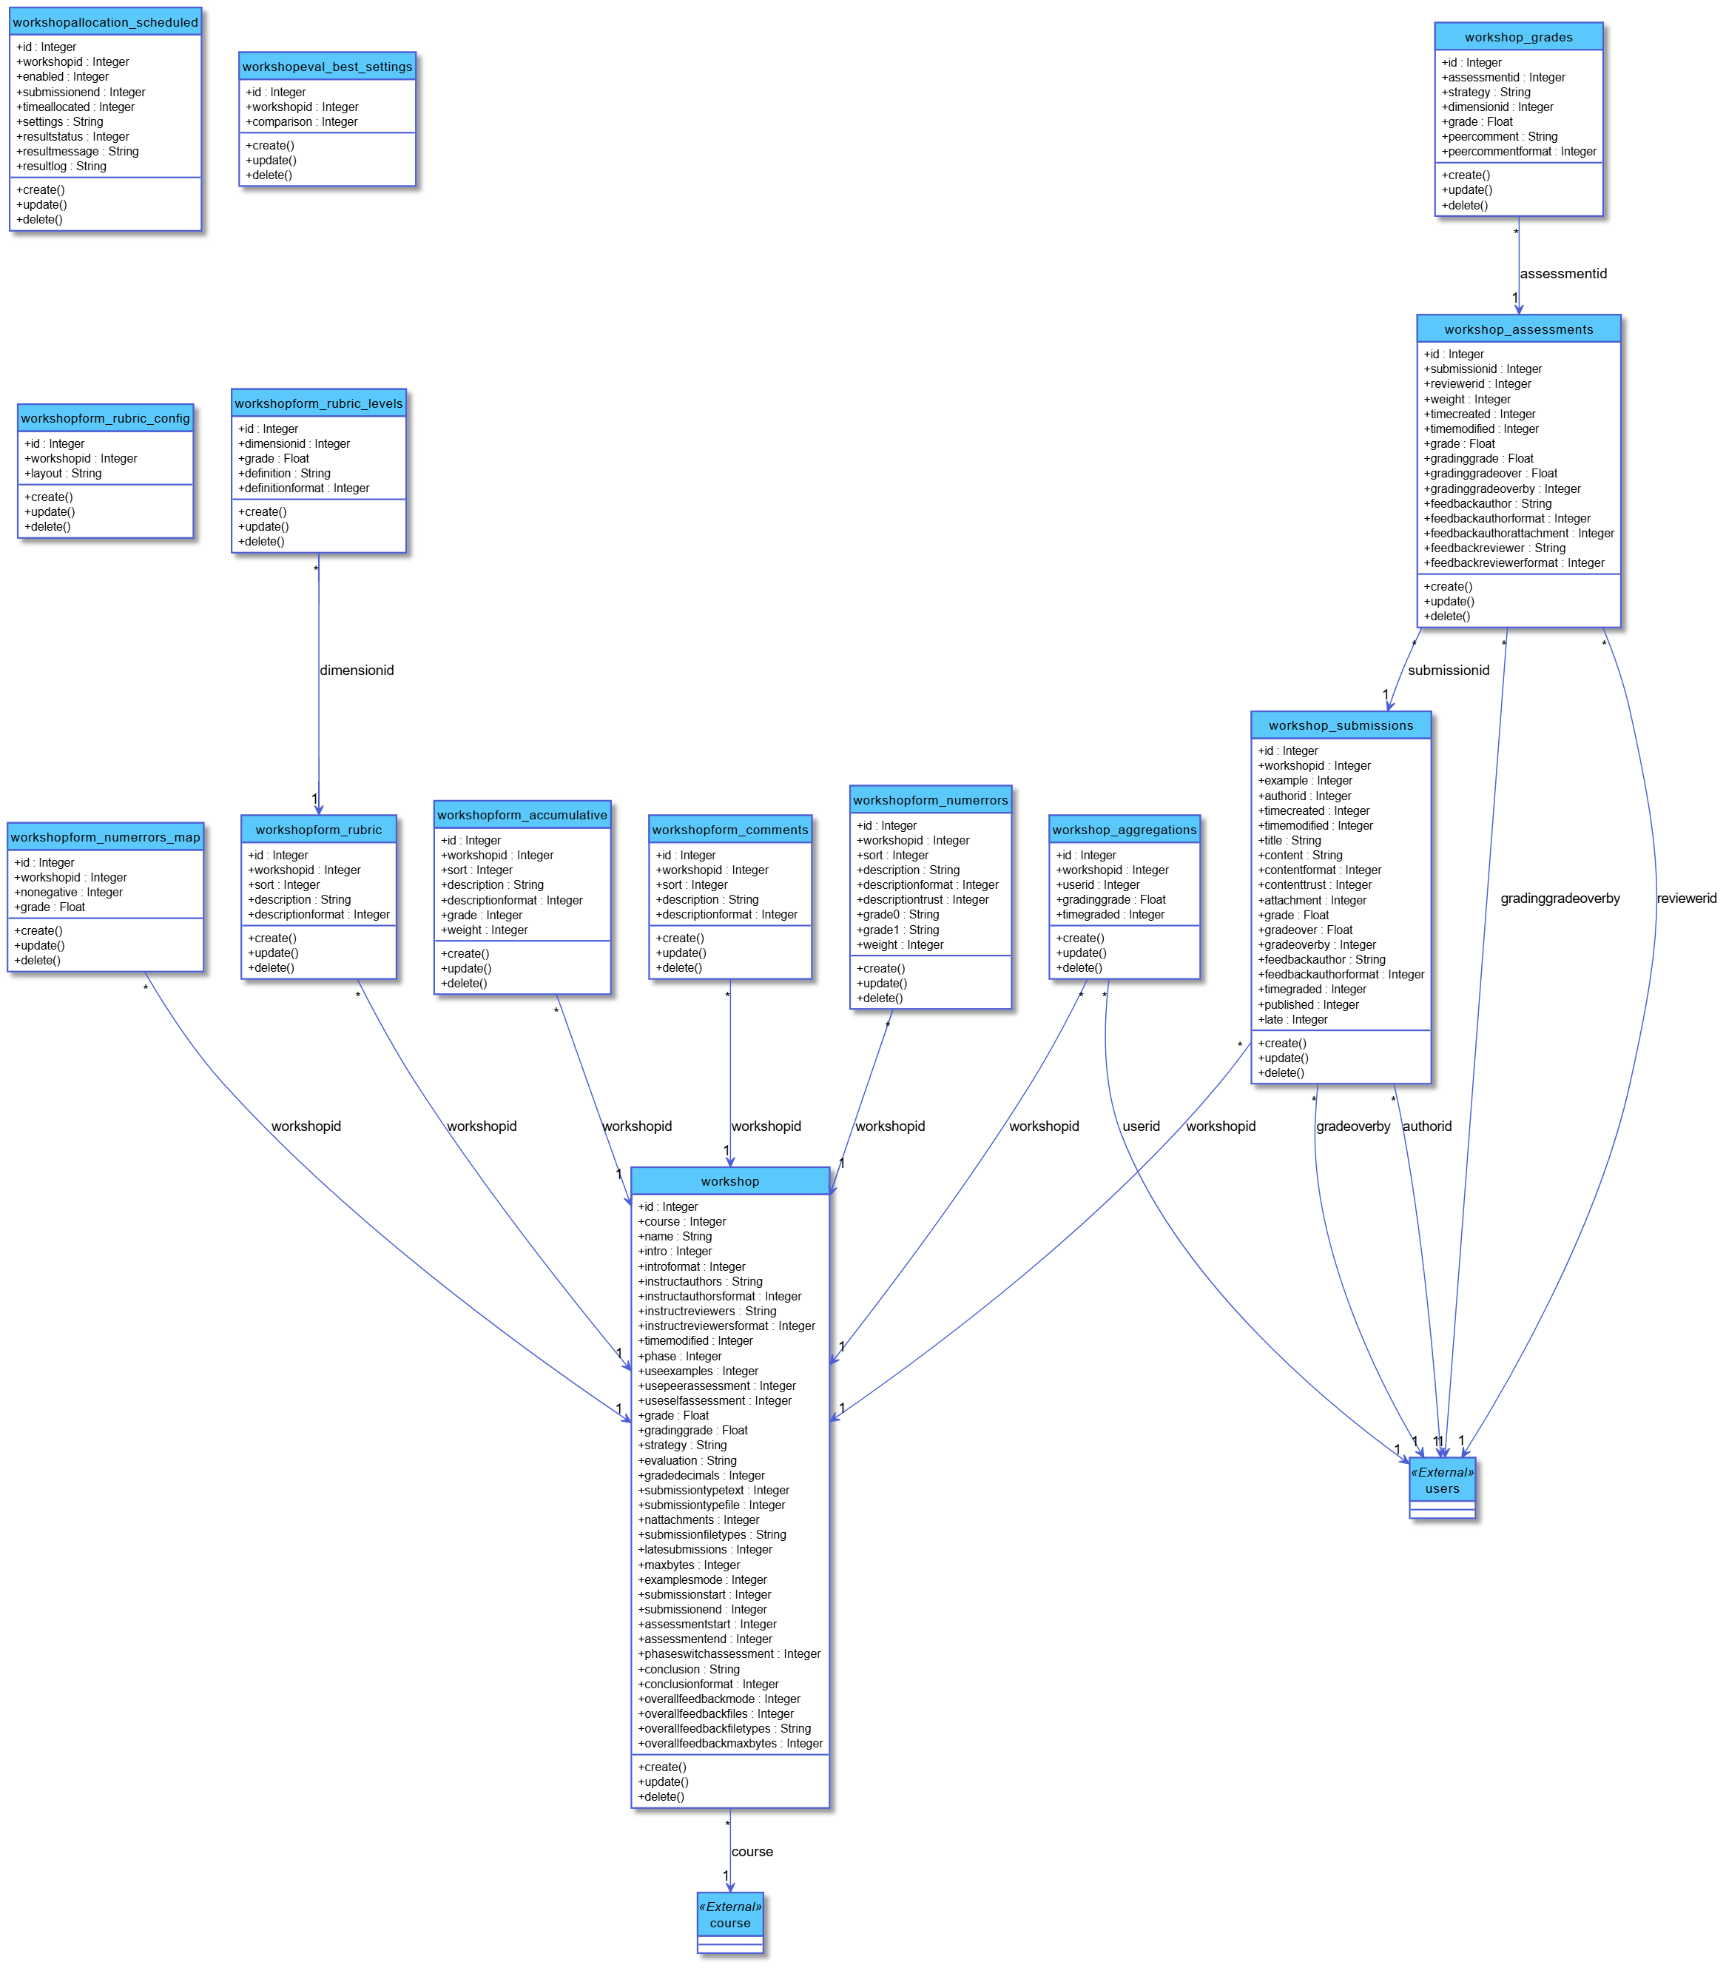

**EntityRelationshipDiagram**

**daris_analytics**

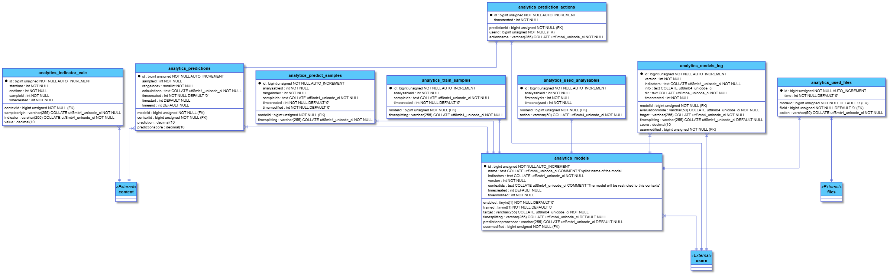

**daris_assignment**

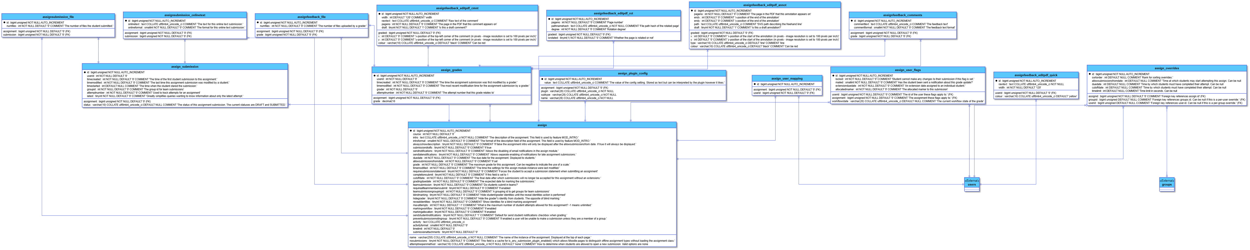**daris_auth**

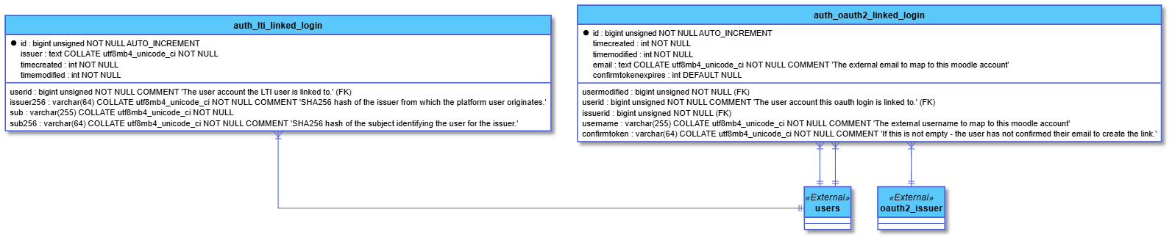

**daris_backup**

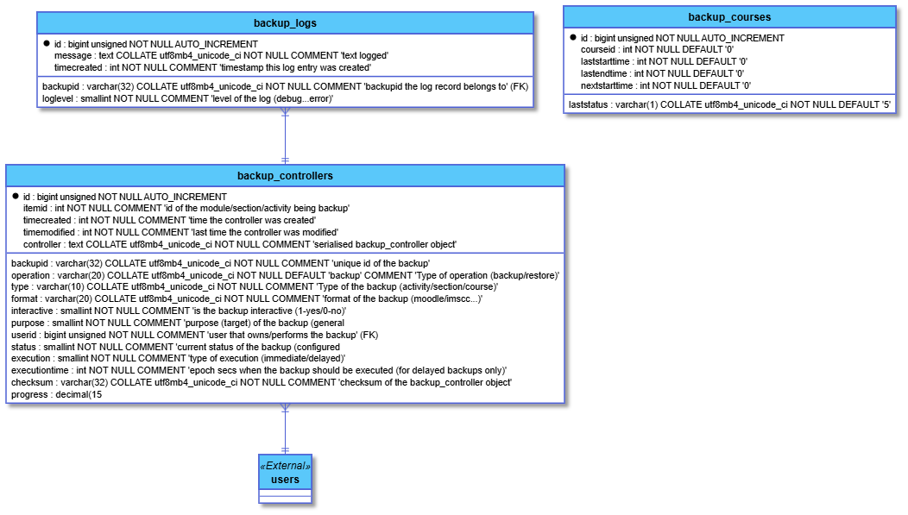**daris_badge**

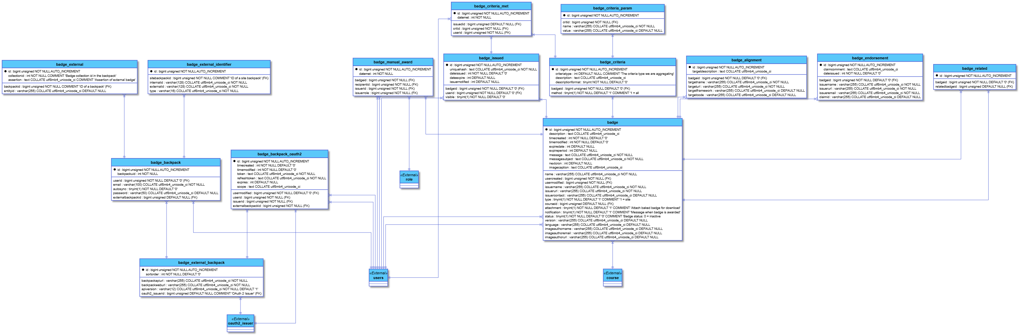

**daris_block**

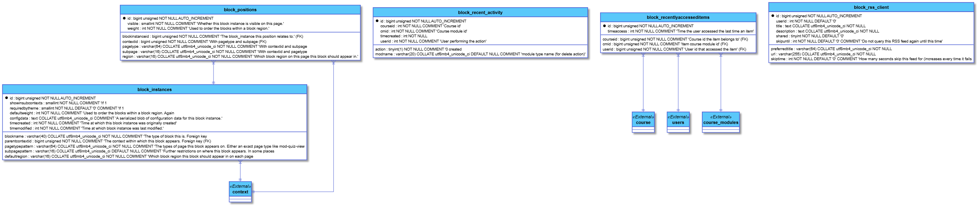**daris_book**

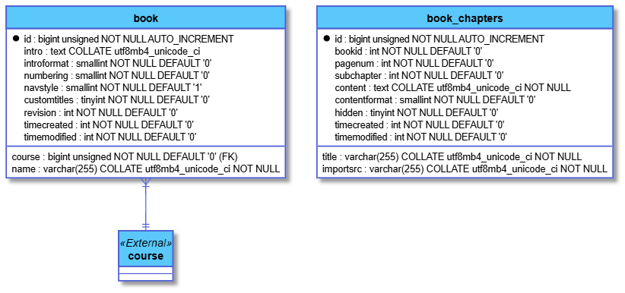

**daris_cache**

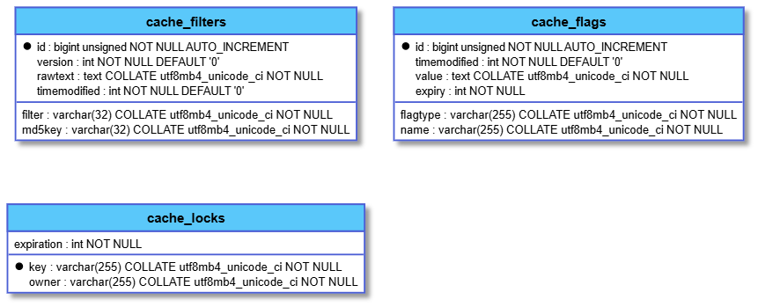

**daris_chat**

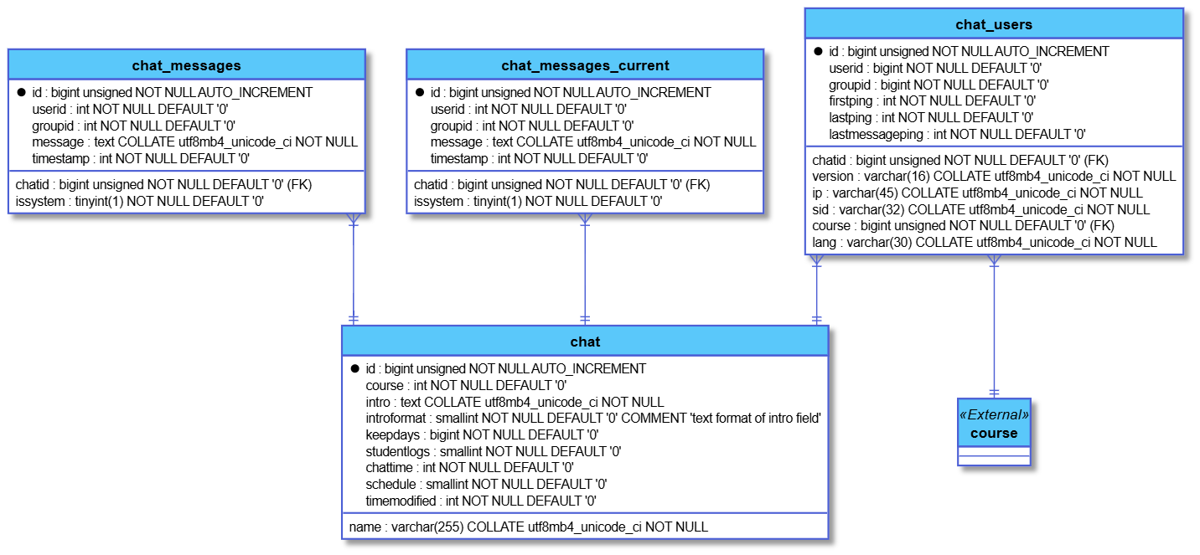**daris_choice**

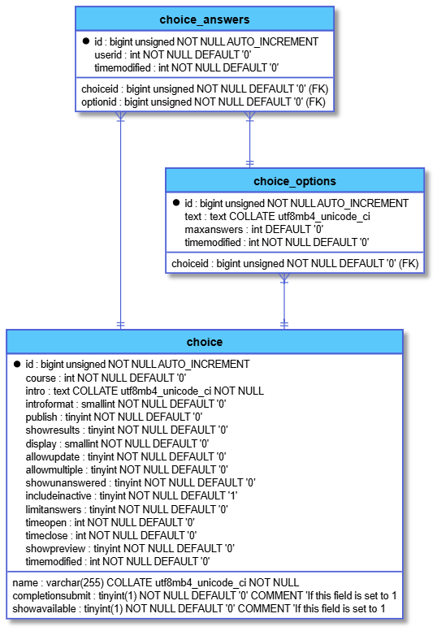

**daris_competency**

**daris_core**



**daris_enrolment**

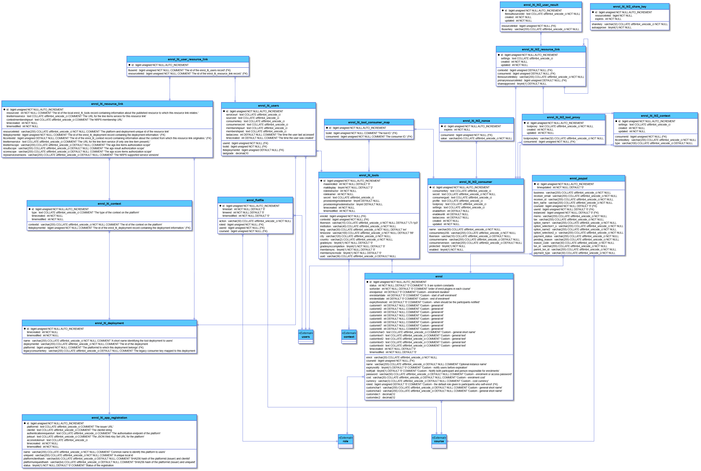

**daris_events**

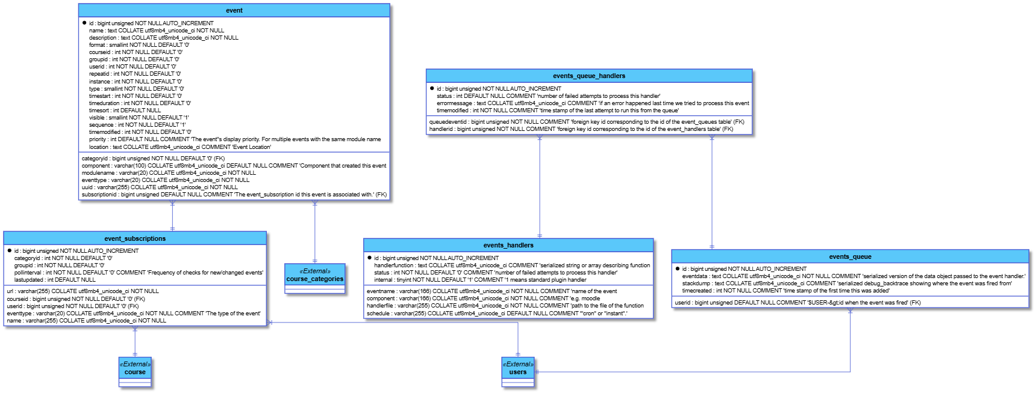

**daris_feedback**

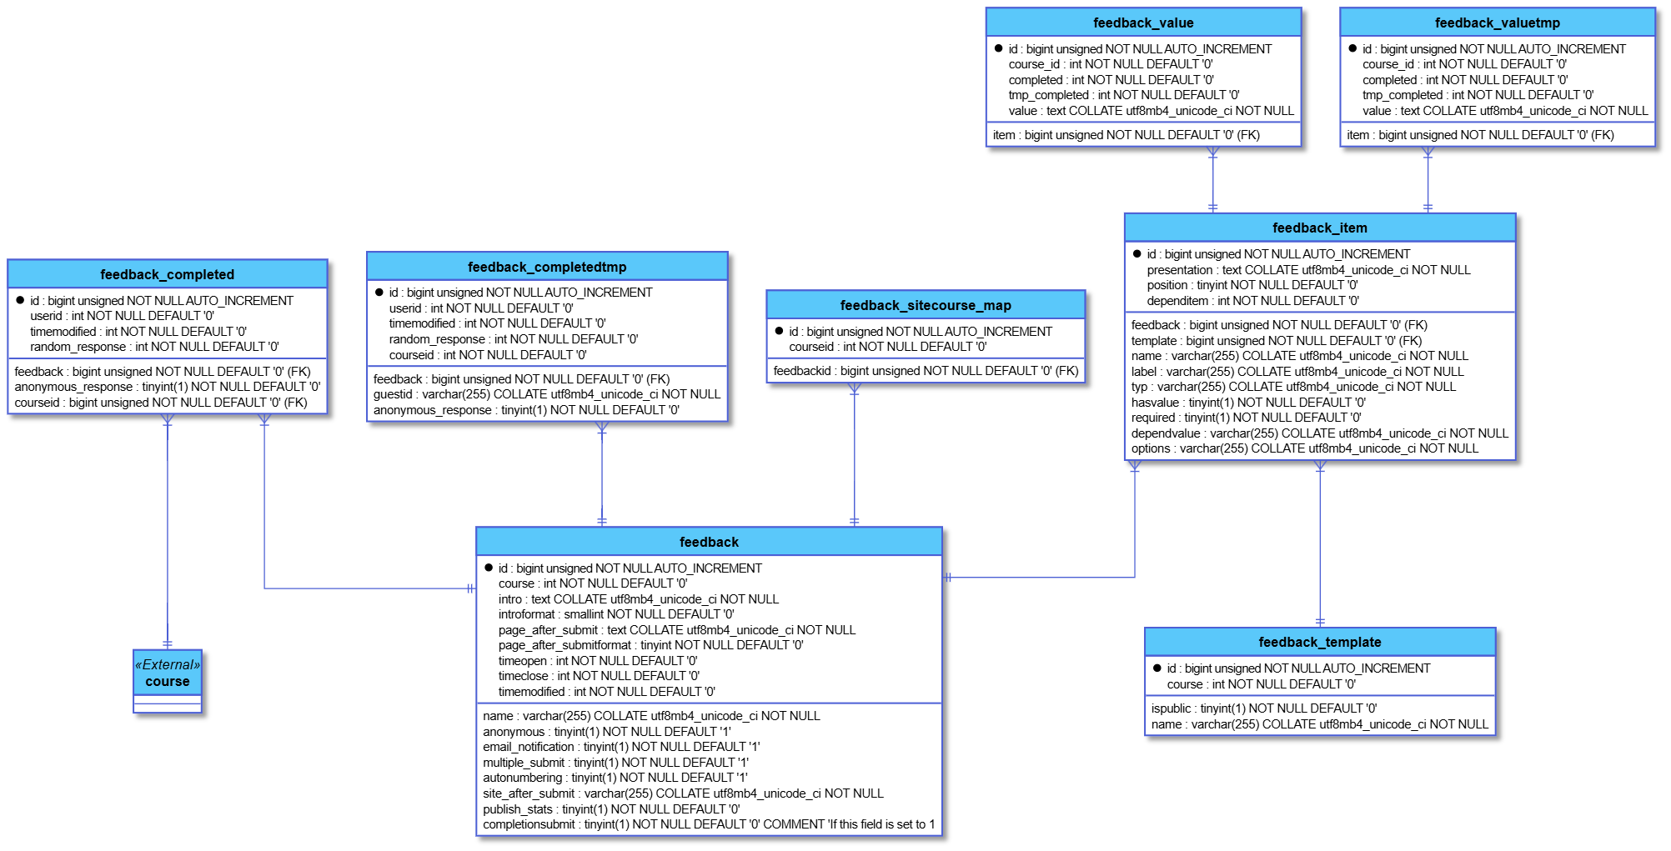

**daris_files**

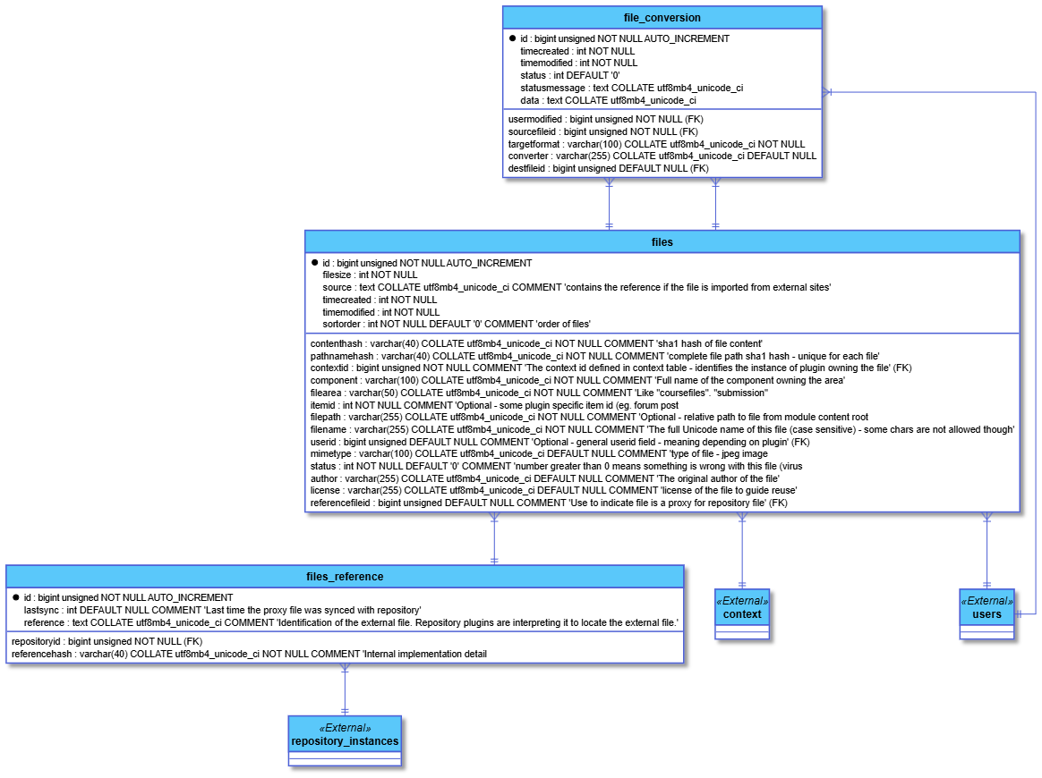

**daris_forum**

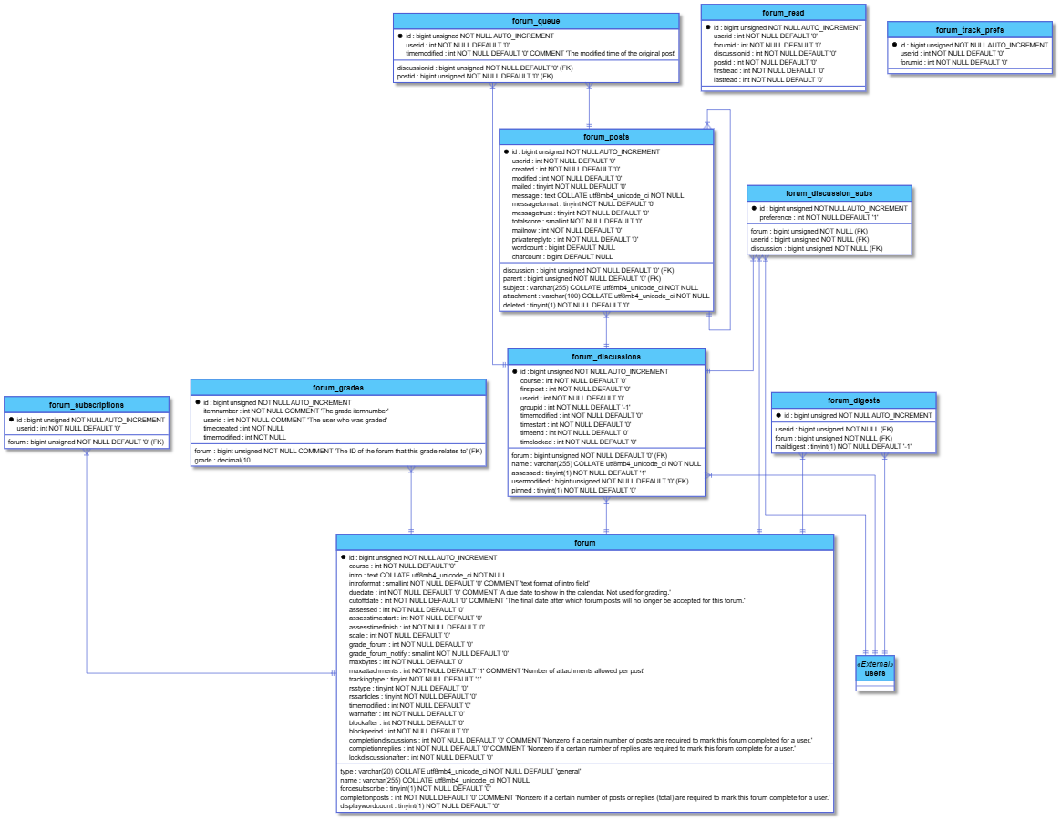**daris_glossary**

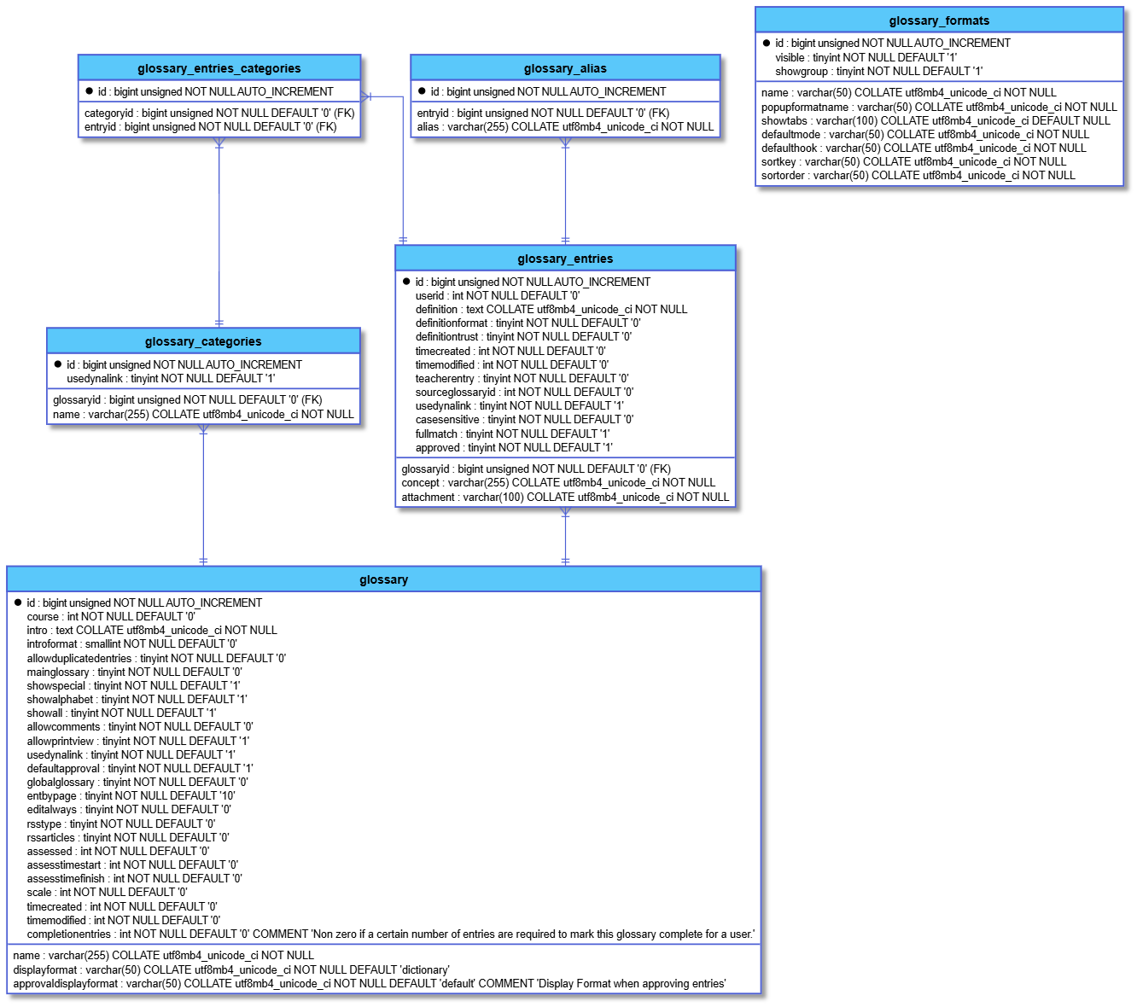

**daris_grades**

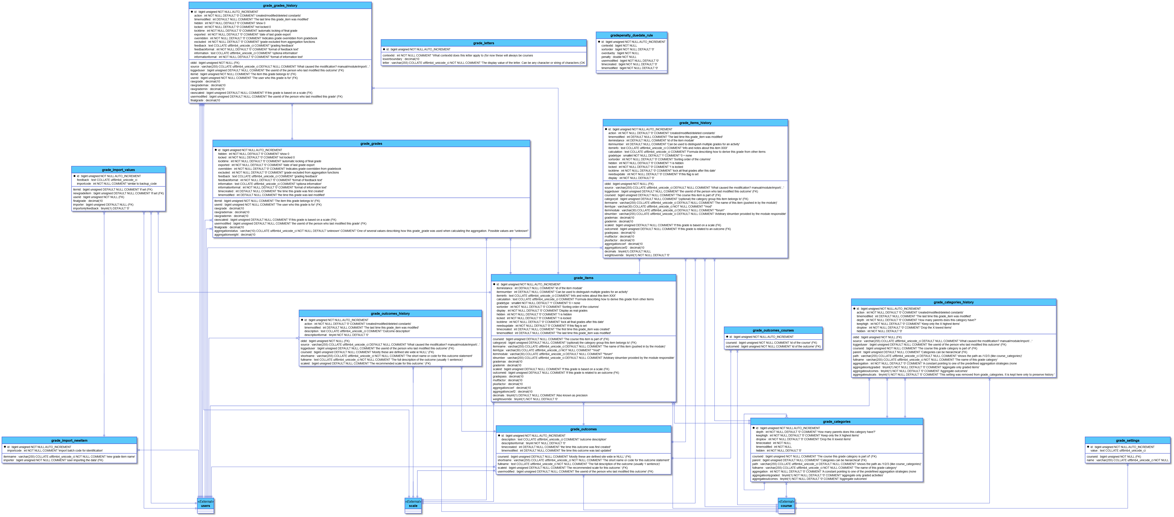

**daris_h5p**

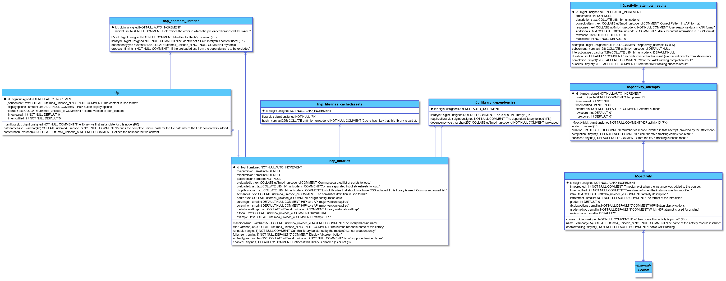**daris_lesson**

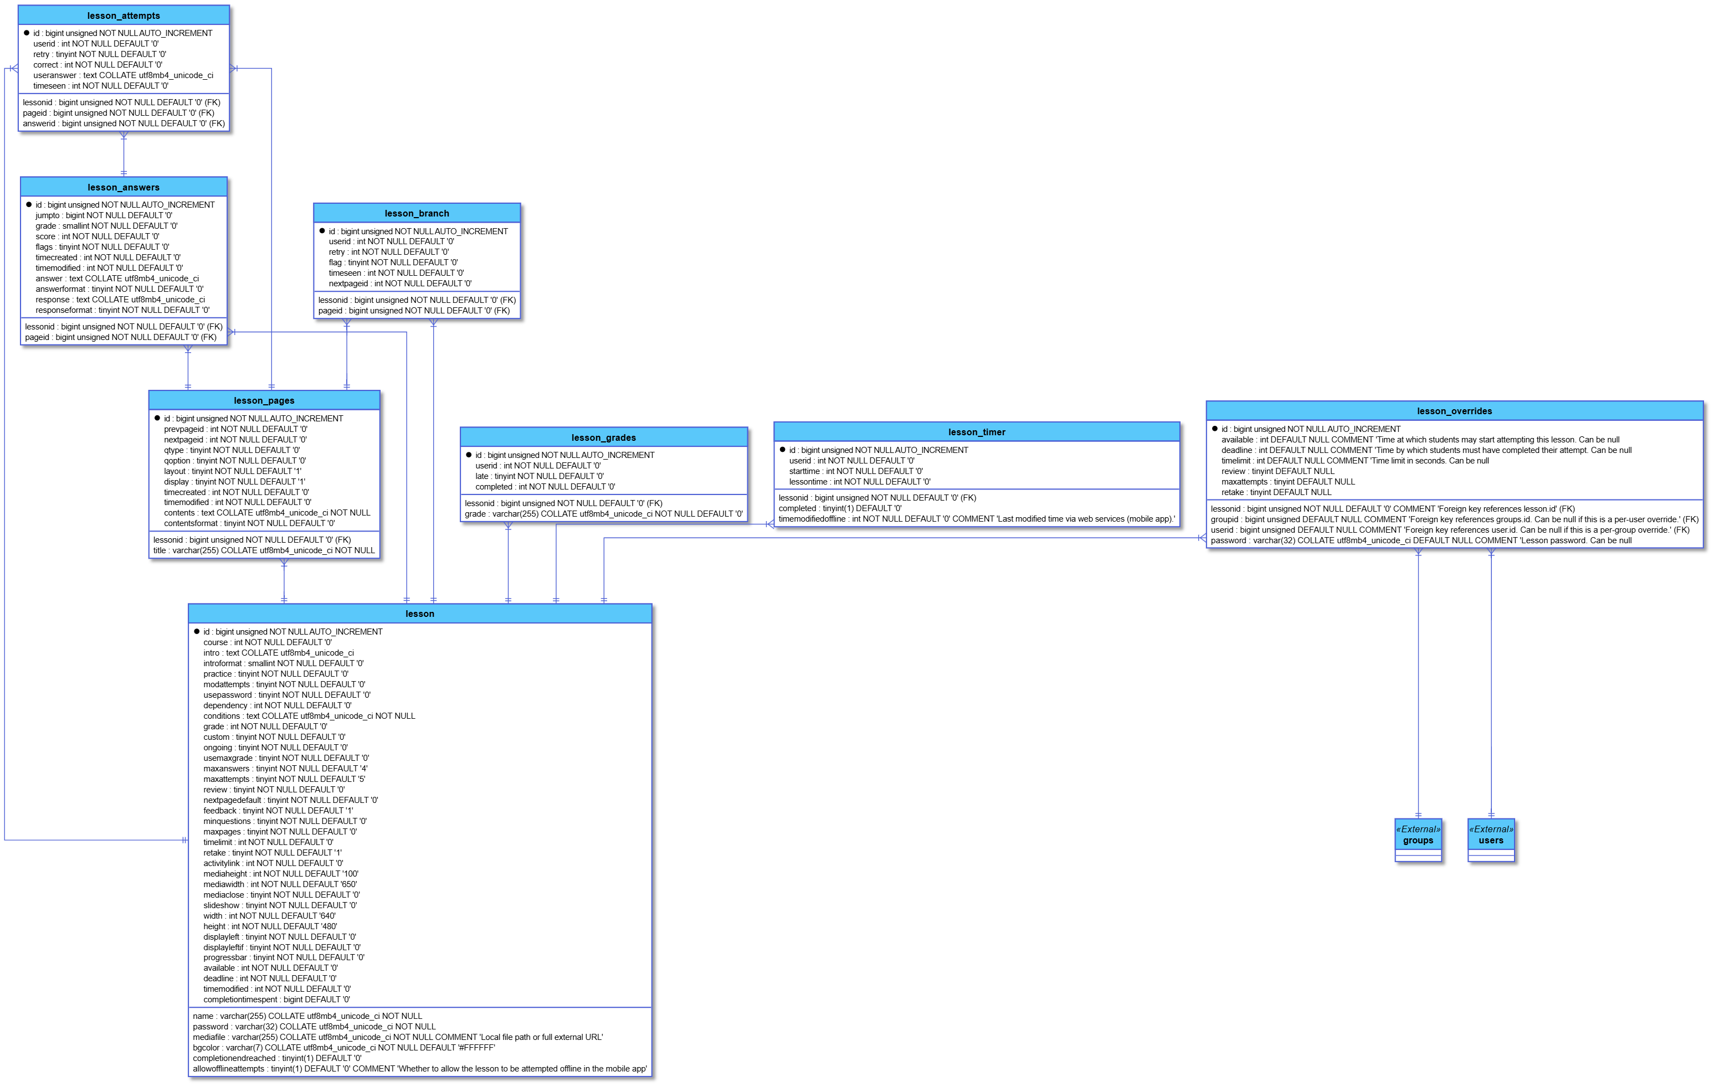**daris_lti**

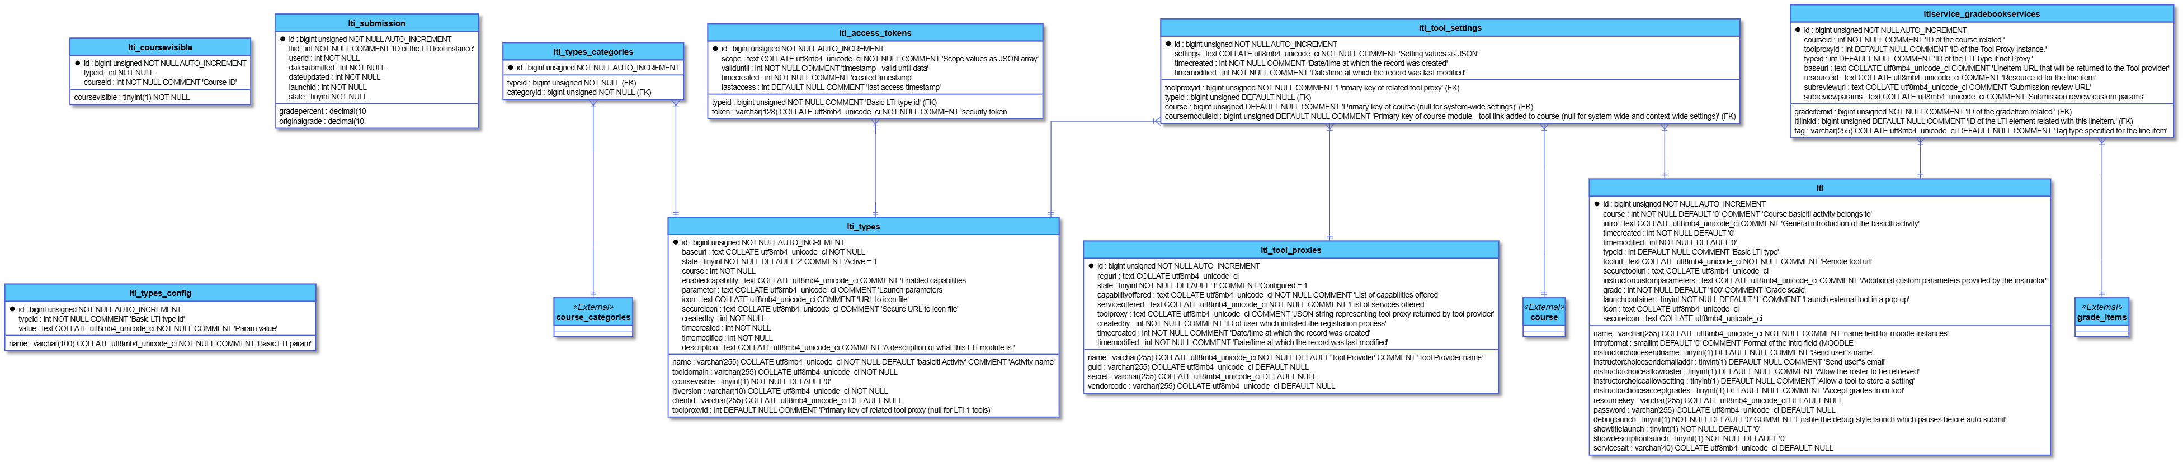

**daris_message**

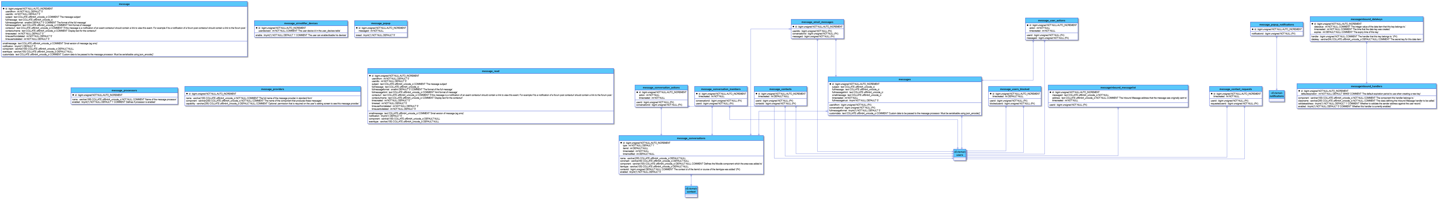

**daris_mnet**

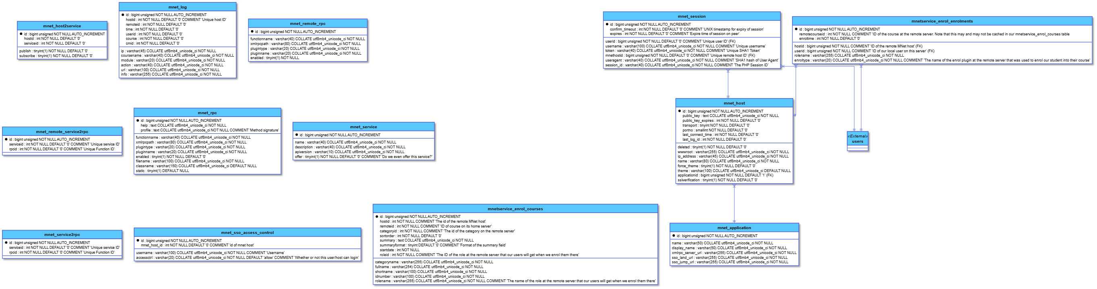

**daris_modules**

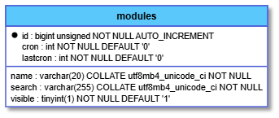

**daris_my_dashboard**

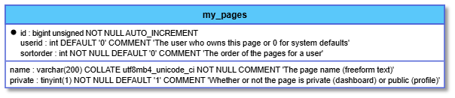

**daris_notification**

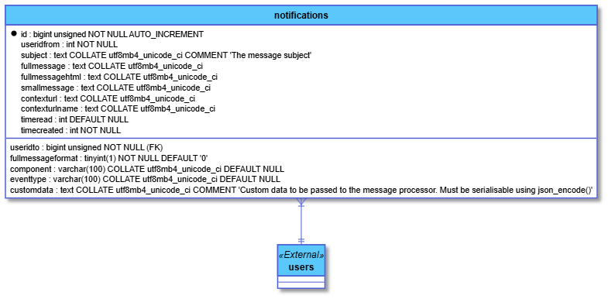**daris_oauth2**

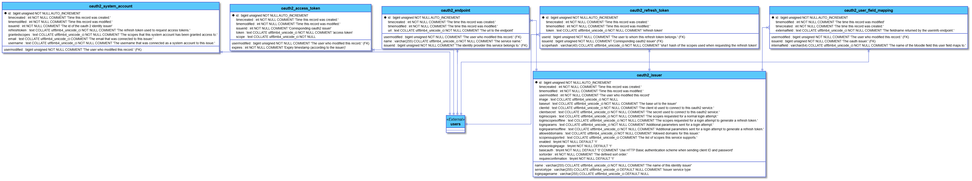

**daris_other**

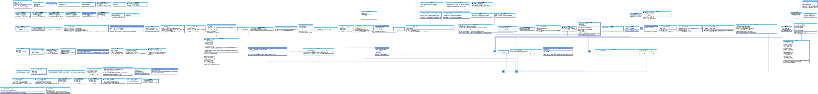**daris_page**

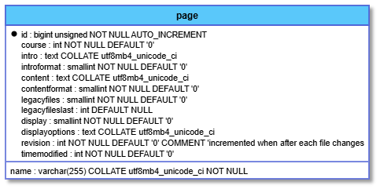

**daris_payment**

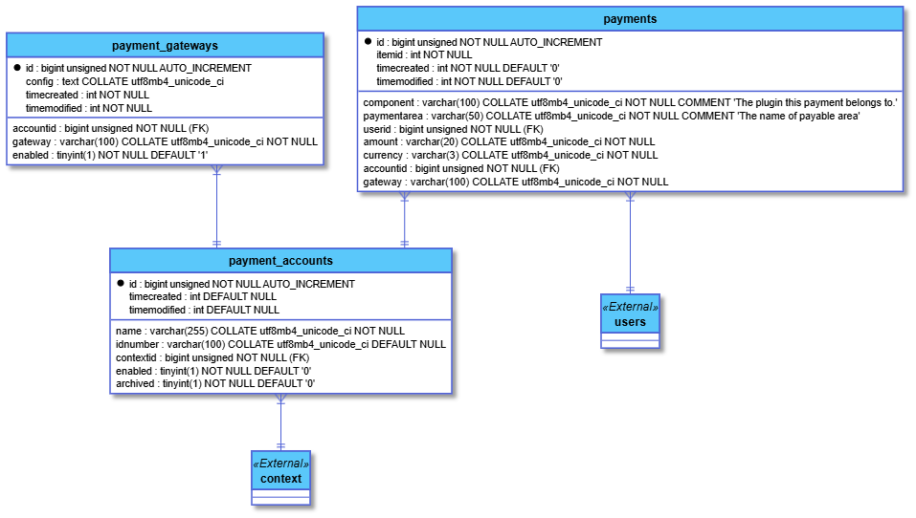**daris_portfolio**

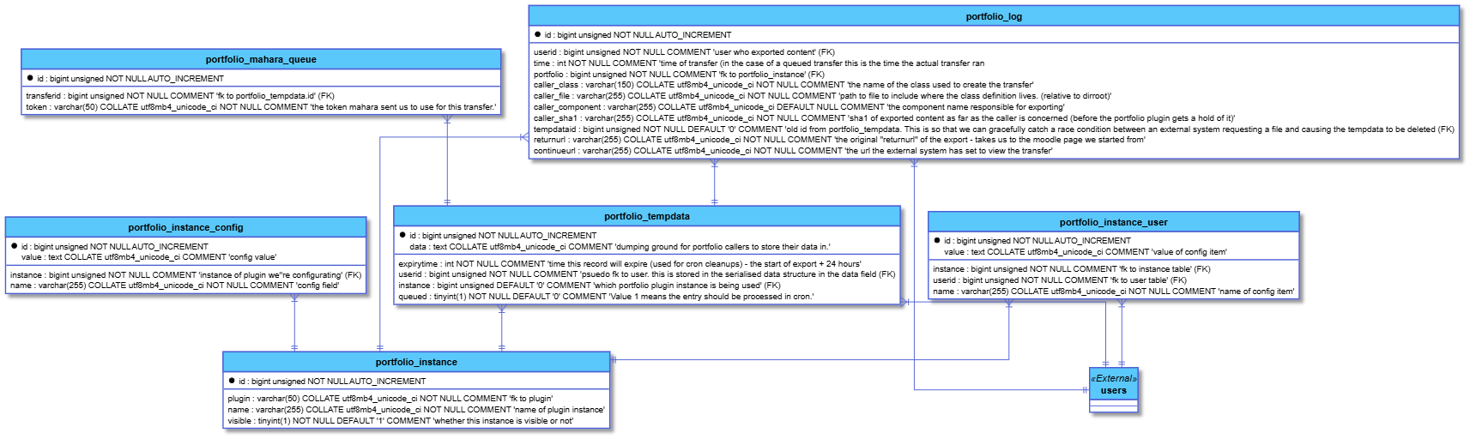

**daris_post**

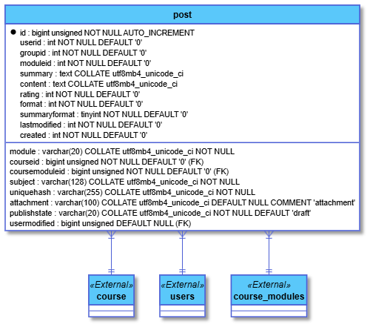

**daris_quiz_question**

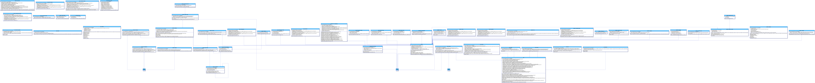

**daris_rating**

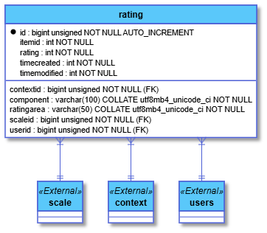

**daris_report**

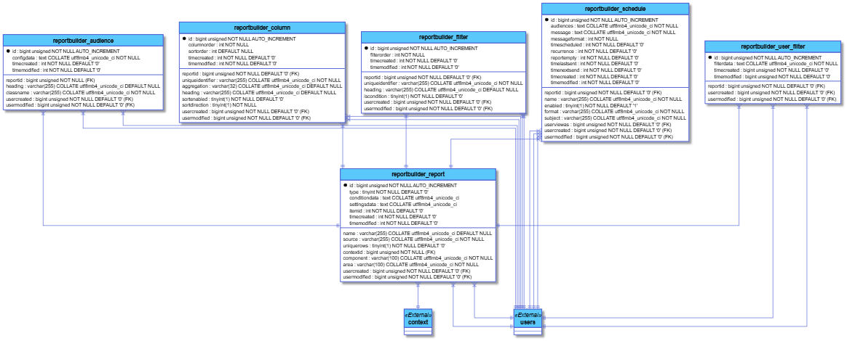

**daris_repository**

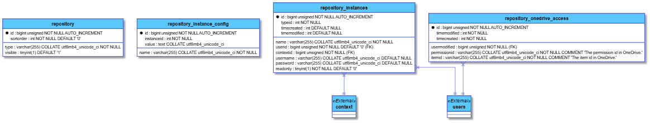

**daris_resource**

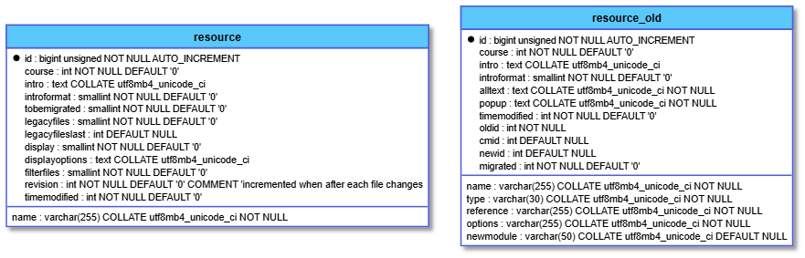

**daris_scorm**

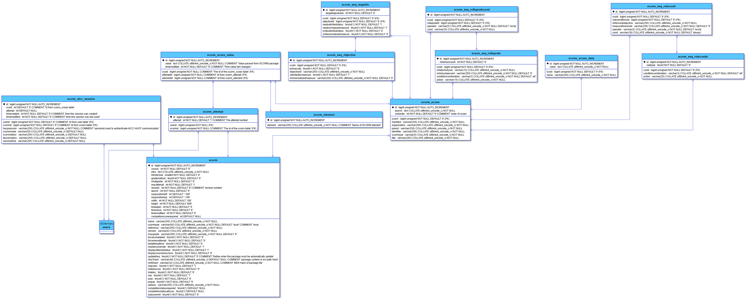

**daris_search**

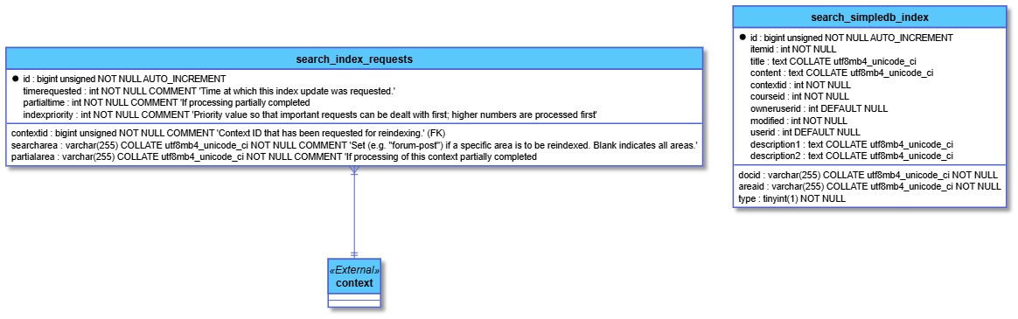

**daris_sessions**

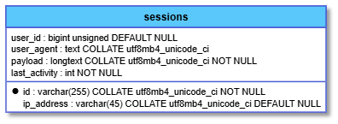

**daris_survey**

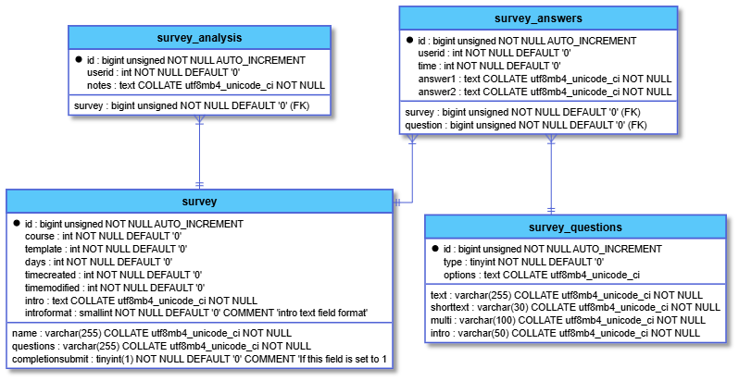**daris_tags**

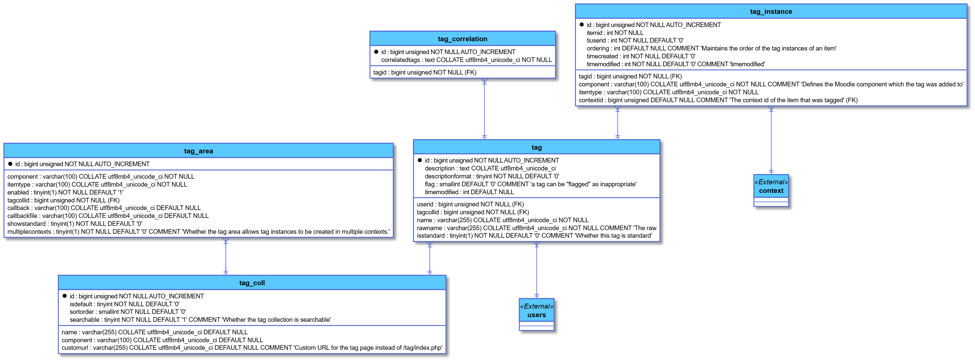

**daris_task**

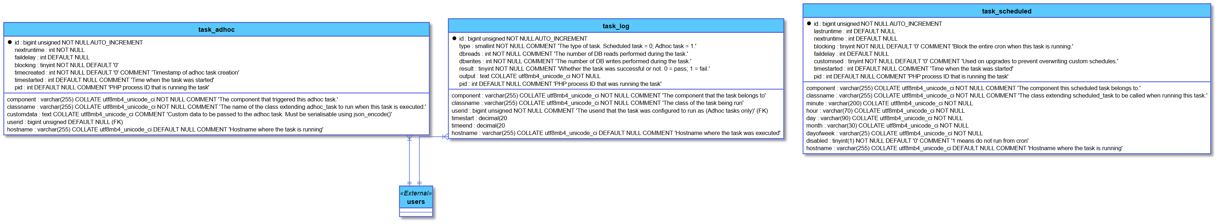

**daris_tool**

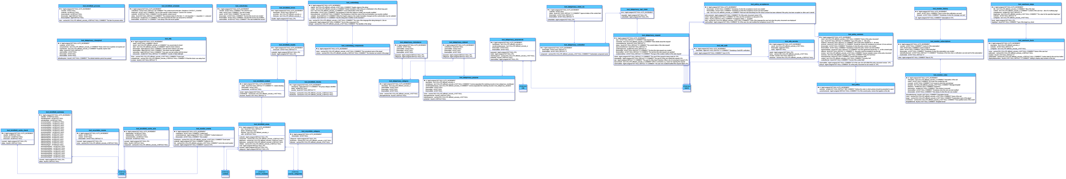

**daris_upgrade**

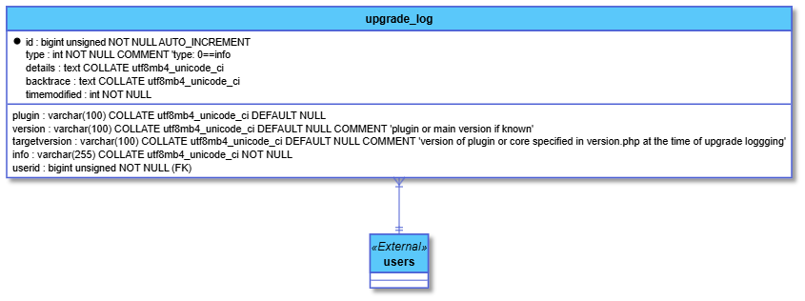

**daris_url**

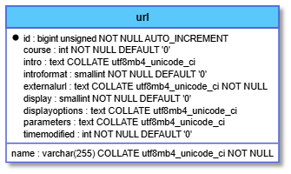

**daris_wiki**

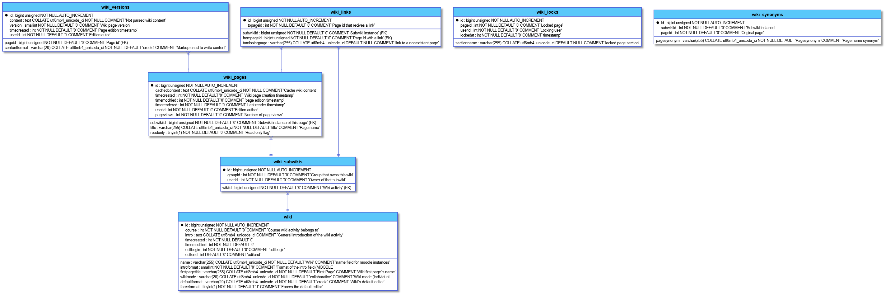

**daris_workshop**

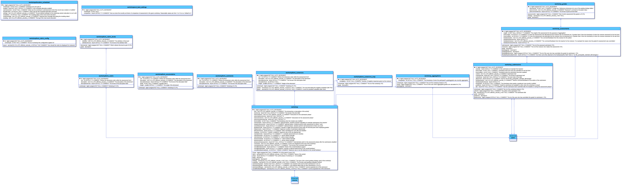

# ****6. System Design & Architecture****

## ****6.1 High-Level Architecture Diagram****

**Daris LMS follows a decoupled, microservices-ready architecture with clear separation between presentation, business logic, and data layers. The system is organized into three primary tiers:**

### **Architecture Layers:**

1. **Presentation Layer (Frontend)**
   * **Built with Next.js 15 using the App Router**
   * **Stateless React components communicating exclusively via REST API**
   * **Client-side state management with Redux Toolkit and RTK Query**
   * **Responsive UI using Shadcn/UI and Tailwind CSS**
2. **Application Layer (Backend)**
   * **Laravel 12 REST API serving JSON responses**
   * **Business logic organized into service classes and controllers**
   * **Authentication handled by Laravel Sanctum**
   * **Search integration via Laravel Scout with TypeSense driver**
3. **Data Layer**
   * **MySQL 8.0+ primary database with normalized schema**
   * **Redis for caching, session management, and queues**
   * **TypeSense cluster for real-time search indexing**
   * **File storage using Laravel Filesystem (local/AWS S3)**

### **Key Architectural Principles:**

* **API-First Design: Frontend communicates only through documented REST endpoints**
* **Stateless Backend: No server-side sessions; authentication via tokens**
* **Horizontal Scalability: Each component can be scaled independently**
* **Modular Design: Features developed as independent, testable modules**
* **Fault Tolerance: Graceful degradation when external services fail**

## ****6.2 Backend Architecture (Laravel)****

### **6.2.1 Directory Structure**

**text**

**app/**

**├── Console/**

**│ └── Commands/ # Custom Artisan commands**

**├── Exceptions/ # Custom exception handlers**

**├── Http/**

**│ ├── Controllers/ # API controllers (organized by module)**

**│ │ ├── Api/V1/ # Versioned API controllers**

**│ │ │ ├── AuthController.php**

**│ │ │ ├── CourseController.php**

**│ │ │ └── ...**

**│ ├── Middleware/ # Custom middleware**

**│ │ ├── Authenticate.php**

**│ │ ├── CheckRole.php**

**│ │ └── ...**

**│ └── Requests/ # Form request validation**

**├── Models/ # Eloquent models**

**│ ├── User.php**

**│ ├── Course.php**

**│ └── ...**

**├── Policies/ # Authorization policies**

**├── Providers/ # Service providers**

**├── Services/ # Business logic services**

**│ ├── SearchService.php**

**│ ├── EnrollmentService.php**

**│ └── ...**

**└── Jobs/ # Queueable jobs**

### **6.2.2 Core Components**

**1. Service Layer Pattern**

**php**

***// Example: EnrollmentService***

**class EnrollmentService {**

**public function enrollUser(User $user, Course $course, string $role): Enrollment**

**{**

***// Business logic for enrollment***

***// Validation, logging, notifications***

**return $enrollment;**

**}**

**}**

**2. Repository Pattern (Optional for complex queries)**

* **Abstracts data access logic**
* **Improves testability**
* **Centralizes query building**

**3. Service Providers**

* **AuthServiceProvider: Registers policies and gates**
* **AppServiceProvider: General bindings**
* **SearchServiceProvider: TypeSense configuration**

**4. Middleware Pipeline**

* **auth:sanctum – Token validation**
* **role:instructor,admin – Role-based access**
* **throttle:api – Rate limiting**
* **localization – Language detection**

### **6.2.3 Key Design Patterns**

* **Observer Pattern: For event-driven actions (e.g., send email on enrollment)**
* **Strategy Pattern: For interchangeable algorithms (e.g., different grading methods)**
* **Factory Pattern: For object creation (e.g., different question types)**
* **Repository Pattern: For data access abstraction**

## ****6.3 Frontend Architecture (Next.js)****

### **6.3.1 Directory Structure (App Router)**

**text**

**app/**

**├── (auth)/ # Auth route group**

**│ ├── login/**

**│ ├── register/**

**│ └── ...**

**├── (dashboard)/ # Protected routes**

**│ ├── courses/**

**│ ├── grades/**

**│ └── ...**

**├── api/ # API routes (for SSR/edge functions)**

**├── components/ # Reusable components**

**│ ├── ui/ # Shadcn components**

**│ ├── course/**

**│ └── ...**

**├── lib/ # Utility libraries**

**│ ├── api/ # RTK Query API definitions**

**│ ├── store/ # Redux store configuration**

**│ └── utils/ # Helper functions**

**└── providers/ # Context providers**

### **6.3.2 State Management Strategy**

**1. RTK Query for Server State**

**typescript**

***// Example: Course API slice***

**const courseApi = createApi({**

**reducerPath: 'courseApi',**

**baseQuery: fetchBaseQuery({ baseUrl: '/api/v1/' }),**

**tagTypes: ['Course', 'Enrollment'],**

**endpoints: (builder) => ({**

**getCourses: builder.query({**

**query: () => 'courses',**

**providesTags: ['Course'],**

**}),**

**enrollInCourse: builder.mutation({**

**query: (courseId) => ({**

**url: `courses/${courseId}/enroll`,**

**method: 'POST',**

**}),**

**invalidatesTags: ['Course', 'Enrollment'],**

**}),**

**}),**

**});**

**2. Redux Toolkit for Client State**

* **UI state (modals, filters, form state)**
* **User preferences (theme, language)**
* **Complex client-side computations**

**3. React Context for Theme/Locale**

* **ThemeProvider (light/dark mode)**
* **LocaleProvider (RTL/LTR, language)**
* **AuthProvider (current user context)**

### **6.3.3 Component Architecture**

* **Atomic Design Principles: Atoms → Molecules → Organisms → Templates → Pages**
* **Server Components by Default: Leverage Next.js 15 server components for data fetching**
* **Client Components for Interactivity: Use 'use client' directive only when needed**
* **Error Boundaries: Graceful error handling at component level**
* **Suspense Boundaries: Loading states for async data**

## ****6.4 Database Schema Overview****

### **6.4.1 Core Tables**

**1. Users & Authentication**

**sql**

***-- users table***

**id, email, username, password_hash, email_verified_at,**

**role_id, avatar_url, bio, qualifications,**

**deleted_at, created_at, updated_at**

***-- roles table***

**id, name, description, permissions_json**

**2. Courses & Content**

**sql**

***-- courses table***

**id, title, slug, category_id, instructor_id,**

**summary, description, visibility, status,**

**thumbnail_url, settings_json, created_at, updated_at**

***-- course_modules table***

**id, course_id, title, description, position,**

**is_published, created_at, updated_at**

***-- resources table***

**id, module_id, title, type, content,**

**file_path, metadata_json, version,**

**created_at, updated_at**

**3. Enrollment & Access**

**sql**

***-- enrollments table***

**id, user_id, course_id, role, status,**

**enrolled_at, completed_at, settings_json**

***-- groups table***

**id, course_id, name, description,**

**max_members, created_at, updated_at**

***-- group_members table***

**id, group_id, user_id, role, joined_at**

**4. Assessment & Grading**

**sql**

***-- assignments table***

**id, course_id, title, description, due_date,**

**max_grade, submission_type, settings_json**

***-- submissions table***

**id, assignment_id, user_id, content,**

**file_paths, submitted_at, grade, feedback,**

**graded_at, grader_id**

***-- quizzes table***

**id, course_id, title, description,**

**time_limit, attempts_allowed, settings_json**

***-- questions table***

**id, quiz_id, type, question_text, options_json,**

**correct_answer, points, position**

### **6.4.2 Indexing Strategy**

* **Primary Keys: Auto-incrementing integers**
* **Foreign Keys: Indexed for join performance**
* **Composite Indexes: For common query patterns**
* **Full-Text Indexes: For searchable text columns (supplemented by TypeSense)**

### **6.4.3 Migration Strategy**

* **Laravel migrations for version control**
* **Seeding for development and testing**
* **Zero-downtime migrations for production**

## ****6.5 API Design & Endpoints****

### **6.5.1 API Conventions**

* **Base URL: /api/v1/**
* **Authentication: Bearer token in Authorization header**
* **Response Format: JSON with consistent structure**
* **Versioning: URL path versioning (v1, v2, etc.)**
* **Pagination: page, per_page parameters**
* **Filtering: filter[field]=value syntax**
* **Sorting: sort=field,-field (descending with -)**
* **Includes: include=relation1,relation2**

### **6.5.2 Endpoint Categories**

**1. Authentication**

**text**

**POST /api/v1/auth/register**

**POST /api/v1/auth/login**

**POST /api/v1/auth/logout**

**POST /api/v1/auth/forgot-password**

**POST /api/v1/auth/reset-password**

**POST /api/v1/auth/refresh**

**2. Users**

**text**

**GET /api/v1/users**

**POST /api/v1/users**

**GET /api/v1/users/{id}**

**PUT /api/v1/users/{id}**

**DELETE /api/v1/users/{id}**

**GET /api/v1/users/me**

**PUT /api/v1/users/me**

**GET /api/v1/users/{id}/courses**

**3. Courses**

**text**

**GET /api/v1/courses**

**POST /api/v1/courses**

**GET /api/v1/courses/{id}**

**PUT /api/v1/courses/{id}**

**DELETE /api/v1/courses/{id}**

**POST /api/v1/courses/{id}/enroll**

**DELETE /api/v1/courses/{id}/unenroll**

**GET /api/v1/courses/{id}/modules**

**GET /api/v1/courses/{id}/students**

**4. Assessment**

**text**

**GET /api/v1/courses/{courseId}/assignments**

**POST /api/v1/courses/{courseId}/assignments**

**GET /api/v1/assignments/{id}/submissions**

**POST /api/v1/assignments/{id}/submit**

**PUT /api/v1/submissions/{id}/grade**

### **6.5.3 Response Standards**

**json**

**{**

**"data": {**

**"id": 1,**

**"type": "course",**

**"attributes": {**

**"title": "Introduction to Laravel",**

**"description": "..."**

**},**

**"relationships": {**

**"instructor": {**

**"data": { "id": 5, "type": "user" }**

**}**

**}**

**},**

**"meta": {**

**"pagination": {**

**"total": 100,**

**"count": 10,**

**"per_page": 10,**

**"current_page": 1,**

**"total_pages": 10**

**}**

**},**

**"links": {**

**"self": "/api/v1/courses?page=1",**

**"next": "/api/v1/courses?page=2",**

**"last": "/api/v1/courses?page=10"**

**}**

**}**

**Error Response:**

**json**

**{**

**"error": {**

**"code": "VALIDATION_ERROR",**

**"message": "The given data was invalid.",**

**"errors": {**

**"email": ["The email field is required."]**

**}**

**}**

**}**

## ****6.6 Authentication & Authorization Flow****

### **6.6.1 Authentication (Laravel Sanctum)**

**text**

**1. User submits credentials → /api/v1/auth/login**

**2. Backend validates credentials**

**3. On success:**

**- Generate Sanctum token**

**- Store token hash in database**

**- Return token to client**

**4. Client stores token (secure HTTP-only cookie or localStorage)**

**5. Subsequent requests include token in Authorization header**

**6. Sanctum middleware validates token on each request**

**Token Management:**

* **Expiration: Configurable (default 30 days)**
* **Scope: Tokens can have abilities (read, write, admin)**
* **Revocation: User can revoke tokens individually or all**
* **Refresh: Optional refresh token mechanism**

### **6.6.2 Authorization (RBAC + Policies)**

**1. Role-Based Access Control**

**php**

***// Roles: Admin, Instructor, Student, Support, Guest***

***// Permissions defined per role in database***

**2. Laravel Policies**

**php**

***// CoursePolicy.php***

**class CoursePolicy {**

**public function view(User $user, Course $course): bool {**

**return $user->isAdmin() ||**

**$course->isInstructor($user) ||**

**$course->isEnrolled($user);**

**}**

**public function update(User $user, Course $course): bool {**

**return $user->isAdmin() || $course->isInstructor($user);**

**}**

**}**

**3. Middleware Protection**

**php**

***// routes/api.php***

**Route::middleware(['auth:sanctum', 'role:instructor,admin'])**

**->group(function () {**

**Route::apiResource('courses', CourseController::class);**

**});**

**4. Context-Based Permissions**

* **System context → Category context → Course context → Module context**
* **Permissions cascade downward unless overridden**
* **Granular control at each level**

## ****6.7 Search & Indexing Architecture (TypeSense)****

### **6.7.1 TypeSense Schema Design**

**json**

**{**

**"name": "courses",**

**"fields": [**

**{"name": "id", "type": "int32"},**

**{"name": "title", "type": "string"},**

**{"name": "description", "type": "string"},**

**{"name": "category", "type": "string", "facet": true},**

**{"name": "instructor_name", "type": "string", "facet": true},**

**{"name": "created_at", "type": "int64"},**

**{"name": "popularity", "type": "int32"},**

**{"name": "tags", "type": "string[]", "facet": true}**

**],**

**"default_sorting_field": "popularity"**

**}**

### **6.7.2 Indexing Strategy**

**1. Real-time Indexing**

**php**

***// Course model***

**class Course extends Model {**

**use Searchable;**

**public function searchableAs(): string {**

**return 'courses';**

**}**

**public function toSearchableArray(): array {**

**return [**

**'id' => $this->id,**

**'title' => $this->title,**

**'description' => $this->description,**

**'category' => $this->category->name,**

**'instructor_name' => $this->instructor->full_name,**

**'created_at' => $this->created_at->timestamp,**

**'popularity' => $this->enrollments_count,**

**'tags' => $this->tags->pluck('name')->toArray()**

**];**

**}**

**}**

**2. Search Query Flow**

**text**

**1. User enters search term**

**2. Frontend calls /api/v1/search?q=term**

**3. Laravel Scout builds TypeSense query**

**4. TypeSense returns ranked results with facets**

**5. Results transformed and returned to client**

**3. Multi-Collection Search**

* **courses collection: Courses, modules, resources**
* **users collection: Instructors, students**
* **content collection: Files, pages, media**

### **6.7.3 Performance Optimization**

* **Caching: Frequently searched queries cached in Redis**
* **Synonyms: Configured for common educational terms**
* **Typo Tolerance: Built-in typo correction**
* **Facet Caching: Pre-computed facet counts**

## ****6.8 File Storage Strategy****

### **6.8.1 Storage Architecture**

**text**

**┌─────────────────────────────────────────────────┐**

**│ Laravel Filesystem │**

**│ (Storage Abstraction Layer) │**

**├─────────────────────────────────────────────────┤**

**│ Local Driver │ S3 Driver │ Custom │**

**│ (Development) │ (Production) │ Drivers │**

**└─────────────────────────────────────────────────┘**

### **6.8.2 File Organization**

**text**

**storage/app/**

**├── public/ # Publicly accessible**

**│ ├── avatars/ # User profile pictures**

**│ ├── thumbnails/ # Course thumbnails**

**│ └── ...**

**├── private/ # Protected files**

**│ ├── submissions/ # Assignment submissions**

**│ ├── resources/ # Course materials**

**│ └── backups/ # System backups**

**└── temp/ # Temporary uploads**

### **6.8.3 File Processing Pipeline**

**php**

***// Example: File upload flow***

**1. Client uploads file → /api/v1/files/upload**

**2. Server validates (size, type, virus scan)**

**3. Generate unique filename (UUID + timestamp)**

**4. Store file in appropriate location**

**5. Create database record with metadata**

**6. Process if needed (image resize, PDF extract)**

**7. Return file URL and metadata to client**

### **6.8.4 Security Measures**

* **Access Control: Signed URLs for private files**
* **Virus Scanning: ClamAV integration for uploads**
* **Quota Management: User/role-based storage limits**
* **Encryption: Server-side encryption for sensitive files**
* **Backup: Regular backups to separate location**

## ****6.9 Caching Strategy (Redis)****

### **6.9.1 Cache Layers**

**1. Application Cache (Laravel Cache)**

**php**

***// Cache expensive queries***

**$courses = Cache::remember('popular_courses', 3600, function () {**

**return Course::withCount('enrollments')**

**->orderBy('enrollments_count', 'desc')**

**->limit(10)**

**->get();**

**});**

**2. API Response Cache**

* **Cache entire API responses for public endpoints**
* **Tag-based cache invalidation**
* **Vary by user role/language**

**3. Session Storage**

* **Sanctum token metadata**
* **User permissions cache**
* **Temporary form data**

### **6.9.2 Cache Invalidation Strategy**

* **Time-based: TTL for time-sensitive data**
* **Event-based: Clear cache on data changes**
* **Tag-based: Invalidate related cache entries**
* **Manual: Clear specific keys when needed**

**Cache Tags Example:**

**php**

***// Cache with tags***

**Cache::tags(['courses', 'user_' . $userId])**

**->put('user_courses', $courses, 3600);**

***// Invalidate all course-related cache***

**Cache::tags('courses')->flush();**

### **6.9.3 Redis Configuration**

**php**

***// config/cache.php***

**'redis' => [**

**'client' => env('REDIS_CLIENT', 'phpredis'),**

**'default' => [**

**'host' => env('REDIS_HOST', '127.0.0.1'),**

**'password' => env('REDIS_PASSWORD'),**

**'port' => env('REDIS_PORT', 6379),**

**'database' => 0, *// Cache***

**],**

**'session' => [**

**'database' => 1, *// Sessions***

**],**

**'queue' => [**

**'database' => 2, *// Queues***

**],**

**],**

## ****6.10 Background Jobs & Queues****

### **6.10.1 Queue Architecture**

**text**

**┌─────────────────────────────────────────────────┐**

**│ Laravel Queue Worker │**

**├─────────────────────────────────────────────────┤**

**│ Redis Queue │ Database │ SQS/Sync │**

**│ (Primary) │ (Fallback) │ (Alternate) │**

**└─────────────────────────────────────────────────┘**

### **6.10.2 Job Categories**

**1. Email Jobs**

**php**

**SendWelcomeEmail::dispatch($user);**

**SendPasswordReset::dispatch($user, $token);**

**SendCourseNotification::dispatch($course, $notification);**

**2. Processing Jobs**

**php**

**ProcessFileUpload::dispatch($file);**

**GenerateThumbnail::dispatch($image);**

**ProcessVideoTranscoding::dispatch($video);**

**3. System Jobs**

**php**

**GenerateReports::dispatch($dateRange);**

**CleanupTempFiles::dispatch();**

**BackupDatabase::dispatch();**

**4. Search Jobs**

**php**

**IndexCourse::dispatch($course);**

**ReindexAllCourses::dispatch();**

**RemoveFromIndex::dispatch($model);**

### **6.10.3 Queue Configuration**

**php**

***// config/queue.php***

**'redis' => [**

**'driver' => 'redis',**

**'connection' => 'queue',**

**'queue' => env('REDIS_QUEUE', 'default'),**

**'retry_after' => 90,**

**'block_for' => null,**

**'after_commit' => false,**

**],**

***// Queue priorities***

**'high' => 0, *// Critical notifications***

**'default' => 1, *// Standard processing***

**'low' => 2, *// Batch operations***

### **6.10.4 Monitoring & Failure Handling**

**1. Failed Jobs Table**

**php**

***// Monitor failed jobs***

**php artisan queue:failed**

***// Retry failed jobs***

**php artisan queue:retry all**

**2. Horizon Dashboard**

* **Real-time queue metrics**
* **Job throughput monitoring**
* **Failed job inspection**
* **Queue balancing**

**3. Alerting**

* **Failed job notifications (Slack, Email)**
* **Queue length warnings**
* **Worker process monitoring**

### **6.10.5 Scheduled Tasks**

**php**

***// app/Console/Kernel.php***

**protected function schedule(Schedule $schedule)**

**{**

***// Daily backups***

**$schedule->command('backup:run')->daily();**

***// Hourly cleanup***

**$schedule->command('cleanup:temp-files')->hourly();**

***// Real-time notifications***

**$schedule->command('notifications:send')->everyMinute();**

***// Weekly reports***

**$schedule->command('reports:generate')->weekly();**

**}**

# ****7. User Interface & Experience****

## ****7.1 Design Principles****

### **7.1.1 Core Design Philosophy**

**Daris LMS follows a human-centered design approach focused on creating intuitive, efficient, and accessible learning experiences. Our design principles guide every interface decision:**

1. **Clarity Over Cleverness**
   * **Use familiar patterns that users already understand**
   * **Provide clear affordances and feedback**
   * **Avoid unnecessary complexity**
2. **Consistency Across Experience**
   * **Maintain visual and interaction consistency**
   * **Establish and follow design patterns**
   * **Create predictable user experiences**
3. **Accessibility by Default**
   * **Design for all abilities from the beginning**
   * **Meet WCAG 2.1 AA standards**
   * **Support keyboard navigation and screen readers**
4. **Progressive Disclosure**
   * **Show only what's needed, when it's needed**
   * **Hide advanced features behind appropriate controls**
   * **Guide users through complex workflows**
5. **Responsive & Adaptive**
   * **Design for all screen sizes and devices**
   * **Adapt layouts based on context and capabilities**
   * **Ensure touch-friendly interactions on mobile**

### **7.1.2 Visual Design Principles**

**Typography Hierarchy:**

**css**

***/* Type scale */***

**--text-xs: 0.75rem; */* 12px */***

**--text-sm: 0.875rem; */* 14px */***

**--text-base: 1rem; */* 16px */***

**--text-lg: 1.125rem; */* 18px */***

**--text-xl: 1.25rem; */* 20px */***

**--text-2xl: 1.5rem; */* 24px */***

**--text-3xl: 1.875rem; */* 30px */***

**--text-4xl: 2.25rem; */* 36px */***

**Color System:**

**css**

***/* Primary palette */***

**--primary-50: #eff6ff;**

**--primary-100: #dbeafe;**

**--primary-500: #3b82f6; */* Brand blue */***

**--primary-900: #1e3a8a;**

***/* Semantic colors */***

**--success: #10b981;**

**--warning: #f59e0b;**

**--error: #ef4444;**

**--info: #3b82f6;**

**Spacing System (8px grid):**

**css**

**--space-1: 0.25rem; */* 4px */***

**--space-2: 0.5rem; */* 8px */***

**--space-4: 1rem; */* 16px */***

**--space-8: 2rem; */* 32px */***

**--space-12: 3rem; */* 48px */***

## ****7.2 UI Component Library (Shadcn/UI)****

### **7.2.1 Component Architecture**

**Daris LMS uses Shadcn/UI as its foundation, extended with custom components for educational workflows:**

**text**

**components/**

**├── ui/ # Base Shadcn components**

**│ ├── button.tsx**

**│ ├── card.tsx**

**│ ├── dialog.tsx**

**│ └── ...**

**├── forms/ # Form components**

**│ ├── form-input.tsx**

**│ ├── form-select.tsx**

**│ ├── form-textarea.tsx**

**│ └── ...**

**├── course/ # Course-specific components**

**│ ├── course-card.tsx**

**│ ├── lesson-viewer.tsx**

**│ ├── quiz-player.tsx**

**│ └── ...**

**├── navigation/ # Navigation components**

**│ ├── sidebar.tsx**

**│ ├── breadcrumb.tsx**

**│ ├── pagination.tsx**

**│ └── ...**

**└── data-display/ # Data visualization**

**├── grade-chart.tsx**

**├── progress-bar.tsx**

**├── statistics-card.tsx**

**└── ...**

### **7.2.2 Custom Component Patterns**

**1. Compound Components**

**tsx**

***// CourseCard component with multiple variants***

**<CourseCard>**

**<CourseCard.Header>**

**<CourseCard.Title>Introduction to Laravel</CourseCard.Title>**

**<CourseCard.Instructor>Dr. Karim</CourseCard.Instructor>**

**</CourseCard.Header>**

**<CourseCard.Content>**

**<ProgressBar value={75} />**

**<DueDate date="2024-03-15" />**

**</CourseCard.Content>**

**<CourseCard.Footer>**

**<Button variant="outline">Continue</Button>**

**</CourseCard.Footer>**

**</CourseCard>**

**2. Loading States**

**tsx**

***// Skeleton loading patterns***

**<SkeletonCard>**

**<SkeletonHeader />**

**<SkeletonLines count={3} />**

**<SkeletonFooter />**

**</SkeletonCard>**

**3. Empty States**

**tsx**

**<EmptyState**

**icon={<BookOpen className="h-12 w-12" />}**

**title="No courses yet"**

**description="Get started by enrolling in your first course"**

**action={**

**<Button>**

**<Plus className="mr-2 h-4 w-4" />**

**Browse Courses**

**</Button>**

**}**

**/>**

### **7.2.3 Theme Configuration**

**typescript**

***// tailwind.config.js***

**module.exports = {**

**theme: {**

**extend: {**

**colors: {**

**primary: {**

**50: '#eff6ff',**

**100: '#dbeafe',**

***// ... up to 900***

**},**

**border: 'hsl(var(--border))',**

**input: 'hsl(var(--input))',**

**ring: 'hsl(var(--ring))',**

**background: 'hsl(var(--background))',**

**foreground: 'hsl(var(--foreground))',**

**},**

**borderRadius: {**

**lg: 'var(--radius)',**

**md: 'calc(var(--radius) - 2px)',**

**sm: 'calc(var(--radius) - 4px)',**

**},**

**},**

**},**

**}**

## ****7.3 Responsive Design Guidelines****

### **7.3.1 Breakpoint System**

**css**

***/* Tailwind breakpoints */***

**sm: 640px */* Mobile landscape */***

**md: 768px */* Tablet portrait */***

**lg: 1024px */* Tablet landscape / Small desktop */***

**xl: 1280px */* Desktop */***

**2xl: 1536px */* Large desktop */***

### **7.3.2 Responsive Patterns**

**1. Mobile-First Approach**

**tsx**

***// Start with mobile layout, enhance for larger screens***

**<div className="flex flex-col md:flex-row">**

**<aside className="w-full md:w-64">**

**{*/* Sidebar content */*}**

**</aside>**

**<main className="flex-1">**

**{*/* Main content */*}**

**</main>**

**</div>**

**2. Adaptive Navigation**

**tsx**

***// Mobile: Bottom navigation***

***// Tablet: Collapsible sidebar***

***// Desktop: Full sidebar***

**3. Responsive Data Tables**

**tsx**

***// On mobile: Cards with stacked layout***

***// On desktop: Full table with columns***

**<Table>**

**<TableHeader>**

**<TableRow>**

**<TableHead className="hidden md:table-cell">ID</TableHead>**

**<TableHead>Course Name</TableHead>**

**<TableHead className="hidden sm:table-cell">Instructor</TableHead>**

**<TableHead className="hidden lg:table-cell">Enrolled</TableHead>**

**<TableHead>Progress</TableHead>**

**</TableRow>**

**</TableHeader>**

**</Table>**

### **7.3.3 Touch-Friendly Design**

* **Minimum touch target: 44×44px**
* **Spacing between targets: 8px minimum**
* **Avoid hover-only interactions on mobile**
* **Swipe gestures for navigation where appropriate**
* **Pinch-to-zoom enabled for content areas**

### **7.3.4 Performance Considerations**

* **Lazy load off-screen content**
* **Optimize images based on viewport**
* **Conditionally load components based on breakpoint**
* **Reduce animations on low-power devices**

## ****7.4 Accessibility Standards (WCAG 2.1 AA)****

### **7.4.1 Keyboard Navigation**

**tsx**

***// All interactive elements must be focusable***

**<button className="focus:ring-2 focus:ring-primary focus:ring-offset-2">**

**Submit**

**</button>**

***// Manage focus order***

**<div tabIndex={0} role="region" aria-label="Course content">**

**{*/* Content */*}**

**</div>**

### **7.4.2 Screen Reader Support**

**tsx**

***// Semantic HTML***

**<nav aria-label="Main navigation">**

**<ul role="menu">**

**<li role="menuitem">**

**<a href="/dashboard">Dashboard</a>**

**</li>**

**</ul>**

**</nav>**

***// ARIA labels for icons***

**<button aria-label="Search courses">**

**<Search className="h-5 w-5" />**

**</button>**

***// Live regions for dynamic content***

**<div aria-live="polite" aria-atomic="true">**

**{notification}**

**</div>**

### **7.4.3 Color & Contrast Requirements**

* **Text contrast ratio: 4.5:1 minimum**
* **Large text contrast ratio: 3:1 minimum**
* **Non-text contrast ratio: 3:1 minimum**
* **Don't use color alone to convey information**

**tsx**

***// Bad: Using only color***

**<span className="text-red-500">Required</span>**

***// Good: Color plus icon/label***

**<span className="text-red-500 flex items-center">**

**<AlertCircle className="mr-1 h-4 w-4" />**

**Required**

**</span>**

### **7.4.4 Form Accessibility**

**tsx**

**<FormField**

**control={form.control}**

**name="email"**

**render={({ field }) => (**

**<FormItem>**

**<FormLabel htmlFor="email">Email</FormLabel>**

**<FormControl>**

**<Input**

**id="email"**

**type="email"**

**placeholder="your@email.com"**

**{...field}**

**aria-describedby="email-error"**

**/>**

**</FormControl>**

**<FormMessage id="email-error" />**

**</FormItem>**

**)}**

**/>**

### **7.4.5 Accessibility Testing Checklist**

* **All images have alt text**
* **Videos have captions and transcripts**
* **Color contrast meets requirements**
* **Keyboard navigation works completely**
* **Screen readers announce content correctly**
* **Focus indicators are visible**
* **Form fields have proper labels**
* **Error messages are accessible**
* **Animations can be reduced or disabled**

## ****7.5 Localization & RTL Support****

### **7.5.1 Internationalization Setup**

**typescript**

***// lib/i18n.ts***

**export const i18n = {**

**defaultLocale: 'en',**

**locales: ['en', 'ar'],**

**} as const**

***// Use next-intl for translations***

**import { useTranslations } from 'next-intl'**

**export function WelcomeMessage() {**

**const t = useTranslations('Dashboard')**

**return (**

**<h1>{t('welcome', { name: 'Samira' })}</h1>**

**)**

**}**

### **7.5.2 RTL Support Implementation**

**css**

***/* CSS logical properties */***

**.text-start {**

**text-align: start;**

**}**

**.margin-inline-start {**

**margin-inline-start: 1rem;**

**}**

***/* RTL-specific styles */***

**[dir="rtl"] .flip-icon {**

**transform: scaleX(-1);**

**}**

**tsx**

***// Component with RTL support***

**import { useLocale } from 'next-intl'**

**export function NavigationMenu() {**

**const locale = useLocale()**

**const isRTL = locale === 'ar'**

**return (**

**<div dir={isRTL ? 'rtl' : 'ltr'}>**

**<ChevronRight className={isRTL ? 'rotate-180' : ''} />**

**</div>**

**)**

**}**

### **7.5.3 Date & Number Formatting**

**tsx**

**import { useFormatter } from 'next-intl'**

**export function CourseDate({ date }: { date: Date }) {**

**const format = useFormatter()**

**return (**

**<time dateTime={date.toISOString()}>**

**{format.dateTime(date, {**

**year: 'numeric',**

**month: 'long',**

**day: 'numeric',**

**hour: '2-digit',**

**minute: '2-digit',**

**})}**

**</time>**

**)**

**}**

### **7.5.4 Translation Files Structure**

**text**

**locales/**

**├── en/**

**│ ├── common.json**

**│ ├── dashboard.json**

**│ ├── courses.json**

**│ └── ...**

**└── ar/**

**├── common.json**

**├── dashboard.json**

**├── courses.json**

**└── ...**

**Example translation file:**

**json**

**{**

**"Dashboard": {**

**"welcome": "Welcome, {name}!",**

**"courses": "My Courses",**

**"upcoming": "Upcoming Deadlines"**

**},**

**"Courses": {**

**"enroll": "Enroll in Course",**

**"completed": "Completed",**

**"inProgress": "In Progress"**

**}**

**}**

## ****7.6 Key User Flows (Wireframes/Prototypes)****

### **7.6.1 Student Onboarding Flow**

**text**

**[Landing Page] → [Sign Up] → [Email Verification] →**

**[Profile Setup] → [Dashboard] → [Course Discovery] →**

**[Course Enrollment] → [First Lesson]**

**Key Screens:**

1. **Landing Page - Value proposition, featured courses**
2. **Sign Up Form - Email, password, name**
3. **Email Verification - Success message, resend option**
4. **Profile Setup - Avatar upload, bio, preferences**
5. **Dashboard - Personalized welcome, course recommendations**
6. **Course Catalog - Filterable grid of available courses**
7. **Course Detail - Syllabus, instructor info, enrollment CTA**
8. **First Lesson - Guided introduction to the platform**

### **7.6.2 Instructor Course Creation Flow**

**text**

**[Dashboard] → [Create Course] → [Basic Info] →**

**[Course Structure] → [Add Content] → [Add Assessments] →**

**[Configure Settings] → [Publish]**

**Key Screens:**

1. **Course Creation Wizard - Step-by-step guidance**
2. **Course Builder - Drag-and-drop module organization**
3. **Content Editor - Rich text editor with media upload**
4. **Assessment Creator - Quiz/assignment configuration**
5. **Settings Panel - Visibility, enrollment, grading settings**
6. **Preview Mode - Student-view preview before publishing**
7. **Publish Confirmation - Final review and publish**

### **7.6.3 Student Learning Flow**

**text**

**[Course Dashboard] → [Module Navigation] → [Content Viewer] →**

**[Interactive Elements] → [Assessment] → [Feedback] →**

**[Progress Tracking]**

**Key Components:**

* **Module Sidebar - Collapsible navigation tree**
* **Content Viewer - Adaptive to content type (video, PDF, text)**
* **Interactive Elements - Embedded quizzes, discussions**
* **Progress Tracker - Visual completion indicators**
* **Note-taking Panel - Integrated note-taking functionality**
* **Bookmarking - Save positions for later return**

### **7.6.4 Grading & Feedback Flow**

**text**

**[Gradebook] → [Select Assignment] → [Student Submissions] →**

**[Rubric Scoring] → [Add Comments] → [Record Grade] →**

**[Return to Students]**

**Key Features:**

* **Batch Grading - Grade multiple submissions efficiently**
* **Rubric Integration - Click-to-score rubrics**
* **Inline Comments - Comment directly on submissions**
* **Audio Feedback - Record voice comments**
* **Template Responses - Save common feedback for reuse**
* **Grade Distribution - Visual analytics of class performance**

### **7.6.5 Mobile-Specific Flows**

**Mobile Navigation Pattern:**

**tsx**

***// Bottom navigation for main sections***

**<BottomNavigation>**

**<NavItem icon={<Home />} label="Home" />**

**<NavItem icon={<BookOpen />} label="Courses" />**

**<NavItem icon={<Calendar />} label="Calendar" />**

**<NavItem icon={<Bell />} label="Notifications" />**

**<NavItem icon={<User />} label="Profile" />**

**</BottomNavigation>**

**Touch-Optimized Interactions:**

* **Swipe to navigate between lessons**
* **Pull-to-refresh for content updates**
* **Gesture-based note-taking**
* **Voice input for search and commands**

### **7.6.6 Prototype Fidelity Guidelines**

**Low-Fidelity (Wireframes):**

* **Focus on layout and flow**
* **Use placeholders for content**
* **Validate information architecture**
* **Test with users early**

**Mid-Fidelity:**

* **Add actual content**
* **Define interaction patterns**
* **Establish visual hierarchy**
* **Conduct usability testing**

**High-Fidelity:**

* **Final visual design**
* **Animations and transitions**
* **Accessibility testing**
* **Performance optimization**

# ****8. API Documentation****

## ****8.1 API Base URL & Versioning****

### **8.1.1 Base URLs**

**text**

**Development: http://localhost:8000/api**

**Staging: https://staging.darislms.com/api**

**Production: https://api.darislms.com/api**

### **8.1.2 Versioning Strategy**

**Daris LMS uses URL path versioning to maintain backward compatibility:**

**http**

**/api/v1/ # Current stable version**

**/api/v2/ # Future version (when released)**

**Version Lifecycle:**

* **Active Support: 18 months from release**
* **Security Updates: 24 months from release**
* **Deprecation Notice: 6 months before removal**
* **Migration Path: Documentation and migration tools provided**

### **8.1.3 API Rate Limiting**

**http**

**X-RateLimit-Limit: 1000**

**X-RateLimit-Remaining: 995**

**X-RateLimit-Reset: 1634567890**

**Rate Limits by Plan:**

* **Guest: 100 requests/hour**
* **Student: 1,000 requests/hour**
* **Instructor: 5,000 requests/hour**
* **Administrator: 10,000 requests/hour**

## ****8.2 Authentication (Sanctum Tokens)****

### **8.2.1 Authentication Methods**

**Daris LMS supports two authentication methods:**

**1. Bearer Token Authentication (Recommended)**

**http**

**GET /api/v1/courses**

**Authorization: Bearer {personal_access_token}**

**2. Cookie-based Authentication (For same-domain SPAs)**

**http**

**GET /api/v1/courses**

**Cookie: daris_session={session_token}**

### **8.2.2 Token Management Endpoints**

#### **Login**

**http**

**POST /api/v1/auth/login**

**Content-Type: application/json**

**{**

**"email": "student@example.com",**

**"password": "securepassword123",**

**"device_name": "Chrome on Windows"**

**}**

**Response:**

**json**

**{**

**"data": {**

**"token": "1|abcdefghijklmnopqrstuvwxyz123456",**

**"user": {**

**"id": 1,**

**"name": "Samira Ahmed",**

**"email": "student@example.com",**

**"role": "student"**

**}**

**}**

**}**

#### **Logout**

**http**

**POST /api/v1/auth/logout**

**Authorization: Bearer {token}**

#### **Register**

**http**

**POST /api/v1/auth/register**

**Content-Type: application/json**

**{**

**"name": "Ahmed Hassan",**

**"email": "ahmed@example.com",**

**"password": "securepassword123",**

**"password_confirmation": "securepassword123",**

**"role": "student"**

**}**

#### **Password Reset**

**http**

**POST /api/v1/auth/forgot-password**

**Content-Type: application/json**

**{**

**"email": "user@example.com"**

**}**

**POST /api/v1/auth/reset-password**

**Content-Type: application/json**

**{**

**"email": "user@example.com",**

**"token": "reset_token_from_email",**

**"password": "newpassword123",**

**"password_confirmation": "newpassword123"**

**}**

### **8.2.3 Token Scopes & Permissions**

**Tokens can have specific abilities for enhanced security:**

**php**

***// Creating a token with specific abilities***

**$token = $user->createToken('mobile-app', [**

**'courses:read',**

**'assignments:submit',**

**'profile:read'**

**]);**

**Common Token Abilities:**

* **\* - All abilities (admin tokens)**
* **courses:read - Read course content**
* **courses:write - Create/edit courses**
* **grades:read - View grades**
* **grades:write - Submit/update grades**
* **profile:read - Read user profile**
* **profile:write - Update user profile**

### **8.2.4 Token Refresh**

**http**

**POST /api/v1/auth/refresh**

**Authorization: Bearer {expired_token}**

**Response:**

**json**

**{**

**"data": {**

**"token": "2|newtokenabcdefghijklmnopqrstuv",**

**"expires_at": "2024-12-31T23:59:59Z"**

**}**

**}**

## ****8.3 Common Request/Response Formats****

### **8.3.1 Request Format**

**All requests should include proper headers:**

**http**

**GET /api/v1/courses**

**Accept: application/json**

**Content-Type: application/json**

**Authorization: Bearer {token}**

**X-Requested-With: XMLHttpRequest**

**Accept-Language: en-US**

### **8.3.2 Response Format Standard**

#### **Successful Response (Single Resource)**

**json**

**{**

**"data": {**

**"id": "1",**

**"type": "course",**

**"attributes": {**

**"title": "Introduction to Laravel",**

**"description": "Learn Laravel from scratch...",**

**"slug": "introduction-to-laravel",**

**"visibility": "public",**

**"created_at": "2024-01-15T10:30:00Z",**

**"updated_at": "2024-01-20T14:45:00Z"**

**},**

**"relationships": {**

**"instructor": {**

**"data": {**

**"id": "5",**

**"type": "user"**

**},**

**"links": {**

**"related": "/api/v1/users/5"**

**}**

**},**

**"modules": {**

**"data": [**

**{ "id": "1", "type": "module" },**

**{ "id": "2", "type": "module" }**

**]**

**}**

**},**

**"links": {**

**"self": "/api/v1/courses/1"**

**}**

**},**

**"included": [**

**{**

**"id": "5",**

**"type": "user",**

**"attributes": {**

**"name": "Dr. Karim",**

**"email": "karim@example.com",**

**"avatar_url": "https://..."**

**}**

**}**

**]**

**}**

#### **Successful Response (Collection)**

**json**

**{**

**"data": [**

**{**

**"id": "1",**

**"type": "course",**

**"attributes": { ... },**

**"relationships": { ... }**

**},**

**{**

**"id": "2",**

**"type": "course",**

**"attributes": { ... },**

**"relationships": { ... }**

**}**

**],**

**"meta": {**

**"pagination": {**

**"total": 150,**

**"count": 10,**

**"per_page": 10,**

**"current_page": 1,**

**"total_pages": 15,**

**"links": {**

**"first": "/api/v1/courses?page=1",**

**"last": "/api/v1/courses?page=15",**

**"prev": null,**

**"next": "/api/v1/courses?page=2"**

**}**

**},**

**"sort": {**

**"field": "created_at",**

**"direction": "desc"**

**},**

**"filter": {**

**"category": "programming"**

**}**

**},**

**"links": {**

**"self": "/api/v1/courses?page=1",**

**"first": "/api/v1/courses?page=1",**

**"last": "/api/v1/courses?page=15",**

**"prev": null,**

**"next": "/api/v1/courses?page=2"**

**}**

**}**

### **8.3.3 Query Parameters**

#### **Pagination**

**http**

**GET /api/v1/courses?page=2&per_page=20**

#### **Filtering**

**http**

**GET /api/v1/courses?filter[category]=programming&filter[level]=beginner**

#### **Sorting**

**http**

**GET /api/v1/courses?sort=created_at,-title # ASC created_at, DESC title**

#### **Field Selection**

**http**

**GET /api/v1/courses?fields[courses]=id,title,description**

#### **Includes (Eager Loading)**

**http**

**GET /api/v1/courses/1?include=instructor,modules,enrollments**

## ****8.4 Error Handling & Status Codes****

### **8.4.1 Standard Error Response**

**json**

**{**

**"error": {**

**"code": "VALIDATION_ERROR",**

**"message": "The given data was invalid.",**

**"details": {**

**"email": ["The email field is required."],**

**"password": ["The password must be at least 8 characters."]**

**},**

**"documentation_url": "https://docs.darislms.com/errors/validation-error"**

**},**

**"meta": {**

**"timestamp": "2024-01-20T14:30:00Z",**

**"request_id": "req_abc123def456",**

**"trace_id": "trace_xyz789"**

**}**

**}**

### **8.4.2 HTTP Status Codes**

#### **2xx - Success**

* **200 OK - Successful GET, PUT, PATCH, DELETE**
* **201 Created - Resource created successfully**
* **202 Accepted - Request accepted for processing**
* **204 No Content - Successful request with no body**

#### **4xx - Client Errors**

* **400 Bad Request - Malformed request syntax**
* **401 Unauthorized - Authentication required/failed**
* **403 Forbidden - Authenticated but not authorized**
* **404 Not Found - Resource doesn't exist**
* **405 Method Not Allowed - HTTP method not supported**
* **409 Conflict - Resource state conflict**
* **422 Unprocessable Entity - Validation errors**
* **429 Too Many Requests - Rate limit exceeded**

#### **5xx - Server Errors**

* **500 Internal Server Error - Generic server error**
* **502 Bad Gateway - Upstream server error**
* **503 Service Unavailable - Maintenance or overload**
* **504 Gateway Timeout - Upstream timeout**

### **8.4.3 Common Error Codes**

| **Code** | **Description** | **Example** |
| --- | --- | --- |
| **AUTH_REQUIRED** | **Authentication required** | **401** |
| **INVALID_TOKEN** | **Token is invalid/expired** | **401** |
| **INSUFFICIENT_PERMISSIONS** | **User lacks required permissions** | **403** |
| **RESOURCE_NOT_FOUND** | **Requested resource doesn't exist** | **404** |
| **VALIDATION_ERROR** | **Request data validation failed** | **422** |
| **RATE_LIMIT_EXCEEDED** | **Too many requests** | **429** |
| **INTERNAL_ERROR** | **Internal server error** | **500** |
| **SERVICE_UNAVAILABLE** | **Service temporarily unavailable** | **503** |

### **8.4.4 Error Recovery**

**http**

**GET /api/v1/courses/999**

**Response:**

**json**

**{**

**"error": {**

**"code": "RESOURCE_NOT_FOUND",**

**"message": "Course not found",**

**"suggestions": [**

**"Check if the course ID is correct",**

**"Verify you have access to this course",**

**"Browse available courses at /api/v1/courses"**

**]**

**}**

**}**

## ****8.5 Endpoint Reference by Module****

### **8.5.1 Authentication Module**

| **Endpoint** | **Method** | **Description** | **Auth Required** |
| --- | --- | --- | --- |
| **/auth/register** | **POST** | **Register new user** | **No** |
| **/auth/login** | **POST** | **Authenticate user** | **No** |
| **/auth/logout** | **POST** | **Invalidate token** | **Yes** |
| **/auth/forgot-password** | **POST** | **Request password reset** | **No** |
| **/auth/reset-password** | **POST** | **Reset password with token** | **No** |
| **/auth/refresh** | **POST** | **Refresh expired token** | **Yes** |
| **/auth/me** | **GET** | **Get current user info** | **Yes** |

### **8.5.2 User Management Module**

| **Endpoint** | **Method** | **Description** | **Roles** |
| --- | --- | --- | --- |
| **/users** | **GET** | **List users** | **Admin** |
| **/users** | **POST** | **Create user** | **Admin** |
| **/users/{id}** | **GET** | **Get user by ID** | **Admin, Self** |
| **/users/{id}** | **PUT** | **Update user** | **Admin, Self** |
| **/users/{id}** | **DELETE** | **Delete user** | **Admin** |
| **/users/{id}/profile** | **GET** | **Get user profile** | **Admin, Self** |
| **/users/{id}/courses** | **GET** | **Get user's courses** | **Admin, Self** |
| **/users/{id}/enrollments** | **GET** | **Get user's enrollments** | **Admin, Self** |

### **8.5.3 Course Management Module**

| **Endpoint** | **Method** | **Description** | **Roles** |
| --- | --- | --- | --- |
| **/courses** | **GET** | **List courses** | **All** |
| **/courses** | **POST** | **Create course** | **Instructor, Admin** |
| **/courses/{id}** | **GET** | **Get course details** | **All (based on visibility)** |
| **/courses/{id}** | **PUT** | **Update course** | **Instructor (owner), Admin** |
| **/courses/{id}** | **DELETE** | **Delete course** | **Instructor (owner), Admin** |
| **/courses/{id}/modules** | **GET** | **List course modules** | **Enrolled users** |
| **/courses/{id}/modules** | **POST** | **Create module** | **Instructor, Admin** |
| **/courses/{id}/enroll** | **POST** | **Enroll in course** | **Student (if public)** |
| **/courses/{id}/unenroll** | **DELETE** | **Unenroll from course** | **Student, Instructor, Admin** |
| **/courses/{id}/students** | **GET** | **List enrolled students** | **Instructor, Admin** |
| **/courses/{id}/stats** | **GET** | **Get course statistics** | **Instructor, Admin** |

### **8.5.4 Assessment Module**

| **Endpoint** | **Method** | **Description** | **Roles** |
| --- | --- | --- | --- |
| **/courses/{courseId}/assignments** | **GET** | **List assignments** | **Enrolled users** |
| **/courses/{courseId}/assignments** | **POST** | **Create assignment** | **Instructor, Admin** |
| **/assignments/{id}** | **GET** | **Get assignment details** | **Enrolled users** |
| **/assignments/{id}** | **PUT** | **Update assignment** | **Instructor, Admin** |
| **/assignments/{id}** | **DELETE** | **Delete assignment** | **Instructor, Admin** |
| **/assignments/{id}/submit** | **POST** | **Submit assignment** | **Student** |
| **/assignments/{id}/submissions** | **GET** | **List submissions** | **Instructor, Admin** |
| **/submissions/{id}** | **GET** | **Get submission** | **Student (own), Instructor, Admin** |
| **/submissions/{id}/grade** | **PUT** | **Grade submission** | **Instructor, Admin** |

### **8.5.5 Content Module**

| **Endpoint** | **Method** | **Description** | **Roles** |
| --- | --- | --- | --- |
| **/files** | **POST** | **Upload file** | **Instructor, Admin** |
| **/files/{id}** | **GET** | **Get file info** | **Based on permissions** |
| **/files/{id}** | **DELETE** | **Delete file** | **Owner, Admin** |
| **/resources** | **GET** | **List resources** | **Enrolled users** |
| **/resources/{id}** | **GET** | **Get resource** | **Enrolled users** |
| **/resources/{id}/download** | **GET** | **Download resource** | **Enrolled users** |
| **/resources/{id}/versions** | **GET** | **Get version history** | **Instructor, Admin** |

### **8.5.6 Search Module**

| **Endpoint** | **Method** | **Description** | **Auth Required** |
| --- | --- | --- | --- |
| **/search** | **GET** | **Global search** | **No (filtered by visibility)** |
| **/search/courses** | **GET** | **Search courses only** | **No (filtered by visibility)** |
| **/search/users** | **GET** | **Search users** | **Yes (limited by role)** |
| **/search/resources** | **GET** | **Search resources** | **Yes (limited by enrollment)** |

**Search Parameters:**

**http**

**GET /api/v1/search?q=laravel&filter[category]=programming&sort=-relevance&page=1**

### **8.5.7 Analytics Module**

| **Endpoint** | **Method** | **Description** | **Roles** |
| --- | --- | --- | --- |
| **/analytics/courses/{id}/progress** | **GET** | **Course progress analytics** | **Instructor, Admin** |
| **/analytics/courses/{id}/engagement** | **GET** | **Student engagement metrics** | **Instructor, Admin** |
| **/analytics/users/{id}/progress** | **GET** | **User progress across courses** | **Student (own), Instructor, Admin** |
| **/analytics/system/health** | **GET** | **System health metrics** | **Admin** |
| **/analytics/system/usage** | **GET** | **Platform usage statistics** | **Admin** |
| **/reports/grades/{courseId}** | **GET** | **Generate grade report** | **Instructor, Admin** |
| **/reports/attendance/{courseId}** | **GET** | **Generate attendance report** | **Instructor, Admin** |

## ****8.6 Webhooks & Integrations****

### **8.6.1 Webhook System**

**Daris LMS provides webhooks to notify external systems of important events.**

#### **Webhook Configuration**

**http**

**POST /api/v1/webhooks**

**Authorization: Bearer {admin_token}**

**Content-Type: application/json**

**{**

**"name": "Grade Notifications",**

**"url": "https://your-system.com/webhooks/grades",**

**"events": [**

**"submission.graded",**

**"grade.updated"**

**],**

**"secret": "your_webhook_secret",**

**"active": true**

**}**

#### **Supported Webhook Events**

**json**

**{**

**"user": [**

**"user.created",**

**"user.updated",**

**"user.deleted",**

**"user.login",**

**"user.logout"**

**],**

**"course": [**

**"course.created",**

**"course.updated",**

**"course.deleted",**

**"course.published"**

**],**

**"enrollment": [**

**"enrollment.created",**

**"enrollment.deleted",**

**"enrollment.completed"**

**],**

**"assessment": [**

**"assignment.created",**

**"assignment.submitted",**

**"submission.graded",**

**"quiz.completed"**

**],**

**"content": [**

**"resource.created",**

**"resource.updated",**

**"resource.deleted"**

**]**

**}**

### **8.6.2 Webhook Payload Example**

**json**

**{**

**"event": "submission.graded",**

**"timestamp": "2024-01-20T14:30:00Z",**

**"data": {**

**"submission_id": "123",**

**"assignment_id": "45",**

**"course_id": "10",**

**"student_id": "78",**

**"grade": 85,**

**"max_grade": 100,**

**"graded_by": "56",**

**"graded_at": "2024-01-20T14:25:00Z"**

**}**

**}**

### **8.6.3 Webhook Security**

1. **Secret Signing: All webhooks are signed with HMAC-SHA256**
2. **Retry Logic: Failed deliveries retried 3 times with exponential backoff**
3. **Rate Limiting: Maximum 100 webhooks/minute per endpoint**
4. **Payload Validation: Validate payload integrity with signature**

**Verifying Signatures:**

**javascript**

**const crypto = require('crypto');**

**function verifySignature(payload, signature, secret) {**

**const hmac = crypto.createHmac('sha256', secret);**

**const digest = hmac.update(payload).digest('hex');**

**return crypto.timingSafeEqual(**

**Buffer.from(signature),**

**Buffer.from(digest)**

**);**

**}**

### **8.6.4 Integration Endpoints**

#### **LTI 1.3 Integration (Future)**

**http**

**POST /api/v1/lti/launch**

**Content-Type: application/x-www-form-urlencoded**

**{**

**"iss": "https://external-tool.com",**

**"login_hint": "user123",**

**"target_link_uri": "https://darislms.com/lti/launch",**

**"lti_message_hint": "encrypted_data"**

**}**

#### **Data Export (GDPR Compliance)**

**http**

**GET /api/v1/users/{id}/export**

**Authorization: Bearer {admin_token_or_user_own_token}**

**Accept: application/zip**

#### **Health Check**

**http**

**GET /api/v1/health**

**Response:**

**json**

**{**

**"status": "healthy",**

**"timestamp": "2024-01-20T14:30:00Z",**

**"services": {**

**"database": "connected",**

**"cache": "connected",**

**"search": "connected",**

**"storage": "connected"**

**},**

**"metrics": {**

**"uptime": "7d 14h 30m",**

**"memory_usage": "45%",**

**"active_users": 1250**

**}**

**}**

### **8.6.5 API Client Libraries**

**Official client libraries are available for popular languages:**

**JavaScript/TypeScript:**

**bash**

**npm install @darislms/javascript-sdk**

**javascript**

**import { DarisLMS } from '@darislms/javascript-sdk';**

**const client = new DarisLMS({**

**baseURL: 'https://api.darislms.com/api/v1',**

**token: 'your_token_here'**

**});**

**const courses = await client.courses.list();**

**PHP:**

**bash**

**composer require darislms/php-sdk**

**php**

**use DarisLMS\Client;**

**$client = new Client([**

**'base_url' => 'https://api.darislms.com/api/v1',**

**'token' => 'your_token_here'**

**]);**

**$courses = $client->courses()->list();**

### **8.6.6 Webhook Management API**

| **Endpoint** | **Method** | **Description** |
| --- | --- | --- |
| **/webhooks** | **GET** | **List webhooks** |
| **/webhooks** | **POST** | **Create webhook** |
| **/webhooks/{id}** | **GET** | **Get webhook details** |
| **/webhooks/{id}** | **PUT** | **Update webhook** |
| **/webhooks/{id}** | **DELETE** | **Delete webhook** |
| **/webhooks/{id}/test** | **POST** | **Test webhook delivery** |
| **/webhooks/{id}/deliveries** | **GET** | **List delivery attempts** |
| **/webhooks/events** | **GET** | **List available events** |

## ****API Documentation Additional Resources****

### **OpenAPI/Swagger Specification**

**Interactive API documentation is available at:**

**text**

**https://api.darislms.com/api/documentation**

### **Postman Collection**

**Download the official Postman collection:**

**text**

**https://docs.darislms.com/postman-collection.json**

### **Rate Limit Headers**

**http**

**X-RateLimit-Limit: 1000**

**X-RateLimit-Remaining: 850**

**X-RateLimit-Reset: 1705766400**

**Retry-After: 60 # When rate limited**

### **API Deprecation**

**Deprecated endpoints include a Deprecation header:**

**http**

**Deprecation: true**

**Sunset: Mon, 31 Mar 2025 23:59:59 GMT**

**Link: </api/v2/courses>; rel="successor-version"**

# ****9. Development Guide****

## ****9.1 Getting Started****

### **9.1.1 Prerequisites**

#### **System Requirements**

* **Operating System: macOS 10.15+, Ubuntu 20.04+, Windows 10+ (WSL2 recommended)**
* **Memory: Minimum 8GB RAM (16GB recommended)**
* **Storage: 10GB free space**

#### **Software Prerequisites**

**Backend Development:**

* **PHP 8.3+ with extensions: bcmath, ctype, fileinfo, json, mbstring, openssl, pdo, tokenizer, xml**
* **Composer 2.5+**
* **MySQL 8.0+ or MariaDB 10.4+**
* **Redis 7.0+**
* **Node.js 20+ (for frontend and asset compilation)**

**Frontend Development:**

* **Node.js 20+**
* **npm 10+ or yarn 1.22+**
* **Git 2.30+**

**Container Development:**

* **Docker 24.0+ with Docker Compose**
* **4+ CPU cores allocated to Docker**

#### **Development Tools**

**bash**

***# Recommended IDE/Editor***

**- PHPStorm or VS Code with extensions:**

**- PHP Intelephense**

**- Laravel Idea (PHPStorm)**

**- Laravel Extension Pack (VS Code)**

**- ES7+ React/Redux/React-Native snippets**

**- Tailwind CSS IntelliSense**

***# Browser Extensions***

**- React Developer Tools**

**- Redux DevTools**

**- JSON Formatter**

**- Lighthouse (for accessibility testing)**

### **9.1.2 Local Environment Setup**

#### **Option A: Docker Setup (Recommended)**

**bash**

***# 1. Clone the repository***

**git clone https://github.com/darislms/darislms.git**

**cd darislms**

***# 2. Copy environment files***

**cp .env.example .env**

**cp docker-compose.dev.yml docker-compose.yml**

***# 3. Start Docker containers***

**docker-compose up -d**

***# 4. Install PHP dependencies***

**docker-compose exec app composer install**

***# 5. Install frontend dependencies***

**docker-compose exec node npm install**

***# 6. Generate application key***

**docker-compose exec app php artisan key:generate**

***# 7. Run database migrations***

**docker-compose exec app php artisan migrate --seed**

***# 8. Start development servers***

***# Backend (API): http://localhost:8000***

***# Frontend (Next.js): http://localhost:3000***

***# TypeSense: http://localhost:8108***

***# Redis Commander: http://localhost:8081***

**Docker Compose Structure:**

**yaml**

**version: '3.8'**

**services:**

**app:**

**build:**

**context: ./backend**

**dockerfile: Dockerfile.dev**

**ports:**

**- "8000:8000"**

**volumes:**

**- ./backend:/var/www/html**

**depends_on:**

**- db**

**- redis**

**- typesense**

**frontend:**

**build:**

**context: ./frontend**

**dockerfile: Dockerfile.dev**

**ports:**

**- "3000:3000"**

**volumes:**

**- ./frontend:/app**

**- /app/node_modules**

**environment:**

**- NEXT_PUBLIC_API_URL=http://localhost:8000/api**

**db:**

**image: mysql:8.0**

**environment:**

**MYSQL_ROOT_PASSWORD: secret**

**MYSQL_DATABASE: darislms**

**MYSQL_USER: daris**

**MYSQL_PASSWORD: daris123**

**ports:**

**- "3306:3306"**

**volumes:**

**- mysql_data:/var/lib/mysql**

**typesense:**

**image: typesense/typesense:0.25.0**

**ports:**

**- "8108:8108"**

**environment:**

**- TYPESENSE_API_KEY=xyz**

**- TYPESENSE_DATA_DIR=/data**

**redis:**

**image: redis:7-alpine**

**ports:**

**- "6379:6379"**

**redis-commander:**

**image: rediscommander/redis-commander:latest**

**environment:**

**- REDIS_HOSTS=local:redis:6379**

**ports:**

**- "8081:8081"**

#### **Option B: Manual Setup**

**bash**

***# Backend Setup***

**cd backend**

**composer install**

**cp .env.example .env**

**php artisan key:generate**

***# Configure database in .env***

**DB_CONNECTION=mysql**

**DB_HOST=127.0.0.1**

**DB_PORT=3306**

**DB_DATABASE=darislms**

**DB_USERNAME=root**

**DB_PASSWORD=**

***# Run migrations***

**php artisan migrate --seed**

***# Start Laravel development server***

**php artisan serve**

***# Frontend Setup***

**cd ../frontend**

**npm install**

**cp .env.example .env.local**

***# Configure API URL in .env.local***

**NEXT_PUBLIC_API_URL=http://localhost:8000/api**

***# Start Next.js development server***

**npm run dev**

### **9.1.3 Initial Configuration**

#### **Environment Configuration**

**env**

**# .env (Backend)**

**APP_NAME="Daris LMS"**

**APP_ENV=local**

**APP_KEY=base64:...**

**APP_DEBUG=true**

**APP_URL=http://localhost:8000**

**APP_TIMEZONE=UTC**

**# Database**

**DB_CONNECTION=mysql**

**DB_HOST=db**

**DB_PORT=3306**

**DB_DATABASE=darislms**

**DB_USERNAME=daris**

**DB_PASSWORD=daris123**

**# Redis**

**REDIS_HOST=redis**

**REDIS_PASSWORD=null**

**REDIS_PORT=6379**

**# TypeSense**

**TYPESENSE_HOST=typesense**

**TYPESENSE_PORT=8108**

**TYPESENSE_PROTOCOL=http**

**TYPESENSE_API_KEY=xyz**

**# Mail (for testing)**

**MAIL_MAILER=log**

**MAIL_HOST=127.0.0.1**

**MAIL_PORT=1025**

**MAIL_USERNAME=null**

**MAIL_PASSWORD=null**

**MAIL_ENCRYPTION=null**

**MAIL_FROM_ADDRESS=noreply@darislms.com**

**MAIL_FROM_NAME="Daris LMS"**

**# File Storage**

**FILESYSTEM_DISK=local**

**AWS_ACCESS_KEY_ID=**

**AWS_SECRET_ACCESS_KEY=**

**AWS_DEFAULT_REGION=**

**AWS_BUCKET=**

**# Security**

**SANCTUM_STATEFUL_DOMAINS=localhost:3000**

**SESSION_DOMAIN=localhost**

**SESSION_SECURE_COOKIE=false**

#### **First-Time Setup Commands**

**bash**

***# Generate application structure***

**php artisan daris:install**

***# Create default roles and permissions***

**php artisan db:seed --class=RolesAndPermissionsSeeder**

***# Create admin user***

**php artisan daris:create-admin**

***# Index existing data for search***

**php artisan scout:import "App\Models\Course"**

**php artisan scout:import "App\Models\User"**

***# Cache routes and config for performance***

**php artisan config:cache**

**php artisan route:cache**

#### **Development Workflow Setup**

**bash**

***# Install pre-commit hooks***

**npm run prepare**

***# Install testing dependencies***

**composer require --dev phpunit/phpunit**

**npm install --save-dev jest @testing-library/react**

***# Set up code quality tools***

**composer require --dev friendsofphp/php-cs-fixer**

**npm install --save-dev eslint prettier**

## ****9.2 Backend Development (Laravel)****

### **9.2.1 Project Structure**

**text**

**backend/**

**├── app/**

**│ ├── Console/ # Artisan commands**

**│ ├── Exceptions/ # Custom exception handlers**

**│ ├── Http/**

**│ │ ├── Controllers/**

**│ │ │ ├── Api/**

**│ │ │ │ └── V1/ # Versioned API controllers**

**│ │ │ └── Web/ # Web controllers (if needed)**

**│ │ ├── Middleware/ # Custom middleware**

**│ │ ├── Requests/ # Form request validation**

**│ │ └── Resources/ # API resources**

**│ ├── Models/ # Eloquent models**

**│ ├── Policies/ # Authorization policies**

**│ ├── Providers/ # Service providers**

**│ ├── Services/ # Business logic services**

**│ ├── Jobs/ # Queueable jobs**

**│ └── Events/ # Event classes**

**├── bootstrap/**

**├── config/ # Configuration files**

**├── database/**

**│ ├── migrations/ # Database migrations**

**│ ├── seeders/ # Database seeders**

**│ └── factories/ # Model factories**

**├── public/ # Public assets**

**├── resources/**

**│ ├── lang/ # Language files**

**│ └── views/ # Blade views (if needed)**

**├── routes/ # Route definitions**

**├── storage/ # Logs, cache, uploads**

**├── tests/ # PHPUnit tests**

**└── vendor/ # Composer dependencies**

### **9.2.2 Creating a New Module**

#### **Module Generator Command**

**bash**

***# Use the custom module generator***

**php artisan make:module Forum**

***# This creates:***

***# - Model: App\Models\Forum\Thread***

***# - Controller: App\Http\Controllers\Api\V1\Forum\ThreadController***

***# - Migration: database/migrations/xxxx_create_threads_table.php***

***# - Policy: App\Policies\Forum\ThreadPolicy***

***# - Request: App\Http\Requests\Forum\StoreThreadRequest***

***# - Resource: App\Http\Resources\Forum\ThreadResource***

***# - Service: App\Services\Forum\ThreadService***

***# - Tests: tests/Feature/Forum/ThreadTest.php***

#### **Manual Module Creation**

**php**

***// 1. Create model with relationships***

**namespace App\Models\Forum;**

**use Illuminate\Database\Eloquent\Model;**

**use Illuminate\Database\Eloquent\Relations\BelongsTo;**

**class Thread extends Model**

**{**

**protected $table = 'forum_threads';**

**protected $fillable = [**

**'title', 'content', 'user_id', 'course_id', 'is_pinned'**

**];**

**public function user(): BelongsTo**

**{**

**return $this->belongsTo(User::class);**

**}**

**public function course(): BelongsTo**

**{**

**return $this->belongsTo(Course::class);**

**}**

**public function replies(): HasMany**

**{**

**return $this->hasMany(Reply::class);**

**}**

**}**

***// 2. Create migration***

**php artisan make:migration create_forum_threads_table**

***// 3. Create controller***

**php artisan make:controller Api/V1/Forum/ThreadController --api --model=Thread**

***// 4. Create policy***

**php artisan make:policy Forum/ThreadPolicy --model=Thread**

***// 5. Register routes***

***// routes/api.php***

**Route::apiResource('forum.threads', \App\Http\Controllers\Api\V1\Forum\ThreadController::class)**

**->middleware(['auth:sanctum', 'role:student,instructor,admin']);**

### **9.2.3 Working with Models & Migrations**

#### **Creating Migrations**

**php**

***// Create a migration***

**php artisan make:migration create_courses_table**

***// Migration example***

**public function up(): void**

**{**

**Schema::create('courses', function (Blueprint $table) {**

**$table->id();**

**$table->string('title');**

**$table->string('slug')->unique();**

**$table->foreignId('category_id')->constrained()->onDelete('cascade');**

**$table->foreignId('instructor_id')->constrained('users')->onDelete('cascade');**

**$table->text('description')->nullable();**

**$table->enum('visibility', ['public', 'private', 'draft'])->default('draft');**

**$table->boolean('is_published')->default(false);**

**$table->json('settings')->nullable();**

**$table->timestamps();**

**$table->softDeletes();**

***// Indexes for performance***

**$table->index(['is_published', 'visibility']);**

**$table->index(['category_id', 'created_at']);**

**});**

**}**

***// Running migrations***

**php artisan migrate**

**php artisan migrate:refresh --seed**

**php artisan migrate:rollback**

#### **Model Best Practices**

**php**

**namespace App\Models;**

**use Illuminate\Database\Eloquent\Model;**

**use Illuminate\Database\Eloquent\SoftDeletes;**

**use App\Traits\Searchable;**

**use App\Traits\Auditable;**

**class Course extends Model**

**{**

**use SoftDeletes, Searchable, Auditable;**

**protected $fillable = [**

**'title', 'slug', 'description', 'visibility',**

**'is_published', 'category_id', 'instructor_id'**

**];**

**protected $casts = [**

**'is_published' => 'boolean',**

**'settings' => 'array',**

**'created_at' => 'datetime:Y-m-d H:i:s',**

**'updated_at' => 'datetime:Y-m-d H:i:s',**

**];**

**protected $with = ['instructor', 'category'];**

**protected $appends = ['enrollment_count', 'progress_percentage'];**

***// Scopes***

**public function scopePublished($query)**

**{**

**return $query->where('is_published', true);**

**}**

**public function scopePublic($query)**

**{**

**return $query->where('visibility', 'public');**

**}**

**public function scopeForUser($query, User $user)**

**{**

**if ($user->isAdmin()) {**

**return $query;**

**}**

**return $query->where(function ($q) use ($user) {**

**$q->where('instructor_id', $user->id)**

**->orWhereHas('enrollments', function ($q) use ($user) {**

**$q->where('user_id', $user->id);**

**})**

**->orWhere('visibility', 'public');**

**});**

**}**

***// Relationships***

**public function instructor()**

**{**

**return $this->belongsTo(User::class, 'instructor_id');**

**}**

**public function enrollments()**

**{**

**return $this->hasMany(Enrollment::class);**

**}**

***// Accessors***

**public function getEnrollmentCountAttribute()**

**{**

**return $this->enrollments()->count();**

**}**

***// Mutators***

**public function setTitleAttribute($value)**

**{**

**$this->attributes['title'] = $value;**

**$this->attributes['slug'] = Str::slug($value);**

**}**

**}**

### **9.2.4 Implementing API Endpoints**

#### **Controller Structure**

**php**

**namespace App\Http\Controllers\Api\V1;**

**use App\Http\Controllers\Controller;**

**use App\Http\Requests\Course\StoreCourseRequest;**

**use App\Http\Requests\Course\UpdateCourseRequest;**

**use App\Http\Resources\CourseResource;**

**use App\Models\Course;**

**use App\Services\CourseService;**

**use Illuminate\Http\JsonResponse;**

**class CourseController extends Controller**

**{**

**public function __construct(**

**protected CourseService $courseService**

**) {**

**$this->authorizeResource(Course::class, 'course');**

**}**

***/\*\****

***\* Display a listing of courses.***

***\*/***

**public function index(): JsonResponse**

**{**

**$courses = Course::with(['instructor', 'category'])**

**->forUser(auth()->user())**

**->filter(request()->only(['category', 'search', 'status']))**

**->sort(request('sort', 'created_at'))**

**->paginate(request('per_page', 15));**

**return CourseResource::collection($courses)->response();**

**}**

***/\*\****

***\* Store a newly created course.***

***\*/***

**public function store(StoreCourseRequest $request): JsonResponse**

**{**

**$course = $this->courseService->create(**

**$request->validated(),**

**$request->user()**

**);**

**return (new CourseResource($course))**

**->response()**

**->setStatusCode(201);**

**}**

***/\*\****

***\* Display the specified course.***

***\*/***

**public function show(Course $course): JsonResponse**

**{**

**$course->load(['instructor', 'category', 'modules.lessons']);**

**return (new CourseResource($course))->response();**

**}**

***/\*\****

***\* Update the specified course.***

***\*/***

**public function update(**

**UpdateCourseRequest $request,**

**Course $course**

**): JsonResponse {**

**$this->courseService->update($course, $request->validated());**

**return (new CourseResource($course->fresh()))->response();**

**}**

***/\*\****

***\* Remove the specified course.***

***\*/***

**public function destroy(Course $course): JsonResponse**

**{**

**$this->courseService->delete($course);**

**return response()->json(null, 204);**

**}**

***/\*\****

***\* Enroll current user in course.***

***\*/***

**public function enroll(Course $course): JsonResponse**

**{**

**$this->authorize('enroll', $course);**

**$enrollment = $this->courseService->enroll(**

**$course,**

**auth()->user()**

**);**

**return response()->json([**

**'message' => 'Successfully enrolled in course',**

**'data' => $enrollment**

**], 201);**

**}**

**}**

#### **Form Request Validation**

**php**

**namespace App\Http\Requests\Course;**

**use Illuminate\Foundation\Http\FormRequest;**

**class StoreCourseRequest extends FormRequest**

**{**

**public function authorize(): bool**

**{**

**return $this->user()->can('create', Course::class);**

**}**

**public function rules(): array**

**{**

**return [**

**'title' => 'required|string|max:255',**

**'description' => 'required|string|min:50',**

**'category_id' => 'required|exists:categories,id',**

**'visibility' => 'required|in:public,private,draft',**

**'settings' => 'sometimes|array',**

**'settings.pass_grade' => 'sometimes|numeric|min:0|max:100',**

**'settings.certificate_enabled' => 'sometimes|boolean',**

**];**

**}**

**public function messages(): array**

**{**

**return [**

**'title.required' => 'Course title is required',**

**'category_id.exists' => 'Selected category does not exist',**

**];**

**}**

**protected function prepareForValidation(): void**

**{**

**$this->merge([**

**'instructor_id' => $this->user()->id,**

**]);**

**}**

**}**

#### **API Resource Transformation**

**php**

**namespace App\Http\Resources;**

**use Illuminate\Http\Request;**

**use Illuminate\Http\Resources\Json\JsonResource;**

**class CourseResource extends JsonResource**

**{**

**public function toArray(Request $request): array**

**{**

**return [**

**'id' => $this->id,**

**'type' => 'course',**

**'attributes' => [**

**'title' => $this->title,**

**'slug' => $this->slug,**

**'description' => $this->description,**

**'visibility' => $this->visibility,**

**'is_published' => $this->is_published,**

**'thumbnail_url' => $this->thumbnail_url,**

**'created_at' => $this->created_at->toISOString(),**

**'updated_at' => $this->updated_at->toISOString(),**

**],**

**'relationships' => [**

**'instructor' => [**

**'data' => [**

**'id' => $this->instructor_id,**

**'type' => 'user',**

**],**

**'links' => [**

**'related' => route('api.v1.users.show', $this->instructor_id),**

**],**

**],**

**'category' => [**

**'data' => [**

**'id' => $this->category_id,**

**'type' => 'category',**

**],**

**],**

**],**

**'links' => [**

**'self' => route('api.v1.courses.show', $this->id),**

**'enroll' => route('api.v1.courses.enroll', $this->id),**

**],**

**'meta' => $this->when($this->relationLoaded('enrollments'), [**

**'enrollment_count' => $this->enrollments_count,**

**'student_count' => $this->enrollments->where('role', 'student')->count(),**

**]),**

**];**

**}**

**public function with(Request $request): array**

**{**

**return [**

**'meta' => [**

**'version' => '1.0',**

**'api_version' => 'v1',**

**],**

**];**

**}**

**}**

### **9.2.5 Testing (PHPUnit)**

#### **Test Structure**

**php**

***// tests/Feature/Api/V1/CourseControllerTest.php***

**namespace Tests\Feature\Api\V1;**

**use Tests\TestCase;**

**use App\Models\User;**

**use App\Models\Course;**

**use Laravel\Sanctum\Sanctum;**

**use Illuminate\Foundation\Testing\RefreshDatabase;**

**class CourseControllerTest extends TestCase**

**{**

**use RefreshDatabase;**

**protected User $admin;**

**protected User $instructor;**

**protected User $student;**

**protected function setUp(): void**

**{**

**parent::setUp();**

**$this->admin = User::factory()->admin()->create();**

**$this->instructor = User::factory()->instructor()->create();**

**$this->student = User::factory()->student()->create();**

**}**

***/** @test */***

**public function it_lists_courses_for_authenticated_user()**

**{**

**Course::factory()->count(3)->create([**

**'instructor_id' => $this->instructor->id,**

**]);**

**Sanctum::actingAs($this->instructor);**

**$response = $this->getJson('/api/v1/courses');**

**$response->assertStatus(200)**

**->assertJsonStructure([**

**'data' => [**

**'*' => [**

**'id',**

**'type',**

**'attributes' => ['title', 'description'],**

**'relationships',**

**'links',**

**],**

**],**

**'meta' => ['pagination'],**

**'links',**

**])**

**->assertJsonCount(3, 'data');**

**}**

***/** @test */***

**public function it_creates_a_course_with_valid_data()**

**{**

**Sanctum::actingAs($this->instructor);**

**$data = [**

**'title' => 'New Course',**

**'description' => 'Course description here...',**

**'visibility' => 'draft',**

**'category_id' => 1,**

**];**

**$response = $this->postJson('/api/v1/courses', $data);**

**$response->assertStatus(201)**

**->assertJsonPath('data.attributes.title', 'New Course');**

**$this->assertDatabaseHas('courses', [**

**'title' => 'New Course',**

**'instructor_id' => $this->instructor->id,**

**]);**

**}**

***/** @test */***

**public function it_prevents_students_from_creating_courses()**

**{**

**Sanctum::actingAs($this->student);**

**$data = ['title' => 'Unauthorized Course'];**

**$response = $this->postJson('/api/v1/courses', $data);**

**$response->assertStatus(403);**

**}**

***/** @test */***

**public function it_enrolls_student_in_public_course()**

**{**

**$course = Course::factory()->public()->create();**

**Sanctum::actingAs($this->student);**

**$response = $this->postJson("/api/v1/courses/{$course->id}/enroll");**

**$response->assertStatus(201)**

**->assertJson(['message' => 'Successfully enrolled in course']);**

**$this->assertDatabaseHas('enrollments', [**

**'user_id' => $this->student->id,**

**'course_id' => $course->id,**

**'role' => 'student',**

**]);**

**}**

***/** @test */***

**public function it_returns_404_for_nonexistent_course()**

**{**

**Sanctum::actingAs($this->admin);**

**$response = $this->getJson('/api/v1/courses/999999');**

**$response->assertStatus(404)**

**->assertJson(['error' => ['code' => 'RESOURCE_NOT_FOUND']]);**

**}**

**}**

#### **Factory Definitions**

**php**

***// database/factories/CourseFactory.php***

**namespace Database\Factories;**

**use Illuminate\Database\Eloquent\Factories\Factory;**

**class CourseFactory extends Factory**

**{**

**public function definition(): array**

**{**

**return [**

**'title' => $this->faker->sentence(4),**

**'slug' => $this->faker->slug(),**

**'description' => $this->faker->paragraphs(3, true),**

**'visibility' => $this->faker->randomElement(['public', 'private', 'draft']),**

**'is_published' => $this->faker->boolean(70),**

**'category_id' => \App\Models\Category::factory(),**

**'instructor_id' => \App\Models\User::factory()->instructor(),**

**'settings' => [**

**'pass_grade' => 70,**

**'certificate_enabled' => true,**

**'max_attempts' => 3,**

**],**

**];**

**}**

**public function published(): static**

**{**

**return $this->state(fn (array $attributes) => [**

**'is_published' => true,**

**'visibility' => 'public',**

**]);**

**}**

**public function draft(): static**

**{**

**return $this->state(fn (array $attributes) => [**

**'is_published' => false,**

**'visibility' => 'draft',**

**]);**

**}**

**public function private(): static**

**{**

**return $this->state(fn (array $attributes) => [**

**'is_published' => true,**

**'visibility' => 'private',**

**]);**

**}**

**}**

#### **Running Tests**

**bash**

***# Run all tests***

**php artisan test**

***# Run specific test***

**php artisan test --filter=CourseControllerTest**

***# Run with coverage***

**XDEBUG_MODE=coverage php artisan test --coverage --min=80**

***# Run tests in parallel***

**php artisan test --parallel**

***# Run specific test file***

**php artisan test tests/Feature/Api/V1/CourseControllerTest.php**

## ****9.3 Frontend Development (Next.js)****

### **9.3.1 Project Structure**

**text**

**frontend/**

**├── app/ # Next.js 15 App Router**

**│ ├── (auth)/ # Auth route group**

**│ │ ├── login/**

**│ │ │ └── page.tsx**

**│ │ ├── register/**

**│ │ │ └── page.tsx**

**│ │ └── layout.tsx**

**│ ├── (dashboard)/ # Protected route group**

**│ │ ├── courses/**

**│ │ │ ├── [id]/**

**│ │ │ │ └── page.tsx**

**│ │ │ └── page.tsx**

**│ │ ├── layout.tsx**

**│ │ └── page.tsx**

**│ ├── api/ # API routes (edge functions)**

**│ │ ├── health/**

**│ │ │ └── route.ts**

**│ │ └── ...**

**│ ├── globals.css # Global styles**

**│ └── layout.tsx # Root layout**

**├── components/ # Reusable components**

**│ ├── ui/ # Shadcn components**

**│ │ ├── button.tsx**

**│ │ ├── card.tsx**

**│ │ └── ...**

**│ ├── course/ # Course-specific components**

**│ ├── forms/ # Form components**

**│ ├── layout/ # Layout components**

**│ └── shared/ # Shared components**

**├── hooks/ # Custom React hooks**

**│ ├── use-auth.ts**

**│ ├── use-toast.ts**

**│ └── ...**

**├── lib/ # Utility libraries**

**│ ├── api/ # API client & RTK Query setup**

**│ │ ├── api.ts**

**│ │ ├── courses.ts**

**│ │ └── ...**

**│ ├── store/ # Redux store**

**│ │ ├── store.ts**

**│ │ └── slices/**

**│ ├── utils/ # Helper functions**

**│ └── validation/ # Zod schemas**

**├── middleware.ts # Next.js middleware**

**├── next.config.js # Next.js configuration**

**├── tailwind.config.js # Tailwind configuration**

**└── types/ # TypeScript types**

### **9.3.2 State Management (Redux Toolkit/RTK Query)**

#### **Store Configuration**

**typescript**

***// lib/store/store.ts***

**import { configureStore } from '@reduxjs/toolkit';**

**import { setupListeners } from '@reduxjs/toolkit/query';**

**import { api } from '@/lib/api/api';**

**import authReducer from './slices/authSlice';**

**import uiReducer from './slices/uiSlice';**

**export const store = configureStore({**

**reducer: {**

**[api.reducerPath]: api.reducer,**

**auth: authReducer,**

**ui: uiReducer,**

**},**

**middleware: (getDefaultMiddleware) =>**

**getDefaultMiddleware().concat(api.middleware),**

**devTools: process.env.NODE_ENV !== 'production',**

**});**

**setupListeners(store.dispatch);**

**export type RootState = ReturnType<typeof store.getState>;**

**export type AppDispatch = typeof store.dispatch;**

#### **API Service Definition**

**typescript**

***// lib/api/api.ts***

**import { createApi, fetchBaseQuery } from '@reduxjs/toolkit/query/react';**

**import type { Course, CourseListResponse, User } from '@/types';**

**export const api = createApi({**

**reducerPath: 'api',**

**baseQuery: fetchBaseQuery({**

**baseUrl: process.env.NEXT_PUBLIC_API_URL,**

**prepareHeaders: (headers, { getState }) => {**

**const token = (getState() as any).auth.token;**

**if (token) {**

**headers.set('authorization', `Bearer ${token}`);**

**}**

**headers.set('Accept', 'application/json');**

**headers.set('Content-Type', 'application/json');**

**return headers;**

**},**

**}),**

**tagTypes: ['Course', 'User', 'Enrollment', 'Assignment'],**

**endpoints: (builder) => ({**

***// Auth endpoints***

**login: builder.mutation({**

**query: (credentials) => ({**

**url: '/auth/login',**

**method: 'POST',**

**body: credentials,**

**}),**

**}),**

**logout: builder.mutation({**

**query: () => ({**

**url: '/auth/logout',**

**method: 'POST',**

**}),**

**}),**

***// Course endpoints***

**getCourses: builder.query<CourseListResponse, void>({**

**query: () => '/courses',**

**providesTags: ['Course'],**

**}),**

**getCourse: builder.query<Course, string>({**

**query: (id) => `/courses/${id}`,**

**providesTags: (result, error, id) => [{ type: 'Course', id }],**

**}),**

**createCourse: builder.mutation<Course, Partial<Course>>({**

**query: (courseData) => ({**

**url: '/courses',**

**method: 'POST',**

**body: courseData,**

**}),**

**invalidatesTags: ['Course'],**

**}),**

**updateCourse: builder.mutation<Course, { id: string; data: Partial<Course> }>({**

**query: ({ id, data }) => ({**

**url: `/courses/${id}`,**

**method: 'PUT',**

**body: data,**

**}),**

**invalidatesTags: (result, error, { id }) => [{ type: 'Course', id }],**

**}),**

**enrollInCourse: builder.mutation<void, string>({**

**query: (courseId) => ({**

**url: `/courses/${courseId}/enroll',**

**method: 'POST',**

**}),**

**invalidatesTags: ['Course', 'Enrollment'],**

**}),**

**}),**

**});**

**export const {**

**useLoginMutation,**

**useLogoutMutation,**

**useGetCoursesQuery,**

**useGetCourseQuery,**

**useCreateCourseMutation,**

**useUpdateCourseMutation,**

**useEnrollInCourseMutation,**

**} = api;**

#### **Custom Hooks for API**

**typescript**

***// hooks/use-courses.ts***

**import { useGetCoursesQuery, useEnrollInCourseMutation } from '@/lib/api/api';**

**export function useCourses() {**

**const {**

**data,**

**isLoading,**

**isError,**

**error,**

**refetch,**

**} = useGetCoursesQuery();**

**const [enroll, { isLoading: isEnrolling }] = useEnrollInCourseMutation();**

**const handleEnroll = async (courseId: string) => {**

**try {**

**await enroll(courseId).unwrap();**

***// Show success toast***

***// Refresh course list***

**refetch();**

**} catch (err) {**

***// Handle error***

**}**

**};**

**return {**

**courses: data?.data || [],**

**pagination: data?.meta?.pagination,**

**isLoading,**

**isError,**

**error,**

**handleEnroll,**

**isEnrolling,**

**refetch,**

**};**

**}**

### **9.3.3 Adding New Pages & Components**

#### **Creating a New Page**

**typescript**

***// app/dashboard/assignments/page.tsx***

**import { Metadata } from 'next';**

**import { AssignmentList } from '@/components/assignment/assignment-list';**

**import { PageHeader } from '@/components/layout/page-header';**

**import { requireAuth } from '@/lib/auth/server';**

**export const metadata: Metadata = {**

**title: 'Assignments | Daris LMS',**

**description: 'View and manage your assignments',**

**};**

**export default async function AssignmentsPage() {**

**await requireAuth();**

**return (**

**<div className="space-y-6">**

**<PageHeader**

**title="Assignments"**

**description="View and submit your course assignments"**

**actions={[**

**{**

**label: 'Create Assignment',**

**href: '/dashboard/assignments/create',**

**variant: 'default',**

**},**

**]}**

**/>**

**<div className="grid gap-6">**

**<AssignmentList />**

**</div>**

**</div>**

**);**

**}**

#### **Creating a New Component**

**typescript**

***// components/course/course-card.tsx***

**import * as React from 'react';**

**import { Card, CardContent, CardFooter, CardHeader } from '@/components/ui/card';**

**import { Badge } from '@/components/ui/badge';**

**import { Button } from '@/components/ui/button';**

**import { Progress } from '@/components/ui/progress';**

**import { Calendar, User, BookOpen } from 'lucide-react';**

**import { Course } from '@/types';**

**import { formatDate } from '@/lib/utils';**

**import Link from 'next/link';**

**interface CourseCardProps {**

**course: Course;**

**showActions?: boolean;**

**onEnroll?: (courseId: string) => void;**

**}**

**export function CourseCard({ course, showActions = true, onEnroll }: CourseCardProps) {**

**const isEnrolled = course.meta?.is_enrolled;**

**const progress = course.meta?.progress || 0;**

**return (**

**<Card className="h-full hover:shadow-lg transition-shadow">**

**<CardHeader className="pb-3">**

**<div className="flex items-start justify-between">**

**<div className="space-y-1">**

**<h3 className="font-semibold leading-none tracking-tight">**

**{course.attributes.title}**

**</h3>**

**<p className="text-sm text-muted-foreground line-clamp-2">**

**{course.attributes.description}**

**</p>**

**</div>**

**<Badge variant={course.attributes.is_published ? "default" : "secondary"}>**

**{course.attributes.is_published ? 'Published' : 'Draft'}**

**</Badge>**

**</div>**

**</CardHeader>**

**<CardContent className="pb-3">**

**<div className="space-y-3">**

**<div className="flex items-center text-sm text-muted-foreground">**

**<User className="mr-2 h-4 w-4" />**

**<span>{course.relationships.instructor.data.attributes.name}</span>**

**</div>**

**<div className="flex items-center text-sm text-muted-foreground">**

**<Calendar className="mr-2 h-4 w-4" />**

**<span>Started {formatDate(course.attributes.created_at)}</span>**

**</div>**

**{isEnrolled && (**

**<div className="space-y-2">**

**<div className="flex items-center justify-between text-sm">**

**<span className="font-medium">Progress</span>**

**<span>{progress}%</span>**

**</div>**

**<Progress value={progress} />**

**</div>**

**)}**

**</div>**

**</CardContent>**

**{showActions && (**

**<CardFooter>**

**<div className="flex w-full gap-2">**

**<Button variant="outline" className="flex-1" asChild>**

**<Link href={`/dashboard/courses/${course.id}`}>**

**<BookOpen className="mr-2 h-4 w-4" />**

**View Details**

**</Link>**

**</Button>**

**{!isEnrolled && course.attributes.visibility === 'public' && (**

**<Button**

**className="flex-1"**

**onClick={() => onEnroll?.(course.id)}**

# ****10. Testing Strategy****

## ****10.1 Testing Levels (Unit, Integration, E2E)****

### **10.1.1 Testing Pyramid**

**text**

**▲**

**│ E2E Tests (10%)**

**│ Integration Tests (20%)**

**│ Unit Tests (70%)**

**└─────────────────────────▶**

**Fast Slow**

**Cheap Expensive**

### **10.1.2 Unit Testing**

**Scope:**

* **Individual functions, methods, and components**
* **Isolated from dependencies using mocks/stubs**
* **Fast execution (< 100ms per test)**

**Backend Unit Tests (PHPUnit):**

**php**

***// tests/Unit/Services/CourseServiceTest.php***

**namespace Tests\Unit\Services;**

**use Tests\TestCase;**

**use App\Services\CourseService;**

**use App\Models\User;**

**use App\Models\Course;**

**use Mockery;**

**use Illuminate\Foundation\Testing\RefreshDatabase;**

**class CourseServiceTest extends TestCase**

**{**

**use RefreshDatabase;**

**private CourseService $service;**

**protected function setUp(): void**

**{**

**parent::setUp();**

**$this->service = new CourseService();**

**}**

***/** @test */***

**public function it_creates_a_course_with_valid_data()**

**{**

**$user = User::factory()->instructor()->create();**

**$data = [**

**'title' => 'New Course',**

**'description' => 'Course description',**

**'visibility' => 'draft',**

**];**

**$course = $this->service->create($data, $user);**

**$this->assertInstanceOf(Course::class, $course);**

**$this->assertEquals('New Course', $course->title);**

**$this->assertEquals($user->id, $course->instructor_id);**

**$this->assertDatabaseHas('courses', ['title' => 'New Course']);**

**}**

***/** @test */***

**public function it_calculates_course_progress_correctly()**

**{**

**$course = Course::factory()->create();**

**$user = User::factory()->create();**

***// Mock completed modules***

**$completedModules = 3;**

**$totalModules = 5;**

**$progress = $this->service->calculateProgress($user, $course, $completedModules, $totalModules);**

**$this->assertEquals(60, $progress);**

**}**

**}**

**Frontend Unit Tests (Jest):**

**typescript**

***// tests/unit/components/CourseCard.test.tsx***

**import { render, screen, fireEvent } from '@testing-library/react';**

**import { CourseCard } from '@/components/course/course-card';**

**import { Course } from '@/types';**

**const mockCourse: Course = {**

**id: '1',**

**type: 'course',**

**attributes: {**

**title: 'Test Course',**

**description: 'Test Description',**

**is_published: true,**

**created_at: '2024-01-01T00:00:00Z',**

**updated_at: '2024-01-01T00:00:00Z',**

**},**

**relationships: {**

**instructor: {**

**data: {**

**id: '2',**

**type: 'user',**

**attributes: { name: 'John Doe', email: 'john@example.com' }**

**}**

**}**

**}**

**};**

**describe('CourseCard', () => {**

**it('renders course title and description', () => {**

**render(<CourseCard course={mockCourse} />);**

**expect(screen.getByText('Test Course')).toBeInTheDocument();**

**expect(screen.getByText('Test Description')).toBeInTheDocument();**

**});**

**it('shows published badge for published courses', () => {**

**render(<CourseCard course={mockCourse} />);**

**expect(screen.getByText('Published')).toBeInTheDocument();**

**});**

**it('calls onEnroll when enroll button is clicked', () => {**

**const handleEnroll = jest.fn();**

**render(<CourseCard course={mockCourse} onEnroll={handleEnroll} />);**

**fireEvent.click(screen.getByText('Enroll'));**

**expect(handleEnroll).toHaveBeenCalledWith('1');**

**});**

**it('shows progress bar for enrolled courses', () => {**

**const enrolledCourse = {**

**...mockCourse,**

**meta: { is_enrolled: true, progress: 75 }**

**};**

**render(<CourseCard course={enrolledCourse} />);**

**expect(screen.getByText('75%')).toBeInTheDocument();**

**expect(screen.getByRole('progressbar')).toHaveAttribute('aria-valuenow', '75');**

**});**

**});**

### **10.1.3 Integration Testing**

**Backend Integration Tests:**

**php**

***// tests/Integration/Api/CourseIntegrationTest.php***

**namespace Tests\Integration\Api;**

**use Tests\TestCase;**

**use App\Models\User;**

**use App\Models\Course;**

**use Laravel\Sanctum\Sanctum;**

**use Illuminate\Foundation\Testing\RefreshDatabase;**

**class CourseIntegrationTest extends TestCase**

**{**

**use RefreshDatabase;**

***/** @test */***

**public function it_properly_integrates_course_creation_with_dependencies()**

**{**

***// Arrange***

**$user = User::factory()->instructor()->create();**

**Sanctum::actingAs($user);**

***// Create category first (dependency)***

**$category = \App\Models\Category::factory()->create();**

***// Act***

**$response = $this->postJson('/api/v1/courses', [**

**'title' => 'Integrated Course',**

**'description' => 'Testing full integration',**

**'category_id' => $category->id,**

**'visibility' => 'public',**

**]);**

***// Assert***

**$response->assertStatus(201);**

***// Check course was created***

**$this->assertDatabaseHas('courses', [**

**'title' => 'Integrated Course',**

**'instructor_id' => $user->id,**

**]);**

***// Check search index was updated***

**$this->assertNotNull(**

**\App\Models\Course::where('title', 'Integrated Course')->first()->searchableAttributes()**

**);**

***// Check notification was sent***

**\Illuminate\Support\Facades\Queue::assertPushed(**

**\App\Jobs\SendCourseCreatedNotification::class**

**);**

**}**

***/** @test */***

**public function it_handles_enrollment_workflow_integration()**

**{**

**$instructor = User::factory()->instructor()->create();**

**$student = User::factory()->student()->create();**

**$course = Course::factory()->create(['instructor_id' => $instructor->id]);**

**Sanctum::actingAs($student);**

**$response = $this->postJson("/api/v1/courses/{$course->id}/enroll");**

**$response->assertStatus(201);**

***// Check enrollment record***

**$this->assertDatabaseHas('enrollments', [**

**'user_id' => $student->id,**

**'course_id' => $course->id,**

**'role' => 'student',**

**]);**

***// Check activity log***

**$this->assertDatabaseHas('activity_logs', [**

**'user_id' => $student->id,**

**'description' => 'enrolled in course',**

**]);**

***// Check notification***

**\Illuminate\Support\Facades\Mail::assertSent(**

**\App\Mail\CourseEnrollmentConfirmation::class,**

**function ($mail) use ($student) {**

**return $mail->hasTo($student->email);**

**}**

**);**

**}**

**}**

**Frontend Integration Tests:**

**typescript**

***// tests/integration/course-enrollment.test.tsx***

**import { render, screen, waitFor, fireEvent } from '@testing-library/react';**

**import userEvent from '@testing-library/user-event';**

**import { Provider } from 'react-redux';**

**import { store } from '@/lib/store/store';**

**import { CourseEnrollment } from '@/components/course/course-enrollment';**

**import { server } from '@/mocks/server';**

**import { rest } from 'msw';**

**import { setupServer } from 'msw/node';**

**const mockCourse = {**

**id: '1',**

**attributes: { title: 'Test Course', visibility: 'public' }**

**};**

**describe('Course Enrollment Integration', () => {**

**beforeAll(() => server.listen());**

**afterEach(() => server.resetHandlers());**

**afterAll(() => server.close());**

**it('integrates API call, state update, and UI feedback', async () => {**

***// Mock successful enrollment API***

**server.use(**

**rest.post('*/courses/1/enroll', (req, res, ctx) => {**

**return res(**

**ctx.status(201),**

**ctx.json({ message: 'Successfully enrolled' })**

**);**

**})**

**);**

**render(**

**<Provider store={store}>**

**<CourseEnrollment course={mockCourse} />**

**</Provider>**

**);**

***// Initial state***

**expect(screen.getByText('Enroll Now')).toBeInTheDocument();**

***// User interaction***

**userEvent.click(screen.getByRole('button', { name: /enroll now/i }));**

***// Loading state***

**expect(screen.getByText('Enrolling...')).toBeInTheDocument();**

**expect(screen.getByRole('button')).toBeDisabled();**

***// Success state***

**await waitFor(() => {**

**expect(screen.getByText('Successfully enrolled!')).toBeInTheDocument();**

**});**

***// Button state change***

**expect(screen.getByRole('button', { name: /view course/i })).toBeInTheDocument();**

***// Verify Redux state update***

**const state = store.getState();**

**expect(state.courses.enrolledCourses).toContain('1');**

**});**

**it('handles API errors gracefully', async () => {**

**server.use(**

**rest.post('*/courses/1/enroll', (req, res, ctx) => {**

**return res(**

**ctx.status(400),**

**ctx.json({ error: 'Enrollment failed' })**

**);**

**})**

**);**

**render(**

**<Provider store={store}>**

**<CourseEnrollment course={mockCourse} />**

**</Provider>**

**);**

**userEvent.click(screen.getByRole('button', { name: /enroll now/i }));**

**await waitFor(() => {**

**expect(screen.getByText('Enrollment failed. Please try again.')).toBeInTheDocument();**

**});**

***// Button should be re-enabled***

**expect(screen.getByRole('button', { name: /try again/i })).toBeEnabled();**

**});**

**});**

### **10.1.4 End-to-End (E2E) Testing**

**Cypress Configuration:**

**javascript**

***// cypress.config.js***

**const { defineConfig } = require('cypress');**

**module.exports = defineConfig({**

**e2e: {**

**baseUrl: 'http://localhost:3000',**

**supportFile: 'cypress/support/e2e.js',**

**specPattern: 'cypress/e2e/**/*.cy.{js,jsx,ts,tsx}',**

**viewportWidth: 1280,**

**viewportHeight: 720,**

**video: true,**

**screenshotOnRunFailure: true,**

**retries: {**

**runMode: 2,**

**openMode: 0,**

**},**

**env: {**

**apiUrl: 'http://localhost:8000/api/v1',**

**adminEmail: 'admin@darislms.test',**

**adminPassword: 'password123',**

**},**

**},**

**});**

**Cypress Test Example:**

**typescript**

***// cypress/e2e/course-management.cy.ts***

**describe('Course Management E2E', () => {**

**beforeEach(() => {**

***// Seed test data***

**cy.task('db:seed');**

***// Login as instructor***

**cy.loginAsInstructor();**

**});**

**it('creates and publishes a new course', () => {**

**cy.visit('/dashboard/courses');**

***// Click create button***

**cy.get('[data-testid="create-course-button"]').click();**

***// Fill course form***

**cy.get('[data-testid="course-title"]').type('E2E Test Course');**

**cy.get('[data-testid="course-description"]').type('This is an E2E test course');**

**cy.get('[data-testid="course-category"]').select('Programming');**

**cy.get('[data-testid="course-visibility"]').select('public');**

***// Add a module***

**cy.get('[data-testid="add-module"]').click();**

**cy.get('[data-testid="module-title"]').type('Introduction');**

**cy.get('[data-testid="module-content"]').type('Welcome to the course');**

***// Save course***

**cy.get('[data-testid="save-course"]').click();**

***// Verify success message***

**cy.contains('Course created successfully').should('be.visible');**

***// Publish course***

**cy.get('[data-testid="publish-course"]').click();**

**cy.get('[data-testid="confirm-publish"]').click();**

***// Verify published state***

**cy.contains('Published').should('be.visible');**

**cy.contains('E2E Test Course').should('be.visible');**

***// Verify course appears in public listing***

**cy.visit('/courses');**

**cy.get('[data-testid="course-grid"]').should('contain', 'E2E Test Course');**

**});**

**it('enrolls student in a course and completes a lesson', () => {**

***// Switch to student account***

**cy.logout();**

**cy.loginAsStudent();**

***// Browse courses***

**cy.visit('/courses');**

**cy.get('[data-testid="course-card"]').first().click();**

***// Enroll in course***

**cy.get('[data-testid="enroll-button"]').click();**

**cy.contains('Successfully enrolled').should('be.visible');**

***// Navigate to first lesson***

**cy.get('[data-testid="course-modules"]').first().click();**

**cy.get('[data-testid="lesson-item"]').first().click();**

***// Mark lesson as complete***

**cy.get('[data-testid="mark-complete"]').click();**

**cy.contains('Lesson completed').should('be.visible');**

***// Verify progress updates***

**cy.get('[data-testid="course-progress"]').should('contain', '25%');**

***// Take a quiz***

**cy.get('[data-testid="quiz-button"]').click();**

**cy.get('[data-testid="quiz-question"]').first().find('input').first().check();**

**cy.get('[data-testid="submit-quiz"]').click();**

***// Verify grade***

**cy.get('[data-testid="quiz-score"]').should('contain', 'Score:');**

**});**

**});**

### **10.1.5 Contract Testing**

**Pact Contract Testing:**

**javascript**

***// tests/contract/course-api.pact.test.js***

**const { Pact } = require('@pact-foundation/pact');**

**const path = require('path');**

**const { CourseApiClient } = require('../../src/api/course-client');**

**describe('Course API Contract', () => {**

**const provider = new Pact({**

**consumer: 'Frontend',**

**provider: 'Backend',**

**port: 1234,**

**log: path.resolve(process.cwd(), 'logs', 'pact.log'),**

**dir: path.resolve(process.cwd(), 'pacts'),**

**logLevel: 'warn',**

**});**

**beforeAll(() => provider.setup());**

**afterAll(() => provider.finalize());**

**describe('GET /api/v1/courses', () => {**

**beforeAll(() => {**

**provider.addInteraction({**

**state: 'courses exist',**

**uponReceiving: 'a request for courses',**

**withRequest: {**

**method: 'GET',**

**path: '/api/v1/courses',**

**headers: {**

**'Accept': 'application/json',**

**},**

**},**

**willRespondWith: {**

**status: 200,**

**headers: {**

**'Content-Type': 'application/json',**

**},**

**body: {**

**data: [**

**{**

**id: '1',**

**type: 'course',**

**attributes: {**

**title: 'Test Course',**

**description: 'Test description',**

**is_published: true,**

**},**

**},**

**],**

**meta: {**

**pagination: {**

**total: 1,**

**count: 1,**

**per_page: 15,**

**current_page: 1,**

**total_pages: 1,**

**},**

**},**

**},**

**},**

**});**

**});**

**it('should return the expected courses', async () => {**

**const client = new CourseApiClient(provider.mockService.baseUrl);**

**const courses = await client.getCourses();**

**expect(courses).toHaveLength(1);**

**expect(courses[0].title).toBe('Test Course');**

**});**

**});**

**});**

## ****10.2 Test Automation Framework****

### **10.2.1 Test Toolchain**

| **Tool** | **Purpose** | **Configuration File** |
| --- | --- | --- |
| **PHPUnit** | **Backend unit/integration tests** | **phpunit.xml** |
| **Pest** | **Alternative PHP testing** | **pest.php** |
| **Jest** | **Frontend unit tests** | **jest.config.js** |
| **React Testing Library** | **Component tests** | **N/A** |
| **Cypress** | **E2E tests** | **cypress.config.js** |
| **Laravel Dusk** | **Browser tests** | **.env.dusk.local** |
| **Pact** | **Contract tests** | **pact.js** |
| **SonarQube** | **Code quality** | **sonar-project.properties** |

### **10.2.2 Test Environment Setup**

**yaml**

***# docker-compose.test.yml***

**version: '3.8'**

**services:**

**test-db:**

**image: mysql:8.0**

**environment:**

**MYSQL_ROOT_PASSWORD: test_password**

**MYSQL_DATABASE: darislms_test**

**ports:**

**- "3307:3306"**

**healthcheck:**

**test: ["CMD", "mysqladmin", "ping", "-h", "localhost"]**

**timeout: 20s**

**retries: 10**

**test-redis:**

**image: redis:7-alpine**

**ports:**

**- "6380:6379"**

**test-typesense:**

**image: typesense/typesense:0.25.0**

**environment:**

**- TYPESENSE_API_KEY=test_key**

**ports:**

**- "8109:8108"**

**test-mailhog:**

**image: mailhog/mailhog**

**ports:**

**- "1025:1025"**

**- "8025:8025"**

### **10.2.3 Continuous Testing Pipeline**

**yaml**

***# .github/workflows/test.yml***

**name: Test Suite**

**on:**

**push:**

**branches: [ main, develop ]**

**pull_request:**

**branches: [ main ]**

**jobs:**

**backend-tests:**

**runs-on: ubuntu-latest**

**services:**

**mysql:**

**image: mysql:8.0**

**env:**

**MYSQL_ROOT_PASSWORD: password**

**MYSQL_DATABASE: laravel_test**

**options: >-**

**--health-cmd="mysqladmin ping"**

**--health-interval=10s**

**--health-timeout=5s**

**--health-retries=3**

**ports:**

**- 3306:3306**

**redis:**

**image: redis:7-alpine**

**ports:**

**- 6379:6379**

**steps:**

**- uses: actions/checkout@v3**

**- name: Setup PHP**

**uses: shivammathur/setup-php@v2**

**with:**

**php-version: '8.3'**

**extensions: mbstring, xml, ctype, iconv, intl, pdo_mysql**

**coverage: xdebug**

**- name: Install Composer dependencies**

**run: composer install --prefer-dist --no-progress**

**- name: Prepare Laravel Application**

**run: |**

**cp .env.testing.example .env.testing**

**php artisan key:generate --env=testing**

**php artisan migrate:fresh --env=testing --seed**

**- name: Run PHPUnit Tests**

**run: vendor/bin/phpunit --coverage-clover=coverage.xml**

**- name: Upload Coverage to Codecov**

**uses: codecov/codecov-action@v3**

**with:**

**file: ./coverage.xml**

**flags: backend**

**frontend-tests:**

**runs-on: ubuntu-latest**

**steps:**

**- uses: actions/checkout@v3**

**- name: Setup Node.js**

**uses: actions/setup-node@v3**

**with:**

**node-version: '20'**

**cache: 'npm'**

**- name: Install Dependencies**

**run: npm ci**

**- name: Run TypeScript Compilation**

**run: npm run build**

**- name: Run Unit Tests**

**run: npm test -- --coverage**

**- name: Run ESLint**

**run: npm run lint**

**- name: Upload Frontend Coverage**

**uses: codecov/codecov-action@v3**

**with:**

**file: ./coverage/lcov.info**

**flags: frontend**

**e2e-tests:**

**runs-on: ubuntu-latest**

**services:**

**app:**

**image: darislms/backend:test**

**env:**

**DB_HOST: mysql**

**DB_DATABASE: laravel_test**

**DB_USERNAME: root**

**DB_PASSWORD: password**

**ports:**

**- 8000:8000**

**steps:**

**- uses: actions/checkout@v3**

**- name: Setup Node.js**

**uses: actions/setup-node@v3**

**with:**

**node-version: '20'**

**- name: Cypress run**

**uses: cypress-io/github-action@v5**

**with:**

**build: npm run build**

**start: npm start**

**wait-on: 'http://localhost:3000'**

**browser: chrome**

**record: true**

**env:**

**CYPRESS_RECORD_KEY: ${{ secrets.CYPRESS_RECORD_KEY }}**

**GITHUB_TOKEN: ${{ secrets.GITHUB_TOKEN }}**

**security-tests:**

**runs-on: ubuntu-latest**

**steps:**

**- uses: actions/checkout@v3**

**- name: Run OWASP Dependency Check**

**uses: dependency-check/Dependency-Check_Action@main**

**with:**

**project: 'DarisLMS'**

**path: '.'**

**format: 'HTML'**

**out: 'reports'**

**- name: Upload Security Report**

**uses: actions/upload-artifact@v3**

**with:**

**name: security-report**

**path: reports/**

### **10.2.4 Test Data Management**

**Factory and Seeder Strategy:**

**php**

***// database/seeders/TestDataSeeder.php***

**namespace Database\Seeders;**

**use Illuminate\Database\Seeder;**

**use App\Models\User;**

**use App\Models\Course;**

**use App\Models\Assignment;**

**class TestDataSeeder extends Seeder**

**{**

**public function run(): void**

**{**

***// Create test users with different roles***

**$admin = User::factory()->create([**

**'email' => 'admin@darislms.test',**

**'role' => 'admin',**

**]);**

**$instructor = User::factory()->create([**

**'email' => 'instructor@darislms.test',**

**'role' => 'instructor',**

**]);**

**$student = User::factory()->create([**

**'email' => 'student@darislms.test',**

**'role' => 'student',**

**]);**

***// Create courses with different states***

**$publishedCourse = Course::factory()->published()->create([**

**'instructor_id' => $instructor->id,**

**'title' => 'Published Test Course',**

**]);**

**$draftCourse = Course::factory()->draft()->create([**

**'instructor_id' => $instructor->id,**

**'title' => 'Draft Test Course',**

**]);**

**$privateCourse = Course::factory()->private()->create([**

**'instructor_id' => $instructor->id,**

**'title' => 'Private Test Course',**

**]);**

***// Create assignments with submissions***

**$assignment = Assignment::factory()->create([**

**'course_id' => $publishedCourse->id,**

**'due_date' => now()->addWeek(),**

**]);**

***// Enroll student in published course***

**$publishedCourse->enrollments()->create([**

**'user_id' => $student->id,**

**'role' => 'student',**

**]);**

***// Create a submission***

**$assignment->submissions()->create([**

**'user_id' => $student->id,**

**'content' => 'Test submission content',**

**'file_path' => 'test/file.pdf',**

**]);**

**}**

**}**

## ****10.3 Performance & Load Testing****

### **10.3.1 Performance Testing Tools**

| **Tool** | **Purpose** | **Usage** |
| --- | --- | --- |
| **Apache JMeter** | **Load/stress testing** | **API and web performance** |
| **k6** | **Load testing as code** | **CI/CD integration** |
| **Lighthouse** | **Web performance audit** | **Core Web Vitals** |
| **Blackfire** | **PHP profiling** | **Performance optimization** |
| **New Relic** | **APM monitoring** | **Production performance** |

### **10.3.2 k6 Load Testing Scripts**

**javascript**

***// tests/load/course-api.js***

**import http from 'k6/http';**

**import { check, sleep } from 'k6';**

**import { Rate } from 'k6/metrics';**

**const errorRate = new Rate('errors');**

**export const options = {**

**stages: [**

**{ duration: '30s', target: 50 }, *// Ramp up to 50 users***

**{ duration: '1m', target: 50 }, *// Stay at 50 users***

**{ duration: '30s', target: 100 }, *// Ramp up to 100 users***

**{ duration: '1m', target: 100 }, *// Stay at 100 users***

**{ duration: '30s', target: 0 }, *// Ramp down to 0***

**],**

**thresholds: {**

**http_req_duration: ['p(95)<500'], *// 95% of requests under 500ms***

**errors: ['rate<0.01'], *// Less than 1% errors***

**},**

**};**

**const BASE_URL = __ENV.API_URL || 'http://localhost:8000/api/v1';**

**export function setup() {**

***// Login and get token for authenticated requests***

**const loginRes = http.post(`${BASE_URL}/auth/login`, {**

**email: 'loadtest@darislms.test',**

**password: 'password123',**

**});**

**const { token } = JSON.parse(loginRes.body).data;**

**return { token };**

**}**

**export default function (data) {**

**const params = {**

**headers: {**

**'Authorization': `Bearer ${data.token}`,**

**'Content-Type': 'application/json',**

**},**

**};**

***// Test course listing***

**const listRes = http.get(`${BASE_URL}/courses`, params);**

**check(listRes, {**

**'course list status is 200': (r) => r.status === 200,**

**'course list response time < 500ms': (r) => r.timings.duration < 500,**

**}) || errorRate.add(1);**

***// Test course details (random course from list)***

**if (listRes.status === 200) {**

**const courses = JSON.parse(listRes.body).data;**

**if (courses.length > 0) {**

**const randomCourse = courses[Math.floor(Math.random() * courses.length)];**

**const detailRes = http.get(`${BASE_URL}/courses/${randomCourse.id}`, params);**

**check(detailRes, {**

**'course detail status is 200': (r) => r.status === 200,**

**'course detail response time < 300ms': (r) => r.timings.duration < 300,**

**}) || errorRate.add(1);**

**}**

**}**

***// Test search functionality***

**const searchRes = http.get(`${BASE_URL}/search?q=test`, params);**

**check(searchRes, {**

**'search status is 200': (r) => r.status === 200,**

**'search response time < 200ms': (r) => r.timings.duration < 200,**

**}) || errorRate.add(1);**

**sleep(1); *// Think time between requests***

**}**

**export function teardown(data) {**

***// Logout or cleanup if needed***

**}**

### **10.3.3 Performance Test Scenarios**

**Scenario 1: Course Enrollment Peak**

**javascript**

***// tests/load/enrollment-peak.js***

**export const options = {**

**scenarios: {**

**enrollment_peak: {**

**executor: 'ramping-vus',**

**startVUs: 0,**

**stages: [**

**{ duration: '2m', target: 1000 }, *// Simulate enrollment opening***

**{ duration: '3m', target: 1000 },**

**{ duration: '2m', target: 0 },**

**],**

**gracefulRampDown: '30s',**

**},**

**},**

**};**

**Scenario 2: Concurrent Quiz Submissions**

**javascript**

***// tests/load/quiz-submission.js***

**export const options = {**

**scenarios: {**

**quiz_submission: {**

**executor: 'constant-vus',**

**vus: 200, *// 200 students submitting simultaneously***

**duration: '5m',**

**},**

**},**

**};**

### **10.3.4 Performance Metrics & SLAs**

| **Metric** | **Target** | **Measurement** |
| --- | --- | --- |
| **API Response Time (p95)** | **< 500ms** | **k6, New Relic** |
| **Page Load Time** | **< 2s** | **Lighthouse, WebPageTest** |
| **Time to Interactive** | **< 3.5s** | **Lighthouse** |
| **Search Query Time** | **< 200ms** | **TypeSense metrics** |
| **Database Query Time** | **< 100ms** | **Query log, Blackfire** |
| **Concurrent Users** | **5,000** | **Load test results** |
| **Throughput** | **100 req/sec** | **JMeter, k6** |

### **10.3.5 Performance Optimization Testing**

**Database Query Optimization:**

**php**

***// tests/Performance/DatabaseQueryTest.php***

**namespace Tests\Performance;**

**use Tests\TestCase;**

**use App\Models\Course;**

**use Illuminate\Support\Facades\DB;**

**use Illuminate\Database\Eloquent\Collection;**

**class DatabaseQueryTest extends TestCase**

**{**

***/** @test */***

**public function n_plus_one_query_problem_detection()**

**{**

***// Create test data***

**$courses = Course::factory()->count(50)->create();**

**DB::enableQueryLog();**

***// Bad: N+1 queries***

**$badCourses = Course::all();**

**foreach ($badCourses as $course) {**

**$instructor = $course->instructor; *// Query executed here***

**}**

**$badQueryCount = count(DB::getQueryLog());**

**DB::flushQueryLog();**

***// Good: Eager loading***

**$goodCourses = Course::with('instructor')->get();**

**foreach ($goodCourses as $course) {**

**$instructor = $course->instructor; *// Already loaded***

**}**

**$goodQueryCount = count(DB::getQueryLog());**

***// Assert significant improvement***

**$this->assertLessThan($badQueryCount / 10, $goodQueryCount);**

**}**

***/** @test */***

**public function indexing_improves_query_performance()**

**{**

**$iterations = 1000;**

**$start = microtime(true);**

***// Query without proper index***

**for ($i = 0; $i < $iterations; $i++) {**

**Course::where('visibility', 'public')**

**->where('is_published', true)**

**->get();**

**}**

**$timeWithoutIndex = microtime(true) - $start;**

***// Add index***

**DB::statement('CREATE INDEX idx_visibility_published ON courses(visibility, is_published)');**

**$start = microtime(true);**

***// Query with index***

**for ($i = 0; $i < $iterations; $i++) {**

**Course::where('visibility', 'public')**

**->where('is_published', true)**

**->get();**

**}**

**$timeWithIndex = microtime(true) - $start;**

***// Assert performance improvement***

**$improvement = ($timeWithoutIndex - $timeWithIndex) / $timeWithoutIndex * 100;**

**$this->assertGreaterThan(50, $improvement); *// At least 50% improvement***

**}**

**}**

## ****10.4 Security Testing****

### **10.4.1 Security Testing Tools**

| **Category** | **Tools** | **Purpose** |
| --- | --- | --- |
| **Static Analysis** | **SonarQube, PHPStan, ESLint** | **Code vulnerability detection** |
| **Dynamic Analysis** | **OWASP ZAP, Burp Suite** | **Runtime vulnerability scanning** |
| **Dependency Scanning** | **OWASP Dependency-Check, npm audit** | **Vulnerable dependency detection** |
| **Secrets Detection** | **TruffleHog, GitGuardian** | **Secret/key leakage prevention** |
| **Container Security** | **Trivy, Clair** | **Docker image vulnerability scanning** |

### **10.4.2 OWASP Top 10 Testing**

#### **A01: Broken Access Control**

**php**

***// tests/Security/AccessControlTest.php***

**namespace Tests\Security;**

**use Tests\TestCase;**

**use App\Models\User;**

**use App\Models\Course;**

**use Laravel\Sanctum\Sanctum;**

**class AccessControlTest extends TestCase**

**{**

***/** @test */***

**public function it_prevents_students_from_accessing_admin_endpoints()**

**{**

**$student = User::factory()->student()->create();**

**Sanctum::actingAs($student);**

**$response = $this->getJson('/api/v1/admin/users');**

**$response->assertStatus(403);**

**}**

***/** @test */***

**public function it_prevents_users_from_accessing_other_users_data()**

**{**

**$user1 = User::factory()->create(['id' => 1]);**

**$user2 = User::factory()->create(['id' => 2]);**

**Sanctum::actingAs($user1);**

***// Attempt to access user2's data***

**$response = $this->getJson('/api/v1/users/2');**

**$response->assertStatus(403);**

**}**

***/** @test */***

**public function it_prevents_idor_attacks()**

**{**

**$user = User::factory()->create();**

**$course = Course::factory()->private()->create();**

**Sanctum::actingAs($user);**

***// Attempt to access private course user isn't enrolled in***

**$response = $this->getJson("/api/v1/courses/{$course->id}");**

**$response->assertStatus(403);**

**}**

**}**

#### **A02: Cryptographic Failures**

**php**

***// tests/Security/CryptographyTest.php***

**namespace Tests\Security;**

**use Tests\TestCase;**

**use Illuminate\Support\Facades\Hash;**

**class CryptographyTest extends TestCase**

**{**

***/** @test */***

**public function passwords_are_properly_hashed()**

**{**

**$password = 'SecurePassword123!';**

**$hashed = Hash::make($password);**

**$this->assertNotEquals($password, $hashed);**

**$this->assertTrue(Hash::check($password, $hashed));**

**$this->assertFalse(Hash::needsRehash($hashed)); *// Uses bcrypt by default***

**}**

***/** @test */***

**public function sensitive_data_is_encrypted_in_database()**

**{**

**$user = \App\Models\User::factory()->create([**

**'api_token' => encrypt('sensitive-token'),**

**]);**

**$this->assertNotEquals('sensitive-token', $user->fresh()->api_token);**

**$this->assertEquals('sensitive-token', decrypt($user->fresh()->api_token));**

**}**

**}**

#### **A03: Injection Prevention**

**php**

***// tests/Security/InjectionTest.php***

**namespace Tests\Security;**

**use Tests\TestCase;**

**use App\Models\User;**

**use Laravel\Sanctum\Sanctum;**

**class InjectionTest extends TestCase**

**{**

***/** @test */***

**public function it_prevents_sql_injection()**

**{**

**Sanctum::actingAs(User::factory()->admin()->create());**

***// Attempt SQL injection in search parameter***

**$maliciousInput = "test'; DROP TABLE users; --";**

**$response = $this->getJson("/api/v1/courses?search={$maliciousInput}");**

***// Should return empty results, not error***

**$response->assertStatus(200);**

**$this->assertDatabaseHas('users', ['email' => 'admin@darislms.test']);**

**}**

***/** @test */***

**public function it_prevents_xss_attacks()**

**{**

**$maliciousScript = '<script>alert("XSS")</script>';**

**$response = $this->postJson('/api/v1/courses', [**

**'title' => $maliciousScript,**

**'description' => 'Test course',**

**]);**

***// Should sanitize input***

**$response->assertStatus(422); *// Validation***

# ****11. Security & Compliance****

## ****11.1 Authentication & Authorization****

### **11.1.1 Authentication Framework**

#### **Multi-Factor Authentication (MFA)**

php

*// config/mfa.php*

return [

'drivers' => [

'totp' => [

'enabled' => true,

'issuer' => 'Daris LMS',

'digits' => 6,

'period' => 30,

],

'sms' => [

'enabled' => true,

'provider' => 'twilio', *// or 'vonage', 'custom'*

'message' => 'Your Daris LMS verification code is: {code}',

],

'email' => [

'enabled' => true,

'expires' => 10, *// minutes*

],

'recovery_codes' => [

'enabled' => true,

'count' => 10,

],

],

'policies' => [

'admin' => [

'required' => true,

'methods' => ['totp', 'sms'],

],

'instructor' => [

'required' => false,

'recommended' => true,

],

'student' => [

'required' => false,

],

],

];

#### **OAuth 2.0/OpenID Connect Integration**

php

*// config/services.php*

'oauth' => [

'providers' => [

'google' => [

'client_id' => env('GOOGLE_CLIENT_ID'),

'client_secret' => env('GOOGLE_CLIENT_SECRET'),

'redirect' => '/auth/google/callback',

'scopes' => ['openid', 'email', 'profile'],

],

'microsoft' => [

'client_id' => env('MICROSOFT_CLIENT_ID'),

'client_secret' => env('MICROSOFT_CLIENT_SECRET'),

'redirect' => '/auth/microsoft/callback',

'tenant' => env('MICROSOFT_TENANT', 'common'),

'scopes' => ['openid', 'email', 'profile', 'User.Read'],

],

],

];

### **11.1.2 Session & Token Management**

#### **Sanctum Token Configuration**

php

*// config/sanctum.php*

return [

'stateful' => explode(',', env('SANCTUM_STATEFUL_DOMAINS', sprintf(

'%s%s',

'localhost,localhost:3000,127.0.0.1,127.0.0.1:8000,::1',

env('APP_URL') ? ','.parse_url(env('APP_URL'), PHP_URL_HOST) : ''

))),

'expiration' => env('SANCTUM_TOKEN_EXPIRATION', 43200), *// 30 days in minutes*

'token_prefix' => 'daris_',

'middleware' => [

'authenticate_session' => Laravel\Sanctum\Http\Middleware\AuthenticateSession::class,

'encrypt_cookies' => App\Http\Middleware\EncryptCookies::class,

'validate_csrf_token' => App\Http\Middleware\ValidateCsrfToken::class,

],

];

#### **Token Lifecycle Management**

php

*// app/Http/Middleware/ValidateApiToken.php*

namespace App\Http\Middleware;

use Closure;

use Laravel\Sanctum\PersonalAccessToken;

use Illuminate\Http\Request;

class ValidateApiToken

{

public function handle(Request $request, Closure $next)

{

$token = $request->bearerToken();

if (!$token) {

return response()->json(['error' => 'Token required'], 401);

}

$accessToken = PersonalAccessToken::findToken($token);

if (!$accessToken) {

return response()->json(['error' => 'Invalid token'], 401);

}

*// Check token expiration*

if ($accessToken->expires_at && $accessToken->expires_at->isPast()) {

return response()->json(['error' => 'Token expired'], 401);

}

*// Check token revocation*

if ($accessToken->revoked_at) {

return response()->json(['error' => 'Token revoked'], 401);

}

*// Update last used at*

$accessToken->update(['last_used_at' => now()]);

return $next($request);

}

}

### **11.1.3 Role-Based Access Control (RBAC)**

#### **Permission Matrix**

php

*// database/seeders/PermissionsSeeder.php*

namespace Database\Seeders;

use Illuminate\Database\Seeder;

use Spatie\Permission\Models\Role;

use Spatie\Permission\Models\Permission;

class PermissionsSeeder extends Seeder

{

public function run(): void

{

*// Reset cached roles and permissions*

app()[\Spatie\Permission\PermissionRegistrar::class]->forgetCachedPermissions();

*// Create permissions*

$permissions = [

*// User management*

'view users',

'create users',

'edit users',

'delete users',

'suspend users',

*// Course management*

'view courses',

'create courses',

'edit courses',

'delete courses',

'publish courses',

*// Enrollment management*

'view enrollments',

'create enrollments',

'edit enrollments',

'delete enrollments',

*// Grade management*

'view grades',

'create grades',

'edit grades',

'delete grades',

*// Content management*

'upload files',

'delete files',

'share files',

*// System administration*

'view system logs',

'manage settings',

'backup system',

'restore system',

];

foreach ($permissions as $permission) {

Permission::create(['name' => $permission]);

}

*// Create roles and assign permissions*

$admin = Role::create(['name' => 'admin']);

$admin->givePermissionTo(Permission::all());

$instructor = Role::create(['name' => 'instructor']);

$instructor->givePermissionTo([

'view courses',

'create courses',

'edit courses',

'delete courses',

'publish courses',

'view enrollments',

'create enrollments',

'edit enrollments',

'delete enrollments',

'view grades',

'create grades',

'edit grades',

'upload files',

'delete files',

'share files',

]);

$student = Role::create(['name' => 'student']);

$student->givePermissionTo([

'view courses',

'view grades',

'upload files',

'share files',

]);

$support = Role::create(['name' => 'support']);

$support->givePermissionTo([

'view users',

'edit users',

'view courses',

'view enrollments',

'create enrollments',

'view grades',

]);

}

}

#### **Context-Aware Permissions**

php

*// app/Policies/CoursePolicy.php*

namespace App\Policies;

use App\Models\User;

use App\Models\Course;

class CoursePolicy

{

use HandlesAuthorization;

public function before(User $user, $ability)

{

if ($user->hasRole('admin')) {

return true;

}

}

public function view(User $user, Course $course): bool

{

*// Global view permission check*

if (!$user->can('view courses')) {

return false;

}

*// Context-specific checks*

return $this->hasCourseAccess($user, $course);

}

public function update(User $user, Course $course): bool

{

if (!$user->can('edit courses')) {

return false;

}

*// Instructor can only edit their own courses*

return $user->hasRole('instructor') && $course->instructor_id === $user->id;

}

public function delete(User $user, Course $course): bool

{

if (!$user->can('delete courses')) {

return false;

}

*// Additional business rule: cannot delete course with active enrollments*

if ($course->enrollments()->active()->exists()) {

return false;

}

return $user->hasRole('instructor') && $course->instructor_id === $user->id;

}

public function enroll(User $user, Course $course): bool

{

*// Check if course is published*

if (!$course->is_published) {

return false;

}

*// Check if course is public or user has invitation*

if ($course->visibility === 'public') {

return true;

}

*// Check for private course invitation*

return $course->invitations()

->where('email', $user->email)

->where('expires_at', '>', now())

->exists();

}

private function hasCourseAccess(User $user, Course $course): bool

{

*// Admin can access all courses*

if ($user->hasRole('admin')) {

return true;

}

*// Instructor can access their own courses*

if ($user->hasRole('instructor') && $course->instructor_id === $user->id) {

return true;

}

*// Support can access courses they're assigned to*

if ($user->hasRole('support') && $course->support_team->contains($user)) {

return true;

}

*// Student can access enrolled courses*

if ($user->hasRole('student') && $course->enrollments()

->where('user_id', $user->id)

->where('status', 'active')

->exists()) {

return true;

}

*// Public courses are viewable by all authenticated users*

return $course->visibility === 'public' && $course->is_published;

}

}

### **11.1.4 Security Headers**

php

*// app/Http/Middleware/SecurityHeaders.php*

namespace App\Http\Middleware;

use Closure;

use Illuminate\Http\Request;

use Symfony\Component\HttpFoundation\Response;

class SecurityHeaders

{

public function handle(Request $request, Closure $next): Response

{

$response = $next($request);

*// Content Security Policy*

$csp = [

"default-src 'self'",

"script-src 'self' 'unsafe-inline' https://cdn.jsdelivr.net https://unpkg.com",

"style-src 'self' 'unsafe-inline' https://fonts.googleapis.com",

"font-src 'self' https://fonts.gstatic.com",

"img-src 'self' data: https:",

"connect-src 'self' https://api.darislms.com wss://ws.darislms.com",

"frame-ancestors 'none'",

"form-action 'self'",

"base-uri 'self'",

];

$response->headers->set('Content-Security-Policy', implode('; ', $csp));

*// Other security headers*

$response->headers->set('X-Frame-Options', 'DENY');

$response->headers->set('X-Content-Type-Options', 'nosniff');

$response->headers->set('Referrer-Policy', 'strict-origin-when-cross-origin');

$response->headers->set('Permissions-Policy', 'camera=(), microphone=(), geolocation=()');

$response->headers->set('X-Permitted-Cross-Domain-Policies', 'none');

*// HSTS for production*

if (app()->environment('production')) {

$response->headers->set('Strict-Transport-Security', 'max-age=31536000; includeSubDomains; preload');

}

return $response;

}

}

## ****11.2 Data Encryption (At Rest & In Transit)****

### **11.2.1 Transport Layer Security (TLS)**

#### **TLS Configuration**

nginx

*# nginx/tls.conf*

ssl_protocols TLSv1.2 TLSv1.3;

ssl_ciphers ECDHE-RSA-AES256-GCM-SHA512:DHE-RSA-AES256-GCM-SHA512:ECDHE-RSA-AES256-GCM-SHA384:DHE-RSA-AES256-GCM-SHA384;

ssl_prefer_server_ciphers on;

ssl_session_cache shared:SSL:10m;

ssl_session_timeout 10m;

ssl_session_tickets off;

*# OCSP stapling*

ssl_stapling on;

ssl_stapling_verify on;

resolver 1.1.1.1 8.8.8.8 valid=300s;

resolver_timeout 5s;

*# HSTS*

add_header Strict-Transport-Security "max-age=63072000; includeSubDomains; preload" always;

*# SSL certificate locations*

ssl_certificate /etc/letsencrypt/live/darislms.com/fullchain.pem;

ssl_certificate_key /etc/letsencrypt/live/darislms.com/privkey.pem;

#### **Certificate Management**

bash

*# Automated certificate renewal with Certbot*

certbot renew --nginx --quiet --post-hook "systemctl reload nginx"

*# Certificate monitoring*

*# Add to cron*

0 12 * * * /usr/bin/certbot renew --nginx --quiet --post-hook "systemctl reload nginx"

### **11.2.2 Data Encryption at Rest**

#### **Database Encryption**

php

*// config/database.php*

'mysql' => [

'driver' => 'mysql',

'url' => env('DATABASE_URL'),

'host' => env('DB_HOST', '127.0.0.1'),

'port' => env('DB_PORT', '3306'),

'database' => env('DB_DATABASE', 'forge'),

'username' => env('DB_USERNAME', 'forge'),

'password' => env('DB_PASSWORD', ''),

'unix_socket' => env('DB_SOCKET', ''),

'charset' => 'utf8mb4',

'collation' => 'utf8mb4_unicode_ci',

'prefix' => '',

'prefix_indexes' => true,

'strict' => true,

'engine' => 'InnoDB',

'options' => extension_loaded('pdo_mysql') ? array_filter([

PDO::MYSQL_ATTR_SSL_CA => env('MYSQL_ATTR_SSL_CA'),

PDO::MYSQL_ATTR_SSL_CERT => env('MYSQL_ATTR_SSL_CERT'),

PDO::MYSQL_ATTR_SSL_KEY => env('MYSQL_ATTR_SSL_KEY'),

PDO::MYSQL_ATTR_SSL_VERIFY_SERVER_CERT => env('MYSQL_ATTR_SSL_VERIFY_SERVER_CERT', false),

]) : [],

],

#### **Application-Level Encryption**

php

*// app/Services/EncryptionService.php*

namespace App\Services;

use Illuminate\Encryption\Encrypter;

use Illuminate\Support\Facades\Crypt;

class EncryptionService

{

private Encrypter $fieldEncrypter;

public function __construct()

{

*// Separate key for field-level encryption*

$key = base64_decode(env('FIELD_ENCRYPTION_KEY'));

$cipher = env('FIELD_ENCRYPTION_CIPHER', 'AES-256-CBC');

$this->fieldEncrypter = new Encrypter($key, $cipher);

}

public function encryptField($value): string

{

if (is_null($value)) {

return $value;

}

return $this->fieldEncrypter->encrypt($value);

}

public function decryptField($value)

{

if (is_null($value)) {

return $value;

}

return $this->fieldEncrypter->decrypt($value);

}

public function hashSensitiveData($value): string

{

*// Use keyed hash for sensitive data that needs verification but not decryption*

return hash_hmac('sha256', $value, env('APP_KEY'));

}

}

*// Model with encrypted fields*

class User extends Model

{

protected $encrypted = [

'ssn',

'credit_card_number',

'bank_account_number',

];

public function setSsnAttribute($value)

{

$this->attributes['ssn'] = app(EncryptionService::class)->encryptField($value);

}

public function getSsnAttribute($value)

{

if (is_null($value)) {

return null;

}

return app(EncryptionService::class)->decryptField($value);

}

}

### **11.2.3 File Storage Encryption**

#### **AWS S3 Encryption**

php

*// config/filesystems.php*

's3' => [

'driver' => 's3',

'key' => env('AWS_ACCESS_KEY_ID'),

'secret' => env('AWS_SECRET_ACCESS_KEY'),

'region' => env('AWS_DEFAULT_REGION'),

'bucket' => env('AWS_BUCKET'),

'url' => env('AWS_URL'),

'endpoint' => env('AWS_ENDPOINT'),

'use_path_style_endpoint' => env('AWS_USE_PATH_STYLE_ENDPOINT', false),

'throw' => false,

'options' => [

'ServerSideEncryption' => 'AES256', *// or 'aws:kms' for KMS encryption*

'SSEKMSKeyId' => env('AWS_KMS_KEY_ID'), *// For KMS encryption*

],

],

#### **Client-Side File Encryption**

javascript

*// frontend/lib/encryption/file-encryption.js*

import * as crypto from 'crypto';

class FileEncryption {

constructor() {

this.algorithm = 'aes-256-gcm';

}

async encryptFile(file, password) {

*// Generate key from password*

const key = await this.deriveKey(password);

*// Generate initialization vector*

const iv = crypto.randomBytes(12);

*// Create cipher*

const cipher = crypto.createCipheriv(this.algorithm, key, iv);

*// Encrypt file*

const encrypted = Buffer.concat([

cipher.update(await file.arrayBuffer()),

cipher.final()

]);

*// Get auth tag*

const authTag = cipher.getAuthTag();

return {

encrypted,

iv: iv.toString('base64'),

authTag: authTag.toString('base64'),

metadata: {

originalName: file.name,

size: file.size,

type: file.type,

encryptedAt: new Date().toISOString()

}

};

}

async deriveKey(password) {

const salt = crypto.randomBytes(16);

const iterations = 100000;

const keyLength = 32;

return new Promise((resolve, reject) => {

crypto.pbkdf2(password, salt, iterations, keyLength, 'sha256', (err, key) => {

if (err) reject(err);

resolve(key);

});

});

}

}

## ****11.3 Audit Logging & Monitoring****

### **11.3.1 Comprehensive Audit Trail**

#### **Audit Log Schema**

php

*// database/migrations/xxxx_xx_xx_create_audit_logs_table.php*

Schema::create('audit_logs', function (Blueprint $table) {

$table->id();

$table->string('event_type'); *// login, logout, create, update, delete, access*

$table->string('event_subtype')->nullable(); *// specific action details*

$table->text('description');

$table->json('old_values')->nullable();

$table->json('new_values')->nullable();

$table->json('metadata')->nullable();

*// User context*

$table->foreignId('user_id')->nullable()->constrained()->onDelete('set null');

$table->string('user_ip')->nullable();

$table->string('user_agent')->nullable();

*// Resource context*

$table->string('resource_type')->nullable(); *// User, Course, etc.*

$table->unsignedBigInteger('resource_id')->nullable();

*// Technical context*

$table->string('request_id')->nullable();

$table->string('session_id')->nullable();

$table->string('route_name')->nullable();

$table->string('http_method')->nullable();

$table->integer('http_status')->nullable();

$table->timestamps();

*// Indexes for efficient querying*

$table->index(['event_type', 'created_at']);

$table->index(['user_id', 'created_at']);

$table->index(['resource_type', 'resource_id', 'created_at']);

$table->index('request_id');

});

#### **Audit Log Service**

php

*// app/Services/AuditLogService.php*

namespace App\Services;

use App\Models\User;

use Illuminate\Http\Request;

use Illuminate\Support\Facades\Log;

use App\Models\AuditLog;

class AuditLogService

{

public function log(string $eventType, ?string $eventSubtype, string $description,

?array $oldValues = null, ?array $newValues = null,

?string $resourceType = null, ?int $resourceId = null,

?array $metadata = null): void

{

try {

$request = app(Request::class);

AuditLog::create([

'event_type' => $eventType,

'event_subtype' => $eventSubtype,

'description' => $description,

'old_values' => $oldValues,

'new_values' => $newValues,

'metadata' => $metadata,

'user_id' => auth()->id(),

'user_ip' => $request->ip(),

'user_agent' => $request->userAgent(),

'resource_type' => $resourceType,

'resource_id' => $resourceId,

'request_id' => $request->header('X-Request-ID'),

'session_id' => $request->session()->getId(),

'route_name' => $request->route() ? $request->route()->getName() : null,

'http_method' => $request->method(),

'http_status' => null, *// Set by middleware after response*

]);

} catch (\Exception $e) {

*// Fallback to file logging if database fails*

Log::error('Audit log failed: ' . $e->getMessage(), [

'event_type' => $eventType,

'description' => $description,

]);

}

}

public function logAuthentication(User $user, string $eventType, bool $success,

?string $failureReason = null): void

{

$this->log(

'authentication',

$eventType,

$success ? "User authenticated successfully" : "Authentication failed: {$failureReason}",

null,

null,

'User',

$user->id,

[

'success' => $success,

'failure_reason' => $failureReason,

'two_factor_enabled' => $user->two_factor_enabled,

]

);

}

public function logDataAccess(User $user, string $resourceType, int $resourceId,

string $accessType, ?string $justification = null): void

{

$this->log(

'data_access',

$accessType,

"User accessed {$resourceType} #{$resourceId}",

null,

null,

$resourceType,

$resourceId,

[

'access_type' => $accessType,

'justification' => $justification,

'role' => $user->role,

]

);

}

public function logDataModification(string $resourceType, int $resourceId,

array $oldValues, array $newValues,

string $modificationType): void

{

$this->log(

'data_modification',

$modificationType,

"{$resourceType} #{$resourceId} modified",

$oldValues,

$newValues,

$resourceType,

$resourceId,

[

'modification_type' => $modificationType,

'changed_fields' => array_keys(array_diff_assoc($newValues, $oldValues)),

]

);

}

}

#### **Audit Middleware**

php

*// app/Http/Middleware/AuditRequests.php*

namespace App\Http\Middleware;

use Closure;

use Illuminate\Http\Request;

use Symfony\Component\HttpFoundation\Response;

use App\Services\AuditLogService;

class AuditRequests

{

public function __construct(

protected AuditLogService $auditLogService

) {}

public function handle(Request $request, Closure $next): Response

{

*// Log request start*

if ($this->shouldAudit($request)) {

$this->logRequestStart($request);

}

$response = $next($request);

*// Update audit log with response status*

if ($this->shouldAudit($request)) {

$this->logRequestComplete($request, $response);

}

return $response;

}

private function shouldAudit(Request $request): bool

{

*// Don't audit health checks, monitoring endpoints, or static assets*

$excludedPaths = [

'/health',

'/ping',

'/metrics',

'/assets/',

'/favicon.ico',

];

foreach ($excludedPaths as $path) {

if (str_starts_with($request->path(), $path)) {

return false;

}

}

return true;

}

private function logRequestStart(Request $request): void

{

$user = $request->user();

if (!$user) {

return;

}

$this->auditLogService->log(

'request',

'start',

"User initiated request to {$request->path()}",

null,

null,

null,

null,

[

'method' => $request->method(),

'path' => $request->path(),

'query_params' => $request->query(),

]

);

}

private function logRequestComplete(Request $request, Response $response): void

{

*// Update the audit log entry with response status*

*// This would typically update an existing log entry created at request start*

}

}

### **11.3.2 Real-Time Monitoring & Alerting**

#### **Monitoring Stack Configuration**

yaml

*# docker-compose.monitoring.yml*

version: '3.8'

services:

prometheus:

image: prom/prometheus:latest

ports:

- "9090:9090"

volumes:

- ./monitoring/prometheus.yml:/etc/prometheus/prometheus.yml

- prometheus_data:/prometheus

command:

- '--config.file=/etc/prometheus/prometheus.yml'

- '--storage.tsdb.path=/prometheus'

- '--web.console.libraries=/etc/prometheus/console_libraries'

- '--web.console.templates=/etc/prometheus/consoles'

- '--storage.tsdb.retention.time=200h'

- '--web.enable-lifecycle'

grafana:

image: grafana/grafana:latest

ports:

- "3001:3000"

environment:

- GF_SECURITY_ADMIN_PASSWORD=admin

volumes:

- grafana_data:/var/lib/grafana

- ./monitoring/dashboards:/etc/grafana/provisioning/dashboards

- ./monitoring/datasources:/etc/grafana/provisioning/datasources

alertmanager:

image: prom/alertmanager:latest

ports:

- "9093:9093"

volumes:

- ./monitoring/alertmanager.yml:/etc/alertmanager/alertmanager.yml

- alertmanager_data:/alertmanager

loki:

image: grafana/loki:latest

ports:

- "3100:3100"

command: -config.file=/etc/loki/local-config.yaml

promtail:

image: grafana/promtail:latest

volumes:

- ./monitoring/promtail-config.yml:/etc/promtail/config.yml

- /var/log:/var/log

- /var/lib/docker/containers:/var/lib/docker/containers:ro

#### **Prometheus Configuration**

yaml

*# monitoring/prometheus.yml*

global:

scrape_interval: 15s

evaluation_interval: 15s

rule_files:

- "alert_rules.yml"

scrape_configs:

- job_name: 'laravel-app'

static_configs:

- targets: ['app:8000']

metrics_path: '/metrics'

- job_name: 'node-exporter'

static_configs:

- targets: ['node-exporter:9100']

- job_name: 'mysql-exporter'

static_configs:

- targets: ['mysqld-exporter:9104']

- job_name: 'redis-exporter'

static_configs:

- targets: ['redis-exporter:9121']

alerting:

alertmanagers:

- static_configs:

- targets: ['alertmanager:9093']

#### **Alert Rules**

yaml

*# monitoring/alert_rules.yml*

groups:

- name: laravel-alerts

rules:

- alert: HighErrorRate

expr: rate(laravel_http_requests_total{status=~"5.."}[5m]) / rate(laravel_http_requests_total[5m]) > 0.05

for: 2m

labels:

severity: critical

annotations:

summary: "High error rate detected"

description: "Error rate is {{ $value }} for endpoint {{ $labels.endpoint }}"

- alert: HighResponseTime

expr: histogram_quantile(0.95, rate(laravel_http_request_duration_seconds_bucket[5m])) > 2

for: 5m

labels:

severity: warning

annotations:

summary: "High response time detected"

description: "95th percentile response time is {{ $value }}s"

- alert: FailedLoginAttempts

expr: rate(laravel_auth_failed_total[5m]) > 10

for: 1m

labels:

severity: warning

annotations:

summary: "High failed login attempts"

description: "{{ $value }} failed login attempts in the last 5 minutes"

- alert: DatabaseConnectionErrors

expr: rate(mysql_global_status_connection_errors_total[5m]) > 5

for: 2m

labels:

severity: critical

annotations:

summary: "Database connection errors"

description: "{{ $value }} database connection errors in the last 5 minutes"

#### **Log Aggregation**

php

*// config/logging.php*

return [

'channels' => [

'stack' => [

'driver' => 'stack',

'channels' => ['daily', 'loki'],

'ignore_exceptions' => false,

],

'loki' => [

'driver' => 'custom',

'via' => \App\Logging\LokiLogger::class,

'level' => env('LOG_LEVEL', 'debug'),

'url' => env('LOKI_URL', 'http://loki:3100'),

'labels' => [

'app' => 'darislms',

'env' => env('APP_ENV', 'production'),

'instance' => gethostname(),

],

],

'security' => [

'driver' => 'daily',

'path' => storage_path('logs/security.log'),

'level' => 'info',

'days' => 90,

'permission' => 0666,

],

],

];

## ****11.4 GDPR & Privacy Compliance****

### **11.4.1 Data Protection Implementation**

#### **Data Processing Register**

php

*// app/Models/DataProcessingActivity.php*

namespace App\Models;

use Illuminate\Database\Eloquent\Model;

class DataProcessingActivity extends Model

{

protected $fillable = [

'name',

'purpose',

'legal_basis',

'data_categories',

'data_subjects',

'retention_period',

'security_measures',

'third_party_sharing',

'data_transfers',

'dpo_contact',

];

protected $casts = [

'data_categories' => 'array',

'data_subjects' => 'array',

'third_party_sharing' => 'array',

'data_transfers' => 'array',

];

}

#### **User Consent Management**

php

*// app/Models/UserConsent.php*

namespace App\Models;

use Illuminate\Database\Eloquent\Model;

class UserConsent extends Model

{

protected $fillable = [

'user_id',

'consent_type',

'consent_version',

'granted_at',

'revoked_at',

'ip_address',

'user_agent',

'consent_text',

'method', *// checkbox, explicit, implied*

];

public function user()

{

return $this->belongsTo(User::class);

}

public function isActive(): bool

{

return !is_null($this->granted_at) && is_null($this->revoked_at);

}

public static function recordConsent(User $user, string $consentType,

string $consentText, string $method = 'checkbox'): self

{

*// Revoke any previous consent of same type*

self::where('user_id', $user->id)

->where('consent_type', $consentType)

->whereNull('revoked_at')

->update(['revoked_at' => now()]);

return self::create([

'user_id' => $user->id,

'consent_type' => $consentType,

'consent_version' => self::getCurrentVersion($consentType),

'granted_at' => now(),

'ip_address' => request()->ip(),

'user_agent' => request()->userAgent(),

'consent_text' => $consentText,

'method' => $method,

]);

}

}

### **11.4.2 Data Subject Rights**

#### **Right to Access (Data Portability)**

php

*// app/Services/DataPortabilityService.php*

namespace App\Services;

use App\Models\User;

use Illuminate\Support\Facades\Storage;

use ZipArchive;

class DataPortabilityService

{

public function exportUserData(User $user): string

{

*// Collect all user data*

$data = [

'profile' => $this->exportProfileData($user),

'courses' => $this->exportCourseData($user),

'enrollments' => $this->exportEnrollmentData($user),

'grades' => $this->exportGradeData($user),

'submissions' => $this->exportSubmissionData($user),

'messages' => $this->exportMessageData($user),

'activity' => $this->exportActivityData($user),

];

*// Create export package*

$exportPath = $this->createExportPackage($user, $data);

*// Log the export for audit trail*

$this->logDataExport($user);

return $exportPath;

}

private function exportProfileData(User $user): array

{

return [

'basic_info' => $user->only(['name', 'email', 'username', 'created_at']),

'profile' => $user->profile ? $user->profile->toArray() : null,

'preferences' => $user->preferences ? $user->preferences->toArray() : null,

];

}

private function createExportPackage(User $user, array $data): string

{

$timestamp = now()->format('Y-m-d_H-i-s');

$filename = "user_export_{$user->id}_{$timestamp}.zip";

$filepath = Storage::disk('exports')->path($filename);

$zip = new ZipArchive();

if ($zip->open($filepath, ZipArchive::CREATE) === true) {

*// Add JSON data*

$zip->addFromString('data.json', json_encode($data, JSON_PRETTY_PRINT));

*// Add user files*

$this->addUserFilesToZip($zip, $user);

$zip->close();

}

# ****12. Maintenance & Support****

## ****12.1 Versioning & Release Process****

### **12.1.1 Versioning Strategy**

#### **Semantic Versioning (SemVer)**

text

MAJOR.MINOR.PATCH[-PRE-RELEASE][+BUILD]

└─ Breaking changes

└─ New features (backwards compatible)

└─ Bug fixes

**Version Examples:**

* 1.0.0 - Initial stable release
* 1.1.0 - New features, backward compatible
* 1.1.1 - Bug fix release
* 2.0.0-beta.1 - Beta pre-release of major version
* 2.0.0+20240120 - Build metadata

#### **Release Channels**

yaml

channels:

canary:

branch: main

auto-deploy: true

environment: staging

version: 2.0.0-canary.{commit_sha}

beta:

branch: release/*

manual-deploy: true

environment: beta

version: 2.0.0-beta.{build_number}

stable:

branch: production

approval-required: true

environment: production

version: 2.0.0

### **12.1.2 Release Process Workflow**

#### **Release Cycle**

text

Phase 1: Planning (Week 1-2)

├─ Feature prioritization

├─ Sprint planning

└─ Resource allocation

Phase 2: Development (Week 3-4)

├─ Feature implementation

├─ Code review

└─ Integration testing

Phase 3: Testing (Week 5)

├─ QA testing

├─ Performance testing

└─ Security audit

Phase 4: Release (Week 6)

├─ Staging deployment

├─ User acceptance testing

└─ Production deployment

#### **Release Checklist**

markdown

# Release Checklist v2.0.0

## Pre-Release (1 week before)

- [ ] All features complete and tested

- [ ] Documentation updated

- [ ] Performance benchmarks passed

- [ ] Security audit completed

- [ ] Database migration scripts ready

- [ ] Rollback plan documented

## Release Day

- [ ] Announce maintenance window

- [ ] Backup production database

- [ ] Deploy to staging environment

- [ ] Run smoke tests

- [ ] Deploy to production

- [ ] Verify system health

- [ ] Send release notifications

## Post-Release (1 week after)

- [ ] Monitor error rates

- [ ] Collect user feedback

- [ ] Update support documentation

- [ ] Conduct retrospective

### **12.1.3 Automated Release Pipeline**

yaml

*# .github/workflows/release.yml*

name: Release Pipeline

on:

push:

branches: [main]

workflow_dispatch:

jobs:

version-bump:

runs-on: ubuntu-latest

outputs:

new_version: ${{ steps.bump.outputs.new_version }}

steps:

- uses: actions/checkout@v3

with:

fetch-depth: 0

- name: Bump version

id: bump

run: |

# Get current version

CURRENT_VERSION=$(jq -r '.version' package.json)

*# Determine bump type based on commit messages*

if git log --oneline -n 20 | grep -q "BREAKING CHANGE"; then

BUMP_TYPE="major"

elif git log --oneline -n 20 | grep -q "feat:"; then

BUMP_TYPE="minor"

else

BUMP_TYPE="patch"

fi

*# Bump version*

NEW_VERSION=$(npm version $BUMP_TYPE --no-git-tag-version | sed 's/v//')

echo "new_version=$NEW_VERSION" >> $GITHUB_OUTPUT

- name: Update CHANGELOG

uses: stefanzweifel/git-auto-commit-action@v4

with:

commit_message: "chore: bump version to ${{ steps.bump.outputs.new_version }}"

file_pattern: 'package.json CHANGELOG.md'

build-and-test:

needs: version-bump

runs-on: ubuntu-latest

steps:

- uses: actions/checkout@v3

- name: Build Docker images

run: |

docker build -t darislms/backend:${{ needs.version-bump.outputs.new_version }} ./backend

docker build -t darislms/frontend:${{ needs.version-bump.outputs.new_version }} ./frontend

- name: Run tests

run: |

docker run --rm darislms/backend:${{ needs.version-bump.outputs.new_version }} npm test

docker run --rm darislms/frontend:${{ needs.version-bump.outputs.new_version }} npm test

deploy-staging:

needs: build-and-test

runs-on: ubuntu-latest

environment: staging

steps:

- name: Deploy to staging

run: |

kubectl set image deployment/darislms-backend \

backend=darislms/backend:${{ needs.version-bump.outputs.new_version }}

kubectl set image deployment/darislms-frontend \

frontend=darislms/frontend:${{ needs.version-bump.outputs.new_version }}

- name: Run staging tests

run: |

./scripts/run-smoke-tests.sh --env staging

release:

needs: deploy-staging

runs-on: ubuntu-latest

environment: production

steps:

- name: Create GitHub Release

uses: softprops/action-gh-release@v1

with:

tag_name: v${{ needs.version-bump.outputs.new_version }}

name: Release v${{ needs.version-bump.outputs.new_version }}

body_path: CHANGELOG.md

draft: false

prerelease: false

- name: Deploy to production

run: |

# Blue-green deployment strategy

./scripts/blue-green-deploy.sh \

--version ${{ needs.version-bump.outputs.new_version }} \

--app darislms

### **12.1.4 Changelog Management**

markdown

# Changelog

All notable changes to this project will be documented in this file.

The format is based on [Keep a Changelog](https://keepachangelog.com/en/1.0.0/),

and this project adheres to [Semantic Versioning](https://semver.org/spec/v2.0.0.html).

## [2.0.0] - 2024-01-20

### Added

- **\*\*Competency Framework\*\***: New competency-based learning module

- **\*\*Peer Review\*\***: Workshop module for peer assessment

- **\*\*SCORM 2004\*\***: Support for SCORM 2004 packages

- **\*\*Mobile App\*\***: New React Native mobile application

- **\*\*Webhooks\*\***: Event-driven webhook system

### Changed

- **\*\*BREAKING\*\***: Updated API response format (v2 schema)

- **\*\*Performance\*\***: Improved search indexing performance by 40%

- **\*\*UI/UX\*\***: Redesigned course player interface

- **\*\*Security\*\***: Enhanced authentication with MFA enforcement for admins

### Deprecated

- API v1 endpoints (scheduled for removal in v3.0.0)

- Legacy file upload system

### Removed

- Support for Internet Explorer 11

- Old reporting module

### Fixed

- Memory leak in video streaming

- Timezone handling in calendar events

- Grade calculation rounding errors

- Accessibility issues in quiz interface

## [1.2.0] - 2023-12-15

...

## ****12.2 Backup & Disaster Recovery****

### **12.2.1 Backup Strategy**

#### **Backup Types & Schedule**

yaml

backup_strategy:

database:

full:

schedule: "0 2 * * *" *# Daily at 2 AM*

retention: 30 days

location: [s3://backups/database, local-nas]

incremental:

schedule: "*/30 * * * *" *# Every 30 minutes*

retention: 7 days

location: s3://backups/database/incremental

files:

user_uploads:

schedule: "0 3 * * *" *# Daily at 3 AM*

retention: 90 days

location: s3://backups/files

system_files:

schedule: "0 4 * * 0" *# Weekly on Sunday*

retention: 365 days

location: [s3://backups/system, glacier]

configuration:

schedule: "0 1 * * *" *# Daily at 1 AM*

retention: forever

location: [github, s3://backups/config]

#### **Automated Backup Script**

bash

#!/bin/bash

*# scripts/backup.sh*

set -euo pipefail

*# Configuration*

BACKUP_DIR="/backups"

DB_NAME="darislms"

DB_USER="backup_user"

S3_BUCKET="s3://darislms-backups"

RETENTION_DAYS=30

DATE=$(date +%Y%m%d_%H%M%S)

*# Create backup directory*

mkdir -p "$BACKUP_DIR/$DATE"

echo "Starting backup process at $(date)"

*# 1. Database backup*

echo "Backing up database..."

mysqldump --single-transaction --routines --triggers \

-u "$DB_USER" "$DB_NAME" \

| gzip > "$BACKUP_DIR/$DATE/database.sql.gz"

*# 2. File system backup*

echo "Backing up user files..."

tar -czf "$BACKUP_DIR/$DATE/files.tar.gz" \

-C /var/www/html/storage/app/public .

*# 3. Configuration backup*

echo "Backing up configuration..."

tar -czf "$BACKUP_DIR/$DATE/config.tar.gz" \

/var/www/html/.env \

/var/www/html/config \

/etc/nginx/conf.d \

/etc/supervisor/conf.d

*# 4. Create backup manifest*

cat > "$BACKUP_DIR/$DATE/manifest.json" << EOF

{

"timestamp": "$(date -Iseconds)",

"version": "$(cat /var/www/html/VERSION)",

"components": {

"database": "database.sql.gz",

"files": "files.tar.gz",

"config": "config.tar.gz"

},

"size": {

"database": "$(stat -c%s "$BACKUP_DIR/$DATE/database.sql.gz")",

"files": "$(stat -c%s "$BACKUP_DIR/$DATE/files.tar.gz")",

"config": "$(stat -c%s "$BACKUP_DIR/$DATE/config.tar.gz")"

},

"checksums": {

"database": "$(sha256sum "$BACKUP_DIR/$DATE/database.sql.gz" | cut -d' ' -f1)",

"files": "$(sha256sum "$BACKUP_DIR/$DATE/files.tar.gz" | cut -d' ' -f1)",

"config": "$(sha256sum "$BACKUP_DIR/$DATE/config.tar.gz" | cut -d' ' -f1)"

}

}

EOF

*# 5. Upload to S3*

echo "Uploading to S3..."

aws s3 sync "$BACKUP_DIR/$DATE" "$S3_BUCKET/$DATE"

*# 6. Clean up old backups*

echo "Cleaning up old backups..."

find "$BACKUP_DIR" -type d -mtime +$RETENTION_DAYS -exec rm -rf {} +

*# 7. Verify backup integrity*

echo "Verifying backup..."

aws s3 cp "$S3_BUCKET/$DATE/manifest.json" /tmp/manifest.json

if diff "$BACKUP_DIR/$DATE/manifest.json" /tmp/manifest.json; then

echo "Backup verification successful"

else

echo "Backup verification failed!" >&2

exit 1

fi

echo "Backup completed successfully at $(date)"

### **12.2.2 Disaster Recovery Plan**

#### **Recovery Time Objectives (RTO) & Recovery Point Objectives (RPO)**

yaml

service_levels:

critical:

services: [database, auth, core-api]

rto: "1 hour"

rpo: "5 minutes"

priority: 1

high:

services: [courses, enrollment, grading]

rto: "4 hours"

rpo: "15 minutes"

priority: 2

medium:

services: [analytics, reports, notifications]

rto: "8 hours"

rpo: "1 hour"

priority: 3

low:

services: [forums, wikis, badges]

rto: "24 hours"

rpo: "4 hours"

priority: 4

#### **Disaster Recovery Procedures**

**Scenario 1: Database Corruption**

bash

#!/bin/bash

*# scripts/recovery/database-recovery.sh*

*# Step 1: Identify last good backup*

LAST_GOOD_BACKUP=$(aws s3 ls s3://darislms-backups/ | grep PRE | tail -1 | awk '{print $2}')

*# Step 2: Stop application*

systemctl stop nginx

systemctl stop php-fpm

systemctl stop laravel-queue

*# Step 3: Restore database*

aws s3 cp "s3://darislms-backups/$LAST_GOOD_BACKUP/database.sql.gz" - | \

gunzip | mysql -u root -p darislms

*# Step 4: Apply recent transactions from binary logs (if available)*

mysqlbinlog --start-datetime="$LAST_GOOD_BACKUP" \

/var/lib/mysql/binlog.* | mysql -u root -p

*# Step 5: Verify data integrity*

php artisan db:check-integrity

*# Step 6: Restart application*

systemctl start php-fpm

systemctl start laravel-queue

systemctl start nginx

*# Step 7: Run smoke tests*

./scripts/run-smoke-tests.sh --post-recovery

**Scenario 2: Complete System Failure**

bash

#!/bin/bash

*# scripts/recovery/full-recovery.sh*

*# Recovery from complete system loss*

*# 1. Provision new infrastructure*

terraform apply -var="environment=dr" -auto-approve

*# 2. Restore database*

./scripts/recovery/database-recovery.sh

*# 3. Restore files*

aws s3 sync s3://darislms-backups/latest/files /var/www/html/storage/app/public

*# 4. Restore configuration*

tar -xzf /backups/config.tar.gz -C /

*# 5. Update DNS (if needed)*

aws route53 change-resource-record-sets \

--hosted-zone-id ZONE_ID \

--change-batch file://dns-update.json

*# 6. Verify recovery*

./scripts/run-recovery-tests.sh

### **12.2.3 Backup Verification & Testing**

php

*// app/Console/Commands/VerifyBackup.php*

namespace App\Console\Commands;

use Illuminate\Console\Command;

use Illuminate\Support\Facades\DB;

use Illuminate\Support\Facades\Storage;

class VerifyBackup extends Command

{

protected $signature = 'backup:verify {--date=}';

protected $description = 'Verify backup integrity';

public function handle(): int

{

$date = $this->option('date') ?: date('Ymd');

$this->info("Verifying backup for date: {$date}");

*// 1. Check backup exists*

if (!Storage::disk('backups')->exists("{$date}/manifest.json")) {

$this->error("Backup not found for date: {$date}");

return 1;

}

*// 2. Verify checksums*

$manifest = json_decode(

Storage::disk('backups')->get("{$date}/manifest.json"),

true

);

foreach ($manifest['checksums'] as $file => $expectedChecksum) {

$actualChecksum = hash_file(

'sha256',

Storage::disk('backups')->path("{$date}/{$file}")

);

if ($actualChecksum !== $expectedChecksum) {

$this->error("Checksum mismatch for {$file}");

return 1;

}

$this->info("✓ {$file} checksum verified");

}

*// 3. Test database restore (in test database)*

$this->testDatabaseRestore($date);

*// 4. Verify file integrity*

$this->verifyFiles($date);

$this->info("Backup verification completed successfully");

*// Record successful verification*

DB::table('backup_verifications')->insert([

'backup_date' => $date,

'verified_at' => now(),

'status' => 'success',

]);

return 0;

}

private function testDatabaseRestore(string $date): void

{

$testDb = "darislms_test_{$date}";

*// Create test database*

DB::statement("CREATE DATABASE IF NOT EXISTS {$testDb}");

*// Restore backup*

$backupPath = Storage::disk('backups')->path("{$date}/database.sql.gz");

$command = "gunzip -c {$backupPath} | mysql -u root {$testDb}";

exec($command, $output, $returnCode);

if ($returnCode !== 0) {

$this->error("Database restore test failed");

throw new \Exception("Database restore failed");

}

*// Run integrity checks*

$this->call('db:check-integrity', ['--database' => $testDb]);

*// Clean up*

DB::statement("DROP DATABASE IF EXISTS {$testDb}");

$this->info("✓ Database restore test passed");

}

}

## ****12.3 Troubleshooting Guide****

### **12.3.1 Diagnostic Tools**

#### **System Health Check**

bash

#!/bin/bash

*# scripts/diagnostics/health-check.sh*

echo "=== Daris LMS Health Check ==="

echo "Timestamp: $(date)"

echo ""

*# 1. System resources*

echo "1. System Resources:"

free -h

echo ""

df -h

echo ""

*# 2. Service status*

echo "2. Service Status:"

systemctl status nginx --no-pager

systemctl status php8.3-fpm --no-pager

systemctl status mysql --no-pager

systemctl status redis-server --no-pager

systemctl status typesense-server --no-pager

echo ""

*# 3. Application logs*

echo "3. Recent Errors:"

tail -100 /var/log/nginx/error.log | grep -E "(error|fatal|emerg)" | tail -20

tail -100 /var/www/html/storage/logs/laravel.log | grep -E "(error|fatal|emerg)" | tail -20

echo ""

*# 4. Database health*

echo "4. Database Health:"

mysql -e "SHOW ENGINE INNODB STATUS\G" | grep -A 10 "LATEST DETECTED DEADLOCK" || echo "No deadlocks detected"

mysql -e "SHOW PROCESSLIST" | head -20

echo ""

*# 5. Queue status*

echo "5. Queue Status:"

php /var/www/html/artisan queue:monitor

php /var/www/html/artisan horizon:status

echo ""

*# 6. Cache status*

echo "6. Cache Status:"

redis-cli info memory | grep -E "(used_memory|maxmemory)"

echo ""

*# 7. Disk space for critical paths*

echo "7. Critical Disk Space:"

du -sh /var/www/html/storage/logs

du -sh /var/www/html/storage/app

du -sh /tmp

echo ""

*# 8. Network connectivity*

echo "8. Network Connectivity:"

curl -I http://localhost/health --max-time 5

curl -I https://api.typesense.com --max-time 5

echo ""

echo "=== Health Check Complete ==="

#### **Performance Diagnostics**

php

*// app/Console/Commands/DiagnosePerformance.php*

namespace App\Console\Commands;

use Illuminate\Console\Command;

use Illuminate\Support\Facades\DB;

use Illuminate\Support\Facades\Cache;

class DiagnosePerformance extends Command

{

protected $signature = 'diagnose:performance {--slow=1000}';

protected $description = 'Diagnose performance issues';

public function handle(): int

{

$slowThreshold = $this->option('slow');

$this->info("Performance Diagnostics");

$this->line("Slow query threshold: {$slowThreshold}ms");

$this->line("");

*// 1. Slow queries*

$this->checkSlowQueries($slowThreshold);

*// 2. Cache efficiency*

$this->checkCacheEfficiency();

*// 3. Queue backlog*

$this->checkQueueBacklog();

*// 4. Memory usage*

$this->checkMemoryUsage();

return 0;

}

private function checkSlowQueries(int $threshold): void

{

$this->info("1. Slow Queries Analysis");

$slowQueries = DB::table('mysql.slow_log')

->where('query_time', '>', $threshold)

->orderBy('query_time', 'desc')

->limit(10)

->get();

if ($slowQueries->isEmpty()) {

$this->info("✓ No slow queries detected");

return;

}

$this->warn("⚠ Found {$slowQueries->count()} slow queries:");

foreach ($slowQueries as $query) {

$this->line("Time: {$query->query_time}ms");

$this->line("Query: " . substr($query->sql_text, 0, 200) . "...");

$this->line("");

}

}

private function checkCacheEfficiency(): void

{

$this->info("2. Cache Efficiency");

$stats = Cache::store('redis')->connection()->info();

$hitRate = $stats['keyspace_hits'] /

($stats['keyspace_hits'] + $stats['keyspace_misses']) * 100;

if ($hitRate > 90) {

$this->info("✓ Cache hit rate: " . round($hitRate, 2) . "% (Good)");

} elseif ($hitRate > 70) {

$this->warn("⚠ Cache hit rate: " . round($hitRate, 2) . "% (Fair)");

} else {

$this->error("✗ Cache hit rate: " . round($hitRate, 2) . "% (Poor)");

}

}

}

### **12.3.2 Common Problem Resolution**

#### **Problem Resolution Matrix**

markdown

| Problem | Symptoms | Immediate Action | Root Cause | Permanent Fix |

|---------|----------|------------------|------------|---------------|

| **\*\*High CPU Usage\*\*** | Slow response, system lag | 1. Restart PHP-FPM<br>2. Check running processes | Memory leaks, infinite loops | Optimize queries, implement caching |

| **\*\*Memory Exhaustion\*\*** | OOM errors, service crashes | 1. Increase swap<br>2. Restart services | Memory leaks, large datasets | Optimize memory usage, add RAM |

| **\*\*Database Slowdown\*\*** | Timeout errors, slow queries | 1. Kill long-running queries<br>2. Add indexes | Missing indexes, table scans | Query optimization, indexing |

| **\*\*Queue Backlog\*\*** | Delayed notifications, tasks | 1. Add more workers<br>2. Clear failed jobs | Insufficient workers, job failures | Scale workers, fix failing jobs |

| **\*\*Storage Full\*\*** | Write errors, upload failures | 1. Clean temp files<br>2. Expand storage | Log accumulation, file growth | Implement log rotation, add storage |

#### **Emergency Restart Procedure**

bash

#!/bin/bash

*# scripts/emergency-restart.sh*

*# Safe restart procedure for production environment*

echo "Starting emergency restart procedure..."

echo "Current time: $(date)"

*# 1. Put application in maintenance mode*

php artisan down --retry=300 --message="System maintenance in progress"

*# 2. Notify monitoring systems*

curl -X POST https://monitoring.darislms.com/api/alert \

-d '{"service": "darislms", "status": "maintenance", "message": "Emergency restart initiated"}'

*# 3. Drain queues (process remaining jobs)*

php artisan queue:restart

sleep 60 *# Wait for jobs to finish*

*# 4. Restart services in order*

services=("redis-server" "mysql" "php8.3-fpm" "nginx" "supervisor")

for service in "${services[@]}"; do

echo "Restarting $service..."

systemctl restart "$service"

sleep 10

*# Verify service is running*

if systemctl is-active --quiet "$service"; then

echo "✓ $service restarted successfully"

else

echo "✗ Failed to restart $service"

systemctl status "$service" --no-pager

fi

done

*# 5. Clear caches*

php artisan config:clear

php artisan route:clear

php artisan view:clear

php artisan cache:clear

*# 6. Bring application back online*

php artisan up

*# 7. Verify system health*

curl -f http://localhost/health || echo "Health check failed"

echo "Emergency restart completed at $(date)"

## ****12.4 Common Issues & Solutions****

### **12.4.1 Database Issues**

#### **Issue: Deadlocks in High-Concurrency Scenarios**

sql

*-- Diagnostic query*

SHOW ENGINE INNODB STATUS\G

*-- Prevention: Use transaction isolation levels*

SET TRANSACTION ISOLATION LEVEL READ COMMITTED;

*-- Solution: Implement retry logic in application*

public function enrollStudentWithRetry(User $user, Course $course, int $maxRetries = 3)

{

for ($attempt = 1; $attempt <= $maxRetries; $attempt++) {

try {

DB::transaction(function () use ($user, $course) {

*// Enrollment logic here*

});

break; *// Success, exit loop*

} catch (\Illuminate\Database\QueryException $e) {

if (str_contains($e->getMessage(), 'Deadlock')) {

if ($attempt === $maxRetries) {

throw $e;

}

usleep(100000 * $attempt); *// Exponential backoff*

continue;

}

throw $e;

}

}

}

#### **Issue: Missing Database Indexes**

sql

*-- Find tables missing primary key*

SELECT

t.table_name,

t.table_rows

FROM information_schema.tables t

LEFT JOIN information_schema.table_constraints tc

ON t.table_schema = tc.table_schema

AND t.table_name = tc.table_name

AND tc.constraint_type = 'PRIMARY KEY'

WHERE t.table_schema = 'darislms'

AND tc.constraint_name IS NULL

AND t.table_type = 'BASE TABLE';

*-- Find unindexed foreign keys*

SELECT

TABLE_NAME,

COLUMN_NAME,

CONSTRAINT_NAME

FROM information_schema.KEY_COLUMN_USAGE

WHERE TABLE_SCHEMA = 'darislms'

AND REFERENCED_TABLE_NAME IS NOT NULL

AND CONSTRAINT_NAME NOT IN (

SELECT CONSTRAINT_NAME

FROM information_schema.TABLE_CONSTRAINTS

WHERE CONSTRAINT_TYPE = 'PRIMARY KEY'

);

### **12.4.2 Application Issues**

#### **Issue: Memory Leaks in PHP-FPM**

bash

*# Monitor PHP-FPM memory usage*

watch -n 5 'ps aux --sort=-rss | grep php-fpm | head -20'

*# Configuration optimization (/etc/php/8.3/fpm/pool.d/www.conf)*

pm = dynamic

pm.max_children = 50

pm.start_servers = 5

pm.min_spare_servers = 5

pm.max_spare_servers = 35

pm.max_requests = 500 *# Restart after 500 requests to clear memory*

#### **Issue: File Upload Failures**

nginx

*# Increase upload limits in nginx*

client_max_body_size 100M;

client_body_buffer_size 128k;

client_body_timeout 300s;

*# PHP configuration*

upload_max_filesize = 100M

post_max_size = 100M

max_execution_time = 300

max_input_time = 300

### **12.4.3 Infrastructure Issues**

#### **Issue: Redis Connection Failures**

php

*// app/Services/CacheService.php*

class CacheService

{

private function getRedisConnection()

{

try {

return Redis::connection();

} catch (\Exception $e) {

*// Fallback to database cache*

\Log::warning('Redis connection failed, falling back to database', [

'error' => $e->getMessage()

]);

return Cache::store('database');

}

}

public function remember($key, $ttl, $callback)

{

$connection = $this->getRedisConnection();

if ($connection instanceof \Illuminate\Redis\Connections\Connection) {

return $connection->remember($key, $ttl, $callback);

}

*// Database cache fallback*

return Cache::remember($key, $ttl, $callback);

}

}

#### **Issue: TypeSense Search Downtime**

php

*// app/Services/SearchService.php*

class SearchService

{

public function search($query, $filters = [])

{

try {

return $this->searchWithTypeSense($query, $filters);

} catch (\Exception $e) {

\Log::error('TypeSense search failed, falling back to database', [

'error' => $e->getMessage(),

'query' => $query,

]);

*// Fallback to database search*

return $this->searchWithDatabase($query, $filters);

}

}

private function searchWithDatabase($query, $filters)

{

*// Implement basic search using MySQL FULLTEXT*

return Course::whereFullText(['title', 'description'], $query)

->when(isset($filters['category']), function ($q) use ($filters) {

return $q->where('category_id', $filters['category']);

})

->paginate(20);

}

}

## ****12.5 Upgrading Guidelines****

### **12.5.1 Upgrade Preparation Checklist**

markdown

# Upgrade Preparation Checklist

## Pre-Upgrade (1 week before)

- [ ] Review release notes and breaking changes

- [ ] Test upgrade in staging environment

- [ ] Backup production database and files

- [ ] Document rollback procedure

- [ ] Schedule maintenance window

- [ ] Notify users about downtime

- [ ] Verify compatibility of custom modules/plugins

## Upgrade Day

- [ ] Put system in maintenance mode

- [ ] Run final backup

- [ ] Execute database migrations

- [ ] Update codebase

- [ ] Clear caches

- [ ] Run post-upgrade scripts

- [ ] Perform smoke tests

- [ ] Disable maintenance mode

- [ ] Monitor system health

## Post-Upgrade (1 week after)

- [ ] Monitor error logs

- [ ] Verify all functionality

- [ ] Update documentation

- [ ] Conduct user training (if needed)

- [ ] Gather feedback

### **12.5.2 Automated Upgrade Script**

bash

#!/bin/bash

*# scripts/upgrade/upgrade-to-v2.sh*

set -euo pipefail

*# Configuration*

VERSION="2.0.0"

BACKUP_DIR="/backups/upgrade-$VERSION-$(date +%Y%m%d)"

APP_DIR="/var/www/html"

echo "=== Daris LMS Upgrade to v$VERSION ==="

echo "Start time: $(date)"

echo ""

*# 1. Pre-upgrade checks*

echo "1. Running pre-upgrade checks..."

if [ ! -d "$APP_DIR" ]; then

echo "Error: Application directory not found"

exit 1

fi

*# Check current version*

CURRENT_VERSION=$(php "$APP_DIR/artisan" --version | grep -oE '[0-9]+\.[0-9]+\.[0-9]+')

echo "Current version: $CURRENT_VERSION"

echo "Target version: $VERSION"

echo ""

*# 2. Create backup*

echo "2. Creating backup..."

mkdir -p "$BACKUP_DIR"

*# Backup database*

mysqldump --single-transaction -u root darislms | gzip > "$BACKUP_DIR/database.sql.gz"

*# Backup files*

tar -czf "$BACKUP_DIR/files.tar.gz" -C "$APP_DIR" .

*# Backup configuration*

cp /etc/nginx/sites-available/darislms "$BACKUP_DIR/nginx.conf"

cp "$APP_DIR/.env" "$BACKUP_DIR/.env"

echo "Backup created at: $BACKUP_DIR"

echo ""

*# 3. Put application in maintenance mode*

echo "3. Enabling maintenance mode..."

php "$APP_DIR/artisan" down --retry=300 --message="Upgrading to v$VERSION"

*# 4. Update codebase*

echo "4. Updating codebase..."

cd "$APP_DIR"

*# Pull latest code (adjust for your deployment method)*

git fetch origin

git checkout "v$VERSION"

*# 5. Update dependencies*

echo "5. Updating dependencies..."

composer install --no-dev --optimize-autoloader

npm ci --only=production

npm run build

*# 6. Run database migrations*

echo "6. Running database migrations..."

php artisan migrate --force

*# 7. Clear caches*

echo "7. Clearing caches..."

php artisan config:cache

php artisan route:cache

php artisan view:cache

*# 8. Run post-upgrade tasks*

echo "8. Running post-upgrade tasks..."

php artisan daris:upgrade-v2

*# 9. Restart services*

echo "9. Restarting services..."

systemctl restart php8.3-fpm

systemctl restart nginx

systemctl restart supervisor

*# 10. Bring application back online*

echo "10. Disabling maintenance mode..."

php artisan up

*# 11. Verify upgrade*

echo "11. Verifying upgrade..."

php artisan --version

curl -f http://localhost/health || {

echo "Health check failed"

exit 1

}

echo ""

echo "=== Upgrade to v$VERSION completed successfully ==="

echo "Completion time: $(date)"

### **12.5.3 Database Migration Strategy**

php

*// database/migrations/2024_01_20_000000_upgrade_to_v2.php*

use Illuminate\Database\Migrations\Migration;

use Illuminate\Database\Schema\Blueprint;

use Illuminate\Support\Facades\Schema;

use Illuminate\Support\Facades\DB;

return new class extends Migration

{

public function up(): void

{

*// 1. Add new columns (backward compatible)*

Schema::table('users', function (Blueprint $table) {

$table->json('preferences')->nullable()->after('email');

$table->boolean('two_factor_enabled')->default(false)->after('preferences');

});

*// 2. Create new tables*

Schema::create('competencies', function (Blueprint $table) {

$table->id();

$table->string('name');

$table->text('description')->nullable();

$table->foreignId('framework_id')->constrained();

$table->integer('position')->default(0);

$table->timestamps();

});

*// 3. Migrate data from old structure to new*

$this->migrateCourseData();

*// 4. Drop deprecated columns (in separate migration if needed)*

Schema::table('courses', function (Blueprint $table) {

$table->dropColumn('legacy_field');

});

}

private function migrateCourseData(): void

{

*// Copy data from old table to new structure*

DB::statement("

INSERT INTO course_competencies (course_id, competency_id, created_at)

SELECT course_id, competency_id, NOW()

FROM legacy_course_skills

WHERE migrated_at IS NULL

");

}

public function down(): void

{

*// Rollback procedures*

Schema::dropIfExists('competencies');

Schema::table('users', function (Blueprint $table) {

$table->dropColumn(['preferences', 'two_factor_enabled']);

});

*// Restore legacy data if needed*

$this->restoreLegacyData();

}

private function restoreLegacyData(): void

{

*// Implementation for rollback*

}

};

### **12.5.4 Zero-Downtime Upgrades**

#### **Blue-Green Deployment Strategy**

yaml

*# kubernetes/blue-green-deployment.yml*

apiVersion: apps/v1

kind: Deployment

metadata:

name: darislms-backend-blue

spec:

replicas: 3

selector:

matchLabels:

app: darislms-backend

version: blue

template:

metadata:

labels:

app: darislms-backend

version: blue

spec:

containers:

- name: backend

image: darislms/backend:2.0.0

ports:

- containerPort: 8000

---

apiVersion: v1

kind: Service

metadata:

name: darislms-backend

spec:

selector:

app: darislms-backend

version: blue *# Initially points to blue*

ports:

- port: 80

targetPort: 8000

bash

#!/bin/bash

*# scripts/upgrade/blue-green.sh*

*# Switch from blue to green deployment*

kubectl patch service darislms-backend \

-p '{"spec":{"selector":{"version":"green"}}}'

*# Monitor traffic shift*

watch 'kubectl get pods -l app=darislms-backend'

*# Rollback if issues detected*

if [ $? -ne 0 ]; then

echo "Rolling back to blue deployment..."

kubectl patch service darislms-backend \

-p '{"spec":{"selector":{"version":"blue"}}}'

exit 1

fi

*# Decommission old deployment*

kubectl delete deployment darislms-backend-blue

### **12.5.5 Version Compatibility Matrix**

yaml

compatibility:

darislms:

"2.0.0":

php: "8.2 - 8.3"

laravel: "^10.0"

mysql: "8.0 - 8.2"

redis: "7.0 - 7.2"

node: "18 - 20"

nextjs: "13.4 - 14.0"

"1.5.0":

php: "8.1 - 8.3"

laravel: "^9.0"

mysql: "8.0 - 8.1"

redis: "6.2 - 7.0"

node: "16 - 18"

nextjs: "12.0 - 13.3"

breaking_changes:

"1.x -> 2.0":

- "API response format changed"

- "Authentication system updated"

- "Database schema changes"

- "Removed deprecated endpoints"

migration_paths:

"1.4.x -> 1.5.0": "Direct upgrade"

"1.5.x -> 2.0.0": "Requires data migration"

"2.0.x -> 2.1.0": "Direct upgrade"

### **12.5.6 Post-Upgrade Verification**

php

*// app/Console/Commands/VerifyUpgrade.php*

namespace App\Console\Commands;

use Illuminate\Console\Command;

use Illuminate\Support\Facades\DB;

use Illuminate\Support\Facades\Schema;

class VerifyUpgrade extends Command

{

protected $signature = 'upgrade:verify {version}';

protected $description = 'Verify upgrade completion';

public function handle(): int

{

$version = $this->argument('version');

$this->info("Verifying upgrade to v{$version}");

$checks = [

'Database schema' => $this->verifyDatabaseSchema($version),

'Configuration' => $this->verifyConfiguration($version),

'Core functionality' => $this->verifyCoreFunctionality(),

'Third-party integrations' => $this->verifyIntegrations(),

'Performance' => $this->verifyPerformance(),

];

$passed = 0;

$total = count($checks);

foreach ($checks as $check => $result) {

if ($result) {

$this->info("✓ {$check}");

$passed++;

} else {

$this->error("✗ {$check}");

}

}

$this->line("");

if ($passed === $total) {

$this->info("All verification checks passed!");

*// Record successful upgrade*

DB::table('upgrade_history')->insert([

'from_version' => $this->getCurrentVersion(),

'to_version' => $version,

'status' => 'success',

'verified_at' => now(),

]);

return 0;

}

$this->error("Upgrade verification failed: {$passed}/{$total} checks passed");

return 1;

}

private function verifyDatabaseSchema(string $version): bool

{

$requiredTables = [

'users', 'courses', 'enrollments', 'competencies',

'assignments', 'submissions', 'grades',

];

foreach ($requiredTables as $table) {

if (!Schema::hasTable($table)) {

$this->error("Missing table: {$table}");

return false;

}

}

*// Version-specific schema checks*

if (version_compare($version, '2.0.0', '>=')) {

if (!Schema::hasColumn('users', 'two_factor_enabled')) {

$this->error("Missing column: users.two_factor_enabled");

return false;

}

}

return true;

}

private function verifyCoreFunctionality(): bool

{

try {

*// Test user authentication*

$user = \App\Models\User::first();

if (!$user) {

$this->warn("No users found for testing");

return true;

}

*// Test course creation*

$course = new \App\Models\Course([

'title' => 'Test Course',

'description' => 'Test description',

]);

$course->save();

$course->delete(); *// Clean up*

return true;

} catch (\Exception $e) {

$this->error("Core functionality test failed: " . $e->getMessage());

return false;

}

}

}

# ****13. Glossary****

## ****Key Terms & Definitions****

### **A**

**Access Control List (ACL)**  
A list of permissions attached to an object that specifies which users or system processes are granted access to objects, as well as what operations are allowed on given objects.

**API (Application Programming Interface)**  
A set of rules and protocols that allows different software applications to communicate with each other. In Daris LMS, the REST API enables frontend-backend communication and third-party integrations.

**Assessment**  
Any method used to evaluate learner performance, including quizzes, assignments, exams, and practical demonstrations. Assessments are used to measure achievement of learning objectives.

**Authentication**  
The process of verifying the identity of a user, device, or system. Daris LMS uses Laravel Sanctum for token-based authentication.

**Authorization**  
The process of determining what permissions an authenticated user has to access specific resources or perform certain actions.

### **B**

**Backend**  
The server-side component of Daris LMS built with Laravel PHP framework. It handles business logic, database operations, and API responses.

**Badge**  
A digital representation of an achievement, skill, or qualification earned by a user. Part of the gamification system in Daris LMS.

**Block**  
A modular UI component that can be placed in different areas of the interface (dashboard, course pages) to display specific information or functionality.

### **C**

**CDN (Content Delivery Network)**  
A geographically distributed network of proxy servers and their data centers that helps deliver content efficiently to users based on their geographic location.

**CI/CD (Continuous Integration/Continuous Deployment)**  
A development practice where developers integrate code into a shared repository frequently, and automated builds and tests are run, with the goal of detecting problems early and deploying reliably.

**Competency**  
A specific skill, knowledge area, or ability that a learner is expected to master. Competencies are organized into frameworks and mapped to learning activities.

**Content Bank**  
A centralized repository where instructors can store and manage reusable educational content, including H5P interactive elements, documents, and media files.

**Context**  
A hierarchical permission system in Daris LMS that allows granular access control at different levels (system, course category, course, module).

**Course**  
A structured learning experience consisting of lessons, assessments, and resources organized around specific learning objectives.

**CRUD (Create, Read, Update, Delete)**  
The four basic operations of persistent storage. In Daris LMS, these operations are implemented through RESTful API endpoints.

### **D**

**Dashboard**  
The main interface users see after logging in, displaying personalized information such as enrolled courses, upcoming deadlines, notifications, and progress metrics.

**Docker**  
A platform that uses containerization to package applications and their dependencies into standardized units for development, shipment, and deployment.

**Draft**  
A state indicating that content (course, lesson, assignment) is not yet published and is only visible to authors and administrators.

### **E**

**Eloquent ORM**  
Laravel's object-relational mapper that provides an ActiveRecord implementation for working with databases using an expressive, fluent syntax.

**Enrollment**  
The process of registering a user in a course, granting them access to course materials and activities.

### **F**

**Facet**  
A search filter that allows users to narrow results by specific attributes (e.g., category, instructor, date) in TypeSense-powered search.

**Frontend**  
The client-side application built with Next.js and React that users interact with directly in their web browsers.

### **G**

**GDPR (General Data Protection Regulation)**  
European Union regulation on data protection and privacy that governs how personal data must be handled. Daris LMS implements features to ensure GDPR compliance.

**Gradebook**  
A centralized interface where instructors can view, manage, and calculate student grades, and where students can view their performance and feedback.

**Group**  
A subset of students within a course, used for collaborative activities, discussions, or differentiated instruction.

### **H**

**H5P (HTML5 Package)**  
An open-source framework for creating and sharing interactive HTML5 content. Daris LMS supports H5P for creating rich, interactive learning materials.

**Horizon**  
Laravel's dashboard and configuration system for monitoring queue jobs in Redis.

### **I**

**iCal**  
A standard calendar file format that allows users to share calendar events. Daris LMS provides iCal feeds for course events and deadlines.

**IMS Content Package (IMSCP)**  
A standard format for packaging and exchanging learning content between different LMS platforms.

**Instructor**  
A user role with permissions to create and manage courses, grade assignments, and monitor student progress.

**Integration**  
The process of connecting Daris LMS with external systems and services through APIs, webhooks, or standards like LTI.

### **J**

**JWT (JSON Web Token)**  
A compact, URL-safe means of representing claims to be transferred between two parties. Used in some authentication flows.

### **L**

**Laravel**  
The PHP framework used to build the Daris LMS backend, providing tools for routing, authentication, caching, and more.

**Laravel Scout**  
Laravel's package for full-text search, integrated with TypeSense in Daris LMS for fast, faceted search capabilities.

**Laravel Sanctum**  
Laravel's lightweight authentication system for SPAs, mobile applications, and simple token-based APIs.

**Lesson**  
A single unit of instruction within a course module, containing content, activities, or assessments.

**LMS (Learning Management System)**  
A software application for the administration, documentation, tracking, reporting, automation, and delivery of educational courses or training programs.

**LTI (Learning Tools Interoperability)**  
A standard developed by IMS Global Learning Consortium that allows educational tools to integrate with learning platforms like Daris LMS.

### **M**

**Middleware**  
Software that sits between an operating system and the applications running on it, enabling communication and data management. In Laravel, middleware filters HTTP requests entering the application.

**Migration**  
Laravel's version control system for database schemas, allowing developers to modify and share the application's database structure.

**Module**  
A collection of related lessons and resources within a course, typically organized around a specific topic or learning objective.

### **N**

**Next.js**  
A React framework for building server-side rendered and statically generated web applications, used for Daris LMS frontend.

**NGINX**  
A web server that can also be used as a reverse proxy, load balancer, mail proxy, and HTTP cache. Used in Daris LMS deployment.

**Notification**  
An alert or message sent to users about system events, course updates, deadlines, or communications.

### **O**

**OpenAPI (formerly Swagger)**  
A specification for building APIs that allows both humans and computers to discover and understand the capabilities of a service.

### **P**

**PHPUnit**  
A programmer-oriented testing framework for PHP, used for unit testing in Laravel applications.

**Plugin**  
A software component that adds a specific feature to an existing computer program. Daris LMS supports a plugin architecture for extending functionality.

**PWA (Progressive Web App)**  
A type of application software delivered through the web, built using common web technologies including HTML, CSS, and JavaScript.

### **Q**

**Queue**  
A mechanism for deferring the processing of time-consuming tasks, such as sending emails or processing files, to improve application responsiveness.

**Quiz**  
An assessment consisting of questions that test a learner's knowledge on a particular subject. Supports multiple question types including multiple choice, true/false, and short answer.

### **R**

**RBAC (Role-Based Access Control)**  
A security approach that restricts system access to authorized users based on their roles within an organization.

**Redis**  
An in-memory data structure store used as a database, cache, and message broker. Used in Daris LMS for caching and queue management.

**REST (Representational State Transfer)**  
An architectural style for designing networked applications, using stateless, cacheable communications protocols (typically HTTP).

**RTL (Right-to-Left)**  
Text direction support for languages like Arabic and Hebrew. Daris LMS includes RTL layout capabilities.

**RTK Query**  
A powerful data fetching and caching tool for Redux applications, used in Daris LMS frontend for efficient API communication.

### **S**

**SCORM (Sharable Content Object Reference Model)**  
A collection of standards and specifications for web-based e-learning that defines how content and LMSs communicate with each other.

**Sentry**  
An error tracking service that helps developers monitor and fix crashes in real time. Integrated with Daris LMS for production monitoring.

**Session**  
A period of interaction between a user and a web application, maintained across multiple requests.

**Shadcn/UI**  
A collection of re-usable components built with Radix UI and Tailwind CSS, used for building accessible, customizable user interfaces in Daris LMS.

**Soft Delete**  
A deletion method where records are marked as deleted but not actually removed from the database, allowing for recovery if needed.

**SSO (Single Sign-On)**  
An authentication scheme that allows a user to log in with a single ID and password to any of several related, yet independent, software systems.

**Student**  
A user role with permissions to enroll in courses, view content, complete assignments, and track progress.

### **T**

**Tailwind CSS**  
A utility-first CSS framework for rapidly building custom user interfaces, used with Shadcn/UI in Daris LMS.

**Token**  
A piece of data that represents something else, such as an authorization to access resources. Daris LMS uses Sanctum tokens for API authentication.

**TypeSense**  
An open-source, typo-tolerant search engine optimized for instant search, used in Daris LMS for fast, relevant search results.

### **U**

**User**  
Any individual who interacts with Daris LMS, categorized into roles such as Student, Instructor, Administrator, Support, and Guest.

### **V**

**Validation**  
The process of ensuring that data submitted to the application meets specific criteria before being processed or stored.

**Visibility**  
A setting that determines who can see and access content. Options include Public (anyone), Private (invited users only), and Draft (authors only).

### **W**

**WCAG (Web Content Accessibility Guidelines)**  
A set of recommendations for making web content more accessible to people with disabilities. Daris LMS targets WCAG 2.1 AA compliance.

**Webhook**  
A method of augmenting or altering the behavior of a web page or web application with custom callbacks.

**Workshop**  
An activity module in Daris LMS that enables peer assessment, where students submit work and evaluate each other's submissions based on a rubric.

### **X-Y-Z**

**xAPI (Experience API)**  
A learning technology specification that allows learning content and learning systems to speak to each other in a manner that records and tracks all types of learning experiences.

**Zero-Downtime Deployment**  
A deployment strategy that allows application updates to be released without interrupting service to users. Daris LMS supports blue-green deployment for this purpose.

## ****Acronyms Quick Reference****

| Acronym | Full Form | Description |
| --- | --- | --- |
| **ACL** | Access Control List | Permission management system |
| **API** | Application Programming Interface | System communication interface |
| **CDN** | Content Delivery Network | Distributed content delivery system |
| **CI/CD** | Continuous Integration/Continuous Deployment | Automated development workflow |
| **CRUD** | Create, Read, Update, Delete | Basic data operations |
| **GDPR** | General Data Protection Regulation | EU data privacy regulation |
| **H5P** | HTML5 Package | Interactive content framework |
| **IMSCP** | IMS Content Package | Learning content packaging standard |
| **JWT** | JSON Web Token | Authentication token format |
| **LMS** | Learning Management System | Educational platform software |
| **LTI** | Learning Tools Interoperability | Educational tool integration standard |
| **ORM** | Object-Relational Mapping | Database abstraction layer |
| **PWA** | Progressive Web App | Web-based application technology |
| **RBAC** | Role-Based Access Control | Permission system based on roles |
| **REST** | Representational State Transfer | Web service architecture style |
| **RTL** | Right-to-Left | Text direction for certain languages |
| **SCORM** | Sharable Content Object Reference Model | E-learning content standard |
| **SSO** | Single Sign-On | Unified authentication system |
| **WCAG** | Web Content Accessibility Guidelines | Web accessibility standards |
| **xAPI** | Experience API | Learning experience tracking standard |

## ****Technical Stack Terminology****

| Term | Category | Description |
| --- | --- | --- |
| **Eloquent** | Backend | Laravel's ORM for database operations |
| **Horizon** | Backend | Laravel's queue monitoring dashboard |
| **Laravel Scout** | Backend | Search integration package |
| **Laravel Sanctum** | Backend | Authentication package |
| **Next.js** | Frontend | React framework with SSR capabilities |
| **PHPUnit** | Testing | PHP testing framework |
| **Prometheus** | Monitoring | Metrics collection and monitoring system |
| **Redis** | Infrastructure | In-memory data structure store |
| **RTK Query** | Frontend | Redux data fetching and caching |
| **Shadcn/UI** | Frontend | Component library for React |
| **Tailwind CSS** | Frontend | Utility-first CSS framework |
| **TypeSense** | Search | Typo-tolerant search engine |

# ****14. Appendices****

## ****Appendix A: ER Diagrams****

### **Core Entity Relationships**

#### **User Management Entities**

| Entity | Primary Key | Foreign Keys | Relationships |
| --- | --- | --- | --- |
| **users** | id | - | One-to-many: enrollments, submissions, messages, audit_logs |
| **roles** | id | - | One-to-many: users, permissions |
| **permissions** | id | role_id | Many-to-one: roles |
| **user_profiles** | id | user_id | One-to-one: users |
| **user_preferences** | id | user_id | One-to-one: users |

#### **Course Management Entities**

| Entity | Primary Key | Foreign Keys | Relationships |
| --- | --- | --- | --- |
| **courses** | id | category_id, instructor_id | One-to-many: modules, enrollments, assignments |
| **course_categories** | id | - | One-to-many: courses |
| **course_modules** | id | course_id | Many-to-one: courses; One-to-many: lessons |
| **lessons** | id | module_id | Many-to-one: course_modules |
| **course_resources** | id | course_id, lesson_id | Many-to-one: courses, lessons |

#### **Enrollment & Access Entities**

| Entity | Primary Key | Foreign Keys | Relationships |
| --- | --- | --- | --- |
| **enrollments** | id | user_id, course_id | Many-to-one: users, courses |
| **enrollment_groups** | id | course_id | Many-to-one: courses; One-to-many: group_members |
| **group_members** | id | group_id, user_id | Many-to-one: enrollment_groups, users |
| **course_invitations** | id | course_id, user_id | Many-to-one: courses, users |

#### **Assessment Entities**

| Entity | Primary Key | Foreign Keys | Relationships |
| --- | --- | --- | --- |
| **assignments** | id | course_id | Many-to-one: courses; One-to-many: submissions |
| **quizzes** | id | course_id | Many-to-one: courses; One-to-many: questions, attempts |
| **questions** | id | quiz_id, bank_id | Many-to-one: quizzes, question_banks |
| **question_banks** | id | - | One-to-many: questions |
| **submissions** | id | assignment_id, user_id | Many-to-one: assignments, users |
| **grades** | id | submission_id, grader_id | Many-to-one: submissions, users |

#### **Content & File Management**

| Entity | Primary Key | Foreign Keys | Relationships |
| --- | --- | --- | --- |
| **files** | id | user_id, course_id | Many-to-one: users, courses |
| **file_versions** | id | file_id | Many-to-one: files |
| **content_bank** | id | user_id | Many-to-one: users |
| **h5p_contents** | id | content_bank_id | Many-to-one: content_bank |

#### **Communication Entities**

| Entity | Primary Key | Foreign Keys | Relationships |
| --- | --- | --- | --- |
| **notifications** | id | user_id | Many-to-one: users |
| **messages** | id | sender_id, recipient_id | Many-to-one: users (as sender), users (as recipient) |
| **forums** | id | course_id | Many-to-one: courses; One-to-many: threads |
| **forum_threads** | id | forum_id, user_id | Many-to-one: forums, users; One-to-many: replies |
| **forum_replies** | id | thread_id, user_id | Many-to-one: forum_threads, users |

#### **System & Administration**

| Entity | Primary Key | Foreign Keys | Relationships |
| --- | --- | --- | --- |
| **audit_logs** | id | user_id | Many-to-one: users |
| **system_settings** | id | - | - |
| **scheduled_tasks** | id | - | - |
| **backup_logs** | id | - | - |

### **Key Relationship Cardinalities**

| Relationship | Type | Description |
| --- | --- | --- |
| **User ↔ Enrollment** | One-to-Many | One user can have multiple enrollments |
| **Course ↔ Enrollment** | One-to-Many | One course can have multiple enrollments |
| **Course ↔ Module** | One-to-Many | One course contains multiple modules |
| **Module ↔ Lesson** | One-to-Many | One module contains multiple lessons |
| **Assignment ↔ Submission** | One-to-Many | One assignment can have multiple submissions |
| **Quiz ↔ Question** | One-to-Many | One quiz contains multiple questions |
| **Forum ↔ Thread** | One-to-Many | One forum contains multiple threads |
| **Thread ↔ Reply** | One-to-Many | One thread contains multiple replies |

### **Index Strategy**

| Table | Indexed Columns | Index Type | Purpose |
| --- | --- | --- | --- |
| **users** | email, username | UNIQUE | Fast lookup, prevent duplicates |
| **courses** | slug, category_id, instructor_id | BTREE | Fast search and filtering |
| **enrollments** | user_id, course_id | COMPOSITE | Fast enrollment checks |
| **assignments** | course_id, due_date | BTREE | Course assignment queries |
| **submissions** | assignment_id, user_id | COMPOSITE | Submission lookup |
| **audit_logs** | user_id, created_at | COMPOSITE | Time-based audit queries |
| **files** | hash, user_id | BTREE | Deduplication and ownership |

## ****Appendix B: API Endpoint Reference (Full List)****

### **Authentication & User Management**

| Endpoint | Method | Description | Auth Required | Roles |
| --- | --- | --- | --- | --- |
| /api/v1/auth/register | POST | Register new user | No | - |
| /api/v1/auth/login | POST | User login | No | - |
| /api/v1/auth/logout | POST | User logout | Yes | All |
| /api/v1/auth/refresh | POST | Refresh token | Yes | All |
| /api/v1/auth/forgot-password | POST | Request password reset | No | - |
| /api/v1/auth/reset-password | POST | Reset password | No | - |
| /api/v1/auth/me | GET | Get current user | Yes | All |
| /api/v1/users | GET | List users | Yes | Admin |
| /api/v1/users | POST | Create user | Yes | Admin |
| /api/v1/users/{id} | GET | Get user | Yes | Admin, Self |
| /api/v1/users/{id} | PUT | Update user | Yes | Admin, Self |
| /api/v1/users/{id} | DELETE | Delete user | Yes | Admin |
| /api/v1/users/{id}/profile | GET | Get user profile | Yes | Admin, Self |
| /api/v1/users/{id}/enrollments | GET | Get user enrollments | Yes | Admin, Self |
| /api/v1/users/{id}/courses | GET | Get user courses | Yes | Admin, Self |
| /api/v1/users/{id}/grades | GET | Get user grades | Yes | Admin, Self |

### **Course Management**

| Endpoint | Method | Description | Auth Required | Roles |
| --- | --- | --- | --- | --- |
| /api/v1/courses | GET | List courses | No* | - |
| /api/v1/courses | POST | Create course | Yes | Instructor, Admin |
| /api/v1/courses/{id} | GET | Get course | No* | - |
| /api/v1/courses/{id} | PUT | Update course | Yes | Instructor (owner), Admin |
| /api/v1/courses/{id} | DELETE | Delete course | Yes | Instructor (owner), Admin |
| /api/v1/courses/{id}/modules | GET | List modules | Yes | Enrolled |
| /api/v1/courses/{id}/modules | POST | Create module | Yes | Instructor, Admin |
| /api/v1/courses/{id}/enroll | POST | Enroll in course | Yes | Student* |
| /api/v1/courses/{id}/unenroll | DELETE | Unenroll from course | Yes | Student, Instructor, Admin |
| /api/v1/courses/{id}/students | GET | List enrolled students | Yes | Instructor, Admin |
| /api/v1/courses/{id}/invitations | GET | List invitations | Yes | Instructor, Admin |
| /api/v1/courses/{id}/invitations | POST | Create invitation | Yes | Instructor, Admin |

### **Content & Modules**

| Endpoint | Method | Description | Auth Required | Roles |
| --- | --- | --- | --- | --- |
| /api/v1/courses/{id}/lessons | GET | List lessons | Yes | Enrolled |
| /api/v1/courses/{id}/lessons | POST | Create lesson | Yes | Instructor, Admin |
| /api/v1/lessons/{id} | GET | Get lesson | Yes | Enrolled |
| /api/v1/lessons/{id} | PUT | Update lesson | Yes | Instructor, Admin |
| /api/v1/lessons/{id} | DELETE | Delete lesson | Yes | Instructor, Admin |
| /api/v1/lessons/{id}/complete | POST | Mark as complete | Yes | Student |
| /api/v1/courses/{id}/resources | GET | List resources | Yes | Enrolled |
| /api/v1/courses/{id}/resources | POST | Upload resource | Yes | Instructor, Admin |

### **Assessment & Grading**

| Endpoint | Method | Description | Auth Required | Roles |
| --- | --- | --- | --- | --- |
| /api/v1/courses/{id}/assignments | GET | List assignments | Yes | Enrolled |
| /api/v1/courses/{id}/assignments | POST | Create assignment | Yes | Instructor, Admin |
| /api/v1/assignments/{id} | GET | Get assignment | Yes | Enrolled |
| /api/v1/assignments/{id} | PUT | Update assignment | Yes | Instructor, Admin |
| /api/v1/assignments/{id} | DELETE | Delete assignment | Yes | Instructor, Admin |
| /api/v1/assignments/{id}/submit | POST | Submit assignment | Yes | Student |
| /api/v1/assignments/{id}/submissions | GET | List submissions | Yes | Instructor, Admin |
| /api/v1/submissions/{id} | GET | Get submission | Yes | Student (own), Instructor, Admin |
| /api/v1/submissions/{id}/grade | PUT | Grade submission | Yes | Instructor, Admin |
| /api/v1/courses/{id}/quizzes | GET | List quizzes | Yes | Enrolled |
| /api/v1/courses/{id}/quizzes | POST | Create quiz | Yes | Instructor, Admin |
| /api/v1/quizzes/{id} | GET | Get quiz | Yes | Enrolled |
| /api/v1/quizzes/{id}/attempt | POST | Start attempt | Yes | Student |
| /api/v1/attempts/{id} | PUT | Submit attempt | Yes | Student |

### **Search & Discovery**

| Endpoint | Method | Description | Auth Required | Roles |
| --- | --- | --- | --- | --- |
| /api/v1/search | GET | Global search | No* | - |
| /api/v1/search/courses | GET | Search courses | No* | - |
| /api/v1/search/users | GET | Search users | Yes | Admin, Instructor |
| /api/v1/search/resources | GET | Search resources | Yes | Enrolled |

### **Communication & Notifications**

| Endpoint | Method | Description | Auth Required | Roles |
| --- | --- | --- | --- | --- |
| /api/v1/notifications | GET | List notifications | Yes | All |
| /api/v1/notifications/{id} | PUT | Mark as read | Yes | All |
| /api/v1/notifications/read-all | POST | Mark all as read | Yes | All |
| /api/v1/messages | GET | List messages | Yes | All |
| /api/v1/messages | POST | Send message | Yes | All |
| /api/v1/messages/{id} | GET | Get message | Yes | Sender, Recipient |
| /api/v1/courses/{id}/announcements | GET | List announcements | Yes | Enrolled |
| /api/v1/courses/{id}/announcements | POST | Create announcement | Yes | Instructor, Admin |

### **Analytics & Reporting**

| Endpoint | Method | Description | Auth Required | Roles |
| --- | --- | --- | --- | --- |
| /api/v1/analytics/courses/{id}/progress | GET | Course progress | Yes | Instructor, Admin |
| /api/v1/analytics/courses/{id}/engagement | GET | Engagement metrics | Yes | Instructor, Admin |
| /api/v1/analytics/users/{id}/progress | GET | User progress | Yes | Admin, Self |
| /api/v1/analytics/system/usage | GET | System usage | Yes | Admin |
| /api/v1/reports/grades/{courseId} | GET | Grade report | Yes | Instructor, Admin |
| /api/v1/reports/completion/{courseId} | GET | Completion report | Yes | Instructor, Admin |

### **Administration**

| Endpoint | Method | Description | Auth Required | Roles |
| --- | --- | --- | --- | --- |
| /api/v1/admin/settings | GET | Get settings | Yes | Admin |
| /api/v1/admin/settings | PUT | Update settings | Yes | Admin |
| /api/v1/admin/backups | GET | List backups | Yes | Admin |
| /api/v1/admin/backups | POST | Create backup | Yes | Admin |
| /api/v1/admin/backups/{id}/restore | POST | Restore backup | Yes | Admin |
| /api/v1/admin/audit-logs | GET | Get audit logs | Yes | Admin |
| /api/v1/admin/system-health | GET | System health | Yes | Admin |
| /api/v1/admin/queue-status | GET | Queue status | Yes | Admin |

### **Advanced Features**

| Endpoint | Method | Description | Auth Required | Roles |
| --- | --- | --- | --- | --- |
| /api/v1/competencies | GET | List competencies | Yes | Instructor, Admin |
| /api/v1/competencies/{id}/users | GET | Users with competency | Yes | Instructor, Admin |
| /api/v1/badges | GET | List badges | No* | - |
| /api/v1/badges/{id}/award | POST | Award badge | Yes | Instructor, Admin |
| /api/v1/calendar/events | GET | Calendar events | Yes | All |
| /api/v1/calendar/events | POST | Create event | Yes | All |
| /api/v1/calendar/export | GET | Export calendar | Yes | All |

*Note: Public access depends on course visibility settings.

## ****Appendix C: Sample Configuration Files****

### **Backend Configuration (.env.example)**

env

# Application Configuration

APP_NAME="Daris LMS"

APP_ENV=production

APP_KEY=base64:...

APP_DEBUG=false

APP_URL=https://darislms.com

APP_TIMEZONE=UTC

APP_LOCALE=en

APP_FALLBACK_LOCALE=en

# Database Configuration

DB_CONNECTION=mysql

DB_HOST=127.0.0.1

DB_PORT=3306

DB_DATABASE=darislms

DB_USERNAME=darislms_user

DB_PASSWORD=strong_password_here

DB_PREFIX=

DB_CHARSET=utf8mb4

DB_COLLATION=utf8mb4_unicode_ci

# Redis Configuration

REDIS_HOST=127.0.0.1

REDIS_PASSWORD=null

REDIS_PORT=6379

REDIS_CLIENT=phpredis

REDIS_CACHE_DB=0

REDIS_QUEUE_DB=1

REDIS_SESSION_DB=2

# TypeSense Search Configuration

TYPESENSE_HOST=127.0.0.1

TYPESENSE_PORT=8108

TYPESENSE_PROTOCOL=http

TYPESENSE_API_KEY=typesense_api_key_here

TYPESENSE_CONNECTION_TIMEOUT_SECONDS=2

# Mail Configuration

MAIL_MAILER=smtp

MAIL_HOST=smtp.mailgun.org

MAIL_PORT=587

MAIL_USERNAME=username

MAIL_PASSWORD=password

MAIL_ENCRYPTION=tls

MAIL_FROM_ADDRESS=noreply@darislms.com

MAIL_FROM_NAME="Daris LMS"

# File Storage

FILESYSTEM_DISK=s3

AWS_ACCESS_KEY_ID=your_aws_key

AWS_SECRET_ACCESS_KEY=your_aws_secret

AWS_DEFAULT_REGION=us-east-1

AWS_BUCKET=darislms-production

AWS_URL=https://s3.amazonaws.com/darislms-production

# Session Configuration

SESSION_DRIVER=redis

SESSION_LIFETIME=120

SESSION_ENCRYPT=true

SESSION_SECURE_COOKIE=true

SESSION_SAME_SITE=lax

# Security Configuration

SANCTUM_STATEFUL_DOMAINS=darislms.com,localhost

SANCTUM_TOKEN_EXPIRATION=43200

CACHE_DRIVER=redis

QUEUE_CONNECTION=redis

# Application Features

ENABLE_REGISTRATION=true

ENABLE_EMAIL_VERIFICATION=true

ENABLE_TWO_FACTOR=false

DEFAULT_USER_ROLE=student

MAX_FILE_UPLOAD_SIZE=104857600 # 100MB

ALLOWED_FILE_TYPES=jpg,jpeg,png,gif,pdf,doc,docx,xls,xlsx,ppt,pptx,txt,mp4,mp3

### **Frontend Configuration (next.config.js)**

javascript

*/** @type {import('next').NextConfig} */*

const nextConfig = {

reactStrictMode: true,

swcMinify: true,

images: {

domains: [

'darislms.com',

'localhost',

's3.amazonaws.com',

'storage.googleapis.com',

],

formats: ['image/avif', 'image/webp'],

},

experimental: {

serverActions: {

bodySizeLimit: '2mb',

},

},

async headers() {

return [

{

source: '/:path*',

headers: [

{

key: 'X-DNS-Prefetch-Control',

value: 'on',

},

{

key: 'Strict-Transport-Security',

value: 'max-age=63072000; includeSubDomains; preload',

},

{

key: 'X-Frame-Options',

value: 'SAMEORIGIN',

},

],

},

];

},

async rewrites() {

return [

{

source: '/api/:path*',

destination: `${process.env.NEXT_PUBLIC_API_URL}/:path*`,

},

];

},

};

module.exports = nextConfig;

### **Nginx Configuration (darislms.conf)**

nginx

server {

listen 443 ssl http2;

listen [::]:443 ssl http2;

server_name darislms.com www.darislms.com;

*# SSL Configuration*

ssl_certificate /etc/letsencrypt/live/darislms.com/fullchain.pem;

ssl_certificate_key /etc/letsencrypt/live/darislms.com/privkey.pem;

ssl_session_cache shared:SSL:10m;

ssl_session_timeout 10m;

ssl_protocols TLSv1.2 TLSv1.3;

ssl_ciphers ECDHE-RSA-AES256-GCM-SHA512:DHE-RSA-AES256-GCM-SHA512;

ssl_prefer_server_ciphers on;

*# Security Headers*

add_header X-Frame-Options "SAMEORIGIN" always;

add_header X-Content-Type-Options "nosniff" always;

add_header Referrer-Policy "strict-origin-when-cross-origin" always;

add_header Permissions-Policy "camera=(), microphone=(), geolocation=()" always;

*# Root directory*

root /var/www/darislms/frontend/public;

index index.html index.htm;

*# Frontend (Next.js) handling*

location / {

try_files $uri $uri/ /index.html;

expires 1h;

add_header Cache-Control "public, no-transform";

}

*# Static assets*

location /_next/static/ {

expires 1y;

add_header Cache-Control "public, immutable";

}

location /static/ {

expires 1y;

add_header Cache-Control "public, immutable";

}

*# API Proxy*

location /api/ {

proxy_pass http://127.0.0.1:8000;

proxy_http_version 1.1;

proxy_set_header Upgrade $http_upgrade;

proxy_set_header Connection 'upgrade';

proxy_set_header Host $host;

proxy_set_header X-Real-IP $remote_addr;

proxy_set_header X-Forwarded-For $proxy_add_x_forwarded_for;

proxy_set_header X-Forwarded-Proto $scheme;

proxy_cache_bypass $http_upgrade;

proxy_read_timeout 300s;

proxy_connect_timeout 300s;

}

*# File upload size*

client_max_body_size 100M;

*# Gzip compression*

gzip on;

gzip_vary on;

gzip_min_length 1024;

gzip_proxied expired no-cache no-store private auth;

gzip_types text/plain text/css text/xml text/javascript

application/javascript application/xml+rss application/json;

*# Error pages*

error_page 404 /404.html;

error_page 500 502 503 504 /50x.html;

}

*# HTTP to HTTPS redirect*

server {

listen 80;

listen [::]:80;

server_name darislms.com www.darislms.com;

return 301 https://$server_name$request_uri;

}

### **Docker Compose (docker-compose.prod.yml)**

yaml

version: '3.8'

services:

*# Laravel Backend*

app:

image: darislms/backend:${APP_VERSION:-latest}

restart: unless-stopped

environment:

APP_ENV: production

APP_DEBUG: false

DB_HOST: database

REDIS_HOST: redis

TYPESENSE_HOST: typesense

volumes:

- app_storage:/var/www/html/storage

- app_logs:/var/www/html/storage/logs

depends_on:

- database

- redis

- typesense

networks:

- darislms_network

*# Next.js Frontend*

frontend:

image: darislms/frontend:${APP_VERSION:-latest}

restart: unless-stopped

environment:

NEXT_PUBLIC_API_URL: https://darislms.com/api

NODE_ENV: production

ports:

- "3000:3000"

networks:

- darislms_network

*# Nginx Reverse Proxy*

nginx:

image: nginx:alpine

restart: unless-stopped

ports:

- "80:80"

- "443:443"

volumes:

- ./nginx/conf.d:/etc/nginx/conf.d

- ./nginx/ssl:/etc/nginx/ssl

- ./logs/nginx:/var/log/nginx

depends_on:

- app

- frontend

networks:

- darislms_network

*# MySQL Database*

database:

image: mysql:8.0

restart: unless-stopped

environment:

MYSQL_DATABASE: darislms

MYSQL_ROOT_PASSWORD: ${DB_ROOT_PASSWORD}

MYSQL_USER: darislms

MYSQL_PASSWORD: ${DB_PASSWORD}

volumes:

- mysql_data:/var/lib/mysql

- ./mysql/conf.d:/etc/mysql/conf.d

command:

- --default-authentication-plugin=mysql_native_password

- --character-set-server=utf8mb4

- --collation-server=utf8mb4_unicode_ci

networks:

- darislms_network

*# Redis Cache*

redis:

image: redis:7-alpine

restart: unless-stopped

command: redis-server --requirepass ${REDIS_PASSWORD}

volumes:

- redis_data:/data

networks:

- darislms_network

*# TypeSense Search*

typesense:

image: typesense/typesense:0.25.0

restart: unless-stopped

environment:

TYPESENSE_API_KEY: ${TYPESENSE_API_KEY}

TYPESENSE_DATA_DIR: /data

volumes:

- typesense_data:/data

networks:

- darislms_network

*# Monitoring (Prometheus)*

prometheus:

image: prom/prometheus:latest

restart: unless-stopped

volumes:

- ./monitoring/prometheus.yml:/etc/prometheus/prometheus.yml

- prometheus_data:/prometheus

ports:

- "9090:9090"

networks:

- darislms_network

*# Monitoring (Grafana)*

grafana:

image: grafana/grafana:latest

restart: unless-stopped

environment:

GF_SECURITY_ADMIN_PASSWORD: ${GRAFANA_PASSWORD}

volumes:

- grafana_data:/var/lib/grafana

- ./monitoring/dashboards:/etc/grafana/provisioning/dashboards

ports:

- "3001:3000"

networks:

- darislms_network

volumes:

mysql_data:

redis_data:

typesense_data:

app_storage:

app_logs:

prometheus_data:

grafana_data:

networks:

darislms_network:

driver: bridge

## ****Appendix D: Third-Party Service Integrations****

### **Email Services**

| Service | Integration Method | Use Case | Configuration Key |
| --- | --- | --- | --- |
| **Mailgun** | SMTP/API | Transactional emails | MAILGUN_DOMAIN, MAILGUN_SECRET |
| **SendGrid** | SMTP/API | Marketing & transactional | SENDGRID_API_KEY |
| **Amazon SES** | SMTP/API | High-volume sending | AWS_SES_KEY, AWS_SES_SECRET |
| **Postmark** | API | Reliable delivery | POSTMARK_API_TOKEN |

### **File Storage Services**

| Service | Integration Method | Use Case | Configuration Key |
| --- | --- | --- | --- |
| **AWS S3** | Laravel Filesystem | Primary file storage | AWS_* |
| **DigitalOcean Spaces** | S3-Compatible | Alternative cloud storage | DO_SPACES_* |
| **Google Cloud Storage** | S3-Compatible | Enterprise storage | GOOGLE_CLOUD_* |
| **Azure Blob Storage** | Laravel Filesystem | Microsoft ecosystem | AZURE_STORAGE_* |

### **Payment Gateways**

| Service | Integration Method | Use Case | Status |
| --- | --- | --- | --- |
| **Stripe** | API | Course payments | Planned |
| **PayPal** | API/REST | International payments | Planned |
| **Razorpay** | API | India-specific payments | Future |
| **Square** | API | POS integration | Future |

### **Analytics & Monitoring**

| Service | Integration Method | Purpose | Configuration Key |
| --- | --- | --- | --- |
| **Google Analytics 4** | JavaScript | User behavior tracking | NEXT_PUBLIC_GA_ID |
| **Sentry** | SDK | Error tracking | SENTRY_DSN |
| **New Relic** | Agent | APM monitoring | NEW_RELIC_LICENSE_KEY |
| **Prometheus** | Metrics endpoint | System metrics | Built-in |
| **Grafana** | Dashboard | Visualization | Built-in |

### **Communication Services**

| Service | Integration Method | Purpose | Configuration Key |
| --- | --- | --- | --- |
| **Twilio** | API | SMS notifications | TWILIO_SID, TWILIO_TOKEN |
| **Vonage** | API | Voice/SMS | VONAGE_API_KEY |
| **Slack** | Webhooks | Team notifications | SLACK_WEBHOOK_URL |
| **Microsoft Teams** | Webhooks | Enterprise notifications | TEAMS_WEBHOOK_URL |

### **CDN Services**

| Service | Integration Method | Purpose | Configuration Key |
| --- | --- | --- | --- |
| **Cloudflare** | DNS/Proxy | Security & CDN | CLOUDFLARE_API_TOKEN |
| **AWS CloudFront** | Distribution | Static asset delivery | AWS_CLOUDFRONT_* |
| **Fastly** | VCL Configuration | Edge computing | FASTLY_API_TOKEN |

### **Single Sign-On (SSO)**

| Service | Integration Method | Protocol | Configuration Key |
| --- | --- | --- | --- |
| **Google Workspace** | OAuth 2.0 | Social login | GOOGLE_CLIENT_* |
| **Microsoft Azure AD** | OAuth 2.0 | Enterprise SSO | AZURE_AD_* |
| **Okta** | SAML 2.0/OIDC | Enterprise SSO | OKTA_* |
| **OneLogin** | SAML 2.0 | Enterprise SSO | ONELOGIN_* |

### **LTI Tool Providers**

| Service | Integration Method | Purpose | LTI Version |
| --- | --- | --- | --- |
| **Turnitin** | LTI | Plagiarism check | 1.3 |
| **Zoom** | LTI | Video conferencing | 1.3 |
| **H5P** | LTI | Interactive content | 1.3 |
| **Kaltura** | LTI | Video platform | 1.3 |

### **Development Tools**

| Service | Integration Method | Purpose | Configuration Key |
| --- | --- | --- | --- |
| **GitHub Actions** | Workflows | CI/CD | Repository secrets |
| **Docker Hub** | Registry | Container images | DOCKER_USERNAME |
| **SonarCloud** | Analysis | Code quality | SONAR_TOKEN |
| **Codecov** | Coverage | Test coverage | CODECOV_TOKEN |

## ****Appendix E: Future Roadmap & TBD Items****

### **Short-Term Roadmap (Q1-Q2 2024)**

| Feature | Priority | Description | Status | ETA |
| --- | --- | --- | --- | --- |
| **Mobile App MVP** | High | React Native mobile application | Planning | Q1 2024 |
| **LTI 1.3 Full Support** | High | Complete LTI tool/provider implementation | Development | Q1 2024 |
| **Advanced Analytics** | Medium | Predictive analytics & learning analytics | Planning | Q2 2024 |
| **Payment Integration** | Medium | Stripe/PayPal for paid courses | Design | Q2 2024 |
| **Video Processing** | Medium | Transcoding, streaming, analytics | Research | Q2 2024 |
| **Accessibility Audit** | High | WCAG 2.1 AA compliance verification | Pending | Q1 2024 |

### **Medium-Term Roadmap (Q3-Q4 2024)**

| Feature | Priority | Description | Status | ETA |
| --- | --- | --- | --- | --- |
| **AI-Powered Features** | Medium | Chatbots, auto-grading, recommendations | Research | Q3 2024 |
| **Advanced Gamification** | Low | Leaderboards, points system, challenges | Planning | Q3 2024 |
| **Micro-Credentials** | Medium | Digital badges with blockchain verification | Research | Q4 2024 |
| **Advanced Reporting** | Medium | Custom report builder, data visualization | Planning | Q4 2024 |
| **Offline Mode** | Low | PWA features for limited connectivity | Research | Q4 2024 |
| **Multi-tenancy** | Medium | Support for multiple institutions | Planning | Q4 2024 |

### **Long-Term Vision (2025+)**

| Feature | Category | Description | Potential Impact |
| --- | --- | --- | --- |
| **Adaptive Learning** | AI | Personalized learning paths | High |
| **VR/AR Integration** | Immersive | Virtual labs and simulations | Medium |
| **Blockchain Credentials** | Security | Immutable certification records | Medium |
| **IoT Integration** | Connected | Lab equipment connectivity | Low |
| **Global Marketplace** | Ecosystem | Course marketplace platform | High |
| **API Marketplace** | Developer | Third-party plugin ecosystem | Medium |

### **Pending Decisions (TBD)**

| Item | Description | Options | Decision Needed By |
| --- | --- | --- | --- |
| **Mobile Framework** | Choose mobile development approach | React Native vs Flutter vs PWA | Q1 2024 |
| **Video Service** | Video hosting & processing solution | AWS MediaConvert vs Mux vs Cloudflare | Q2 2024 |
| **Analytics Platform** | Advanced analytics backend | Metabase vs Redash vs Custom | Q2 2024 |
| **Internationalization** | Full i18n implementation strategy | next-intl vs i18next vs Custom | Q3 2024 |
| **Payment Processor** | Primary payment gateway | Stripe vs PayPal vs Razorpay | Q3 2024 |
| **AI Provider** | AI/ML service provider | OpenAI vs Anthropic vs Self-hosted | Q4 2024 |

### **Technical Debt & Improvements**

| Area | Issue | Impact | Priority | Solution |
| --- | --- | --- | --- | --- |
| **Database** | Missing composite indexes | Performance | High | Add strategic indexes |
| **API** | Response size optimization | Bandwidth | Medium | Implement compression |
| **Frontend** | Bundle size reduction | Load time | Medium | Code splitting, tree shaking |
| **Testing** | E2E test coverage | Quality | High | Expand Cypress tests |
| **Security** | Regular penetration tests | Security | High | Quarterly security audits |
| **Documentation** | API documentation completeness | Developer Experience | Medium | Auto-generate OpenAPI specs |

### **Research & Exploration**

| Topic | Purpose | Current Status | Next Steps |
| --- | --- | --- | --- |
| **WebAssembly** | Client-side processing | Research | Evaluate use cases |
| **GraphQL** | Alternative to REST | Research | Prototype implementation |
| **Edge Computing** | Reduced latency | Research | Evaluate Cloudflare Workers |
| **Web3 Integration** | Decentralized features | Early Research | Study use cases |
| **Quantum-safe Crypto** | Future-proof security | Monitoring | Track standards development |
| **Accessibility AI** | Automated accessibility | Research | Evaluate tools like axe-core |

### **Community & Ecosystem**

| Initiative | Description | Goal | Timeline |
| --- | --- | --- | --- |
| **Plugin System** | Public API for extensions | Enable third-party development | Q3 2024 |
| **Theme Marketplace** | Custom UI themes | Allow branding customization | Q4 2024 |
| **Translation Program** | Crowdsourced translations | Support 10+ languages | Ongoing |
| **Developer Portal** | API documentation & tools | Improve developer experience | Q2 2024 |
| **Partner Program** | Integration partnerships | Build ecosystem | Q3 2024 |
| **Open Source Roadmap** | Community feature voting | Increase community involvement | Q1 2024 |

# ****15. References****

## ****External Documentation Links****

### **Core Framework Documentation**

| Resource | URL | Description |
| --- | --- | --- |
| **Laravel Documentation** | <https://laravel.com/docs> | Official Laravel PHP framework documentation |
| **Next.js Documentation** | <https://nextjs.org/docs> | Next.js React framework documentation |
| **React Documentation** | <https://react.dev/learn> | Official React library documentation |
| **Redux Toolkit Documentation** | <https://redux-toolkit.js.org/> | State management library documentation |
| **TypeScript Documentation** | <https://www.typescriptlang.org/docs/> | TypeScript language documentation |
| **Tailwind CSS Documentation** | <https://tailwindcss.com/docs> | Utility-first CSS framework documentation |

### **Authentication & Security**

| Resource | URL | Description |
| --- | --- | --- |
| **Laravel Sanctum** | <https://laravel.com/docs/sanctum> | API token authentication for Laravel |
| **Spatie Laravel Permission** | <https://spatie.be/docs/laravel-permission> | Role and permission management |
| **OWASP Top Ten** | <https://owasp.org/www-project-top-ten/> | Web application security risks |
| **OWASP Cheat Sheet Series** | <https://cheatsheetseries.owasp.org/> | Security best practices |
| [**JWT.io**](https://jwt.io/) | <https://jwt.io/introduction> | JSON Web Token specification |

### **Database & Search**

| Resource | URL | Description |
| --- | --- | --- |
| **MySQL Documentation** | <https://dev.mysql.com/doc/> | MySQL database documentation |
| **Redis Documentation** | <https://redis.io/documentation> | In-memory data structure store |
| **TypeSense Documentation** | <https://typesense.org/docs/> | Open-source search engine |
| **Laravel Scout** | <https://laravel.com/docs/scout> | Laravel package for full-text search |
| **Eloquent ORM** | <https://laravel.com/docs/eloquent> | Laravel's database ORM |

### **Testing & Quality Assurance**

| Resource | URL | Description |
| --- | --- | --- |
| **PHPUnit Documentation** | <https://phpunit.de/documentation.html> | PHP testing framework |
| **Jest Documentation** | <https://jestjs.io/docs/getting-started> | JavaScript testing framework |
| **Cypress Documentation** | <https://docs.cypress.io/> | End-to-end testing framework |
| **React Testing Library** | <https://testing-library.com/docs/react-testing-library/intro/> | React component testing |
| **Laravel Dusk** | <https://laravel.com/docs/dusk> | Browser automation and testing |

### **DevOps & Deployment**

| Resource | URL | Description |
| --- | --- | --- |
| **Docker Documentation** | <https://docs.docker.com/> | Containerization platform |
| **Docker Compose** | <https://docs.docker.com/compose/> | Multi-container Docker applications |
| **Kubernetes Documentation** | <https://kubernetes.io/docs/home/> | Container orchestration |
| **NGINX Documentation** | <https://nginx.org/en/docs/> | Web server and reverse proxy |
| **GitHub Actions** | <https://docs.github.com/en/actions> | CI/CD automation |
| **AWS Documentation** | <https://docs.aws.amazon.com/> | Cloud services documentation |

### **Accessibility & Standards**

| Resource | URL | Description |
| --- | --- | --- |
| **WCAG 2.1 Guidelines** | <https://www.w3.org/WAI/WCAG21/quickref/> | Web Content Accessibility Guidelines |
| **ARIA Authoring Practices** | <https://www.w3.org/WAI/ARIA/apg/> | Accessible Rich Internet Applications |
| **WebAIM Checklist** | <https://webaim.org/standards/wcag/checklist> | WCAG compliance checklist |
| **Axe Core Documentation** | <https://www.deque.com/axe/> | Accessibility testing engine |

### **API & Integration Standards**

| Resource | URL | Description |
| --- | --- | --- |
| **OpenAPI Specification** | <https://spec.openapis.org/oas/v3.1.0> | API description format |
| **REST API Tutorial** | <https://restfulapi.net/> | REST API best practices |
| **JSON API Specification** | <https://jsonapi.org/format/> | JSON API standard |
| **LTI Specification** | <https://www.imsglobal.org/activity/learning-tools-interoperability> | Learning Tools Interoperability |
| **SCORM Documentation** | <https://scorm.com/scorm-explained/> | Sharable Content Object Reference Model |

### **Performance & Monitoring**

| Resource | URL | Description |
| --- | --- | --- |
| **Lighthouse** | <https://developers.google.com/web/tools/lighthouse> | Web performance auditing tool |
| **WebPageTest** | <https://www.webpagetest.org/> | Website performance testing |
| **Prometheus Documentation** | <https://prometheus.io/docs/introduction/overview/> | Monitoring system |
| **Grafana Documentation** | <https://grafana.com/docs/> | Visualization and analytics |
| **Sentry Documentation** | <https://docs.sentry.io/> | Error tracking and monitoring |

### **Education & LMS Standards**

| Resource | URL | Description |
| --- | --- | --- |
| **IMS Global Standards** | <https://www.imsglobal.org/> | Educational technology standards |
| **xAPI Specification** | <https://xapi.com/overview/> | Experience API for learning |
| **Common Cartridge** | <https://www.imsglobal.org/activity/common-cartridge> | Content packaging standard |
| **QTI Specification** | <https://www.imsglobal.org/activity/question-and-test-interoperability> | Assessment interoperability |

## ****Standards & Regulations****

### **Web Standards**

| Standard | Organization | Purpose | Version |
| --- | --- | --- | --- |
| **HTML5** | W3C | Markup language for web pages | HTML 5.3 |
| **CSS3** | W3C | Styling language for web pages | CSS Level 3 |
| **ECMAScript** | ECMA International | JavaScript language specification | ES2023 |
| **HTTP/1.1** | IETF | Application protocol for distributed systems | RFC 9112 |
| **HTTP/2** | IETF | Binary protocol for efficient web | RFC 9113 |
| **HTTP/3** | IETF | QUIC-based transport protocol | RFC 9114 |
| **WebSocket** | IETF | Full-duplex communication protocol | RFC 6455 |

### **Security Standards**

| Standard | Organization | Purpose | Compliance |
| --- | --- | --- | --- |
| **TLS 1.3** | IETF | Transport Layer Security | RFC 8446 |
| **OAuth 2.0** | IETF | Authorization framework | RFC 6749 |
| **OpenID Connect** | OpenID Foundation | Identity layer on OAuth 2.0 | 1.0 |
| **SAML 2.0** | OASIS | Security Assertion Markup Language | 2.0 |
| **JWT** | IETF | JSON Web Token | RFC 7519 |
| **CSP** | W3C | Content Security Policy | Level 3 |
| **HSTS** | IETF | HTTP Strict Transport Security | RFC 6797 |

### **Accessibility Standards**

| Standard | Organization | Purpose | Level |
| --- | --- | --- | --- |
| **WCAG** | W3C | Web Content Accessibility Guidelines | 2.1 AA |
| **ATAG** | W3C | Authoring Tool Accessibility Guidelines | 2.0 |
| **UAAG** | W3C | User Agent Accessibility Guidelines | 2.0 |
| **Section 508** | US Government | US federal accessibility requirements | Revised |
| **EN 301 549** | ETSI | European accessibility requirements | 2021 |
| **AODA** | Ontario Government | Accessibility for Ontarians with Disabilities Act |  |

### **Data Protection Regulations**

| Regulation | Jurisdiction | Purpose | Key Requirements |
| --- | --- | --- | --- |
| **GDPR** | European Union | Data protection and privacy | Consent, right to access, data portability, right to erasure |
| **CCPA** | California, USA | Consumer privacy rights | Right to know, delete, opt-out, non-discrimination |
| **PIPEDA** | Canada | Personal information protection | Consent, limiting collection, accuracy, safeguards |
| **LGPD** | Brazil | General data protection law | Similar to GDPR with local adaptations |
| **PDPA** | Singapore | Personal data protection | Consent, purpose limitation, access and correction |
| **HIPAA** | USA | Health information privacy | Protected health information safeguards |

### **Educational Standards**

| Standard | Organization | Purpose | Version |
| --- | --- | --- | --- |
| **LTI** | IMS Global | Learning Tools Interoperability | 1.3 |
| **QTI** | IMS Global | Question and Test Interoperability | 3.0 |
| **Common Cartridge** | IMS Global | Content packaging and exchange | 1.3 |
| **OneRoster** | IMS Global | Rostering and grade exchange | 1.2 |
| **Caliper Analytics** | IMS Global | Learning analytics interoperability | 1.2 |
| **xAPI** | ADL Initiative | Experience tracking and analytics | 1.0.3 |
| **SCORM** | ADL Initiative | Content packaging and tracking | 2004 4th Edition |

### **API Standards**

| Standard | Organization | Purpose | Version |
| --- | --- | --- | --- |
| **OpenAPI** | OpenAPI Initiative | API description format | 3.1.0 |
| **JSON API** | JSON API | Specification for building APIs | 1.1 |
| **REST** | Architectural style | Representational State Transfer | - |
| **GraphQL** | GraphQL Foundation | Query language for APIs | October 2021 |
| **gRPC** | Google | High-performance RPC framework | 1.0 |
| **SOAP** | W3C | Simple Object Access Protocol | 1.2 |

### **Performance Standards**

| Metric | Standard | Target | Measurement Tool |
| --- | --- | --- | --- |
| **Core Web Vitals** | Google | LCP < 2.5s, FID < 100ms, CLS < 0.1 | Lighthouse |
| **Page Load Time** | Industry | < 3 seconds | WebPageTest |
| **API Response Time** | Industry | < 200ms p95 | Monitoring tools |
| **Time to Interactive** | Industry | < 5 seconds | Lighthouse |
| **Uptime** | SLA | 99.9% | Monitoring tools |
| **Error Rate** | Industry | < 0.1% | Error tracking |

## ****Tools & Libraries Used****

### **Backend (Laravel) Tools**

| Tool/Library | Version | Purpose | License |
| --- | --- | --- | --- |
| **Laravel Framework** | 10.x | PHP web framework | MIT |
| **Laravel Sanctum** | 3.x | API authentication | MIT |
| **Laravel Scout** | 10.x | Full-text search | MIT |
| **Laravel Horizon** | 5.x | Queue monitoring | MIT |
| **Laravel Telescope** | 4.x | Debugging assistant | MIT |
| **Spatie Laravel Permission** | 5.x | Role-based permissions | MIT |
| **Spatie Laravel Activitylog** | 4.x | Activity logging | MIT |
| **Spatie Laravel Backup** | 8.x | Application backup | MIT |
| **Laravel Excel** | 3.x | Excel import/export | MIT |
| **Laravel PDF** | 3.x | PDF generation | MIT |
| **Laravel Socialite** | 5.x | Social authentication | MIT |
| **PHPUnit** | 10.x | Testing framework | BSD-3-Clause |
| **Pest** | 2.x | Testing framework | MIT |
| **Faker** | 1.x | Fake data generation | MIT |
| **Carbon** | 3.x | DateTime library | MIT |
| **Guzzle** | 7.x | HTTP client | MIT |
| **Monolog** | 3.x | Logging library | MIT |

### **Frontend (Next.js) Tools**

| Tool/Library | Version | Purpose | License |
| --- | --- | --- | --- |
| **Next.js** | 15.x | React framework | MIT |
| **React** | 18.x | UI library | MIT |
| **TypeScript** | 5.x | Type-safe JavaScript | Apache-2.0 |
| **Redux Toolkit** | 2.x | State management | MIT |
| **RTK Query** | 2.x | Data fetching and caching | MIT |
| **React Router DOM** | 6.x | Routing | MIT |
| **React Hook Form** | 7.x | Form management | MIT |
| **Zod** | 3.x | Schema validation | MIT |
| **Axios** | 1.x | HTTP client | MIT |
| **React Query** | 3.x | Server state management | MIT |
| **TanStack Table** | 8.x | Table component | MIT |
| **React DnD** | 16.x | Drag and drop | MIT |
| **React Player** | 2.x | Video player | MIT |
| **React PDF** | 8.x | PDF viewer | MIT |
| **React ChartJS 2** | 5.x | Charting library | MIT |
| **React Select** | 5.x | Select component | MIT |
| **React Datepicker** | 4.x | Date picker | MIT |

### **UI & Styling Libraries**

| Tool/Library | Version | Purpose | License |
| --- | --- | --- | --- |
| **Tailwind CSS** | 3.x | Utility-first CSS framework | MIT |
| **Shadcn/UI** | 0.x | Component library | MIT |
| **Radix UI** | 1.x | Primitives for UI components | MIT |
| **Lucide React** | 0.x | Icon library | MIT |
| **Framer Motion** | 10.x | Animation library | MIT |
| **clsx** | 2.x | CSS class utilities | MIT |
| **class-variance-authority** | 0.x | Type-safe class utilities | MIT |
| **tailwind-merge** | 2.x | Merge Tailwind classes | MIT |
| **@tailwindcss/forms** | 0.x | Form styling | MIT |
| **@tailwindcss/typography** | 0.x | Typography | MIT |

### **Search & Database Tools**

| Tool/Library | Version | Purpose | License |
| --- | --- | --- | --- |
| **TypeSense** | 0.25.x | Search engine | GPL-3.0 |
| **MySQL** | 8.x | Relational database | GPL-2.0 |
| **Redis** | 7.x | In-memory data store | BSD-3-Clause |
| **phpRedis** | 6.x | PHP extension for Redis | PHP |
| **Predis** | 2.x | Redis client for PHP | MIT |
| **Doctrine DBAL** | 3.x | Database abstraction layer | MIT |
| **Laravel Migrations** | Built-in | Database schema versioning | MIT |

### **Testing & Quality Tools**

| Tool/Library | Version | Purpose | License |
| --- | --- | --- | --- |
| **Jest** | 29.x | JavaScript testing framework | MIT |
| **React Testing Library** | 14.x | React component testing | MIT |
| **Cypress** | 13.x | End-to-end testing | MIT |
| **Testing Library** | 14.x | DOM testing utilities | MIT |
| **MSW (Mock Service Worker)** | 1.x | API mocking | MIT |
| **Faker.js** | 8.x | Test data generation | MIT |
| **ESLint** | 8.x | JavaScript linting | MIT |
| **Prettier** | 3.x | Code formatting | MIT |
| **PHP CodeSniffer** | 3.x | PHP coding standards | BSD-3-Clause |
| **PHPStan** | 1.x | PHP static analysis | MIT |
| **Psalm** | 5.x | PHP static analysis | MIT |
| **Laravel Pint** | 1.x | Laravel code style fixer | MIT |

### **DevOps & Deployment Tools**

| Tool/Library | Version | Purpose | License |
| --- | --- | --- | --- |
| **Docker** | 24.x | Containerization | Apache-2.0 |
| **Docker Compose** | 2.x | Multi-container orchestration | Apache-2.0 |
| **Kubernetes** | 1.28 | Container orchestration | Apache-2.0 |
| **Helm** | 3.x | Kubernetes package manager | Apache-2.0 |
| **GitHub Actions** | - | CI/CD automation | - |
| **Jenkins** | 2.x | CI/CD automation | MIT |
| **Ansible** | 2.x | Configuration management | GPL-3.0 |
| **Terraform** | 1.x | Infrastructure as Code | MPL-2.0 |
| **Prometheus** | 2.x | Monitoring and alerting | Apache-2.0 |
| **Grafana** | 10.x | Visualization and analytics | AGPL-3.0 |
| **Loki** | 2.x | Log aggregation | AGPL-3.0 |
| **Sentry** | SDK | Error tracking | BSD-3-Clause |
| **Blackfire** | 2.x | PHP profiling | Proprietary |

### **Development & Productivity Tools**

| Tool/Library | Version | Purpose | License |
| --- | --- | --- | --- |
| **Git** | 2.x | Version control | GPL-2.0 |
| **Composer** | 2.x | PHP dependency manager | MIT |
| **npm** | 10.x | Node package manager | Artistic-2.0 |
| **yarn** | 4.x | Package manager | BSD-2-Clause |
| **VS Code** | Latest | Code editor | MIT |
| **PHPStorm** | Latest | PHP IDE | Proprietary |
| **Postman** | Latest | API development | Free/Paid |
| **Insomnia** | Latest | API testing | MIT |
| **TablePlus** | Latest | Database GUI | Proprietary |
| **DBeaver** | Latest | Database GUI | Apache-2.0 |
| **Redis Insight** | Latest | Redis GUI | Redis Source Available License |

### **Security Tools**

|  |  |  |  |
| --- | --- | --- | --- |
| Tool/Library | Version | Purpose | License |
| **OpenSSL** | 3.x | Cryptography toolkit | Apache-2.0 |
| **Let's Encrypt** | - | SSL certificate authority | Apache-2.0 |
| **Certbot** | Latest | SSL certificate automation | Apache-2.0 |
| **ClamAV** | Latest | Antivirus scanning | GPL-2.0 |
| **OWASP ZAP** | Latest | Security testing | Apache-2.0 |
| **SonarQube** | Latest | Code quality and security | LGPL-3.0 |
| **Snyk** | Latest | Vulnerability scanning | Apache-2.0 |
| **Dependency-Check** | Latest | Dependency vulnerability scanning | Apache-2.0 |

### **Documentation Tools**

| Tool/Library | Version | Purpose | License |
| --- | --- | --- | --- |
| **OpenAPI Generator** | 6.x | API documentation generation | Apache-2.0 |
| **Swagger UI** | 5.x | API documentation interface | Apache-2.0 |
| **Redoc** | 2.x | API documentation | MIT |
| **MkDocs** | 1.x | Static site generator | BSD-2-Clause |
| **Docusaurus** | 3.x | Documentation website | MIT |
| **PlantUML** | Latest | Diagram generation | GPL-3.0 |
| **Mermaid** | 10.x | Diagram and chart generation | MIT |
| **JSDoc** | 4.x | JavaScript documentation generator | Apache-2.0 |
| **PHP Documentor** | 3.x | PHP documentation generator | MIT |

### **Third-Party Services**

| Service | Purpose | Integration Method | Pricing Tier |
| --- | --- | --- | --- |
| **AWS S3** | File storage | Laravel Filesystem | Pay-as-you-go |
| **AWS CloudFront** | CDN | Distribution | Pay-as-you-go |
| **Mailgun** | Email delivery | SMTP/API | Flexible |
| **SendGrid** | Email delivery | SMTP/API | Flexible |
| **Twilio** | SMS notifications | API | Pay-as-you-go |
| **Stripe** | Payment processing | API | Transaction-based |
| **Google Analytics** | Analytics | JavaScript | Free |
| **Sentry** | Error tracking | SDK | Free/Paid |
| **New Relic** | APM monitoring | Agent | Paid |
| **Cloudflare** | DNS & Security | Proxy | Free/Paid |
| **GitHub** | Code hosting | Git | Free/Paid |
| **DigitalOcean** | Cloud hosting | Infrastructure | Pay-as-you-go |

### **Educational Tools Integration**

| Tool | Purpose | Integration Method | Status |
| --- | --- | --- | --- |
| **H5P** | Interactive content | LTI/Embed | Supported |
| **Zoom** | Video conferencing | LTI | Planned |
| **Turnitin** | Plagiarism check | LTI | Future |
| **Google Drive** | File storage | OAuth/API | Supported |
| **OneDrive** | File storage | OAuth/API | Supported |
| **YouTube** | Video hosting | Embed | Supported |
| **Vimeo** | Video hosting | Embed | Supported |
| **Padlet** | Collaborative boards | LTI/OEmbed | Future |
| **Kahoot!** | Interactive quizzes | LTI | Future |